Slow at prediction time (especially with large datasets) Requires good distance metrics and feature scaling

•Instance-based learning:  k-NN, decision trees  Instance-Based Learning (IBL) is a type of learning where the model doesn’t explicitly learn a general function during training. Instead, it memorizes the training data and uses it to make predictions by comparing new inputs to stored instances.  Think of it like this: instead of learning rules, the model says, “Let me look at similar examples I’ve seen before.” | Strengths  • Easy to explain predictions  • Simple to implement and conceptualize.  • No training!  • Often good in practice  Can handle complex decision boundaries | Weaknesses  - Sensitive to irrelevant + correlated features  - Can try to solve via variations. More later  - Prediction stage can be expensive  - No “model” to interpret  - Slow at prediction time (especially with large datasets)Requires good distance metrics and feature scaling
K-NN  - Compute distances between x and all training points x_i. Common choices: Euclidean, Manhattan, cosine, etc.  - Select the k closest points (i.e., the k smallest distances).These are your k-nearest neighbors.  - Count the frequency of each label y_i among these k neighbors.  Return the label with the highest count — this is the majority vote. | Training/learning: given  Prediction: for , find k most similar training points  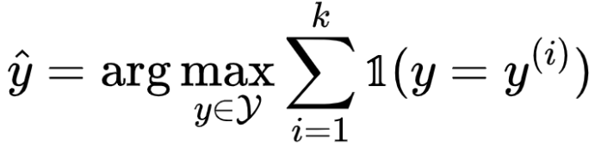  among the k points, output most popular class
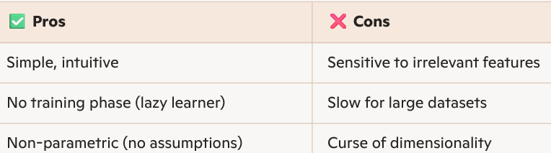 | 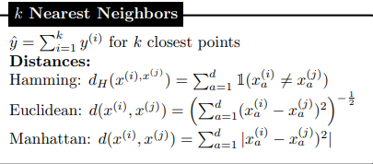
k-Nearest Neighbors: Standardization  Compute empirical mean/stddev for a feature (in train set)  Do the same for test points | 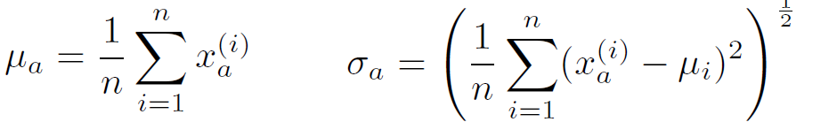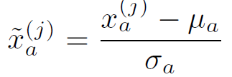
Examples 1  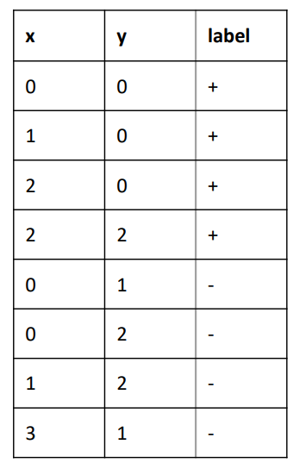 | Q1-1: Table shows all the training points in 2D space and their labels.  Assume 3NN classifier and Euclidean distance. What should be the labels of the points A: (1, 1) and B(2, 1)?  3 nearest neighbors to point A are (0, 1) [-], (1, 0) [+], (1, 2) [-]. Hence, the label should be [-]  3 nearest neighbors to point B are (2, 0) [+], (2, 2) [+], (3, 1) [-]. Hence, the label should be [+]
Example 2 Training data:  - (x(1)=2.0, y(1)=Red)  - (x(2)=3.0, y(2)=Red)  - (x(3)=4.0, y(3)=Blue)  - (x(4)=5.0, y(4)=Blue)  - (x(5)=6.0, y(5)=Blue)(  - Test point: x=4.5 k=3  - Distance metric: Euclidean ∣x−x(i)∣ (1D) | Distances from x=4.5  - ∣4.5−2.0∣=2.5 → Red  - ∣4.5−3.0∣=1.5 → Red  - ∣4.5−4.0∣=0.5 → Blue  - ∣4.5−5.0∣=0.5 → Blue  - ∣4.5−6.0∣=1.5 → Blue  - For k=3 , 3 closes values are Blue, Blue, Blue, or, Blue, Blue Red  Majority Blue, so x=4.5 label is Blue
Decision trees  Model: assign a label to inputs 𝐱 by traversing a tree starting from the root node  •if at a leaf node, output the label  • else go to the branch of the tree determined by the node feature index 𝑖 and the input’s corresponding feature 𝐱[𝑖]  •if categoric, determined by assigning 𝐱[𝑖] to one of the category groupings  •if numeric, determined by whether 𝐱[𝑖] is greater or less than a threshold Learning: groupings, thresholds, and leaf labels determined via greedy heuristics | 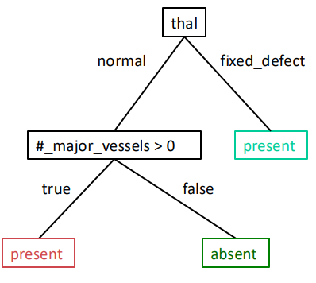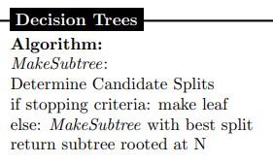  Dali na ispit i resavanje so Information Gain?
Example  Show a decision tree that would perfectly classify the following data set  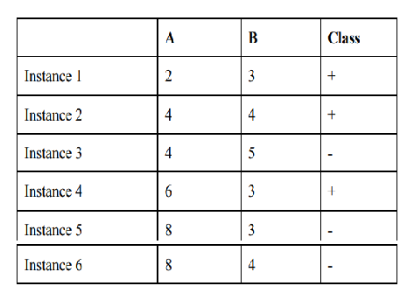 | Step 1: Analyze the data  Let's look for patterns:  Looking at feature A:  - A = 2: Instance 1 → +  - A = 4: Instance 2 (+), Instance 3 (-) → mixed  - A = 6: Instance 4 → +  - A = 8: Instance 5 (-), Instance 6 (-) → -  Looking at feature B:  - B = 3: Instance 1 (+), Instance 4 (+), Instance 5 (-) → mixed  - B = 4: Instance 2 (+), Instance 6 (-) → mixed  - B = 5: Instance 3 → - | Step 2: Find pure splits  Let's try A ≤ 3:  - Yes: Instance 1 only → + (pure)  - No: Instances 2-6  For A > 3: Instances 2-6 (2+, 3-)  Let's split this by A ≤ 7:  - Yes: Instances 2,3,4 (A=4,4,6) → 2+, 1-  - No: Instances 5,6 (A=8,8) → -,- (pure)  Now we need to handle the mixed group  (Instances 2,3,4).  For Instances 2,3,4 (A=4,4,6; B=4,5,3):  - Instance 2: (4,4) +  - Instance 3: (4,5) -  - Instance 4: (6,3) +  Let's split by B ≤ 4.5:  - Yes: Instances 2,4 → +,+ (pure)  - No: Instance 3 → - (pure)
 | Step 3: Construct the decision tree  [Root: A ≤ 3?]  ├── Yes: Class = + (Instance 1)  └── No: [A ≤ 7?]  ├── Yes: [B ≤ 4.5?]  │ ├── Yes: Class = + (Instances 2,4)  │ └── No: Class = - (Instance 3)  - └── No: Class = - (Instances 5,6) | Step 4: Verification  - Inst1 (2,3,+): A≤3? Yes → + ✓  - Inst2 (4,4,+): A≤3? No → A≤7? Yes → B≤4.5? Yes → + ✓  - Inst3 (4,5,-): A≤3? No → A≤7? Yes → B≤4.5? No → - ✓  - Inst4 (6,3,+): A≤3? No → A≤7? Yes → B≤4.5? Yes → + ✓  - Instance 5 (8,3,-): A≤3? No → A≤7? No → - ✓  - Instance 6 (8,4,-): A≤3? No → A≤7? No → - ✓  All 6 instances are perfectly classified.
GTP solution | - Root split A ≤ 6 separates {instances 5,6}  (both −) on the No branch — pure negative.  - The Yes branch contains instances {1,2,3,4} with classes +,+,−,+.  Splitting that branch by B ≤ 4 gives:  - B ≤ 4 → instances {1,2,4} all + (pure positive).  - B > 4 → instance {3} which is −.  All leaves are pure, so the tree classifies every training instance correctly. | 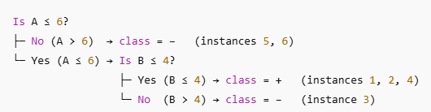  Idea try to start with branch pure (in case A<=6 pure negative) and than one branch of B pure….
Example 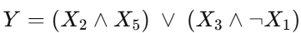 | 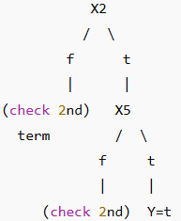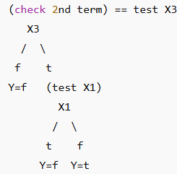

Evaluation: data splitting, metrics
Accuracy of a Model  Using a Test set | Typically: use a statistic 𝜃 ^ that is an unbiased estimator of 𝜃 computed over an independent test set  𝔼 [𝜃^] = 𝜃  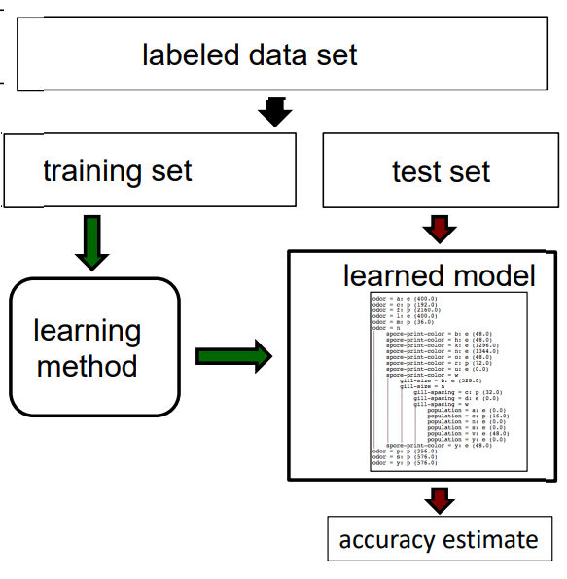 do not train on test set
Accuracy of a method as a function of the train set size?  • Plot learning curves | 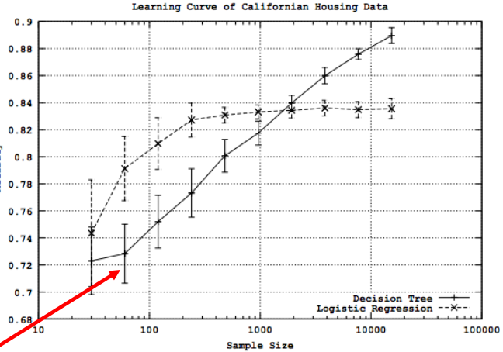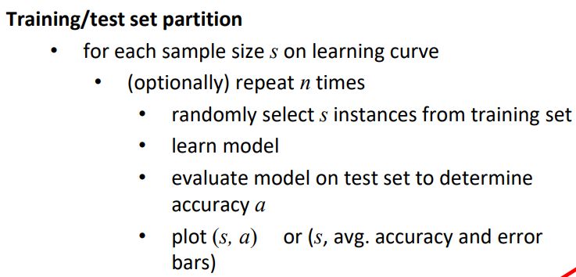  Intervals are confidence intervals (for given sample size 95% vonf. Interval for accuracy  • For some model h, a test set S with n samples  • We have h producing r errors out of n.  • Our estimate of the error rate: errorS (h) = r/n With C% probability, true error is in interval  With C% probability, true error is in interval  •zC depends on C, similar to a z-score  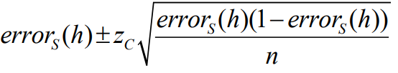
Single Train/Test Split | Limitations  1. May not have enough data for sufficiently large training/test sets  • A larger test set gives us more reliable estimate of accuracy (i.e. a lower variance estimate)  • But… a larger training set will be more representative of how much data we actually have for the learning process  2. A single training set cannot reveal how sensitive accuracy is to specific training samples.
Multiple Train/test Split | Strategy I: Random Resampling  Address the second issue by repeatedly  randomly partitioning the available data  into training and test sets.  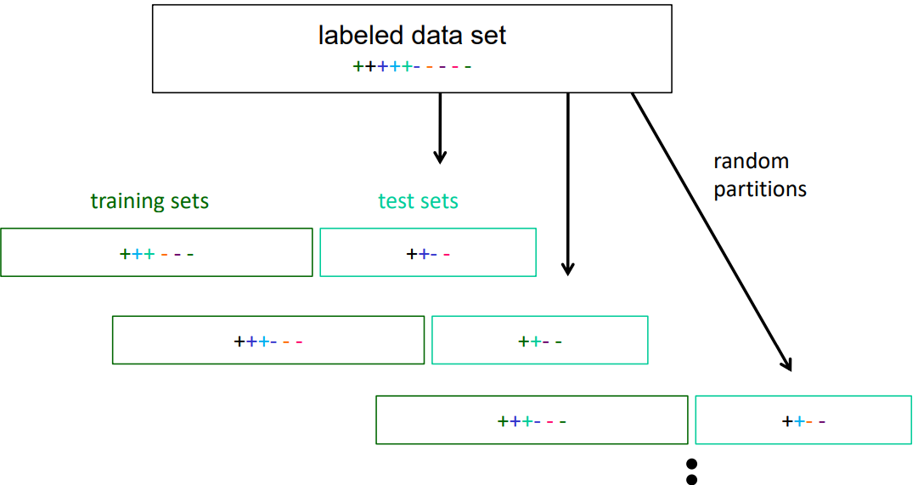 |  | Strategy I. Stratified Sampling: first stratify instances by class, then randomly select instances from each class proportionally  • want to ensure that class proportions are maintained in each selected set  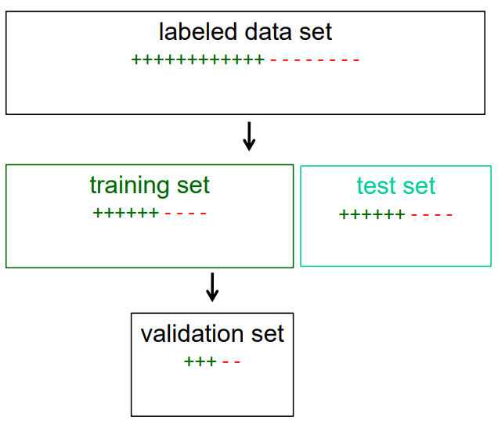
 | Strategy II: k-fold Cross Validation  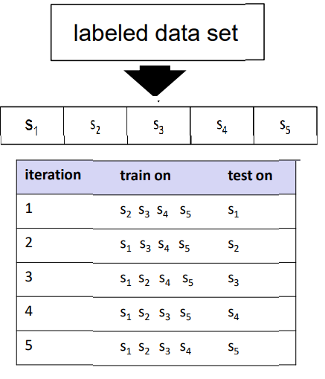 | Strategy II: Cross Validation Tips  • 10-fold cross validation is common, but smaller values folds are often used when learning takes a lot of time  • in leave-one-out cross validation, k = # instances  • in stratified cross validation, stratified sampling is used when partitioning the data  • CV makes efficient use of the available data for testing  • note that whenever we use multiple training sets, as in CV and random resampling, we are evaluating a learning method (with specific choices) as opposed to an individual learned hypothesis  • You can use CV for tuning as well!
(A) The accuracy of a model is the training set accuracy, and its estimator is the test set accuracy. F
(B) An unbiased estimator 𝜃^ always equals its correspond true parameter 𝜃. F
(A)The accuracy of a model is based on its true distribution; training/test sets only approximate this. (B)It only equals the true parameter in expectation, i.e. it’s true in the limit of a large number of estimates. This means there’s no systematic error
(A) The sample size on the learning curve is the size of test set. F
(B) A larger training set would provide a lower variance estimate of the accuracy of a learned model. F
(A)The sample size on the learning curve is for training set.
(B)A larger test set rather than a larger training set does so
NOT true? 1. Class proportions are maintained same in the stratified sampling.
2. In leave-one-out cross validation, the number of partition equals to the number of instances.
3. In cross validation, we are evaluating the performance of an individual learned hypothesis. In cross validation, we are evaluating a learning method as opposed to a specific individual learned hypothesis.
Beyond Accuracy: Confusion Matrices  Confusion matrix 2class  Accuracy  Other metrics | 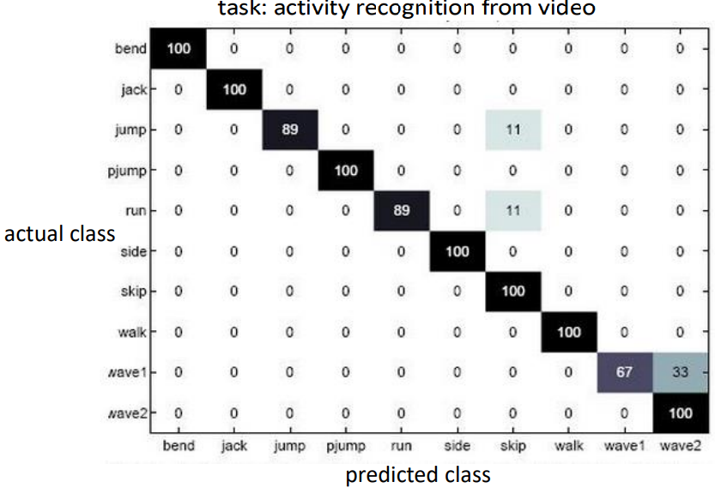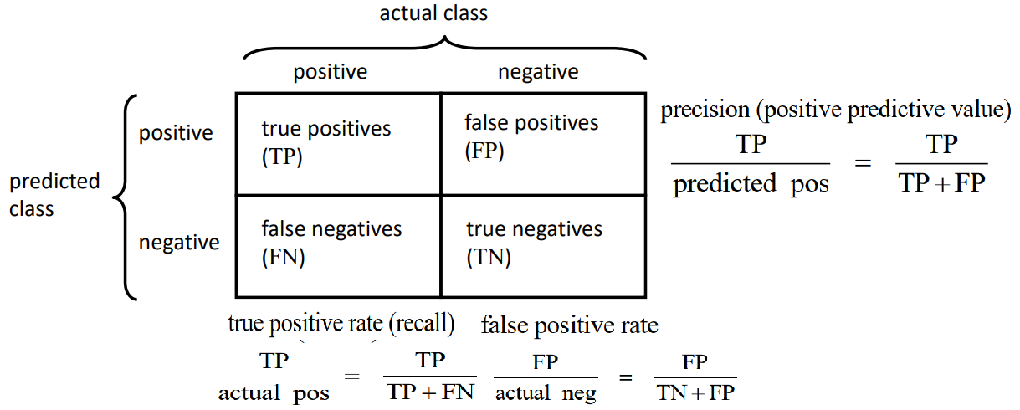
ROC curves | Suppose a classifier returns label probabilities rather than a label Pr(Y|x) instead of Y  • not optimal to simply take the maximum probability if cost of FP and FN differ  • choose threshold c and output Y=True if Pr(Y=True|x) ≥ c else Y=False

Every point on the curve correspond to threshold of prediction  AUC (Area Under Curve) meaning  1.0 perfect, 0.8-0.9 very good, 0.7-0.8 good,0.5 random <0.5 worse than random | 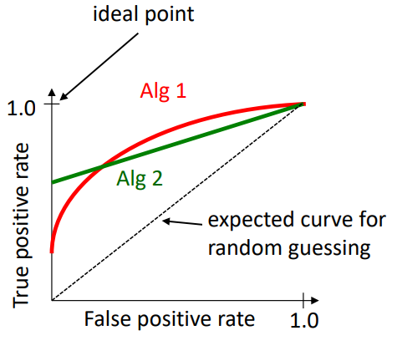 | Red curve (Alg 1):  - Stays higher → better performance  - Higher TPR for the same FPR compared to Alg 2  - Covers a larger area under the curve (higher AUC)  - More accurate classifier | Green curve (Alg 2):  - Closer to the diagonal, meaning weaker performance  - Still better than random guessing but not as good as Alg 1  Diagonal dashed line:  - Represents random guessing (AUC = 0.5): flipping a coin; no useful predictive power
You sort predictions by confidence.  ✔ Gradually lower threshold and compute TPR & FPR.  ✔ Plot those points → that is the ROC curve.  ✔ Steeper and higher curve = better model. | 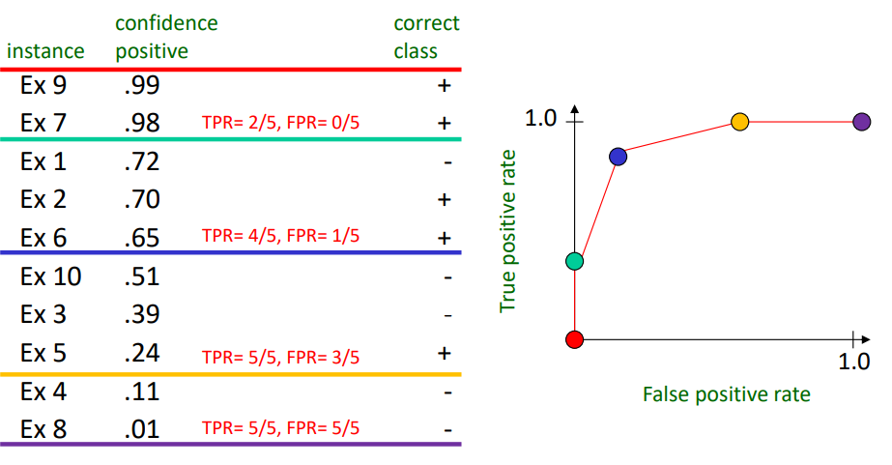
ROC Curves: Misclassification Cost  •The best operating point depends on relative cost of FN and FP misclassifications | 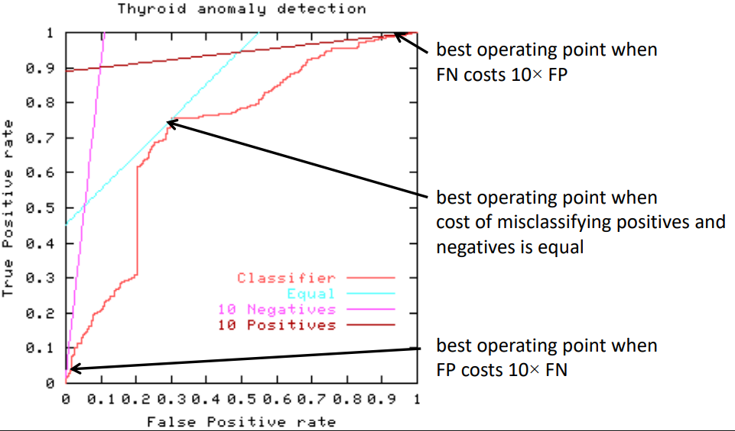
Other Metrics: Precision/Recall Curve  • (TP-rate): threshold on the confidence of an instance being positive is varied | 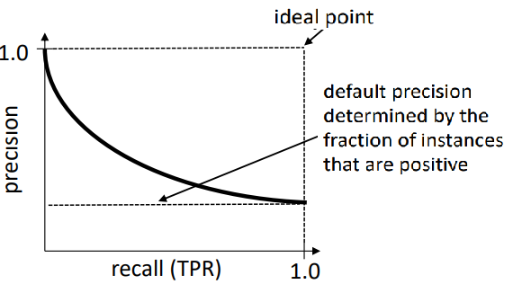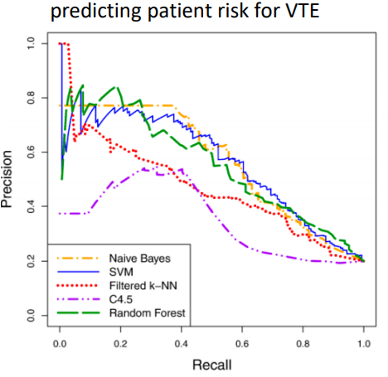
ROC vs. PR curves
Both
• Allow predictive performance to be assessed at various levels of confidence
• Assume binary classification tasks
• Sometimes summarized by calculating area under the curve ROC curves
ROC
• Insensitive to changes in class distribution (ROC curve does not change if the proportion of positive and negative instances in the test set are varied)
• Can identify optimal classification thresholds for tasks with differential misclassification costs Precision/recall curves
Precision/recall curves
• Show the fraction of predictions that are false positives
• Well suited for tasks with lots of negative instances
Parametric modeling: linear & logistic regression, regularization, MLE, MAP
Linear Classification 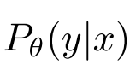, MLE, gradient descent 1/(1+e^{-x} )
LIkelhood function
Msximum likelihood e.g. Bernouli
Conditional Likelood
Logistic regression
Loss
Logistic regression (not binary) softmax
Linear regression setup
Matrix notation
Closed formt solution 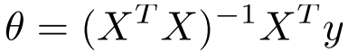 if X^{T}X invertible
Metric ??
MSE/RMSE MAE, R-squared
But what if 𝒅 ≫ ? • e.g. a training set of 𝑛 =1K documents, each represented as a bag-of-words vector (𝑋[𝑗,𝑖] =
# 𝑡𝑖𝑚𝑒𝑠 𝑤𝑜𝑟𝑑 𝑖 𝑖𝑠 𝑖𝑛 𝑑𝑜𝑐𝑢𝑚𝑒𝑛𝑡 𝑗) with vocabulary size 𝑑 =10K • now 𝑋 ⊤𝑋 will not be invertible ???? kade predavanje
Regularization ridge, lasso not have closed form,
Probabilstc interpretation
Bayesian inference MAP
MAP vs ML
Optimization gradient descent, SGS, convergence
Optimization ML
Iterative methods: Gradient descent convergence
Let’s analyze it. We’ll need some assumptions • convex and differentiable objective • has 𝐿-Lipschitz-continuous gradients
Drawback
•ImageNet: 106 samples… so for 100 iterations, 10⁸ gradients
Solution to grad descent SGD
Unsupervised learning centroid cluster, PCA
Clustering partitional hierarchical Bayesian
k-means clustering
Mixture models 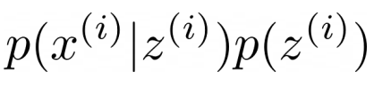 gaussian
Dimensionality PCA  uses: • Visualization • More efficient use of resources (e.g., time, memory, communication) • Noise removal (improving data quality) • Further processing by machine learning algorithms (representation transfer) | •PCA, Kernel PCA, ICA: Powerful unsupervised learning techniques for extracting hidden (potentially lower dimensional) structure from high dimensional datasets.  PCA: orthogonal projection / transformation of the data  •Into a (possibly lower dimensional) subspace  •Goal: maximize variance of the projected data
• Maximizing variability
• Equivalent to minimizing reconstruction error
Recursively get unit orthogonal vectors v1, v2,…,vr ∈R^{d}
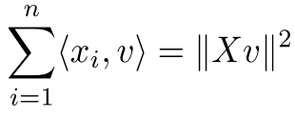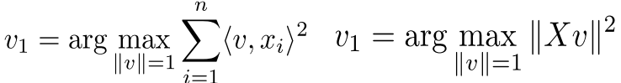
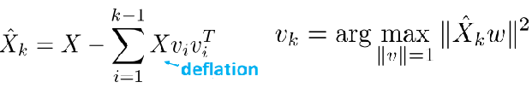
 | 00
NN, perceptron (only linear separation)
Multilayer perceptron

Unsupervised learning centroid cluster, PCA | •PCA, Kernel PCA, ICA: Powerful unsupervised learning techniques for extracting hidden (potentially lower dimensional) structure from high dimensional datasets.
uses: • Visualization • More efficient use of resources (e.g., time, memory, communication) • Noise removal (improving data quality) • Further processing by machine learning algorithms (representation transfer) | PCA: orthogonal projection / transformation of the data  •Into a (possibly lower dimensional) subspace (d dimensions to r dimensions)  •Goal: maximize variance of the projected data
d dimensions to r dimensions | • Maximizing variability  • Equivalent to minimizing reconstruction error  Recursively get unit orthogonal vectors v1, v2,…,vr ∈R^{d}    
The v’s are eigenvectors of XX^{T} (Gram matrix) ~ covariance matrix μ=0
PCA is the eigendecomposition of sample covariance
 | • Maximum variance direction 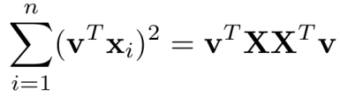  • Minimum reconstruction error 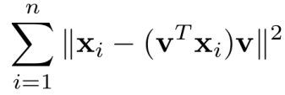 | 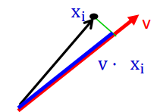  Maximizing blue segment is the same as minimizing the green
•In Homework 2, you will see how PCA can be used to obtain low-dimensional representations of words  •Also known as word embeddings / word vectors  • Can be applied on downstream supervised tasks like document classification | Constrained optimization (Lagrangian + KKT conditions) Lagrangian  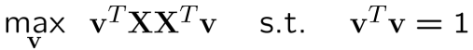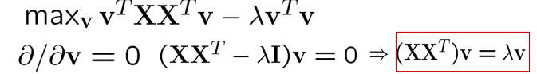  •means that v (the first PC) is an eigenvector of XX^{T}  • eigenvalue 𝜆 denotes the amount of variability captured along that dimension  Applications  •Visualization •More efficient use of resources (e.g. time, memory, communication) •Noise removal (improving data quality) •Further processing by machine learning algorithms (representation transfer)

Perceptron
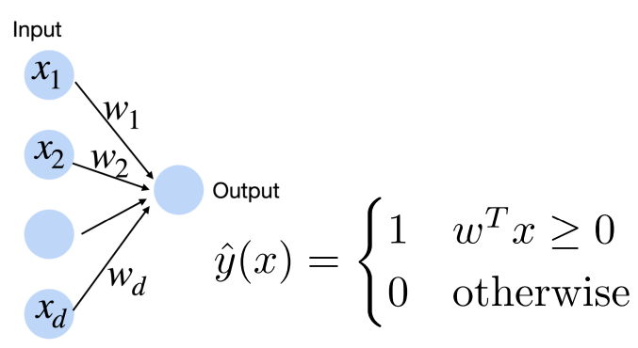PERCEPTRON
Updating if misclassify occurs no hidden laer

