Lect 24
less-than-full supervision  • do more with less (labeled data)  Semi-supervised learning  Active learning  Weakly supervise learning |  |  | transfer learning  • do more with more (o.o.d. data)  multi-task learning  meta lerning  foundation models
Semi-supervised learning  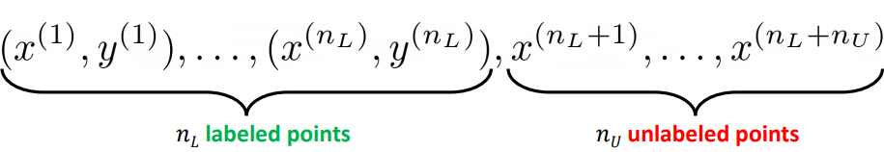 nL labeled, nU unlabeled  N=nL+nU  Downside:  •Getting labels for all our instances might be expensive.  • Ex: medical images: doctors need to produce labels |  |  | intuition: which is the better classifier?  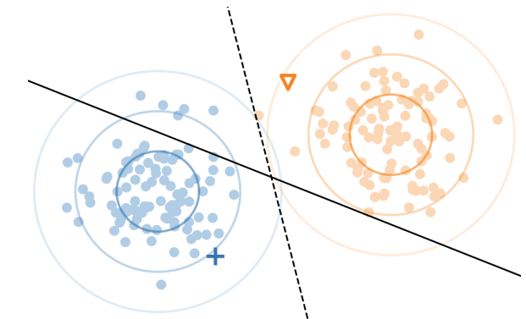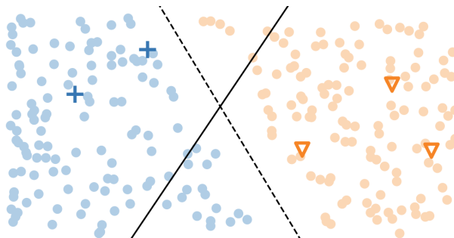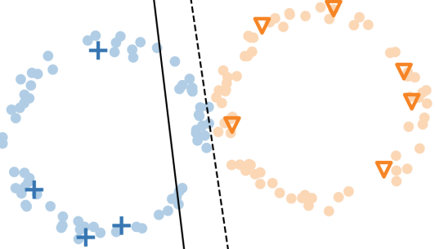
Semi-Supervised Learning: Techniques (Huge space of approaches)  •label propagation  • classic technique  • explicit: compute labels for the unlabeled data, then train a model  • graph neural networks  • modern technique  • implicit: use for predictions directly |  |  | 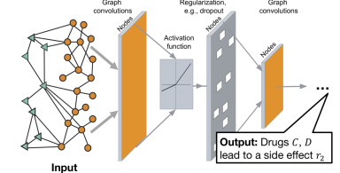
- Assumptions: Smoothness Assumption: Points close together are likely to have the same label
- Cluster Assumption: Data points tend to form clusters, and points in the same cluster are likely to share labels C number of clusters
- Manifold Assumption: High-dimensional data lies on a lower-dimensional manifold
Label Propagation: Setup  •Have:  •Goal: label the 𝑛_{𝑈} unlabeled points  •Basic idea: points that are close should have similar labels  •Approach: create a complete graph with edge weights |  |  | •Approach: create a complete graph with edge weights  Similarity matrix Matrix W  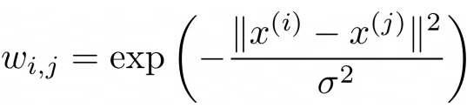 Gauss similarity  •Define a transition matrix 𝑇 with  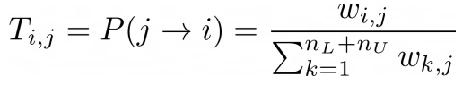
Label Propagation: Algorithm  •Set 𝑌 to be a 𝑛𝐿 + 𝑛𝑈 × 𝐶 matrix with each row 𝑖 the class distribution of point 𝑖 (labeled or unlabeled)  •At each iteration,  - Propagate: 𝑌 ← 𝑇𝑌  - Normalize 𝑌 (row-wise)  - Clamp labeled data  (force the labeled points to their known distributions, i.e. 1 for their label’s class, 0 for the others)  •Continue until convergence |  |  | 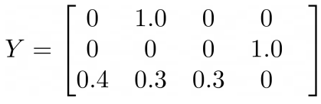 one hot e
Result  •Let’s compare this to just using kNN to label points:  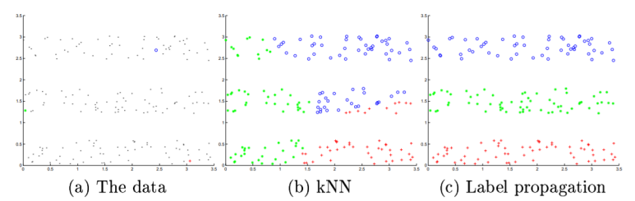  •3 color strips:  • one labeled point in each.  • kNN ignores structure  •label propagation uses structure |  |  | Example kinez  - 1000 users in a social network  - 20 labeled (10 "Sports Fans",  - 10 "Book Lovers")  - 980 unlabeled (unknown interests)  - Users are connected based on  - friendship/interaction frequency  W[i,j] = 1.0 if users are friends  W[i,j] = 0.5 if they have mutual friends  W[i,j] = 0.0 otherwise |  | 2. Initial Y matrix 2 classes C=1000x2  User 1 (labeled Sports): [1.0, 0.0]  User 2 (labeled Books): [0.0, 1.0]  User 3 (unlabeled): [0.5, 0.5] # uniform  ...  User 1000: [0.5, 0.5]
3.First propagation  Ynew = T × Yold  Example: Unlabeled user connected to:  - 2 Sports fans: each with [1.0, 0.0]  - 1 Book lover: [0.0, 1.0]  - 3 unlabeled: [0.5, 0.5] | After propagation(before normalize)  Y_user ≈  [ (2×1.0 + 1×0.0 + 3×0.5)/6  (2×0.0 + 1×1.0 + 3×0.5)/6 ]≈  [ 0.583, 0.417 ] already normalized |  | 4.Normalize already normalized here  5. Clamping  - Clamping:  - Reset labeled users back to their true labels  - Sports fans: [1.0, 0.0]  - Book lovers: [0.0, 1.0] | 6.Convergence:  After ~10-20 iterations, labels stabilize  Unlabeled users connected mostly to Sports fans → classified as Sports  Unlabeled users in "book club" cluster → classified as Books
Mathematics  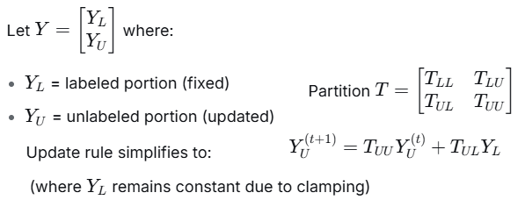 |  |  | Key Properties:  - Convergence Guaranteed: The algorithm always converges to a unique solution  - Closed-form Solution:  Y_{U}∗=(I−T_{UU})⁻¹ T_{UL}Y_{L}​  - Interpretation: Random walk with absorption at labeled nodes  Advantages: Simple and intuitive, Works well when data has clear cluster structure  - Non-parametric
Kinez example Gaussian 1D  Setup  - Classes: A = [1,0], B=[0,1].  - Labeled nodes: node 1 → A, node 2 → B.  - Unlabeled nodes: 3 and 4.  - Coordinates (1D):  - x1=0.0 (A)  - x2=4.0 (B)  - x3=1.0 (unlabeled)  - x4=2.0 (unlabeled)  - Gaussian width: σ=1.5⇒σ2=2.25.  Compute squared distances and then  wij=exp(−d/σ²). |  | Weight (adjacency) matrix W  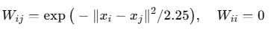  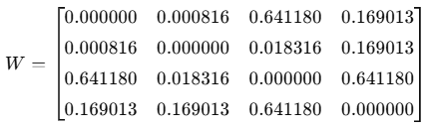  ( ex.x1​−x3​=1⇒w13​=e^{−1/2.25}≈0.64118.)  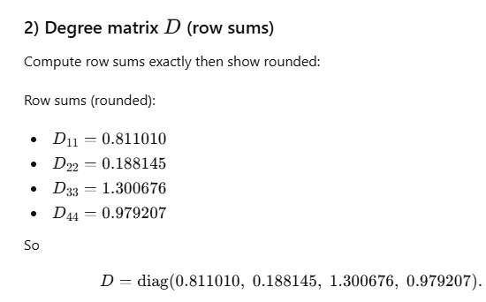 | 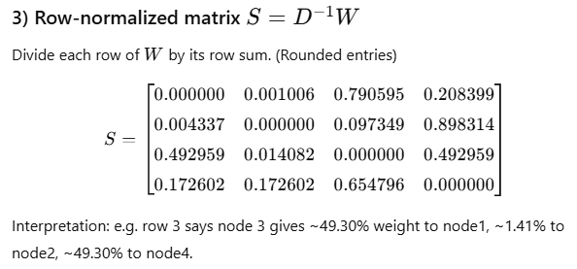  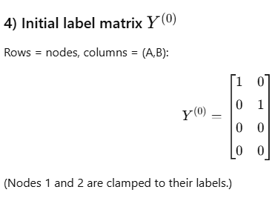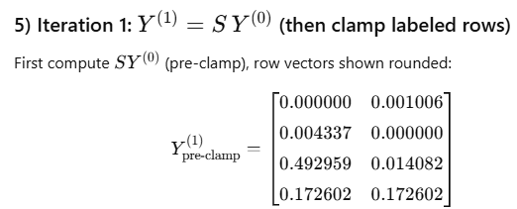
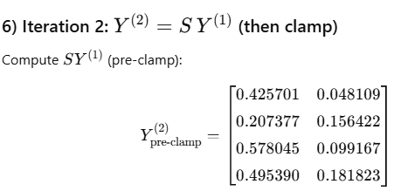 |  | 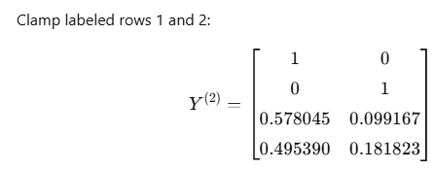 | 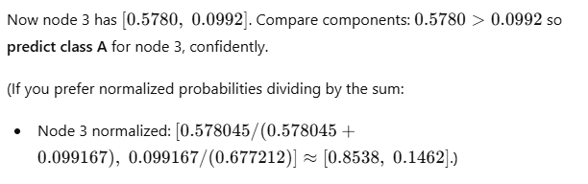
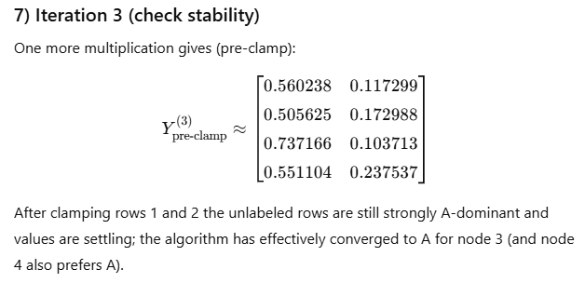 |  |  | Conclusion / takeaway  - Using Gaussian similarity with σ=1.5\sigma=1.5σ=1.5 and the chosen coordinates makes node 3 much closer to node 1 than node 2, so the propagated label for node 3 is decisively A.  - You can tune confidence by changing σ\sigmaσ: larger σ\sigmaσ makes the kernel broader (more smoothing), smaller σ\sigmaσ makes similarity decay faster (more local influence)
Limitations: Y=TY  - Computationally expensive for large graphs: O(n³) for matrix inversion  - Sensitive to graph construction  - Assumes label smoothness over the graph |  |  | Applications:  - Text classification with few labeled documents  - Image classification in large datasets  - Protein function prediction  - Fraud detection with few known fraud examples
Before Clamping after Y=TY  Point 1: [0.583, 0.250, 0.167] ← Was [1.0, 0.0, 0.0]  Point 2: [0.100, 0.700, 0.200] ← Was [0.0, 1.0, 0.0]  Point 3: [0.400, 0.350, 0.250] ← Propagated from neighbors  Point 4: [0.300, 0.400, 0.300] ← Propagated from neighbors |  |  | After clamping  Point 1: [1.0, 0.0, 0.0] ← CLAMPED back to "Sports"  Point 2: [0.0, 1.0, 0.0] ← CLAMPED back to "Books"  Point 3: [0.400, 0.350, 0.250] ← Unchanged (unlabeled)  Point 4: [0.300, 0.400, 0.300] ← Unchanged (unlabeled)
Graph Neural Networks: Motivations  •Setting: data that comes with some associated graph structure indicating similarity Example: citation networks.  •Instances are scientific papers  • Labels: subfield/genre  •Graphs: if a paper cites another, there’s an edge between them |  |  | 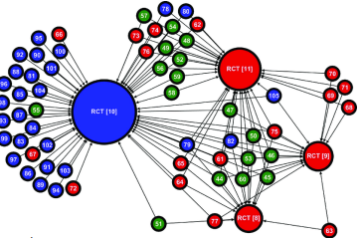
Approach  •Idea: want to use the graph information in our predictions.  •Semi-supervised aspect: don’t need all the graph’s nodes to be labeled; instead, use  the trained network to predict unlabeled nodes.  •One popular network: graph convolutional network (GCN) |  |  | 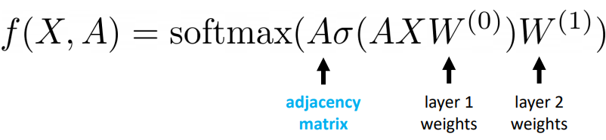
•Just like a feedforward network, but also mix together nodes by multiplying by adjacency matrix  •Can also normalize, use Laplacian, many variations |  |  | 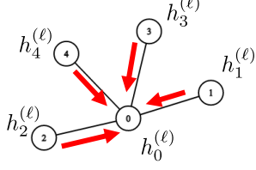
Note the resemblance to CNNs:  •Pixels: arranged as a very regular graph  •Want: more general configurations (less regular) |  |  | 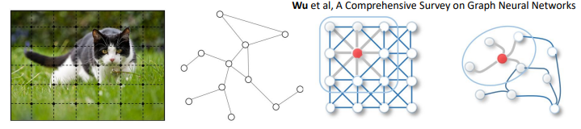
1. Label propagation will produce similar outcomes to k nearest neighbors when label density is high  2. Label propagation is guaranteed to recover the true labels for its unlabeled points. |  |  | True If label density is high, there will be nearby points (i.e. small distances) that are labeled so LabelProp will have similar behavior to kNN.  False LabelProp works only if underlying distance assumption holds ??
Active Learning: Setup  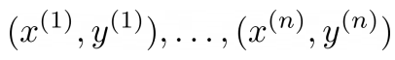  •So far we have collected data passively:  1. sample unlabeled data points i.i.d. from a distribution  2. label a random subset of them  •This reflects one way of obtaining data in practice, but we can also collect data actively:  •the unlabeled points still come i.i.d. from some distribution  •the learning algorithm decides whether or not to label them |  |  | Intuition: which point’s label is most useful?  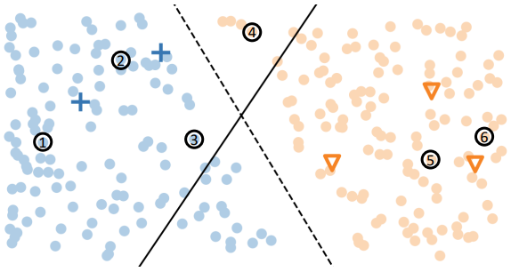
Different active learning settings  Pool-based active learning: you are given a set of unlabeled i.i.d. points 𝑥1, … , 𝑥𝑛 ∼ 𝐷 and can pick which ones to label  Stream-based active learning: you see the i.i.d. points 𝑥1, … sequentially and must irrevocably decide whether to label 𝑥𝑖 before seeing 𝑥𝑖+1 Other settings exist The one you’re in depends on the application |  |  | if we label the points i.i.d. we need Ω( 1/𝜀) samples to learn a threshold 𝜃^ with error 𝜀 •if we label using binary search we only need 𝑂(log 1/ 𝜀 ) !
Margin-based active learning  Intuition: harder-to-classify points are more informative  Idea: train a linear classifier on a few i.i.d. points, then actively pick points based on distance from the classifier |  |  | 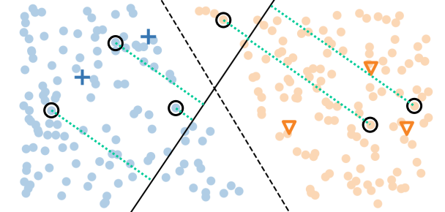

Active learning summary

Theoretically:

•Goal: prove much (e.g. exponentially) smaller sample complexity relative to passive learning (e.g. (log 1 𝜀 ) vs. Ω( 1Τ𝜀))

•Reality: hard to show outside linear models / nice distributions

Empirically:

•Lots of heuristics for selecting points, often based on their estimated difficulty (as in margin-based active learning)

•Numerous applications where labels are expensive
Weak Supervision: Motivation  •As before, labels are very expensive to get.  •Sometimes we can get cheaper sources to label points  •Noisy…  •But can acquire several of them  •Some examples of sources:  •Heuristics (expressed via small programs)  • Pre-trained models  • Lookups in knowledge bases  • Crowdsourced workers |  |  | @labeling_function()  def check_out(x):  return SPAM if "check out" in x.text.lower()  else ABSTAIN
Weak Supervision: Pipeline  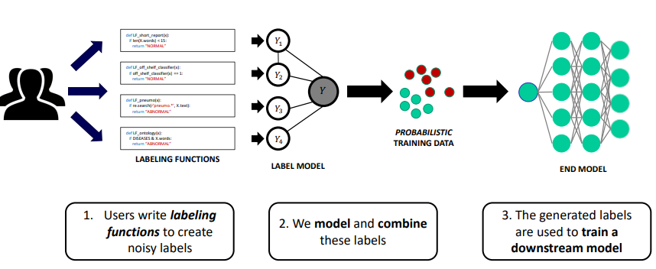 |  |  | Weak Supervision: Intuition & Majority Vote  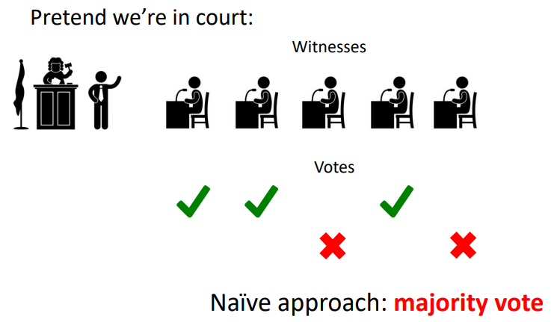
Weak Supervision: Can we do better? Some witnesses can be less reliable, and/or some of them may vote in a block.  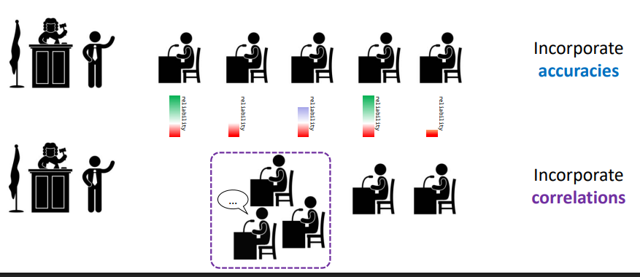 |  |  | Weak Supervision: Label Model  Suppose we have labeling functions 𝜆1, 𝜆2, … , 𝜆𝑚 and the true (unobserved) label is 𝑌. •Goal: we want to compute the conditional probability  𝑃(𝑌|𝜆1, 𝜆2, … , 𝜆𝑚)  •Why: want to know given a set of votes from the m labeling functions, how likely is Y to be 0? To be 1?  •Approach:  • model the accuracies and correlations of different labeling functions using a probabilistic (graphical) model  •infer the model parameters using unsupervised learning  • Use the resulting model to produce (soft) labels for supervised training

kinez
Less-than-full Supervision naslov od predavanja  Refers to learning paradigms that use partial, weak, or alternative forms of supervision instead of relying on large amounts of meticulously labeled data. It challenges the traditional supervised learning assumption that we need high-quality, complete labels for every training example  Core Idea Instead of requiring full, accurate labels for every data point (which is expensive/time-consuming), these methods work with:  - Less labeled data (few examples)  - Weaker/lower-quality labels (coarse, noisy, or indirect)  - D ifferent forms of supervision (constraints, rankings, etc.) | Data-Efficient Learning (DEL)  Data-efficient learning refers to machine learning methods and techniques that achieve high performance using minimal training data or minimizing data requirements. It's about getting the most out of limited or expensive data  Core Idea  Instead of relying on massive datasets ("big data"), data-efficient learning focuses on quality over quantity, smart algorithms, and leveraging prior knowledge to reduce data dependency.  Why It Matters  Cost Reduction  -Labeling data is expensive/time-consuming (especially in medicine, science, etc.)  -Data collection can be difficult (rare events, specialized domains)  Practical Constraints  -Privacy/ethical limitations on data availability  -Edge devices with limited storage/compute  Real-World Applications  - Medical diagnosis (limited patient data)  -Robotics (real-world trial data is costly)  -Scientific discovery (experiments are expensive)
Key Paradigms & Examples  1.Weak Supervision  What: Using cheaper, noisier, or easier-to-obtain labels instead of perfect ground truth. Examples:  - Medical Imaging: Instead of pixel-level tumor segmentation (requires expert radiologist tracing), use:  -Weak labels: "This scan contains a tumor" (image-level label)  -Noisy labels: Labels from medical textbooks or automated reports  - Multiple noisy labelers: Combine labels from junior doctors  - E-commerce Product Categorization:  -Instead of manually labeling millions of products  -Use product titles/descriptions as heuristic rules: If title contains "wireless" → category "Electronics"  -Combine many such noisy rules using Label Models (Snorkel framework)  Sentiment Analysis:  -Instead of hiring linguists to label thousands of reviews  -Use emojis as proxies: 😊 → positive, 😠 → negative  -Use keywords: "terrible", "awful" → negative; "excellent", "love" → positive  2. Semi-Supervised Learning  What: Combining a small labeled dataset with a large unlabeled dataset.  Examples:  Document Classification:  - Label 100 legal documents as "contract" or "brief"  - Use 10,000 unlabeled legal documents  - Consistency: Train model to produce same prediction for slightly perturbed versions of same document  Image Recognition:  -Label 50 ca t/dog images  - Use 5,000 unlabeled animal images  -Pseudo-labeling: Use model's confident predictions on unlabeled data a temporary  labels for further training | Key Techniques & Approaches  - Transfer Learning  -Use knowledge from a related task with abundant data  - Example: Fine-tune a model pre-trained on ImageNet for specific medical imaging  2. Few-Shot / One-Shot / Zero-Shot Learning  -Learn from very few examples (or none at all)  -Example: Recognize new objects from just 1-5 examples  3. Active Learning  -Intelligently select the most informative data points to label  -Example: Query the most uncertain samples for human labeling  4. Self-Supervised Learning  -Create supervision from the data itself without labels  -Example: Predict missing parts of an image or next word in a sentence  5. Semi-Supervised Learning  -Combine small labeled data with large unlabeled data  -Example: Use consistency regularization on unlabeled data  6. Data Augmentation & Synthesis  -Artificially expand dataset through transformations  -Example: GANs to generate realistic synthetic data  7. Meta-Learning (Learning to Learn)  -Train models that can quickly adapt to new tasks with little data  -Example: Model-agnostic meta-learning (MAML)  8. Knowledge Distillation  -Transfer knowledge from a large model to a smaller one  -Example: Train compact model using outputs of large model
3. Self-Supervised Learning  What: Creating supervisory signals from the data itself without human labeling.  Examples:  - NLP (BERT/GPT):  - Masked Language Modeling: Hide words in sentences, train model to predict them  - "The [MASK] sat on the mat" → predict "cat"  - No human labels needed—text itself provides supervision  - Computer Vision:  - Jigsaw Puzzle: Shuffle image patches, train model to reassemble  - Rotation Prediction: Train model to predict how much image was rotated (0°, 90°, 180°, 270°)  - Contrastive Learning (SimCLR): Train to identify different augmentations of same image as "similar" | Applications  -Healthcare: Disease diagnosis from limited medical images  -Autonomous Driving: Learning rare but critical scenarios  -Manufacturing: Defect detection with few examples  -Natural Language Processing: Adapting to new domains/languages  -Robotics: Learning manipulation skills with minimal real-world trials
4. Distant Supervision  What: Using existing knowledge bases or databases to automatically generate labels.  Examples:  - Relation Extraction (identifying relationships between entities):  - From knowledge base: (Elon Musk, founded, Tesla)  - Find all sentences containing "Elon Musk" and "Tesla"  - Automatically label them as expressing "founded" relation  - Noisy! Some sentences might be: "Elon Musk sold Tesla stock" (wrong label)  - Company Financial Analysis:  - Use SEC filings database to automatically label companies as "profitable" vs. "unprofitable"  - Use these noisy labels to train sentiment classifiers on news articles | Challenges 1.  1.Overfitting Risk: Small datasets easier to overfit  2. Generalization: Ensuring models work beyond training distribution  3. Algorithm Complexity: Many DEL methods are computationally intensive  4. Evaluation: Standard benchmarks often still use large datasets
5. Partial/Incomplete Labels  What: Labels exist but are incomplete or cover only parts of the data.  Examples:  - Object Detection:  - Only label some objects in each image, not all instances  - Model learns to find both labeled and unlabeled objects  - Medical Diagnosis:  - Doctors label only obvious/difficult cases, skip clear negatives  - Labels are biased toward interesting/uncertain cases  - Multi-label Classification:  - For an image with "dog, ball, grass, sky", only label "dog, ball"  - Missing labels treated as "unknown" rather than "negative" | Philosophical Shift  From: "More data → Better performance"  To: "Smarter learning from less data"  Data-efficient learning is becoming increasingly important as we reach diminishing returns from simply scaling datasets, and as we apply AI to domains where data is inherently scarce or expensive.
- Learning from Constraints/Rules
What: Supervision comes as rules or constraints rather than direct labels.
Examples:
- Healthcare: Rule: "If patient has fever AND cough, likely infection"
-Rule: "Blood pressure cannot be negative"
-Train model to respect these domain constraints
Calendar Scheduling:
-Constraints: "Meetings must be during work hours"
-"No two meetings in same room at same time
-" Learn scheduling patterns while respecting constraints
Real-World Case Study: Medical Imaging
Problem: Detect rare diseases in chest X-rays
Challenge: Expert radiologist labels cost $100+ per image and take 15+ minutes

Less-than-full supervision solutions:
- Weak Labels: Use diagnostic reports (text) to generate image labels
-Report says "pneumonia present" → label image as pneumonia
-Noise: Report might mention "rule out pneumonia" (different meaning)
2. Semi-Supervised: Label 1,000 images, use 100,000 unlabeled images
-Train with consistency regularization across augmentations
3. Transfer Learning: Pre-train on natural images (ImageNet), fine-tune on medical data 4. Active Learning: Start with 100 labeled images
- Identify 100 most uncertain cases for expert labeling
-Repeat - get maximum information per labeling dollar
Advantages
1. Cost Reduction: Labeling costs often dominate ML project budgets
2. Speed: Deploy models faster without waiting for complete labeling
3. Scalability: Handle problems where full labeling is impossible
4. Utilize Existing Resources: Leverage databases, rules, unlabeled data
Challenges
1. Noise Propagation: Weak/noisy labels can degrade performance
2. Bias: Supervision bias leads to model bias
3. Complexity: Algorithms often more complex than standard supervised learning
4. Evaluation Difficult: Hard to measure true performance with imperfect supervision
Key Frameworks & Tools
- Snorkel: Weak supervision framework (Stanford)
- FixMatch: Semi-supervised learning for images
- BERT/GPT: Self-supervised language models
- WeaSEL: Weakly supervised learning with label models
The paradigm shift: Instead of "How do we get more labels?" ask "How can we learn effectively with the imperfect supervision we already have or can cheaply obtain?"

