FLOW based model
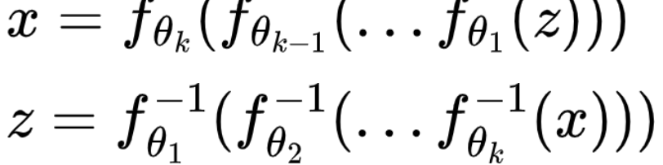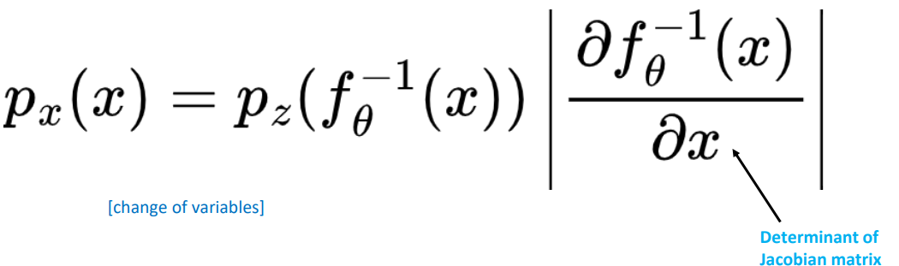  Kind of transformation  • Affine: f(x) = A⁻¹ (x - b)  • Elementwise: f(x1 , …, xd ) = (f(x1 ), …, f(xd ))  • Splines  Desirable properties:  •Invertible  •Differentiable | Training  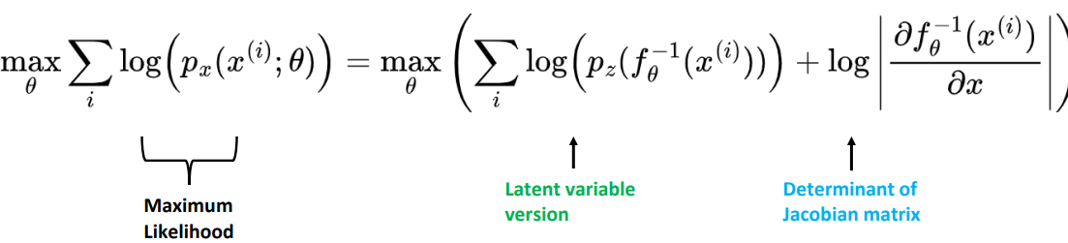
Forward: X = f(Z) = aZ + b  Inverse: Z = f⁻¹(X) = (X - b)/a  Jacobian: |det(J)| = a |Jacobian| F(z)’/dz=a | - Z ~ N(0,1) (simple base distribution)  - X is our observed data  - We need to learn parameters a and b
- J is the Jacobian matrix of the forward transformation f  - J⁻¹ is the Jacobian matrix of the inverse transformation f⁻¹ | - Forward Jacobian (f: Z → X) J = df/dz = d/dz (aZ + b) = a  Inverse Jacobian (f⁻¹: X → Z) Z = (X - b)/a  J⁻¹ = df⁻¹/dx = d/dx ((X - b)/a) = 1/a
log-likelihood for one sample using change of variables   | p_{X}(x) = p_{Z}(z) * |det(J⁻¹)| where z = f⁻¹(x)  = p_{Z}((x-b)/a) * |1/a|
- N_{z}(0,1)=E^-(z-0)²/2pi | log p_{X}(x) = log p_{Z}(z) + log|det(J⁻¹) =  log N(z; 0,1) + log|1/a| Z = f⁻¹(X) = (X - b)/a  = -0.5*z² - 0.5*log(2π) - log|a|
- Training Samples: x₁ = 3, x₂ = -1, x₃ = 1, x₄ = 5 | L(a,b) = Σ_i [ -0.5*((x_i - b)/a)² - 0.5*log(2π) - log|a| ]  = -0.5/a² * Σ_i (x_i - b)² - 4*log|a| - 2*log(2π)
For b  ∂L/∂b = 1/a² * Σ_i (x_i - b) = 0  ⇒ Σ_i (x_i - b) = 0  ⇒ 4b = Σ_i x_i = 3 + (-1) + 1 + 5 = 8  ⇒ b = 2 | For a  ∂L/∂a = (1/a³) * Σ_i (x_i - b)² - 4/a = 0 ⇒  (1/a³) * Σ_i (x_i - 2)² = 4 ⇒  Σ_i (x_i - 2)² = 4a²
Calculate Σ(x_i - 2)²:  - x₁ = 3: (3-2)² = 1  - x₂ = -1: (-1-2)² = 9  - x₃ = 1: (1-2)² = 1  - x₄ = 5: (5-2)² = 9  Total = 1 + 9 + 1 + 9 = 20  So: 20 = 4a² ⇒ a² = 5 ⇒ a = √5 ≈ 2.236 | Forward transformation: X = 2.236 * Z + 2  Inverse transformation: Z = (X - 2) / 2.236

