Chat sheet
•PAC Learning (Probably Approximately Correct)  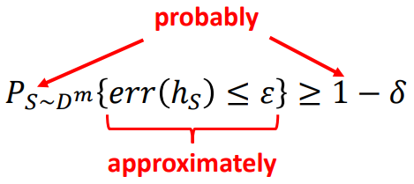  S∼D^{m}: Training set S is drawn randomly of size m from distribution D.  err(h_{S}​): True error of hypothesis h_{S​} on new examples from D (not training error).  err(hS​)≤ε: The hypothesis is approximately correct (error ≤ ε).  - Probability ≥ 1−δ: This happens probably (with confidence at least 1−δ. | A concept class C is PAC-learnable if there exists a learning algorithm that:  - Takes any dataset S of size m (each example drawn from some unknown distribution D).  - Outputs a hypothesis h_{S}:X↦Y (a function from inputs to labels).  - And for any chosen ε>0 (accuracy) and δ>0 (confidence), the algorithm ensures that: With probability at least 1−δ over random training sets S of size m, the error of h_{S} is at most ε.  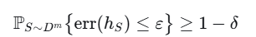  - So long as the number of examples m is at least some polynomial function of 1/ε​ and 1/δ​ (and possibly other parameters, like the complexity of C).  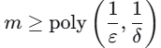
If empirical risk =0 learnable with sample complexity (risk on training set)  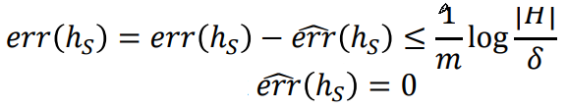 consistent state | tree nodes n, depth 2 has |H|=#pairs x #leavs labelings =(n over2)2⁴  δ=0.99, ε=0.05  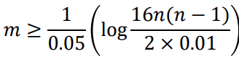
Inconsistent case 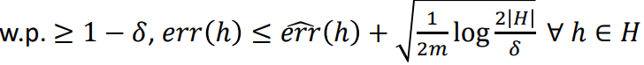 | VC dimensions  Linear classifiers in ℝ𝑑 : 𝑑 + 1  Finite hypothesis spaces: ≤ log |𝐻|  𝐿-layer ReLU networks with 𝑊 weights: 𝑂(𝑊𝐿 log 𝑊)

If H has VC dimension d, draw m samples from D -> with probability >1- δ for all h  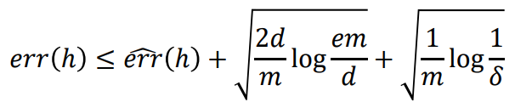  Empirical error+complexity penality +confidance penality  VC dimension ~ |H| measure of capacity of hypothesis class roughly m~d~VC(H) | Shattering: A hypothesis class H shatters a set of data points  S = {x₁, x₂, ..., x_d} if, for every possible way of labeling the points in  S (as +1 or -1), there exists some hypothesis h in H that produces that exact labeling.  VC dimension of a hypothesis class H is the size of the largest set of points S that can be shattered by H

Kinez ****  PAC learning is a framework that provides probabilistic guarantees on the performance of a machine learning model, using a limited number of examples, even when the underlying data distribution is unknown  PAC can we guarantee that concept is good  - Probably: We can't be 100% sure, but be very confident (e.g., 95% or 99% sure).  - Approximately: Your concept won't be perfect. It might make a mistake sometimes (e.g., you might misidentify a fox as a dog), but its error rate will be very small.  - Correct: The goal is to have a good, usable concept.  PAC learning: proving that a learning algorithm, after seeing a limited number of examples, will probably produce a hypothesis that is approximately correct. | Mathematically prove:  PAC learning is about proving that a learning algorithm, after seeing a limited number of examples, will probably produce a hypothesis that is approximately correct.  - - # training examples to be confident in our model?  - - Can particular class of problems even be learned from reasonable amount of data?  - - What does it mean for a learning algorithm to be "successful"?
Concept (c) true rule function c: X->(0,1)  - Hypothesis (h): The model's proposed rule, learned from the training data.  - hope h is a good approximation of c.  - Instance Space (X): Set of all possible things we might want to classify (images)  - Distribution (D) not known : A probability distribution over the instance space X. It tells us how likely we are to encounter any given example in the real world. Only sees examples of samples from D.  - Labeling/Oracle: source that give true label c(x) for any data point x. from training dataset.  - Hypothesis Class (H): The set of all possible hypotheses (models) that the learning algorithm is allowed to consider. For example, it could be the set of all linear classifiers, or all decision trees of a certain depth. | The Two Parameters of "Goodness"  PAC learning defines "goodness" with two parameters:  - Accuracy Parameter (ε - Epsilon): This defines "Approximately Correct."  - -It represents the error tolerance. We are willing to accept a hypothesis whose error is at most ε (e.g., ε = 0.05 for a 5% error rate).  - -The error is measured with respect to the unknown distribution D. It's the probability that h disagrees with c on a randomly drawn example from D.  - Confidence Parameter (δ - Delta): This defines "Probably."  - It represents our confidence tolerance. We want the probability that our algorithm fails to produce a good hypothesis to be at most δ (e.g., δ = 0.05 for a 95% confidence level).
Caveats Drawbacks of most PAC guarantees:
•do not adapt to easy data (worst-case)
•does not consider the effect of optimization
•capacity measures might be misleading for modern deep nets

Exam Spring 2009-120min  Problem 5–Miscellaneous Questions (15 points)  - Assume that you are considering a noise-free data set that contains two real-valued features, each of which ranges from 0 to L, where L is a positive integer. Your hypothesis space contains all rectangles that can be created in this 2D feature space, where the boundaries of the rectangles are integer-valued. That is, a hypothesis is of the following form  F₁ ∈ [A, B) ∧ F₂ ∈ [C, D)  where 0 A < B L and 0 C < D L and A, B, C, and D are all integers.  Assuming that the correct concept is in your hypothesis space, according to the PAC model, how many examples do you need to collect in order to be 98% confident that you will learn the underlying Boolean concept to 97% accuracy when L = 4? (Note: you are not required to solve this for any L; it is fine to only solve for this specific value of L.) | 1-δ=0.98, δ= 0.02 and 1-ϵ=0.97, ϵ=0.03  - F1​∈[A,B):  - - A can be 0,1,2,3,4 but B>A and B≤4.  - - Actually A∈{ 0,1,2,3,4} but B must be <=4 z=> A<B  Possible pairs (A,B)  - A=0: B=1,2,3,4 → 4 choices  - A=1: B=2,3,4 → 3 choices  - A=2: B=3,4 → 2 choices  - A=3: B=4 → 1 choice  - A=4 no B since B≤4 and B>A → 0 choices.  Total for F1: 4+3+2+1=10 intervals.  Similarly for F2​: same → 10 intervals.  So total rectangles = 10×10=100. => |H|=100  3. PAC sample complexity for finite H, realizable case  In the realizable case (target in H), the standard PAC bound says:  We need  m≥1/ϵ (ln∣H∣+ln1/δ)  to guarantee that with probability at least 1−δ, error ≤ ϵ  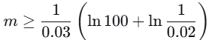  ln100=ln(10²)=2ln10≈2×2.302585=4.60517  ln1/0.02≈3.912023  Sum inside: 4.60517+3.912023≈8.517193.  Divide by 0.03:  m≥8.517193/.03≈283.9064 => m>=284
- Briefly explain how each of these approaches attempt to avoid overfitting. Only discuss one approach for each method and discuss a different approach for each. Assume that Boolean-valued functions are being learned.  - random forests  - naïve Bayes  - neural networks with hidden units  ii. Naïve Bayes  Approach: Strong Structural Assumptions (Independence Assumption)  Naïve Bayes avoids overfitting by making a very strong, simplifying assumption about the data: it assumes that all input features are conditionally independent given the class label. This drastically reduces the model's complexity and capacity.  A more complex model without this assumption would have to learn the interactions between all the features, which requires a vast amount of data. By assuming independence, Naïve Bayes severely constrains the hypothesis space. It only has to learn the individual probability of each feature given the class, which is a much simpler task requiring far fewer parameters. This inherent bias prevents it from fitting the noise in the training data, making it robust to overfitting, especially in high-dimensional spaces. | Random Forests avoid overfitting primarily by building a large number of de-correlated decision trees and averaging their predictions. This is achieved through two key mechanisms:  - Bagging (Bootstrap Aggregating): Each tree is trained on a different random subset of the training data. This introduces variability between the trees.  - Random Feature Selection: When splitting a node, the algorithm is restricted to a random subset of the features. This prevents any single strong feature from dominating the tree structures and forces the trees to learn different patterns.  A single decision tree is highly sensitive to its training data and can overfit by growing too deep. By creating many such trees on different data and feature subsets, each one overfits in a slightly different way. When their predictions (votes) are averaged, these idiosyncratic overfits cancel out, leaving a much more robust and generalizable model.

iii. Neural Networks with Hidden Units
Approach: Explicit Penalization of Complexity (Regularization)
Unlike the previous methods, Neural Networks are highly flexible models that can easily overfit. A primary method to avoid this is the use of L1 or L2 Regularization (also called Weight Decay).
This approach works by adding a penalty term to the loss function that the network is trying to minimize. This penalty is proportional to the magnitude of the network's weights.
- L2 Regularization penalizes the sum of the squares of the weights, encouraging them to be small.
- L1 Regularization penalizes the sum of the absolute values, which can drive some weights to zero, effectively simplifying the network.
By forcing the weights to remain small, the model's output function becomes smoother and less complex. It prevents the network from learning extreme, complex patterns that are likely to be
∈

Exam spring 2003 cs760  Problem 3 – Computational Learning Theory (10 points)  - Assume that we have the predictions below of five experts, as well as the correct answer. Using the weighted majority algorithm (with β=0.5) in order to track the best expert, show how the weight given to each expert changes after each example. Show your work.  Expert 1 2 3 4 5 Correct Answer  T T T F F F  Weights ________________________________________  F T F T T T  Weights ________________________________________  T F F F T F |  | 1. Initial setup  We have 5 experts, initial weight for each = 1.  Penalty factor: β=0.5 (if wrong, multiply weight by 0.5; if correct, weight unchanged).  2. First example  Predictions: E1=T, E2=T, E3=T, E4=F, E5=F  Correct answer: F  Who is wrong?  Wrong if prediction ≠ F → prediction = T.  So E1, E2, E3 are wrong. E4, E5 are correct.  Update weights:  - E1: 1×0.5=0.5  - E2: 1×0.5=0.5  - E3: 1×0.5=0.5  - E4: 11 (unchanged)  - E5: 11 (unchanged)  Weights after first example:  (0.5, 0.5, 0.5, 1, 1)
3. Second example  Predictions: E1=F, E2=T, E3=F, E4=T, E5=T  Correct answer: T  Who is wrong?  Wrong if prediction ≠ T → prediction = F.  So E1, E3 are wrong. E2, E4, E5 are correct.  Current weights: (0.5, 0.5, 0.5, 1, 1)  Update:  - E1: 0.5×0.5=0.250.5×0.5=0.25  - E2: 0.50.5 (unchanged)  - E3: 0.5×0.5=0.250.5×0.5=0.25  - E4: 11 (unchanged)  - E5: 11 (unchanged)  Weights after second example:  (0.25, 0.5, 0.25, 1, 1) | 4. Third example  Predictions: E1=T, E2=F, E3=F, E4=F, E5=T  Correct answer: F  Who is wrong?  Wrong if prediction ≠ F → prediction = T.  So E1, E5 are wrong. E2, E3, E4 are correct.  Current weights: (0.25, 0.5, 0.25, 1, 1)  Update:  - E1: 0.25×0.5=0.125  - E2: 0.5 (unchanged)  - E3: 0.25 (unchanged)  - E4: 1 (unchanged)  - E5: 1×0.5=0.5  Weights after third example:  (0.125, 0.5, 0.25, 1, 0.5)  5. Final table of weights

5. Final table of weights final
Expert | Initial | After Ex1 | After Ex2 | After Ex3
1 | 1 | 0.5 | 0.25 | 0.125
2 | 1 | 0.5 | 0.5 | 0.5
3 | 1 | 0.5 | 0.25 | 0.25
4 | 1 | 1 | 1 | 1
5 | 1 | 1 | 1 | 0.5

Problem 4 – Overfitting Avoidance (12 points)  - Use a Venn diagram of feature space to illustrate how a decision tree might overfit a training set. Briefly explain your answer. |  | Odgovor kinezot

Briefly describe how one can choose the number of hidden units to use in a neural network in order to reduce the chances of overfitting
- Informally (i.e., verbally or pictorially) explain how using a kernel might lead to overfitting in a support-vector machine.
5. e) What do you feel is the most important improvement that PAC learning offers over learning in the limit? Explain your answer. |  | The most important improvement that PAC (Probably Approximately Correct) learning offers over learning in the limit is that it provides a quantifiable and practical performance guarantee, moving from a purely theoretical notion of "eventual" learning to a framework that is relevant for real-world applications.

Learning in the Limit: The Theoretical Baseline
- Core Idea: A learner "learns in the limit" a concept if, after seeing some finite (but unknown) number of examples, its hypothesis will never change again and will be 100% correct.
- Limitations:
  - No Bounds: It gives no indication of how many examples are needed to reach this perfect hypothesis. It could be a thousand, a million, or a number larger than the atoms in the universe.
  - No "Probably": It demands exact correctness. There is no room for a hypothesis that is correct 99.9% of the time, which is often sufficient and more realistic.
  - No "Approximately": It provides no useful guidance for when to stop training or how good the current hypothesis is. You can only know you've "learned" in hindsight, after the hypothesis has stabilized.
In essence, "learning in the limit" is a beautiful theoretical model of what it means to "know" something, but it is useless for designing practical algorithms because it offers no measurable guarantees within a feasible timeframe.

PAC Learning: The Practical Improvement
PAC learning directly addresses these limitations by introducing two crucial, quantifiable parameters:
- Accuracy Parameter (ε): The learner's hypothesis is allowed to be Approximately Correct. Its error can be at most ε (e.g., 1% or 5%).
- Confidence Parameter (δ): The learner only needs to be Probably successful. It can fail to produce a good hypothesis with a small probability δ (e.g., 1% or 5%).
The most important improvement is the consequence of these parameters: PAC learning provides a concrete sample complexity bound.

Exam fall2001 ???  6.a What role does the VC Dimension play in machine learning?  It is a fundamental concept in computational learning theory that provides a quantitative measure of a model's capacity or complexity, particularly for binary classifiers.  Core Description  The VC Dimension is defined as the largest number of points that a classification algorithm can shatter.  To "shatter" a set of points means that for every possible way of labeling those points (e.g., some as class 0, others as class 1), the model can perfectly separate them. It's a measure of the model's expressive power. | Key Roles and Motivation in Machine Learning  The VC Dimension plays several crucial theoretical and practical roles:  1. Quantifying Model Complexity enable beyond vague notions of a model being "simple" or "complex." precisely say that: A linear classifier in 2D has a VC dimension of 3 (it can shatter 3 points in general position, but not 4).  A sine wave has an infinite VC dimension (it can shatter any finite set of points).
2. Providing Theoretical Bounds for Generalization most important role ???
The VC dimension is central to probably approximately correct (PAC) learning theory. It allows us to establish a generalization bound—a theoretical guarantee on how the model will perform on new, unseen data. A simplified version of this bound states that the test error is bounded by:
Test Error ≤ Training Error + Ω(√((VC Dimension) / (Number of Training Examples)))
If 𝐻 has VC dimension 𝑑 and we draw 𝑚 samples i.i.d. from 𝐷 then with probability at least 1 − 𝛿 the following is true for all ℎ ∈ 𝐻:
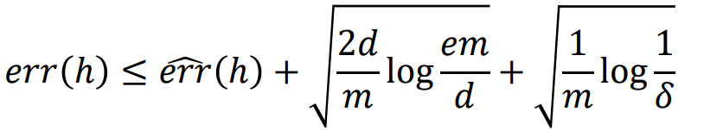
- The Trade-off: As model capacity (VC Dimension) increases, the training error may decrease, but the second term (the generalization error bound) increases. This perfectly captures the Bias-Variance Trade-off.
- The Danger of Overfitting: A model with a very high VC dimension relative to the amount of training data will have a large gap between its training and test performance. It can memorize the training set (low training error) but will fail to generalize (high test error).
- The Value of Data: For a fixed model complexity (VC Dimension), the generalization gap shrinks as the number of training examples increases. This formally justifies why more data is usually beneficial.
3. Guiding the Principle of Structural Risk Minimization (SRM)
SRM is a formal framework for model selection that directly uses the VC dimension. The idea is to:
- Create a nested sequence of model families with increasing VC dimensions (e.g., polynomials of degree 1, 2, 3...).
- For each family, train a model to minimize training error.
- Choose the model that minimizes the sum of the training error and the VC-dimension-dependent generalization bound.
This provides a rigorous method to navigate the bias-variance tradeoff and avoid overfitting by explicitly penalizing model complexity.

Summary
In essence, the VC Dimension provides a theoretical foundation for why we should avoid overly complex models. It directly links a model's capacity to its potential to overfit, justifying the need for techniques like regularization, pruning, and choosing simpler models when data is scarce. While it can be challenging to compute for complex models like deep neural networks, the intuition it provides is central to modern machine learning practice.

COPILOT exam questions  Questions , training ML | Vapnik-Chervonenkis Dimension Questions and Answers - Sanfoundry
Kinez exam questions da prepisam

CMU
- -701 midterm  4.Computational learning theory 20  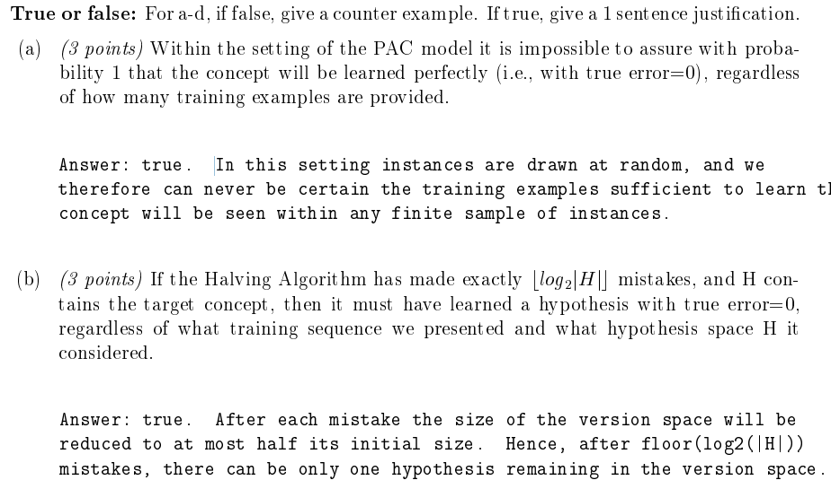 | 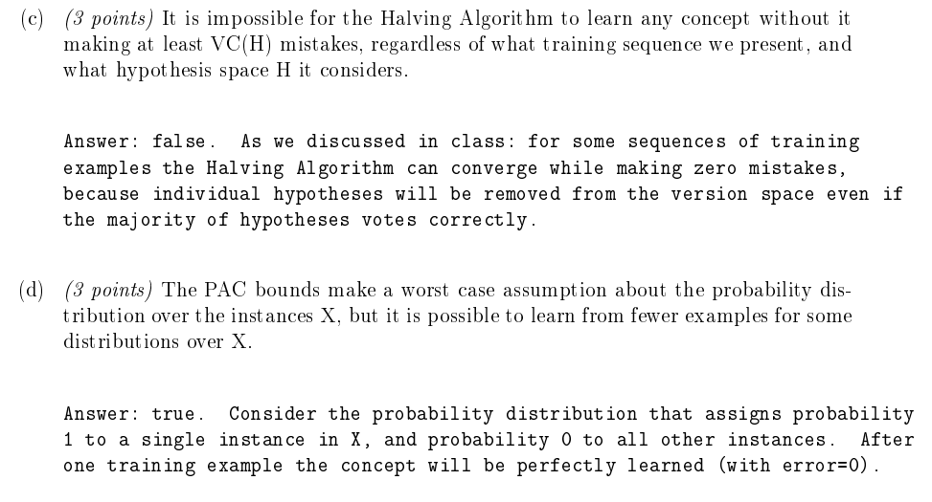  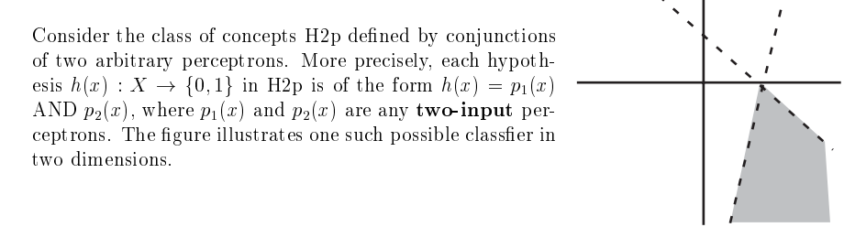
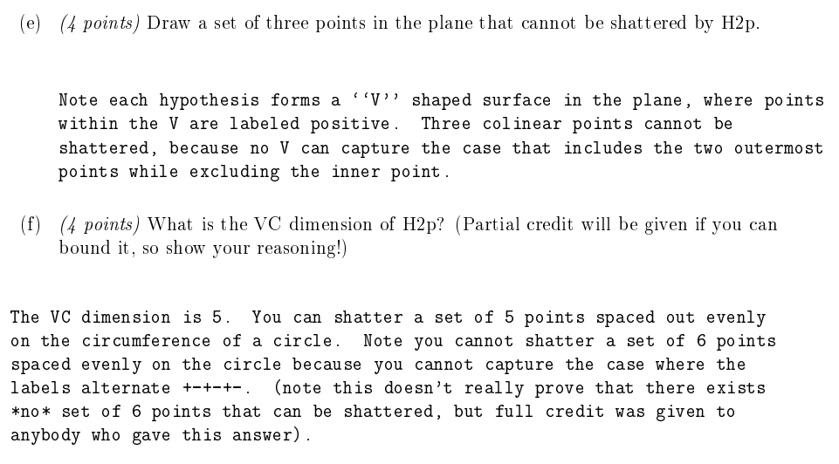
2003 CMU  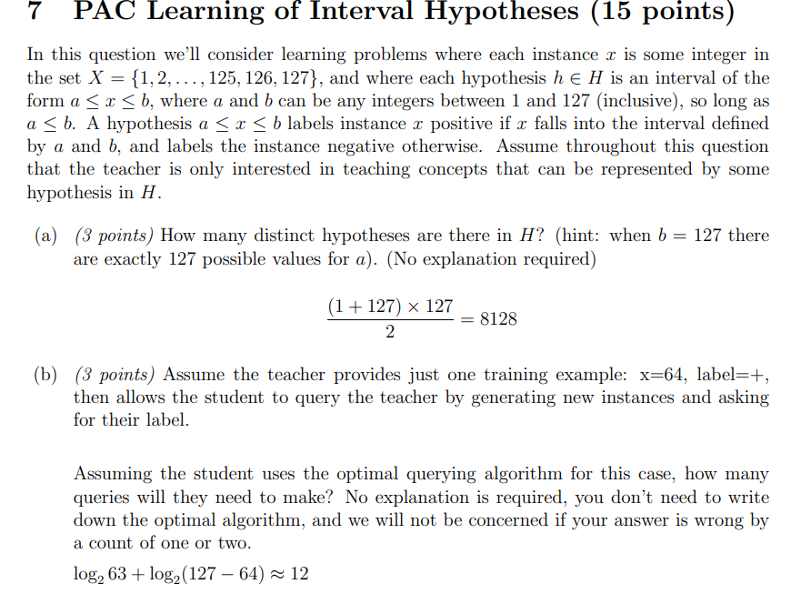 | 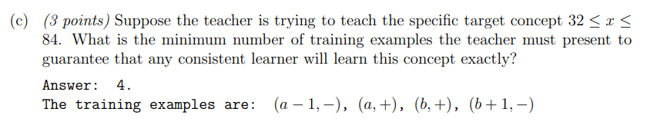  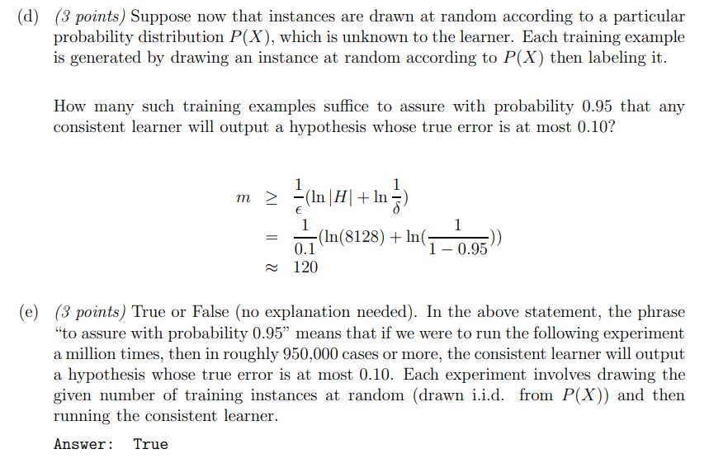
CMU 2005 sp  - https://www.cs.cmu.edu/~aarti/Class/10701/exams/midterm2005sp-solution.pdf | 2006, 7  https://www.cs.cmu.edu/~aarti/Class/10701/exams/midterm2006-solution.pdf
CMU 2006  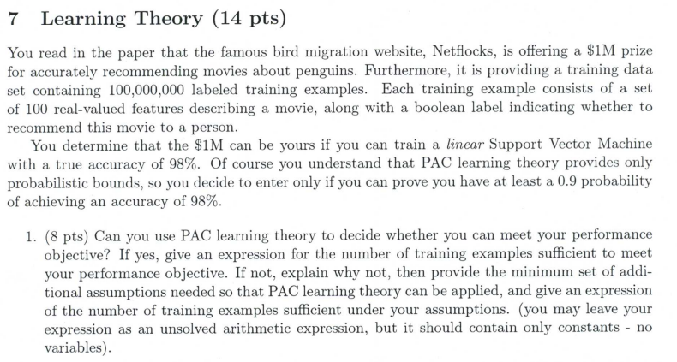 | 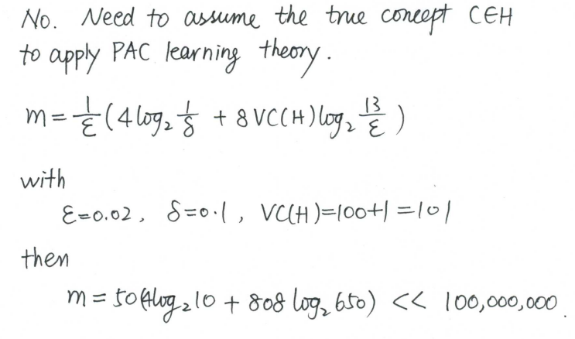
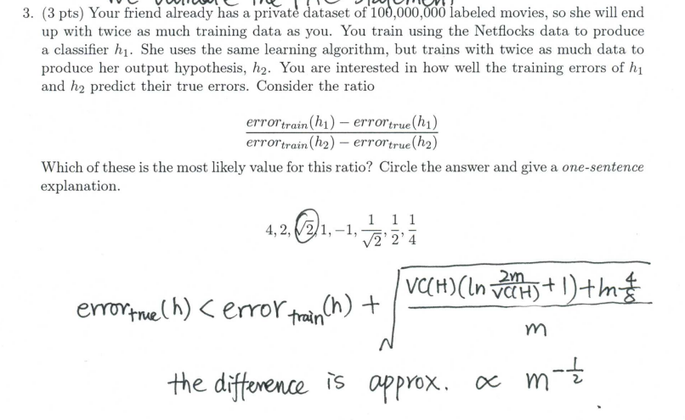
2007 7.learning theory  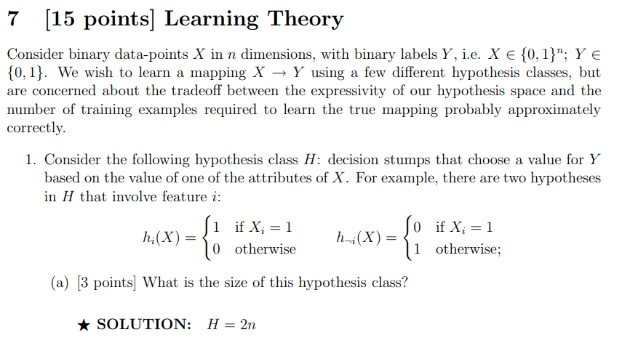  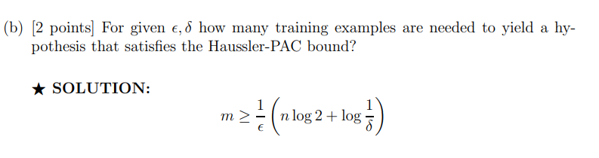  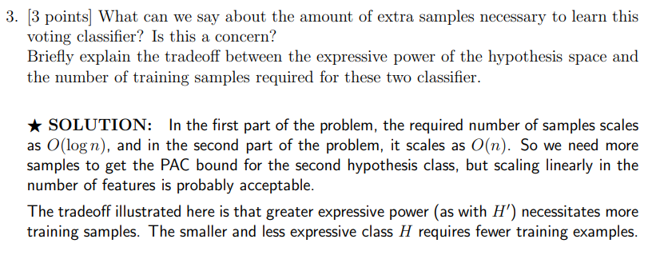 | 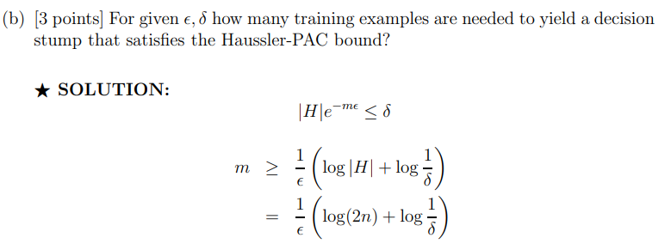  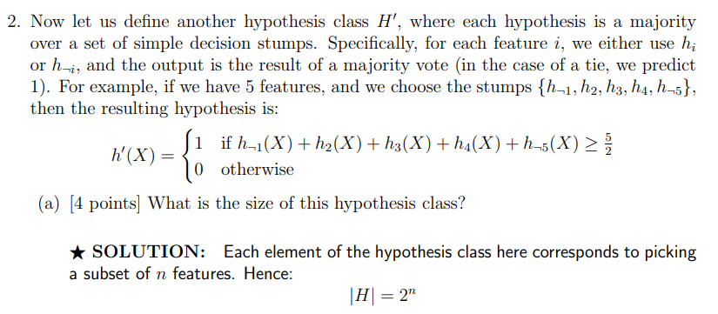
2008  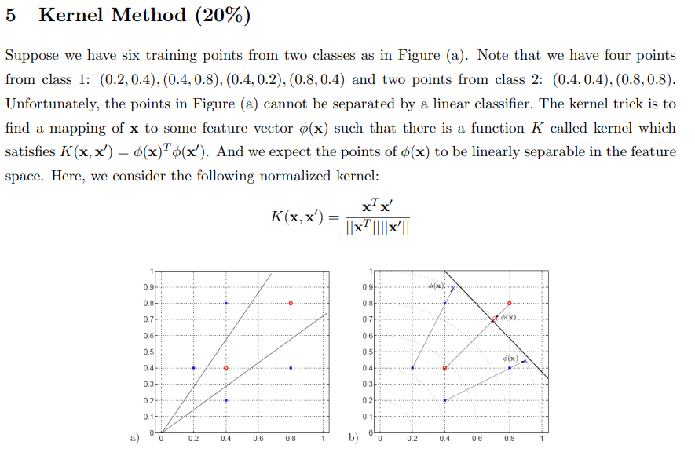 | 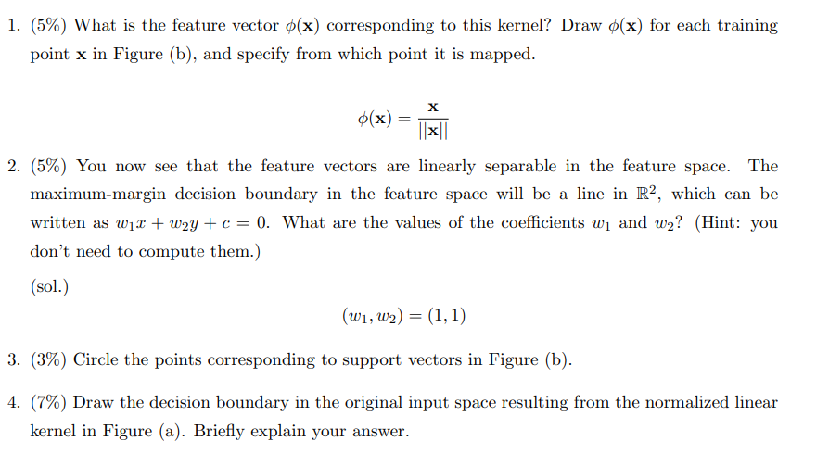
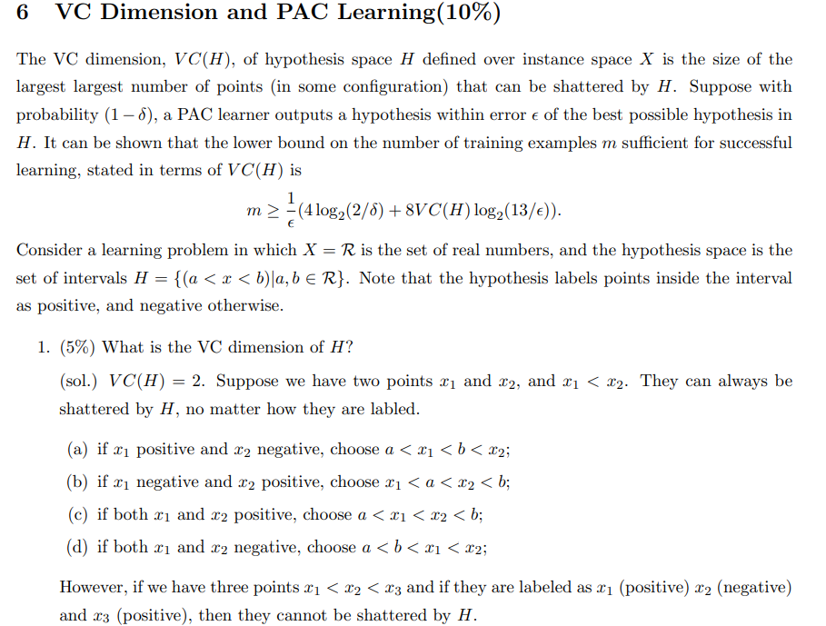 | 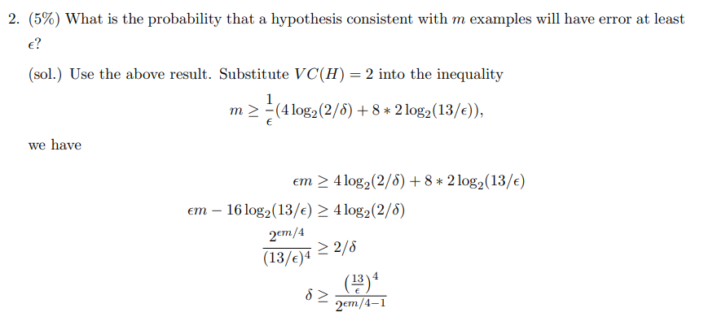
Fall 2002 final  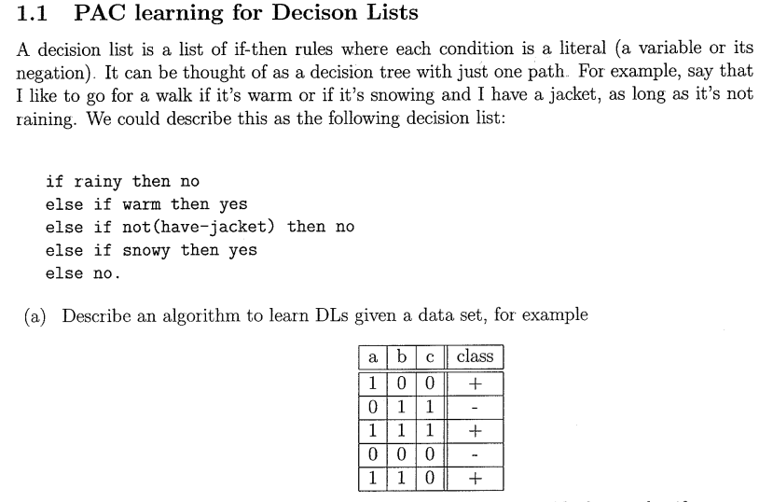 | 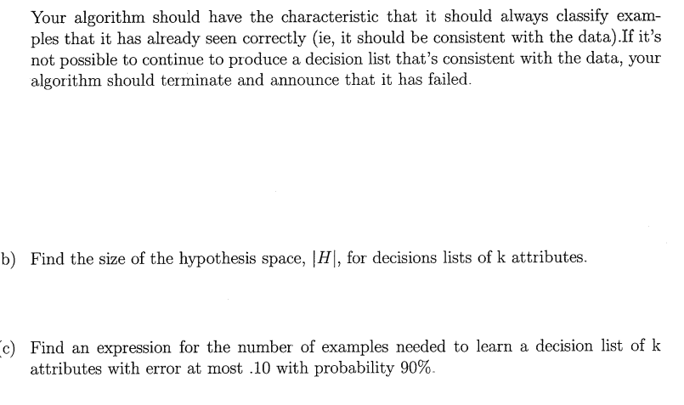  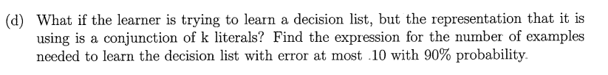
2006  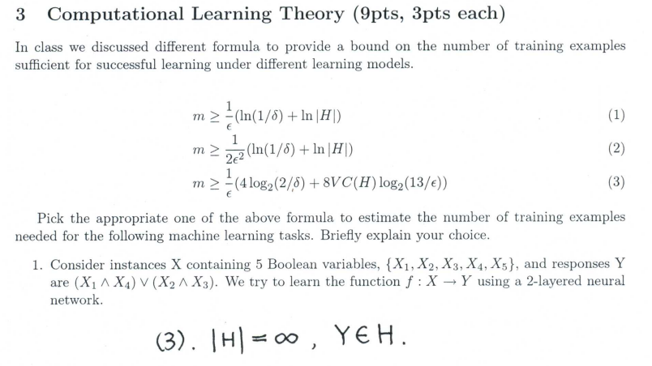 | 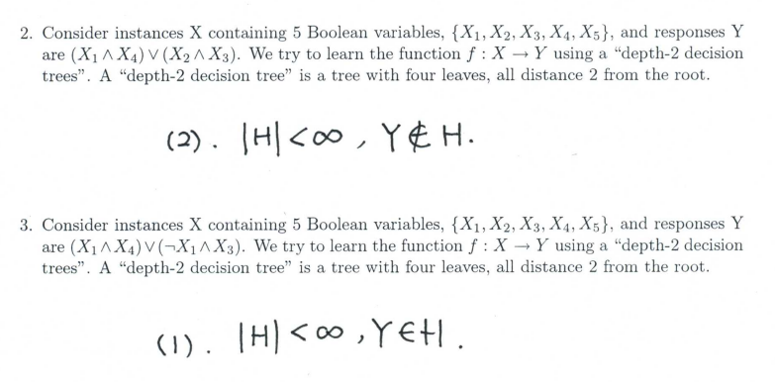
2007  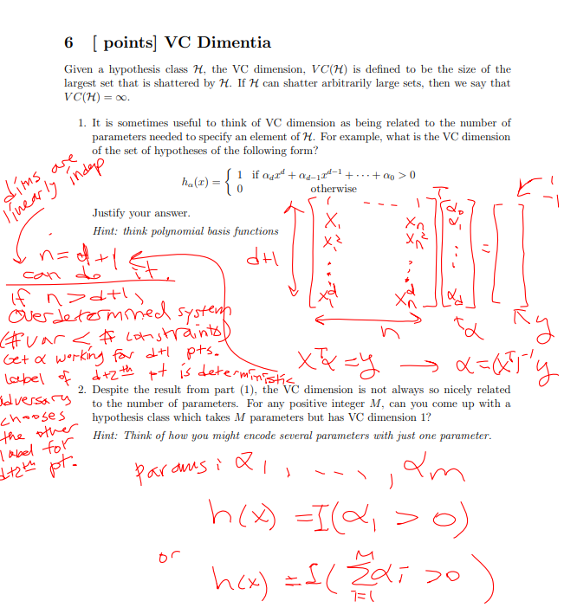 | 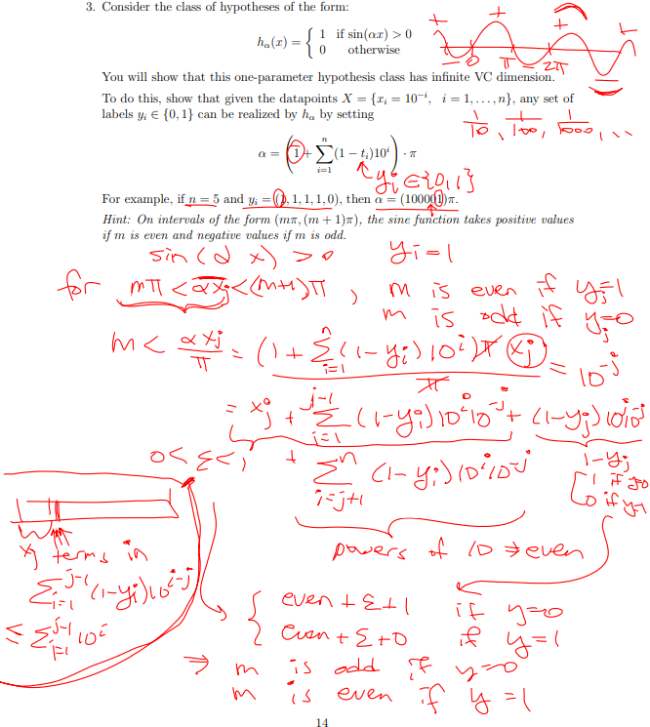
2008  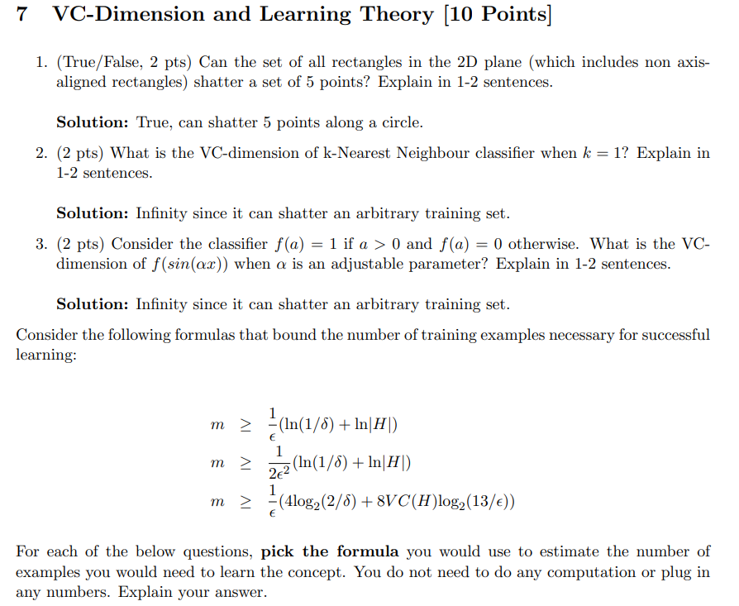 | 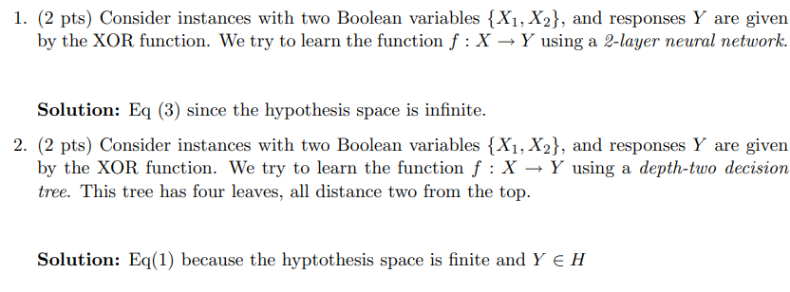
4z. 2010 10f  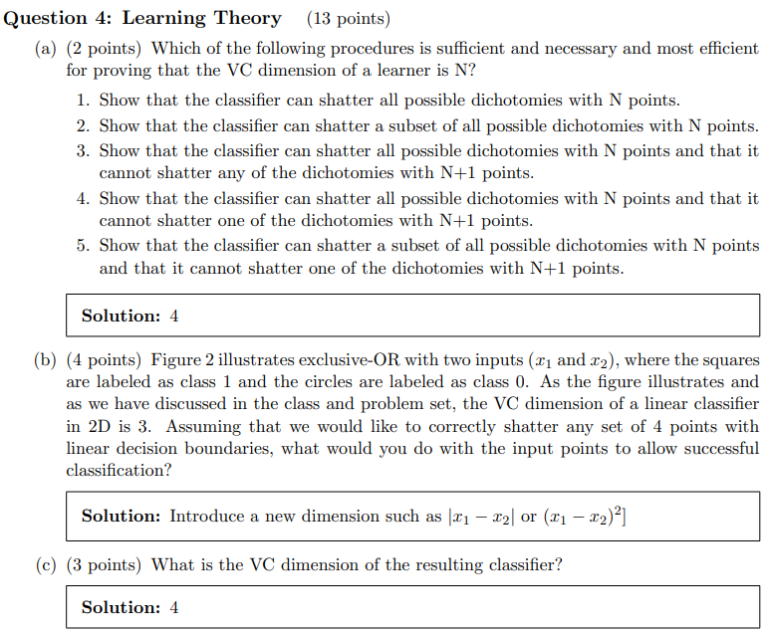 | 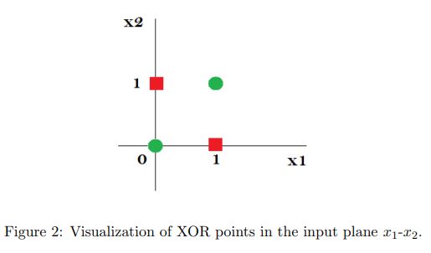  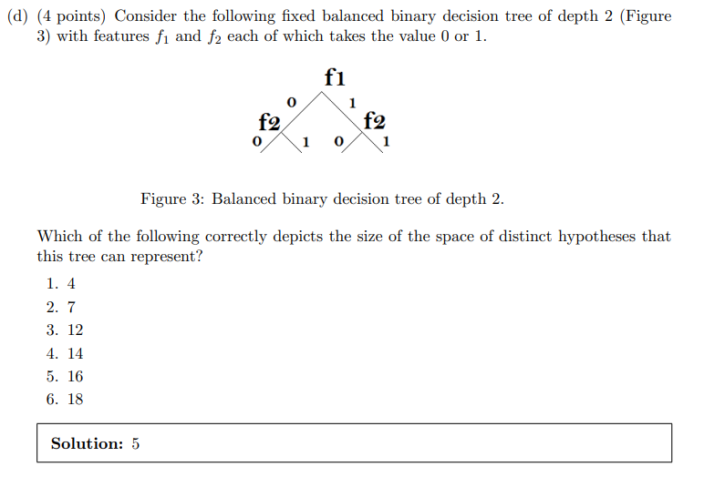
4z. 2010 10f
