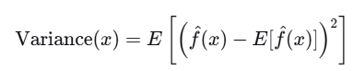
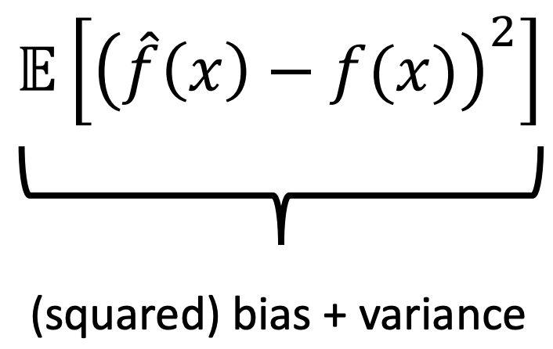
Example: Polynomial Interpolation  •1st order polynomial has high bias, low variance  •50th order polynomial has low bias, high variance  •4th order polynomial represents a good trade-off | 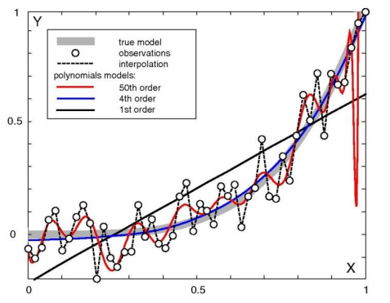
The bias-variance tradeoff  The B-V decomposition models predictive error as having two controllable components  • more expressive learners reduce bias but increase variance  • typically depicted via a capacity vs. error plot suggesting an optimal capacity  • can be extended beyond regression to classification | 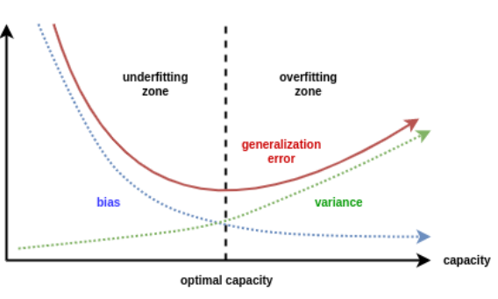
Quiz True or False:  increasing the number of neighbors (k) in k-NN will typically increase the bias and reduce the variance | True or False: increasing the regularization strength in LASSO will typically increase the bias and reduce the variance
True or False: adding degree 2 polynomial features to a linear model will typically increase the bias and reduce the variance
Caveats  • There is not always a strict tradeoff: with ensemble methods we can often reduce bias and/or variance without increasing the other term  •Neural networks (and even simpler models) sometimes yield a double descent phenomenon, where error goes down, then up, then down again as model capacity increases | 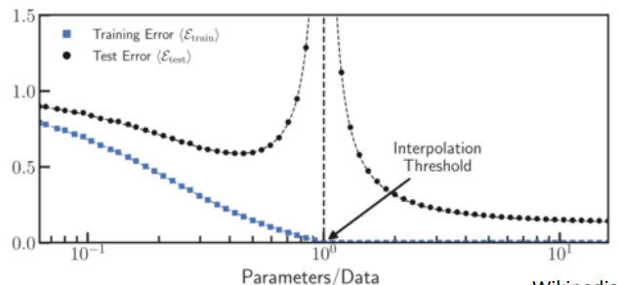

VAZNO  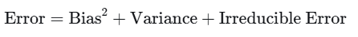 | Bias  Expectation of predicted function trained over different training set (average of prediction over many training set) minus true underlain function  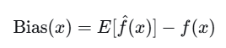
Important  - Not just one model vs. true model — Bias involves average over many hypothetical training sets.  - High bias = average model systematically misses the true pattern (underfitting).  That’s what we see in the 1st order polynomial: even with different data, it’ll always be a straight line, far from the true curve on average.  - Low bias = the average model is close to the true function.  The 50th order polynomial, on average over many datasets, could wiggle around the true function closely (low bias) but have high variance (individual fits vary wildly). | VARIANCE    Variance = the average squared difference between individual model predictions and the average prediction (over many training datasets).


Interpretation in the figure:  - High variance (50th order polynomial):  Small changes in training data cause large changes in predictions — the model is sensitive to noise. | - Low variance (1st order polynomial):  Different training sets produce similar straight-line fits — predictions don’t change much.
- Not just one model vs. true model — Bias involves average over many hypothetical training sets.  In the figure, the lines shown are likely single fits to illustrate the behavior, but conceptually bias is about how the average over fits differs from truth.  - High bias = the average model systematically misses the true pattern (underfitting).  That’s what we see in the 1st order polynomial: even with different data, it’ll always be a straight line, far from the true curve on average.  - Low bias = the average model is close to the true function.  The 50th order polynomial, on average over many datasets, could wiggle around the true function closely (low bias) but have high variance (individual fits vary wildly). | Visual intuition in the figure:  If you imagine repeating the experiment with different random samples of data points (black dots):  - The 1st order polynomial lines from different datasets would be nearly the same (low variance).  - The 50th order polynomial lines would wiggle wildly in different ways each time (high variance).  - The 4th order polynomial lines would vary somewhat, but stay reasonably close to the true trend (balanced variance).

