Sample Solutions
1. Meta-Learning – MAML Derivation
Question: Derive the update rule for Model-Agnostic Meta-Learning (MAML). Why is second-order differentiation often required?
Solution:
- Setup:
  - We have tasks Ti drawn from a distribution p(T).
  - For each task, we split data into support set (for inner update) and
query set (for meta-update).
- Inner update (task-specific adaptation):
- where α is the inner learning rate.
- Outer update (meta-optimization):
- Evaluate adapted parameters on query set:
- Gradient of meta-loss:
- Why second-order?
- Since depends on θ, chain rule applies:
- This introduces second-order derivatives (Hessian terms).
- Final meta-update:
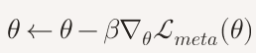 where β is the meta learning rate.
Key Point: MAML requires second-order gradients because the adapted parameters are functions of θ . First-order approximations (FOMAML) skip Hessians for efficiency.

2. PEFT – LoRA Decomposition
Question: Show mathematically how LoRA decomposes weight updates into low-rank matrices. Why does this reduce the number of trainable parameters?
Solution:
- Standard fine-tuning:
- For a pretrained weight matrix 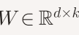, fine-tuning updates all entries.
- Trainable parameters = d x k
- LoRA idea:
- Instead of updating W directly, represent the update as:
∇ W=AB
- where:
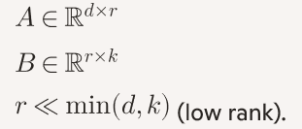
- Effective weight during fine-tuning:
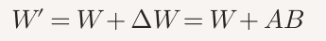
- Parameter efficiency:
- Trainable parameters = d x r+r x k.
- If r is small, this is much less than d x k.
- Example:
- Suppose d=4096,k=4096.
- Full fine-tuning: ~16M parameters.
- LoRA with r=8: 4096x 8+8x 4096=65,536 parameters.
- Huge reduction in trainable parameters.
- Key Point: LoRA leverages low-rank structure to approximate updates, drastically reducing memory and compute while retaining adaptability.

3. Multi-Task Learning – Regularization
Question: Explain how MTL acts as a form of inductive bias or regularization. Why does sharing parameters reduce overfitting?
Solution:
- Inductive bias:
  - By forcing tasks to share representations, the model learns features that generalize across tasks.
- Regularization effect:
  - Shared layers constrain the hypothesis space.
  - Prevents the model from overfitting to noise in any single task.
- Mathematical intuition:
  - Suppose loss is:
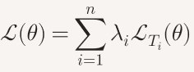

- Optimization balances multiple tasks.
  - Gradient updates are averaged across tasks, smoothing noisy task-specific signals.
- Result:
- Acts like a data-dependent regularizer.
- Encourages representations that capture common structure, improving generalization.

4. Self-Supervised Learning – Contrastive vs. Reconstruction
Question: Compare the effectiveness of contrastive loss vs. reconstruction loss in self-supervised learning. What are the trade-offs?
Solution:
- Contrastive loss (e.g., InfoNCE):
  - Objective: bring positive pairs (augmentations of same input) closer, push negatives apart.
  - Strengths: learns discriminative features, good for downstream classification.
  - Weaknesses: requires large batch sizes or memory banks for negatives.
- Reconstruction loss (e.g., autoencoders, masked modeling):
  - Objective: reconstruct input from partial/noisy representation.
  - Strengths: captures holistic structure, good for generative tasks.
  - Weaknesses: may learn trivial pixel-level features, less discriminative.
- Trade-off:
  - Contrastive → better for tasks needing separable embeddings.
  - Reconstruction → better for tasks needing generative fidelity.
- Hybrid approaches (e.g., SimCLR + MAE):
- Combine both to balance discriminative and generative properties.

