S17-exam
2a 12 poins  2ai A Perceptron can learn to correctly classify the following data, where each consists of three binary input values and a binary classification value: (111,1),  (110,1),  (011,1),  (010,0),  (000,0). |  | a AND b or C true  1  1  1  0  0  Decision plane x1+x2+x3=2
Find the boundary region (label y=0 define as y=-1)  w=(0,0,0) bias: b=0, learning rate η=1  step 1: x =(1,1,1) y=+1 test y^= wx1=(0,0,0)(1,1,1)+0=0 misclassify 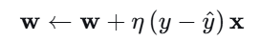 w=(0,0,0)+1(1-0)(1,1,1)=(1,1,1)  b=b+1  w←w+ηyi​xi​, b←b+ηyi​. |  | Step:  w _{t+1}=w_{t} + η (y^{i}-y^{^i} )x^{i} update to our prediction η learning rate y∈{0,1)  w _{t+1}=w_{t} + ηy^{i}x^{i} when y∈{-1,1)  Updation w _{t+1}=w_{t} if prediction is wrong  w_{t} x^{i}+η y^{i} ||x^{i} ||² when y∈{0,1) y^{i}x^{i} on mistakes  bias b is treat as w0 coefficient and x0 =1
Initial Setup  - Initial weights: Let's start with all weights = 0  w = (0, 0, 0), b = 0  - Learning rate: η = 0.5  - Activation: ŷ = 1 if w·x + b ≥ 0, else 0  - Update rule: Δw = η(y - ŷ)x, Δb = η(y - ŷ) | Epch1  x = (1,1,1), y = 1  z = 0×1 + 0×1 + 0×1 + 0 = 0  ŷ = 1 (since 0 ≥ 0) ✓ CORRECT  No update  w = (0,0,0), b = 0 | x = (1,1,0), y = 1  z = 0×1 + 0×1 + 0×0 + 0 = 0  ŷ = 1 ✓ CORRECT  No update  w = (0,0,0), b = 0 | x = (0,1,1), y = 1  z = 0×0 + 0×1 + 0×1 + 0 = 0  ŷ = 1 ✓ CORRECT  No update  w = (0,0,0), b = 0
x = (0,1,0), y = 0  z = 0×0 + 0×1 + 0×0 + 0 = 0  ŷ = 1 (since 0≥ 0)✗ WRONG (predicted 1, true label 0)  Update: error = (0 - 1) = -1  Δw = 0.5 × (-1) × (0,1,0) = (0,-0.5,0)  Δb = 0.5 × (-1) = -0.5  New w = (0,0,0) + (0,-0.5,0) = (0,-0.5,0)  New b = 0 + (-0.5) = -0.5 | x = (0,0,0), y = 0  z = 0×0 + (-0.5)×0 + 0×0 +  (-0.5) = -0.5  ŷ = 0 ✓ CORRECT  No update  w = (0,-0.5,0), b = -0.5 | Epoch2  x = (1,1,1), y = 1  z = 0×1 + (-0.5)×1 + 0×1 + (-0.5) = -1.0  ŷ = 0 ✗ WRONG (predicted 0, true label 1)  Update: error = (1 - 0) = 1  Δw = 0.5 × 1 × (1,1,1) = (0.5,0.5,0.5)  Δb = 0.5 × 1 = 0.5  New w = (0,-0.5,0) + (0.5,0.5,0.5) = (0.5,0,0.5)  New b = -0.5 + 0.5 = 0 | x = (1,1,0), y = 1  z = 0.5×1 + 0×1 + 0.5×0 + 0 = 0.5  ŷ = 1 ✓ CORRECT  No update  w = (0.5,0,0.5), b = 0  ….. 5 epohs  Final weights: w = (1.0, -0.5, 1.0), b = -0.5  2x₁ - x₂ + 2x₃ = 1
Try manually  w₁ = 1, w₂ = 1, w₃ = 1, b = -1.5 |  | - (1,1,1): 1+1+1-1.5 = 1.5 > 0 → Class 1 ✓  - (1,1,0): 1+1+0-1.5 = 0.5 > 0 → Class 1 ✓  - (0,1,1): 0+1+1-1.5 = 0.5 > 0 → Class 1 ✓  - (0,1,0): 0+1+0-1.5 = -0.5 ≤ 0 → Class 0 ✓  - (0,0,0): 0+0+0-1.5 = -1.5 ≤ 0 → Class 0 ✓
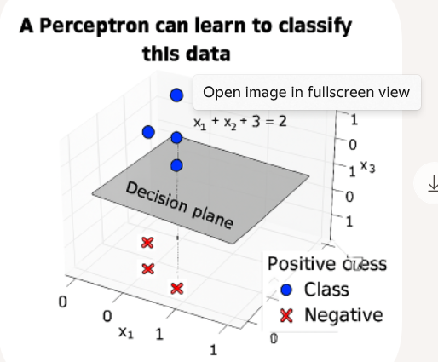
2aii The Perceptron Learning Rule is a sound and complete method for a Perceptron to learn to correctly classify any two-class problem. ≡  The perceptron Learning rule will find a linear separator if one exist ≡  The perceptron rule produces global minimum for squared error  learning rule  - Perceptron Convergence Theorem  This theorem states: If the training data is linearly separable, the Perceptron Learning Rule will find a separating hyperplane in a finite number of steps.  If the data is not linearly separable, the algorithm will not converge — it will keep updating weights indefinitely. |  | Soundness: If the Perceptron converges on a solution, that solution will correctly classify all training examples. In other words, it won’t misclassify any examples it was trained on.  Completeness: If the data is linearly separable, the Perceptron Learning Rule is guaranteed to find a separating hyperplane in a finite number of steps. That’s the completeness part—it will eventually succeed if success is possible.  The Perceptron Learning Rule is not guaranteed to converge if the data is not linearly separable. In such cases, it can oscillate indefinitely without finding a solution
“Sound and complete” meaning
- Sound: If it returns a solution, that solution is correct.
✅ True for Perceptron — once it stops, all training data are correctly classified.
- Complete: It always returns a solution in finite time when a solution exists.
✅ True for Perceptron only if data is linearly separable.
But the statement says: “correctly classify any two-class problem.”
That’s false — there exist two-class problems that are not linearly separable (e.g., XOR), for which the Perceptron cannot find a correct classification, no matter how long it runs.
2a iii) Training neural networks has the potential problem of overfitting the training data. |  | Overfitting occurs when a neural network learns the noise and specific patterns in the training data too well, rather than capturing the underlying general structure.  Why Neural Networks Are Prone to Overfitting  - High capacity: Neural networks, especially deep ones, have millions of parameters and can model extremely complex functions.  - Small or noisy datasets: If the training data is limited or contains outliers, the network may latch onto irrelevant patterns.  - Too many epochs: Training for too long without regularization can lead to memorization.
2b. (12 points)  2bi. What is the search space and what is the search method used by the backpropagation algorithm for training neural networks?  Variants of the Search Method:  Method How It Works Characteristics  Batch Gradient Uses entire dataset Stable but slow, can end in  Descent to compute gradient local min faster  Stochastic GD Uses one random per Noisy but can escape local  (SGD) update minima, faster  Mini-batch GD Uses small random Balance of stability  subsets (batches) and speed |  | The search space is the set of all possible configurations of the network’s parameters—specifically, the weights and biases across all layers  The search method is gradient based optimization a form of Gradient Descent.  1. Gradient Calculation (Backpropagation Proper):  - Forward Pass: Compute predictions and loss  - Backward Pass: Calculate the gradient ∇J(W) - the direction of steepest ascent  - This uses the chain rule to efficiently compute how each parameter affects the final loss  - Parameter Update (Gradient Descent): Wnew = Wold - η * ∇J(W)  - η is the learning rate (step size)  - ∇J(W) is the gradient (direction of steepest ascent)  - We move against the gradient to descend the loss landscape
ii) What quantity does backpropagation minimize? |  | The quantity that is minimized during the training process is the Loss Function (also called the Cost Function or Objective Function).
iii) Does the back-propagation algorithm, when run until a minimum is achieved, always find the same solution no matter what the initial set of weights are? Briefly explain why or why not. |  | back-propagation does not always find the same solution when run until convergence, and the initial set of weights significantly impacts which solution is found.
Step: perceptron border hyperplane if prediction is wrong
w _{t+1}=w_{t} + η (y^{i}-y^{^i} )x^{i} update to our prediction η learning rate y∈{0,1)
w _{t+1}=w_{t} + ηy^{i}x^{i} when y∈{-1,1)
Updation w _{t+1}=w_{t} if prediction is correct do nothing
w_{t} x^{i}+η y^{i} ||x^{i} ||² when y∈{-1,1) y^{i}x^{i} on mistakes
bias b is treat as w0 coefficient and x0 =1
c. Demonstrate how the perceptron without bias (i.e. we set the parameter  b = 0 and keep it fixed) updates its parameters given the following training sequence: x1 = (0,0,0,1,0,0,1) y1 = 1  x2 = (1,1,0,0,0,1,0) y2 = -1  x3 = (0,0,1,1,0,0,0) y3 = 1  x4 = (1,0,0,0,1,1,0) y4 = -1  x5 = (1,0,0,0,0,1,0) y5 = -1 |  | - Weights initialization: Let's start with all weights = 0  w = (0, 0, 0, 0, 0, 0, 0)  - Learning rate: η = 1 (for simplicity)  - Activation: ŷ = sign(w·x) where sign(z) = 1 if z ≥ 0, -1 if z < 0  - Update rule: Δw = η * y * x (only when misclassified)
x₁ = (0,0,0,1,0,0,1), y₁ = 1  w·x₁ = 0×0 + 0×0 + 0×0 + 0×1 + 0×0 + 0×0 + 0×1 = 0  ŷ₁ = sign(0) = 1 ✓ CORRECT  no update |  | x₂ = (1,1,0,0,0,1,0), y₂ = -1  w·x₂ = 0×1 + 0×1 + 0×0 + 0×0 + 0×0 + 0×1 + 0×0 = 0 wx₂ >=0 pred. y^=1  ŷ₂ = sign(0) = 1 ✗ WRONG (predicted 1, true label -1)  Δw = 1 × (-1) × (1,1,0,0,0,1,0) = (-1,-1,0,0,0,-1,0)  New w = (0,0,0,0,0,0,0) + (-1,-1,0,0,0,-1,0) = (-1,-1,0,0,0,-1,0)  Weights after update: w = (-1, -1, 0, 0, 0, -1, 0)
x₃ = (0,0,1,1,0,0,0), y₃ = 1  w·x₃ = (-1)×0 + (-1)×0 + 0×1 + 0×1 + 0×0 + (-1)×0 + 0×0 = 0  ŷ₃ = sign(0) = 1 ✓ CORRECT  no update  w = (-1, -1, 0, 0, 0, -1, 0) |  | x₄ = (1,0,0,0,1,1,0), y₄ = -1  w·x₄ = (-1)×1+(-1)×0+0×0+0×0 +0×1+(-1)×1+0×0 = -1+0+0+0+0-1 + 0 = -2  ŷ₄ = sign(-2) = -1 ✓ CORRECT  no update  - w = (-1, -1, 0, 0, 0, -1, 0)
x₅ = (1,0,0,0,0,1,0), y₅ = -1  w·x₅ = (-1)×1+ (-1)×0+ 0×0+ 0×0+ 0×0 + (-1)×1 + 0×0 = -1+ 0+ 0+ 0+ 0 -1 + 0 = -2  ŷ₅ = sign(-2) = -1 ✓ CORRECT  no update  w = (-1, -1, 0, 0, 0, -1, 0) final result |  | verification  - x₁: (0,0,0,1,0,0,1)→w·x₁=0×0+0×0+0×0+0×1+0×0+(-1)×0+0×1=0→ŷ= 1 ✓  - x₂: (1,1,0,0,0,1,0)→w·x₂ =(-1)×1+(-1)×1+0×0+0×0+0×0+(-1)×1+0×0=-3 → ŷ = -1 ✓  - x₃: (0,0,1,1,0,0,0) → w·x₃ = 0 + 0 + 0 + 0 + 0 + 0 + 0 = 0 → ŷ = 1 ✓  - x₄: (1,0,0,0,1,1,0) → w·x₄ = -1 + 0 + 0 + 0 + 0 -1 + 0 = -2 → ŷ = -1 ✓  - x₅: (1,0,0,0,0,1,0) → w·x₅ = -1 + 0 + 0 + 0 + 0 -1 + 0 = -2 → ŷ = -1 ✓

CD760 2016
CD760 2016  CD760 2016  Suppose you are given the neural network that maps an input value 𝑥 to two output values 𝑦# and 𝑦$. The output units use linear activation functions, and the hidden unit uses an exponential activation function. You can assume that these units do not use biases. Show the specific update rule that would be used for each weight in the network when doing online training with the following error function 1/2 (y1-o1)² +1/2 (y2-o2)² where 𝑦1and 𝑦2 are the target values, and 𝑜1and 𝑜2 are the activations of the two output units. | 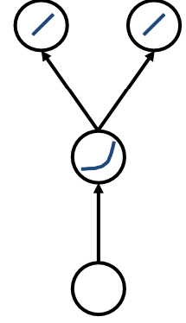 | Input x, hidden unit exponential activation (no bias)  Output y1,y2, (no bias), error E=1/2(𝑦1 – 𝑜1)² +1/2(y2-o2)²  weights
 |  | 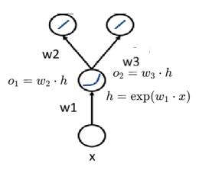 | 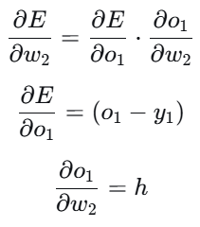  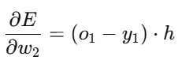 | 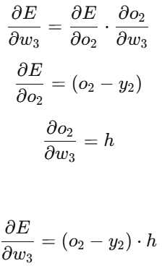
For w1 first term  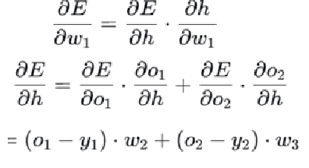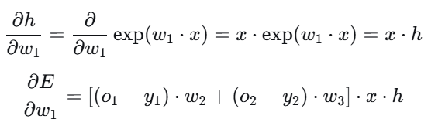 | - Final update rules Using gradient descent with learning rate η:  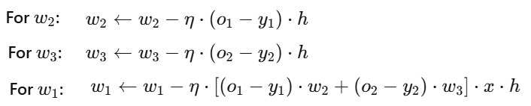
7. Hinge Loss  The hinge loss is used for maximum-margin classification (e.g., in Support Vector Machines).  It doesn’t just want correct classification — it wants predictions to be confident and far from the decision boundary. | For one training example (xi,yi), with yi∈{−1,+1} model predict f(xi​)=w⋅xi​+b  Hinge loss L_{i}(w)=max(0, 1−y_{i}(w⊤x_{i}+b)) Total loss L(w)= ∑_{i}max(0, 1−y_{i}(w⊤x_{i}+b))  Case meaning loss correct&confident  y_{i}(w⊤x_{i}+b) >=1 outside margin 0 correctly class  0 < y_{i}(w⊤x_{i}+b) <1 correct but inside positive penalized correct but to close  margin margins  y_{i}(w⊤x_{i}+b) <=0 misclassified large penalty (>=1) wrong side large
Hinge loss pushes each point not just to be correct,  but to be at least one unit away from the decision boundary —  enforcing a “safe margin” for confident classification.  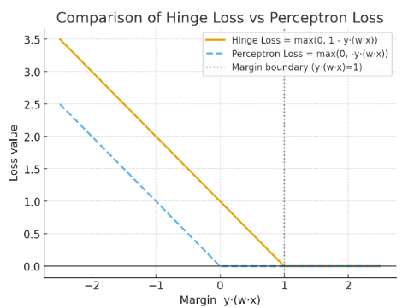 | - For y(w⋅x)<0: both penalize misclassified points.  - For 0<y(w⋅x)<1: hinge loss still penalizes, encouraging a margin ≥ 1, while perceptron loss gives no penalty.  - For y(w⋅x)≥1: hinge loss becomes 0 — the point is correct and safely away from the decision boundary.  So hinge loss = perceptron loss + margin enforcement.

CS760-2021
2 Neural Networks  - Derive the derivative of ReLU activation function (5)  ReLU(x) = max(0, x). | 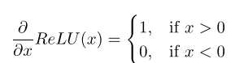  And, undefined at x=0 since left derivative and right derivative are differen
- Derive the derivative of hyperbolic tangent activation function tanh(x) = e^{x}−e^{−x}/ ex+e^{−x} | 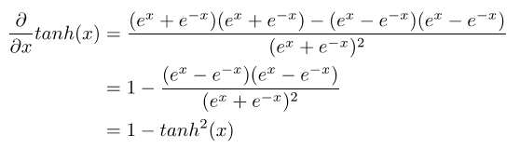
Compare sigmoid, hyperbolic tangent, and ReLU activation functions. (5 pts) | - tanh(x) = 2σ(2x) – 1  - ReLU has a non-differentiable point, but sigmoid and hyperbolic tangent are differentiable at all points.  - Sigmoid and hyperbolic tangent suffer from the vanishing gradient problem, but ReLU does not.  • They have different ranges.

CMU-2024
CS230: Stanford Deep Learning 2021  Consider a convolutional neural network block whose input size is 64 × 64 × 8. The block consists of the following layers:  - A convolutional layer 32 filters with height and width 3 and 0 padding which has both a weight and a bias (i.e. CONV3-32)  - A 2 × 2 max-pooling layer with stride 2 and 0 padding (i.e. POOL-2)  - A batch normalization layer (i.e. BATCHNORM) Compute the output activation volume dimensions and number of parameters of the layers. You can write the activation shapes in the format (H, W, C where H, W, C are the height, width, and channel dimensions, respectively  - (2 points) What is the output activation volume dimensions and number of parameters for CONV3-32? | - i. Activation volume dimensions: 62 × 62 × 32 Number of parameters: (3 ∗ 3 ∗ 8 + 1) ∗ 32 = 2336
- (2 points) What is the output activation volume dimensions and number of parameters for POOL2? | - Activation volume dimensions: 31 × 31 × 32 Number of parameters: 0
- (2 points) What is the output activation volume dimensions and number of parameters for BATCHNORM? | - Activation volume dimensions: 31 × 31 × 32 Number of parameters: 2 * 32
Now you will design a very small convolutional neural network for the task of digit predict: given a 16 × 16 image (with 3 channels i.e. RGB), you want to predict the digit shown in the image. Therefore, this is a 10-class classification problem.
Your network will have 4 layers, given in order: a convolutional layer, a max-pooling layer, a flatten layer, and a fully-connected layer.
Design the neural network to solve this problem. Of course, there are many, many solutions to this question. To narrow the solution space, here are some restrictions:
• Your convolutional layer must have a stride of 1 and have 4 filters. Because of memory limits, this layer’s activation volume should not have no more than 576 total elements in the tensor per input image (e.g. a 2 × 2 × 8 tensor has 2 ∗ 2 ∗ 8 = 32 total elements in it).
• Your max-pooling layer must have the same stride as pool size e.g. a 2 × 2 pooling layer must have a stride of 2.
• Again because of memory limits, your final fully-connected layer will not have a bias term, and its total number of parameters cannot exceed 1440.
The rest is up to you. Answer the following questions to incrementally build out your small CNN architecture.
- (4 points) What are the hyperparameters of the convolutional layer you propose (i.e. filter size, padding)? Also, what are the activation volume dimensions for this layer? | - POSSIBLE SOLUTION Filter size: 5; padding: 0 (stride: 1; filters: 4) Activation volume dimensions: 12 × 12× 4  - 2 points for correct AVD given hyperparams, 2 points for making sure that dims are ≤ 12 × 12
- v. (4 points) What are the hyperparameters of the max-pooling layer you propose (i.e. pool size)? Also, what are the activation volume dimensions for this layer? | - POSSIBLE SOLUTION Pool size and stride: 2 (padding: 0) Activation volume dimensions: 6 × 6 × 4  - 2 points for correct AVD given hyperparams, 2 points for making sure that dims are ≤ 6 × 6
- vi. (2 points) What are the activation volume dimensions of the final fully-connected layer? | - ONLY SOLUTION(S) Activation volume dimensions: 1 × 10 or just 10
- vii. (4 points) You start training your model and notice underfitting, so you decide to add data augmentation as part of your preprocessing pipeline. Given that you are working with images of handwritten digits, for each data augmentation technique, state whether or not the technique is appropriate for the task. If not, explain why not.  (a) Scaling slightly | Is appropriate
(b) Flipping vertically or horizontally | Is not appropriate; e.g. 7 is vertically flipped and is unreadable
(c) Rotating by 90 or 180 degrees | Is not appropriate; e.g. 6 turns into 9
(d) Shearing slightly | Is appropriate
CS230: Stanford Deep Learning 2020  (a) (1 point) Give a reason why one would use a 1 × 1 convolution. Hint: what does performing a 1 × 1 convolution achieve in terms of the resulting output volume? (1 sentence) | A (1 × 1) convolution would be useful if you wanted to reduce the number of channels while preserving the spatial dimensions.
(b) (1 point) What would you set the padding of a 2D CONV layer to be (as a function of the filter width f) to ensure that the output has the same dimension as the input? Assume the stride is 1. (1 formula) | (f−1)/2
(c) (2 points) You have an input volume of 32 × 32 × 3. What are the dimensions of the resulting volume after convolving a 5 × 5 kernel with zero padding, stride of 1, and 2 filters? (1 formula) | (28 × 28 × 2)
(d)(2 point) How many weights and biases would the layer defined in (c) have? (1 formula) | Number of parameters = (F ∗ F ∗ D) ∗ K + K = 5 ∗ 5 ∗ 3 ∗ 2 + 2 = 152
(e) (Extra credit: 1 point) You want to process time-series data with a 1D CONV that has the same configuration as the layer presented in (c) but with a kernel of size 5. The input volume of shape T ×3 models three fluctuating values over time. How many weights and biases does this layer have? Assume the same configuration (padding, stride, number of filters) as in (c) and show your work. | Number of parameters = (F ∗ D) ∗ K + K = (5 ∗ 3) ∗ 2 + 2 = 32
(f) (Extra credit: 1 point) You want to process a video with a 3D CONV that has the same configuration as the layer presented in (c) but with kernel of shape 5 × 5 × 5. The input video can be seen as a sequence of images indexed by time, i.e. a volume of shape W ×H ×T ×3. How many weights and biases does this layer have? Assume the same configuration (padding, stride, number of filters) ass in (c) and show your work. | Number of parameters = (F ∗F ∗F ∗D)∗K+K = 5∗5∗5∗3∗2+2 = 752
CS230: Stanford Deep Learning w2019  Question 3 (Convolutional Neural Networks, 28 points) Two historians approach you for your deep learning expertise. They want to classify images of historical objects into 3 classes depending on the time they were created:  • Antiquity (y = 0)  • Middle Ages (y = 1)  • Modern Era (y = 2) | 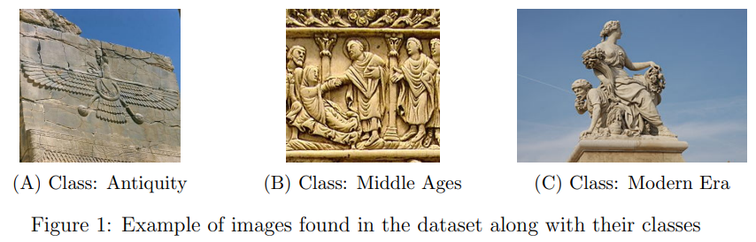
(a)Over the last few years, the historians have collected nearly 5,000 hand-labelled RGB images  (i) (2 points) Before training your model, you want to decide the image resolution to be used. Why is the choice of image resolution important?  (ii) (1 point) If you had 1 hour to choose the resolution to be used, what would you do? | Trade-off between accuracy and model complexity  (See lecture of Prof. Katanforoosh) Print pictures of images with different resolutions and ask friends if they can properly recognize images.
(b)You have now figured out a good image resolution to use.  (i) (2 points) How would you partition your dataset? Formulate your answer in percentages. | Several ratios possible. One way of doing it: split the initial dataset into 64% training/16% dev/20% testing set. Training on the training set and tuning the hyperparameters after looking at the performance on the dev set.
(ii) (3 points) After visually inspecting the dataset, you realize that the training set only contains pictures taken during the day, whereas the dev set only has pictures taken at night. Explain what is the issue and how you would correct it | • It can cause a domain mismatch. • The difference in the distribution of the images between training and dev might lead to faulty hyperparameter tuning on the dev set, resulting in poor performance on unseen data. • Solution: randomly mix pictures taken at day and at night in the two sets and then resplit the data.
(c) (3 points) As you train your model, you realize that you do not have enough data. Cite 3 data augmentation techniques that can be used to overcome the shortage of data. | A lot of answers can be accepted, including Rotation, Cropping, Flipping, Luminosity/Contrast Changes
(d) (8 points) You come up with a CNN classifier. For each layer, calculate the number of weights, number of biases and the size of the associated feature maps. The notation follows the convention:  • CONV-K-N denotes a convolutional layer with N filters, each them of size K×K, Padding and stride parameters are always 0 and 1 respectively.  • POOL-K indicates a K × K pooling layer with stride K and padding 0.  • FC-N stands for a fully-connected layer with N neurons.  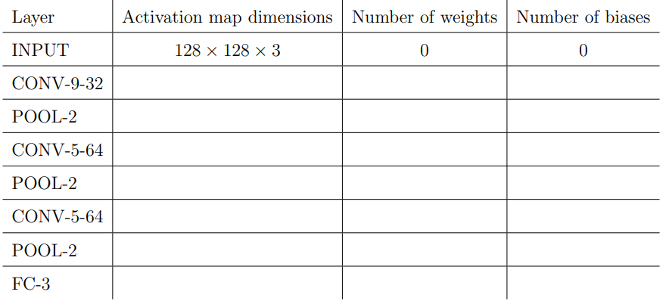 | Successively:  • 120 × 120 × 32 and 32 × (9 × 9 × 3 + 1)  • 60 × 60 × 32 and 0  • 56 × 56 × 64 and 64 × (5 × 5 × 32 + 1)  • 28 × 28 × 64 and 0  • 24 × 24 × 64 and 64 × (5 × 5 × 64 + 1)  • 12 × 12 × 64 and 0  • 3 and 3 × (12 × 12 × 64 + 1)
CS230 stanford s2021  (At least one correct answer)  (a) (2 points) Suppose you have a CNN model for image classification, with multiple Conv, Max pooling, ReLU activation layers, and a final Softmax output. Ignoring the bias and numerical precision issues, which of the statements below are true?  (i) Multiplying the weights by a factor of 10 during inference does not affect the prediction accuracy.  (ii) Multiplying the weights by a factor of 10 during training does not affect training convergence.  (iii) Multiplying the input data by a factor of 10 during inference does not affect the prediction accuracy.  (iv) Subtracting the input data by its mean per channel during inference does not affect the prediction accuracy. | (i) (iii).  For (ii), multiplying the weights will change the gradient/weight ratio.  For (iv), subtracting by mean is a data normalization technique and will affect prediction accuracy.
(d) (2 points) Select the statements that are true  (i) If the input to a ConvNet is a zero image (all zeros), the class probabilities will be uniform.  (ii) You train a model and you observe that the validation set accuracy is significantly lower than the train accuracy. Your friend suggests you to use batch normalization and you agree it is a good idea. After using batch normalization, the new model is likely to have a smaller gap between the train and validation accuracies.  (iii) For an n-dimensional vector y, the softmax of y will be the same as the softmax of cy, where c is any real number since softmax normalises the predictions to yield a probability distribution.  (iv) For data normalization, we typically compute the mean and standard deviation across the entire dataset, before splitting it into train/val/test splits. | 2.(c) (2 points) Although Pooling layers certainly cause a loss of information between Convolutional layers, why would we add Pooling layers to our network?  Solution: Pooling layers cause spatial dimensions to shrink and allow us to use fewer parameters to obtain smaller and smaller hidden representations of the input.
Question 3 (Convolutional Architectures, 20 points)  Say you have an input image whose shape is 128 × 128 × 3. You are deciding on the hyperparameters for a Convolutional Neural Network; in particular, you are in the process of determining the settings for the first Convolutional layer. Compute the output activation volume dimensions and number of parameters of each of the possible settings of the first Convolutional layer, given the input has the shape described above. You can write the activation shapes in the format (H, W, C) where H, W, C are the height, width, and channel dimensions, respectively.  i. (2 points) The first Convolutional layer has a stride of 1, a filter size of 3, input padding of 0, and 64 filters. | Activation volume dimensions: 14 × 14 × 64  Number of parameters: (3 ∗ 3 ∗ 3 + 1) ∗ 64 = 1792
ii. (2 points) The first Convolutional layer has a stride of 1, a filter size of 5, input padding of 2, and 16 filters. | Activation volume dimensions: 128 × 128 × 16 Number of parameters: (5 ∗ 5 ∗ 3 + 1) ∗ 16 = 1216
iii. (2 points) The first Convolutional layer has a stride of 2, a filter size of 2, input padding of 0, and 32 filters. | Activation volume dimensions: 64 × 64 × 32 Number of parameters: (2 ∗ 2 ∗ 3 + 1) ∗ 32 = 416
Now that you have determined the output shapes and number of parameters for these configurations, you are going to create a deeper CNN. Say you create a CNN made of three identical modules, each of which consists of: a Convolutional layer, a Max-Pooling layer, and a ReLU layer. All Pooling layers will have a stride of 2 and a width/height of 2. For example, say we define the Convolutional layer to have stride 1, filter size 1, input padding of 0, and 8 filters. Then the module architecture would be:  • 1 × 1 × 8 Conv with stride 1 and 0 padding  • 2 × 2 Max-Pool with stride 2  • ReLU  Three such modules make up the entire network. Given the following Convolutional hyperparameters, compute the output activation volume dimensions after passing the input through the entire network, as well as the number of parameters in the entire network  iv. (4 points) The Conv layers have a stride of 1, a filter size of 3, input padding of 0, and 64 filters. | iv. Activation volume dimensions: 14 × 14 × 64 Number of parameters: (3 ∗ 3 ∗ 3 + 1) ∗ 64 + (3 ∗ 3 ∗ 64 + 1) ∗ 64 ∗ 2 = 75, 648
v. (4 points) The Conv layers have a stride of 1, a filter size of 5, input padding of 2, and 16 filters. | v. Activation volume dimensions: 16 × 16 × 16 Number of parameters: (5 ∗ 5 ∗ 3 + 1) ∗ 16 + (5 ∗ 5 ∗ 16 + 1) ∗ 16 ∗ 2 = 14, 048
vi. (4 points) The Conv layers have a stride of 2, a filter size of 2, input padding of 0, and 32 filters. | vi. Activation volume dimensions: 2 × 2 × 32 Number of parameters: (2 ∗ 2 ∗ 3 + 1) ∗ 32 + (2 ∗ 2 ∗ 32 + 1) ∗ 32 ∗ 2 = 8672
vii. (2 points) Say you want to solve a 10-class classification problem given the input (e.g. the input represents a digit, and you want to predict which digit it is). To do so, you decide to add a Fully-Connected layer after your three Conv-Pool-ReLU modules. The input to the FC layer is the output of the last module, completely flattened. Which of the three previous architectures (given in parts iv., v., and vi.) will allow for the FC layer to have the smallest number of parameters? Give the number of parameters for said layer. | vii. The last of the three i.e. the architecture from part vi. It has the smallest output, and will result in a FC layer with (2 ∗ 2 ∗ 32 + 1) ∗ 10 = 1290 parameters.
CS230 Stanford Deep Learning f2019  Question 3 Convolutional Architectures (12 points)  Consider the convolutional neural network defined by the layers in the left column below. Fill in the shape of the output volume and the number of parameters at each layer. You can write the shapes in the numpy format (e.g. (128,128,3)).  Notation:  • CONV5-N denotes a convolutional layer with N filters with height and width equal to 5. Padding is 2, and stride is 1.  • POOL2 denotes a 2x2 max-pooling layer with stride of 2 and 0 padding.  • FC-N denotes a fully-connected layer with N neurons | 