Quiz 2021 primer  A robot wants to deliver a package from warehouse at s1 to a home at s9. However, it wants to avoid trench (present at s6). Arrows shows the optimal policy. What is V*(s1) approximately? Assume discount factor 𝛾 = 0.8 and rewards as follows  Rewards:  r(s, a) = -100 if entering the trench s6,  r(s, a) = +100 if entering home s9  r(s, a) = 0 otherwise | 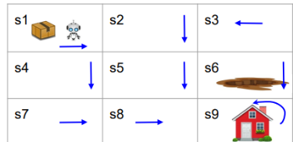  The optimal policy avoids s6, so no negative reward will ever be collected.  The optimal path (following the arrows):  s1→s2→s5→s8→s9
Rewards along the path: s1→s2→s5→s8→s9  0 0 0 100  V* (s1)=0+ 𝛾(0)+ 𝛾²(0)+ 𝛾³(100)=100x0.512=51.2 | 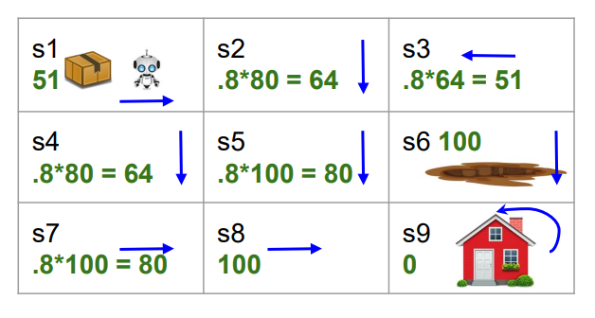
- Predavanja 2021
- Updating Q Q(s,a)←Q(s,a)+η[R+γ max _{a′}​ Q(s′,a′)−Q(s,a)]

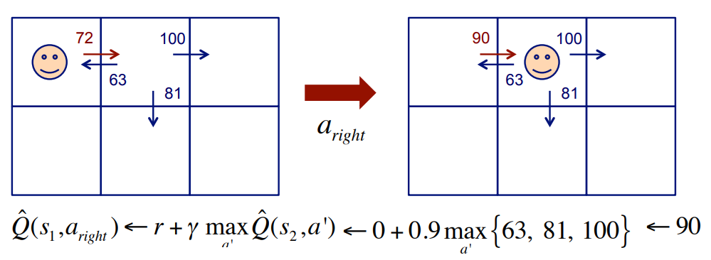

CS760 s1994  3. Reinforcement Learning (30 points)  i. Consider the state-space drawn below; states are represented as nodes and actions by directed arrows. The number near an arrow is the current estimate of the Q-value for that state transition. Unless indicated, the reward (R) received upon entering a state is zero.  Assume an agent starts in state A, deterministically follows the policy specified by the current Q function, and wishes to maximize its discounted cumulative reward (with γ = 0.9). Also assume this agent is performing one-step Q-learning (with η = 0.25).  In the drawings below, circle the arcs the agent will take and show the updated Q-function following each of its first four steps. Briefly explain your calculations in space to the right |  | 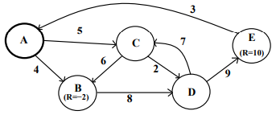  - γ = 0.9 (discount factor) η = 0.25 (learning rate) Rewards are 0 unless specified  - The agent starts in state A and follows the current Q-values (greedy policy w.r.t current Q)  - One-step Q-learning update:  - Q(s,a)←Q(s,a)+η[R+γ max _{a′}​ Q(s′,a′)−Q(s,a)]  - V*(s)=r(s)+ γ max_{a} ∑_{s’}P(s’/s,a)V*(s’)
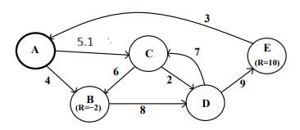  Q(s,a)←Q(s,a)+ η TD error  Update Q(A->C) <- 5+0.25*0.4=5.1.  Agent move to C | - Greedy: A → B: Q = 4, A → C: Q = 5  Greedy choice: A → C (Q=5>Q=4).  Update Q(A→C):  s’=C, from C max{6,2}=6, A->C revard R=0 since no revard entering C)  TD target=R+γmaxQ(C)= 0+0.9*6=5.4  TD error= TD target-Q(A->C)  TD error =5.4-5=0.4 (0.25 = learning r)  Update Q(A->C) <-=5+0.25*0.4=5.1. | 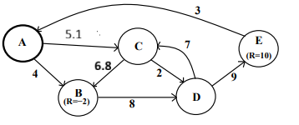  Update A(C->B) <- 6+0.25x3.2=6.8  Agent moves to B | Greedy C->B:Q=6, C->D (Q=2)  Greedy choice C->B: s=B  Update (C->B):  S’=B, from B max(B)=Q(B->D)=8  R=2 (entering B)  TD target =-2+0.9x8=5.2  TD error=5.2-6=-0.89  Update A(C->B) <- 6+0.25x(-0.8)=5.8  Popraveno za -2 (drugite ne se poraveni)
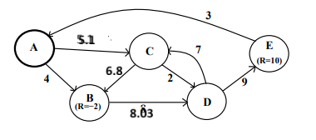  Update Q(B->D)=8.03  Agent move to D | B->D: Q=8, Greedy choice B->D:  Update Q(B->D)  S’=D, from D: max A(D)=max7,9)=9  R=0 (entering D)  TD target =0+0.9x9=8.1  Td error=8.1-8=0.1  Update Q(B->D) <- 8+0.25=0.1=8.03 | 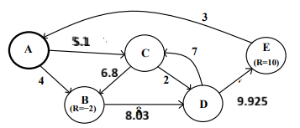  Update Q(D->E)=9.925  Agent moved to E  Path=A->C->B->D->E | Greedy D->C, Q=7, D->E, Q=9  Greed choice D->E Q=9  Update Q(D->E)  S’=E From E: max Q=Q(E->A)=3,  R=10 (entering E)  TD target =10+0.9x3=12.7  Td error=12.7-9=3.7  Update Q(D->E) <- 9+0.25x3.7=9.925  Agent moved to E

CS760 f1997  2. Reinforcement Learning and Neural Networks (25 pts)  Part A Imagine an environment like the Agent World, but where the learner can only move LEFT or RIGHT. The agent’s sensors report the distances to the left wall and right walls. The world is 3 meters wide, the agent’s step size is 1 meter, and the agent always starts 1 meter from the right wall. Finally, the agent gets a reward of +2 when moving left and of +1 when moving right, unless it tries to move into a wall, in which case its reward is -10. (Assume the agent is dimensionless - i.e., has zero width - and that the agent can abut the wall without penalty.)  Apply the one-step, Q-learning algorithm to this problem, using a table to represent your Q function (all entries in the table should initially be zero); let gamma = 0.9. In the space below, show the state of the Q-table after the first two (2) steps of the learner. For simplicity, always follow the current policy during learning (i.e., no exploration) and break ties by moving to the right. Briefly explain why the steps were chosen. |  | 1. Problem Setup  - World width: 3 meters  - Agent step size: 1 meter  - Agent is dimensionless (no width, can touch wall)  - Start: 1 meter from right wall → position = 2 meters from left wall, 1 meter from right wall.  Let’s define state as distances to left wall and right wall:  Position from left wall = x, so:  - Distance to left wall = x  - Distance to right wall = 3−x  Start: x=2 → (left dist = 2, right dist = 1)  - Actions: LEFT or RIGHT  - Rewards:  - Move LEFT: +2 Move RIGHT: +1 Try to move into wall: -10  - Discount: γ=0.9
But here α=1  The problem says one-step Q-learning, often meaning full update α=1α=1 if not given. Let's assume α=1α=1 since they say "one-step". |  | - Q-table initially 0 for all state-action pairs.  - Policy during learning: greedy with respect to Q-values, tie → choose RIGHT.  - Q-learning update:
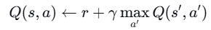  Initialy Q=0 =>  State S0: x=0 (touching left wall)  State S1: x=1  State S2: x=2  State S3: x=3 (touching right wall)  Start S2 |  | State representation only 3 positions stepping 1m at time  - x=0: left wall, right wall 3m away → state = (0,3)  - x=1: left wall 1m, right wall 2m → state = (1,2)  - x=2: left wall 2m, right wall 1m → state = (2,1)  - x=3: left wall 3m, right wall 0m → state = (3,0)  - walls at x=0 and x=3. Step size 1m means from x=2, moving right → x=3 (wall), moving left → x=1.  Start x=2: left dist=2 right=1
Reward from S2  - Action LEFT → new x=1 → reward +2 (move left)  - Action RIGHT → new x=3 → reward -10 (hits wall), since moving right into right wall. |  | From S1:  - Action LEFT → new x=0 → reward -10 (hits wall)  - Action RIGHT → new x=2 → reward +1 (move right)
From S0:  - Action LEFT → x=-1 invalid? can’t, so assume -10 reward and state stays? The problem says "tries to move into a wall" → implies attempted action into wall gives -10 and agent doesn’t move. Let's assume no movement on wall hit. |  | From S3:  - Action RIGHT → wall hit, reward -10, no move.  - Action LEFT → x=2, reward +2.
So transition summary:  - S0: L: (S0, -10), R: (S1, +1)  - S1: L: (S1, -10), R: (S2, +1)  - S2: L: (S1, +2), R: (S2, -10)  - S3: L: (S2, +2), R: (S3, -10) | initial state of the Q table:  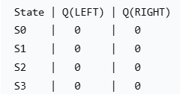  Now Q-table after step 1  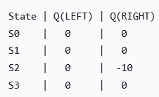 | Step 1  Start in S2.  Q-values: Q(S2,LEFT)=0, Q(S2,RIGHT)=0 → tie → break ties by moving RIGHT.  Step 1 action: RIGHT from S2.  Reward = -10, next state = S2 (stays because hit wall).  Q-update:  Q(S2,RIGHT)← r+γ max(Q(S2,LEFT),Q(S2,RIGHT))= −10+0.9×max(0,0  −10+0.9×max(0,0)=-10
 | New Q-table after step 2:  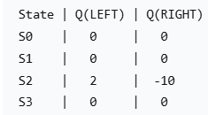 | Step 2  Now in S2, current Q:  Q(S2,LEFT)=0, Q(S2,RIGHT)=-10  Max is 0 (LEFT). Greedy → choose LEFT.  Action LEFT from S2:  Reward = +2, next state = S1.  Update:  Q(S2,LEFT)←r+γmax(Q(S1,LEFT),Q(S1,RIGHT))  Q(S1,LEFT)=0, Q(S1,RIGHT)=0 → max = 0.  Q(S2,LEFT)←2+0.9×0=2
Part B. Instead of using a Q-table, imagine you used a perceptron to learn the Q function. Assume your perceptron has two inputs - the (unnormalized) distances to the left and right walls - and that all the free parameters in your perceptron are initialized to 1.  Under the assumptions of Part A, what would be the first training example given to this perceptron? Explain your answer. Finally, show the changes (if any) in the perceptron that result from this training example (using the delta rule with eta = 0.1).  Ne razbrav |  | Start position x=2, left wall=2, right wall =1, state=(2,1), action right, result -10, next state x=2 => distance (2,1) again => first training example  Update target = r+ γmax​ _{a′}Q(s′,a′)  At the moment of the first update, all initial Q-values are computed by the perceptron before learning. perceptron’s Q-values depend on parameters.  We have two separate perceptrons (or single multi-output network) for Q(s,LEFT) and Q(s,RIGHT).  - Two inputs: dL​ (distance to left wall), dR (distance to right wall)  - Perceptron for each action: Q(s,a;wa)=wa0+wa1dL+wa2dR​ all parameters in to 1,1.  So for any state s=(dL,dR):  Q(s,LEFT)=1+1⋅dL​+1⋅dR​=1+dL​+dR​  Q(s,RIGHT)=1+1⋅dL+1⋅dR=1+dL+dR
First step s=(2,1) initial values Q(s,LEFT)=1+2+1=4, Q(s,RIGHT)=1+2+1=4 tie chose right  Execute RIGHT → hit wall → reward r=−10, state unchanged (still s′=(2,1)).  Next state s′ Q-values (before update): Q(s′,LEFT)=4 Q(s′,LEFT)=4 max Q(s′)=4 |  | Q-learning target for action RIGHT in state (2,1)  target=r+γmax _{a}′Q(s′,a′) ​ =−10+0.9×4=−6.4  Current prediction for Q(s,RIGHT) is 4.  So error δ = target − prediction = −6.4−4=−10.4
Applying the delta rule with η=0.1  Delta rule for a linear perceptron:  Δwj=η⋅δ⋅xj​ where x0=1 (bias) x1=dL, x2=dR=1  Initial weights for RIG HT-action perceptron: [w0,w1,w2]=[1,1,1]  Updates: Δw0=0.1×(−10.4)×1=−1.04  Δw1=0.1×(−10.4)×2=−2.08  Δw2=0.1×(−10.4)×1=−1.04 |  | Update  w0^{new}​=1−1.04=−0.04  w1^{new}=1−2.08=−1.08  w2^{new}=1−1.04=−0.04  EFT-action perceptron weights remain unchanged ([1, 1, 1]) because we only updated the RIGHT-action perceptron based on the (s, a, r, s') transition.  Training ex. Input [1,2,1] target -6.4 for right, new weights [-0.04, -1.08, -0.04]
Part C. Describe one (1) important strength and one (1) major weakness of using a compact representation like neural networks, rather than complete tables, to represent Q functions. Strength: Weakness: |  | Strength:  A compact representation such as a neural network can generalize across similar states, allowing the agent to learn useful Q-value estimates for unseen or rarely visited states, which is crucial in large or continuous state spaces where Q-tables are infeasible  Weakness:  Neural networks can introduce instability and approximation error, meaning Q-value updates may interfere with each other and convergence to the true Q-function is no longer guaranteed, unlike tabular Q-learning which converges under standard assumptions.
CS760 f1998 2. Reinforcement Learning (25 pts)  Imagine an environment that has two Boolean-valued sensors, S1 and S2, with the legal transitions and immediate rewards shown below The initial state is always (or for short).  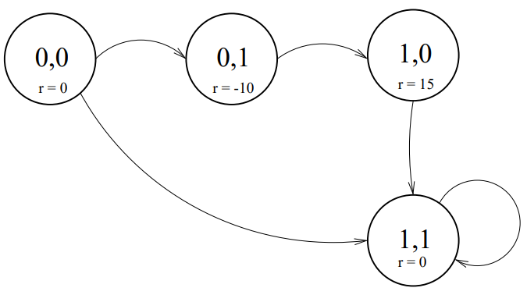 |  | Part A. For what range of values of the discount rate (ie, gamma), would a reinforcement learner prefer the indirect route from state to state ?  Direct route: ⟨0,0⟩ → ⟨1,1⟩. Reward on arrival to ⟨1,1⟩ is 0, so the return Gdirect=0  Indirect route: ⟨0,0⟩ → ⟨0,1⟩ (reward −10 → ⟨1,0⟩ (reward +15 → ⟨1,1⟩ (reward 0.  Discounted return (with discount γ\gammaγ):  > G_{direct=0}  Prefer indirect route when Gindirect > Gdirect=0 gama>10/15=2/3
Part B. Apply the one-step, Q-learning algorithm to this problem, using a table to represent your Qfunction (assume all entries in the table initially equal 3); let gamma = 0.9. Notice that you can "implement" your Q-table be writing the Q values directly on the arcs of the graph above.  Describe the state of the Q-table after each of the first two (2) steps of the learner. For simplicity, always follow the current policy during learning (ie, no exploration) and break any ties by moving to the lowest-numbered state (treating S1 S2 as a binary number). Briefly explain below your calculations. |  | α=1 new Q becomes the target  r+γ max_{a}′Q(s′,a′) γ=0.8, initially every Q=3  ⟨S1,S2⟩ as a binary number 00=0, 01=1, 10=2, 11=3)  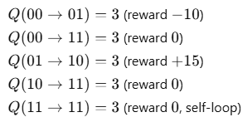
Start state: ⟨0,0⟩.  Current Qs from 00: to 01 = 3, to 11 = 3 → tie, pick lowest-numbered next state → 01.  =- 10+0.9x3=-7.3 |  | Q(00→01)=−7.3 (updated)  Q(00→11)=3  Q(01→10)=3  Q(10→11)=3  Q(11→11)=3 |  | Update Q(01→10) <= r+γ max Q(10,a’)=15+0.9x3=17.7  Q(00→01)=−7.3  Q(00→11)=3  Q(01→10)=17.7 (updated)  Q(10→11)=3  Q(11→11)=3
Part C. Instead of using a Q-table, imagine that you have chosen to use a nearest-neighbor approach to represent the Q function. Under the assumptions of Part B, what would be the first training example added to your nearest-neighbor memory? Explain your answer.
? Part D. Imagine now that you have a task that involves N Boolean-valued features, where all states are reachable from all other states. As a function of N, what is the ratio of memory needed to (i) store the Q function as a table vs. (ii) the memory needed to represent the Q function as a neural network with one layer of 0.5xN hidden units? Use the standard feedforward neuralnetwork topology that you used in HW3. Compute a numeric value for N=50.
? Part E. When incrementally updating estimated Q values, commonly alpha times the latest estimate is added to (1 - alpha) times the previous estimate. Is such a technique needed in deterministic environments when the Q-function is represented in a neural network? Explain your answer.
Qualitatively describe any necessary properties of alpha (no need to mention that alpha is in [0,1]).
CS f1999 2 – Reinforcement Learning (16 points)  a. Consider the reinforcement environment drawn below (let γ=0.9). The numbers on the arcs indicate the immediate rewards. |  | 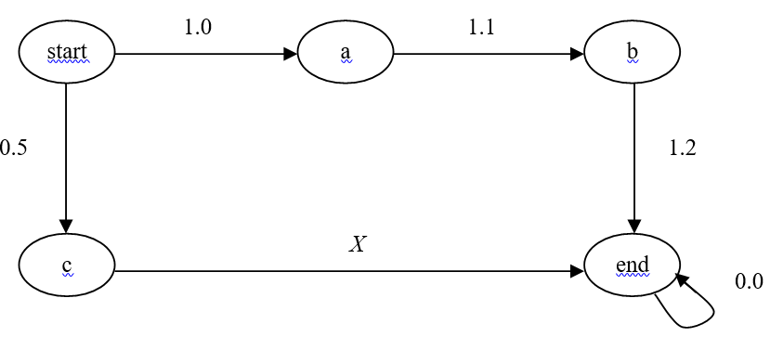
For which values of X would a reinforcement learner end up preferring the lower route over the upper one? Justify your answer.
Assume we create a neural network, with one layer of hidden units, for this environment, and that all the hidden and output units have sigmoidal output functions. Furthermore, assume that all the weights and thresholds on this network are initialized to zero. What “desired output” for this network would be produced the first time the learner went from start to a? (Don’t worry about the details of the representation of the state, i.e., the network’s input.)
b. Explain one (1) strength and one (1) weakness of using a neural-network rather than a look-up table to represent a Q function
strenght
weaknes
CS760 f2001  Problem 4 – Reinforcement Learning (14 points)  Prob 4. Consider the deterministic reinforcement environment drawn below. The numbers on the arcs indicate the immediate rewards. Let the discount rate equal 0.9. |  | 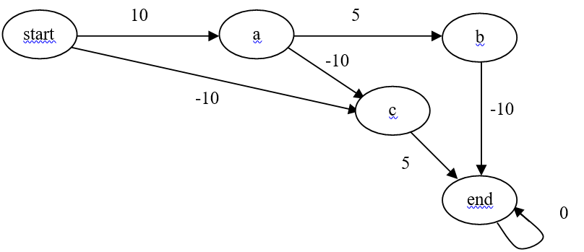
a).What is the best route for going from start to end? Why? |  | G(start,a,b,end)= 10+0.9⋅5+0.9²⋅(−10)=6.4  G(start,a,c,end)= 10+0.9⋅(-10)+0.9²⋅(5)=5.05  G(start,c,end)= -10+0.9⋅5=-5.5
b).Represent the Q table by placing Q values on the arcs on the environment's state-action graph; initialize all of the Q values to 2 except initialize all of the arcs directly involving node a to have a Q value of -1. For Step 1, do exploitation. Show on the graph below the full Q table after Step 1. Specify the action chosen and display the calculations involved in altering the Q table. |  | 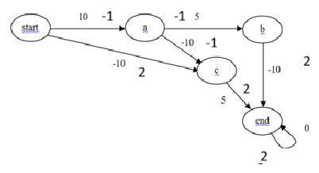
Exploatation means Q learning with α=1 and γ=0.9  From start Q values are: start -> a : Q = −1 start -> c : Q = 2 exploitation chose c  Next is c ->end Q=2 |  | for α=1  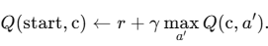 => Q(start,c)=r+ γ max Q(c,a’)=-10+0.9x2=-8.2
After step 1 graph is: 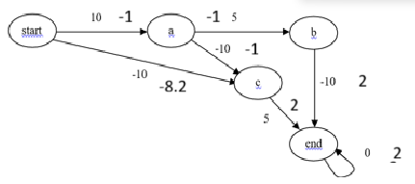
c). Assume that after Step 1, the RL agent is magically transported back to the state start. Show the resulting Q table after the learner takes its second step from the starting state. Step 2 should be exploration. Be sure to again state the action chosen and display your calculations. |  | Exploration means do NOT take the greedy (highest-Q) action.  From start: Q(start → a) = −1, Q(start → c) = −8.2  Greedy would choose start → a (because −1 > −8.2).  Since Step 2 is exploration, the agent chooses the non-greedy action:  Chosen action: start → c. The next transition is c->end only outgoing  Q_{new}​(start,c)=-8.2 +1(-10+0.9(2)-(-8.2))=-8.2 new value stay the same
d). Explain one (1) major advantage and one (1) major disadvantage of using a Q network instead of a Q table in reinforcement learning.  Advantage: Generalization to unseen states  A Q-network (neural network approximating Q(s,a) can generalize from experiences it has seen to states it has never visited exactly.  Why this is powerful:  - In environments with huge or continuous state spaces, you cannot store a Q-value for every state-action pair in a table.  - A Q-network learns patterns: similar states produce similar Q-values.  - This allows RL agents to operate in complex environments (video games, robotics, self-driving cars).  Example:  In Atari games, the agent never sees the exact same pixel frame twice, so a Q-table is impossible; a Q-network learns to approximate Q-values for new states. |  | ❌ Disadvantage: Training instability and approximation errors  A Q-network introduces instability and can diverge or oscillate.  Why it happens:  - Neural networks approximate Q-values with bias and noise.  - Updates to the network affect all states simultaneously.  - Temporal-difference targets use the network’s own predictions, creating a moving target.  - Training can be sensitive to:  - network architecture  - learning rate  - replay buffer sampling  - exploration strategy  Example:  DQN often requires:  - experience replay  - target networks  - careful hyper-parameters to avoid divergence.  A Q-table never has this problem—updates are exact and stable.
CS760 s2001 Problem 3 – Reinforcement Learning (23 points)  Consider the deterministic reinforcement environment drawn below. The numbers on the arcs indicate the immediate rewards |  | 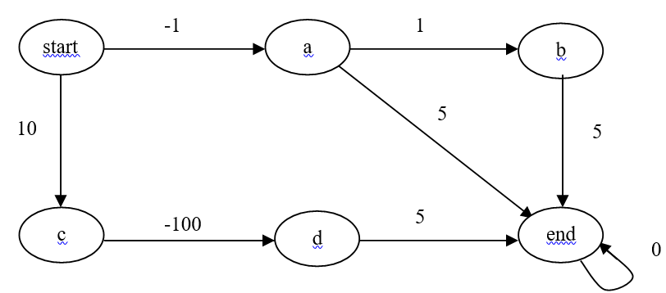
a). For what range of values for the discount rate (γ) would a reinforcement learner end up preferring going directly from a to end, rather than going via b? Justify your answer.
For the remainder of Problem 2, let γ = 0.9. Also, break ties when choosing actions in favor of going to states that appear earlier in alphabetic order.
b).Represent the Q table by placing Q values on the arcs on the environment's state-action graph; initialize all of the Q values to 3 except initialize the arc between a and b to 4. For Step 1, do an exploration action. Show on the graph below the full Q table after Step 1. Specify the action chosen and display the calculations involved in altering the Q table.
c). Assume that after Step 1, the RL agent is magically transported back to the state start. Show the resulting Q table after the learner takes its Step 2 from the starting state. Step 2 should be an exploitation action. Be sure to again state the action chosen and display your calculations.

d).Again the learner is magically transported back to the starting state and it takes Step 3 from there. Step 3, and any subsequent steps, should be exploration actions. This time, however, use the SARSA algorithm (but still use your Q table from Part c). Show all the actions and calculations leading up to the first Q table update due to SARSA.
e). Assume that instead of using a Q table, you decide to switch (starting after Part d's calculations) to using the nearest-neighbor approach to represent the Q function. Show the training examples produced by the actions performed in Parts b-d above. (Do not redo Parts b-d using the nearest-neighbor method; simply show the nearest-neighbor training examples.)

What do you feel is the most important "design decision" you would need to make in order to apply the nearest-neighbors approach to this task?
CS760 f2004 2. Reinforcement Learning (13 points)  Consider the deterministic reinforcement environment drawn below (let γ=0.5). The numbers on the arcs indicate the immediate rewards. |  | 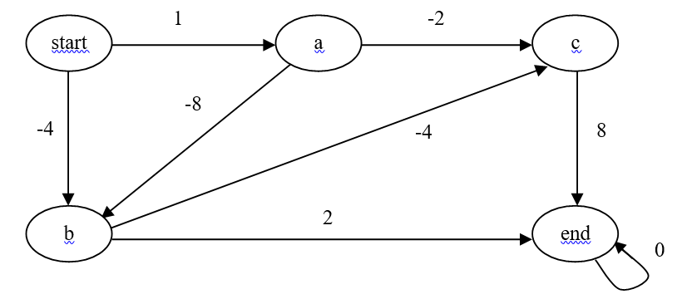
- Assume we use a Q table for this task and initialize all of its entries to the immediate rewards obtained from each state-action pair.  i.A learner follows the path start → a → b → end. Using one-step, regular Q learning, which entries in the Q table change? Show the calculations that produce the new Q table entries (assume α=1) |  | Follow 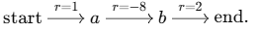 α=1  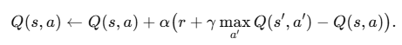 => 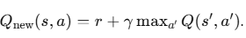  Initial Q table  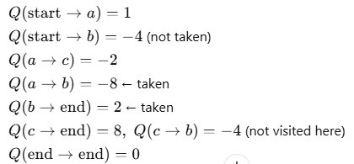
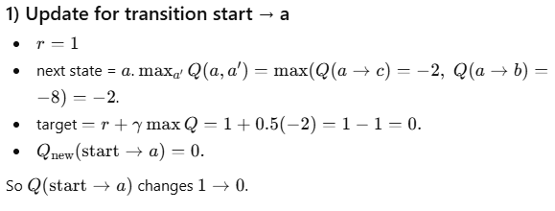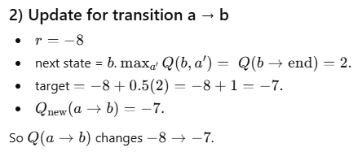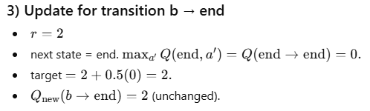
Only start->a and ab-> change
ii. Which of the learner’s steps in Part i are exploration steps? Explain.  --- ---  Since the Q-table is initialized to immediate rewards, at each state we can check whether the chosen action is greedy (highest Q) or non-greedy (exploration). |  | State start  Available actions:  start → a : Q = 1  start → b : Q = −4  Greedy action = start → a  exploitation | At state a At state b unchanged exploitation  Available actions:  a → c : Q = −2  a → b : Q = −8  Greedy action = a → c (−2 > −8)  ❌ The learner chose a → b → exploration not greedy
iii. Repeat Part i, but this time use one-step SARSA (start with the original Q table, not the one that results from the learning in Part i). For those Q updates that are the same as in Part i, simply say so and do not repeat the calculations. |  | 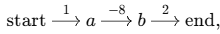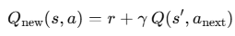  start → a: Reward r=1, Next state s′=a, next actual action a _{anext}=a →b with Q(a,b)=−8 (γQ(a,b)=0.5×(−8)=−4.  Q_{new}(start,a)=1+(−4)=−3 =>  a->b r=-8, next state s’=b, next actual action b ->b has=> Q(b,end)=2  γQ(b,end)=0.5×2=1, Q_{new} (a,b)= -8+1=-7  b → end r=2  Q_{new}​(b,end)=2+ γ⋅Q(end,end) =2+0=2 unchanged
- Why does the converge proof of Q learning done in class and in Mitchell, not apply to the case of using a function approximator to represent Q functions?
CS760 f2006 Problem 3 – Reinforcement Learning (11 points)  - Consider the deterministic reinforcement environment drawn below (let γ=0.9). The numbers on the arcs indicate the immediate rewards. |  | 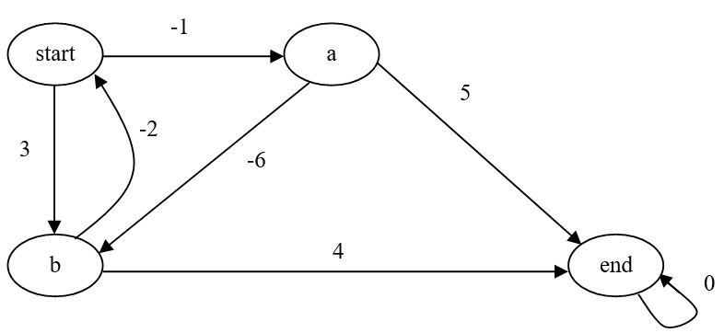
Assume we use a Q table for this task and initialize all of its entries to 2.
A learner follows the path start → b → start → a → end. Using two-step Q learning,
which entries in the Q table change? Show the calculations that produce the new Q table entries. Indicate the changes to the Q table by writing the new Q values on the graph above.
b).What role do options play in reinforcement learning?
CS760 s2003 Problem 2 – Reinforcement Learning (17 points)  Consider the deterministic reinforcement environment drawn below. The numbers on the arcs indicate the immediate rewards. Let the discount rate equal 0.5.  Assume that the current Q table is represented by the Q values on the arcs on the environment's state-action graph below. Also assume that the learner is currently in Node b. |  | 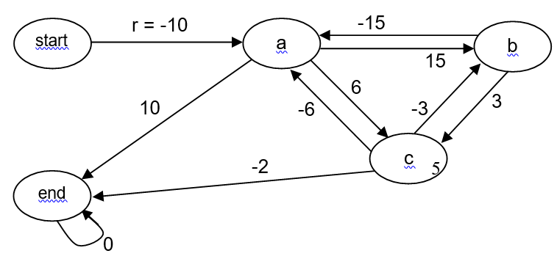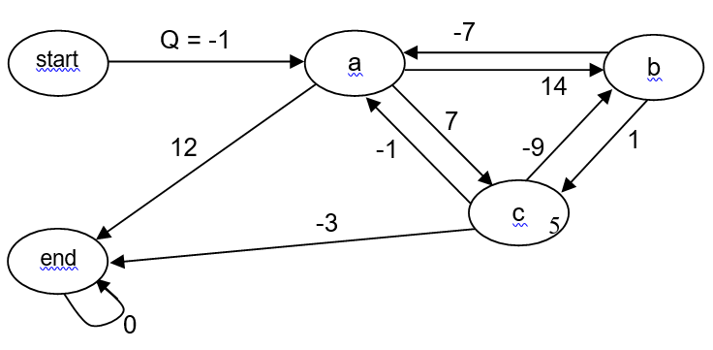
a).The learner chooses to do an exploration step out of Node b, using the “softmax” function. What is the probability is that the learner will choose the action that leads to Node a (be sure to state any assumptions you need to make in order to compute this probability)? |  | Actions available from b and their Q-values From the Q-value graph:  b → a has Q(b,a)=−7 , b → c has Q(b,c)=1  assumption Softmax temperature τ=1  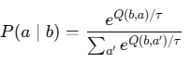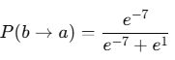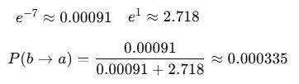
The action b → a has a much lower Q-value than b → c.
Softmax strongly favors higher-Q actions, but still assigns a non-zero probability to worse actions.
This keeps exploration possible, unlike greedy or ε-greedy in exploitation mode.

b).Assume that the learner is magically transported to Node c and that the Q table is still in the state shown below. For this question, assume the learner chooses to first go to Node b and then to Node a. Be sure to show the calculations that produce your answers to the questions below.  - Using one-step Q learning, what new value would there be on the c→ b arc? |  | 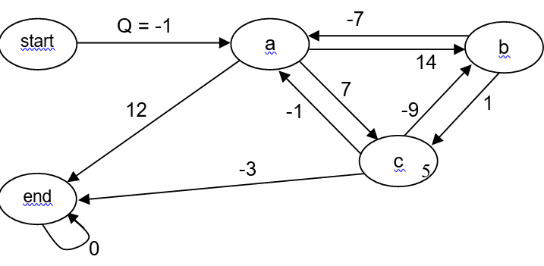
Discount γ=0.5, α=1  Immediate reward for taking the action c→b=−6.  Current Q-values (from the Q-value graph):  Qold​(c,b)=−3 (current value)  Q(b,a)=−7 (value on the b→a)  Q(b,c)=14 (value on the b→c) |  | One-step Q-learning update for Q(c,b)  Q-learning (with α=1) uses the target  target=r(c,b)+γ max_{a′}Q(b,a′)  From the assumed Qs at b:  Max _{a′}Q(b,a′)=max{Q(b,a), Q(b,c)}=max{−7, 14}=14. =>  target=−6+0.5×14=−6+7=1.  With α=1 Q_{new}(c,b)=1  (Interpretation: Q-learning bootstraps to the best action at b, which here is b→c with Q=14, so the c→b jumps up to 1
ii.Using one-step SARSA learning, what new value would there be on the c→ b arc? |  | SARSA (on-policy) uses the actual next action taken in the next state.  b→a so SARSA bootstraps with Q(b,a).  target=r(c,b)+γQ(b,a)=−6+0.5×(−7)=−9.5.  With α=1 _{Qnew}(c,b)=−9.5
c). This time assume the learner is currently in Node start and the Q table contains the values in the graph above (the values before you answered Part b). The learner does three (3) exploitation steps and employs two-step Q learning along the way. Indicate on the graph above what changes in the Q table this time. Show your calculations below. |  | 
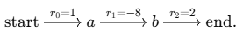 Discount γ=0.5, α=1
CS760 s2009 s2010 f2011,
CS760 s2014 Problem 3- Reinforcement Learning (20 points)  Consider the deterministic reinforcement environment drawn below (let y=0.1). The numbers on the arcs indicate the immediate rewards. Assume we learn a Q-table. Also assume all the initial values in your Q table are 5.  a) Suppose the learner follows the path A-> B→ C→ E → A. Using one-step, standard learning, show the calculations that produce the new Q table entries and report the final table on the graph above. Assume α=0.5 α=1 |  | 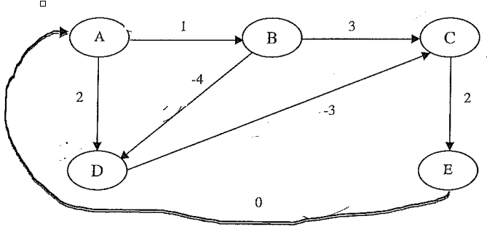
Step 1: A → B  From A: chosen action = A→B, R=1.  From B, possible next Q: max of Q(B,D)=5, Q(B,C)=5 ⇒ max = 5.  TD target = R + γ × max Q(B,·) = 1 + 0.1×5 = 1.5.  Since α=1, new Q(A,B) = 1.5 (old value irrelevant). |  | Step 2: B → C  From B: chosen action = B→C, R=3.  From C, possible next Q: only C→E = 5 ⇒ max = 5.  TD target = 3 + 0.1×5 = 3.5.  New Q(B,C) = 3.5.
Step 3: C → E  From C: chosen action = C→E, R=2.  From E, possible next Q: only E→A = 5 ⇒ max = 5.  TD target = 2 + 0.1×5 = 2.5.  New Q(C,E) = 2.5. |  | Step 4: E → A  From E: chosen action = E→A, R=0.  From A, possible next Q: max of Q(A,B)=1.5 (updated in step 1), Q(A,D)=5 ⇒ max = 5.  TD target = 0 + 0.1×5 = 0.5.  New Q(E,A) = 0.5.
b)After the learning in part (a), what will be the next two states, in order, visited by the agent if it performs no exploration steps? Show the results of one-step, standard Q learning after the agent takes this path. |  | From part (a), the Q-table after the first path A→B→C→E→A was:  Q(A,D) = 5  Q(A,B) = 1.5  Q(B,D) = 5  Q(B,C) = 3.5  Q(D,C) = 5  Q(C,E) = 2.5  Q(E,A) = 0.5
From A: Q(A,D) = 5, Q(A,B) = 1.5  Greedy choice: max(5, 1.5) = 5 → choose A→D.  From D:  Q(D,C) = 5 (only action to C, R=-3)  Thus next two states visited: D → C |  | α=1, γ=0.1  Step 5 (new): A → D  From A, chosen action = A→D, R=2.  From D, possible next Q: only D→C = 5 ⇒ max = 5.  TD target = 2 + 0.1×5 = 2.5.  New Q(A,D) = 2.5.  Agent moves to D.
Step 6 (new): D → C  From D, chosen action = D→C, R=-3.  From C, possible next Q: only C→E = 2.5 ⇒ max = 2.5.  TD target = -3 + 0.1×2.5 = -3 + 0.25 = -2.75.  New Q(D,C) = -2.75.  Agent moves to C. |  | Final updated Q-table after these two additional steps (including previous updates):  Q(A,D) = 2.5 (updated in step 5)  Q(A,B) = 1.5  Q(B,D) = 5  Q(B,C) = 3.5  Q(D,C) = -2.75 (updated in step 6)  Q(C,E) = 2.5  Q(E,A) = 0.5
staro  b)After the learning in part (a), what will be the next two states, in order, visited by the agent if it performs no exploration steps? Show the results of one-step, standard Q learning after the agent takes this path. |  | A->B possible actions A→D (R=2), A→B (R=1). Agent actually goes A→B (R=1).  s = A, a = A→B, s' = B. Initial Q(A,B) = 5.  From B: possible actions B→D (Q=5), B→C (Q=5), so max Q(B) = 5.  TD target = R + γ max Q(B) = 1 + 0.1×5 = 1.5  TD error = 1.5 − 5 = −3.5  Update: Q(A,B) ← 5 + 0.5×(−3.5) = 5 − 1.75 = 3.25
B → C From B: possible actions B→D (R=−4), B→C (R=3). Agent goes B→C (R=3).  Initial Q(B,C) = 5.  s' = C: possible actions C→E (Q=5), so max Q(C) = 5.  TD target = 3 + 0.1×5 = 3.5  TD error = 3.5 − 5 = −1.5  Update: Q(B,C) ← 5 + 0.5×(−1.5) = 5 − 0.75 = 4.25 |  | C → E  From C: action C→E (R=2). Initial Q(C,E) = 5.  s' = E: possible action E→A (Q=5), so max Q(E) = 5.  TD target = 2 + 0.1×5 = 2.5  TD error = 2.5 − 5 = −2.5  Update: Q(C,E) ← 5 + 0.5×(−2.5) = 5 − 1.25 = 3.75
E → A From E: action E→A (R=0). Initial Q(E,A) = 5.  s' = A: possible actions: A→D (Q=5), A→B (Q=3.25 now), so max Q(A) = 5.  TD target = 0 + 0.1×5 = 0.5  TD error = 0.5 − 5 = −4.5  Update: Q(E,A) ← 5 + 0.5×(−4.5) = 5 − 2.25 = 2.75 |  | 