HOMEWORK 4: STRUCTURED DATA + MODELS

Prepare a write-up that includes your solutions to the following questions from the course exercise sheet. Make sure to include all your code and clearly specify where each new problem begins.

Coding

- Geospatial Datasets [3 points]
7. [Geospatial Datasets] For each of the datasets below, specify whether it is in a vector or raster data format. If it is in a vector data format, explain which types of geometries it contains (e.g., a point or linestring). Explain your reasoning.

- NYC Building Footprints
The NYC Building Footprints data is typically in vector format, as it represents the outlines or geometric shapes of buildings. Given are Feature-Based Representation
- The data consists of individual features, where each feature represents a discrete building.
- Each building is defined by its geometry in the form of polygons (closed shapes formed by coordinates).
- Africa Population 2020
The Africa Population 2020 data is typically represented in raster format when visualized as population density maps or grids.
- Raster data is ideal for continuous data like population density, where each cell in the grid represents the number of people per unit area.
- Himalayan Glacial Lakes
This data combines descriptive attributes (e.g., area, elevation, basin) with vector spatial information (coordinates – points and polygons) for representing and analyzing glacial lakes

Code in week9-1

library(sf)
library(ggplot2)

# Read the spatial data
lakes <- st_read("D:\\AAMatej\\AA-MATEJ-8-2024-SEMESTAR\\436-Statistical Data Visualization\\436- OD TEKOVNI PREDAVANJA\\HW\\HW4\\GL_3basins_2015.topojson")

# Ensure CRS is assigned if missing
if (is.null(st_crs(lakes))) {
lakes <- st_set_crs(lakes, 4326)
}

# Check if all geometries are valid
if (!all(st_is_valid(lakes))) {
stop("Spatial data contains invalid geometries.")
}

# Transform to the desired CRS (if needed)
#lakes <- st_transform(lakes, crs = 4326)
lakes <- st_make_valid(lakes)

# Visualize the lakes
ggplot(data = lakes) +
geom_sf(fill = "blue", color = "black") +
theme_minimal() +
labs(title = "Himalayan Glacial Lakes")

- Wisconsin EV Charging
The data provided for Wisconsin EV Charging stations is in vector format:
Points: Each charging station is represented as a geographic point with latitude and longitude coordinates (e.g., )
Structure:
GeoJSON Format: The data is structured as a FeatureCollection, which contains multiple individual features (stations). Features are Properties: fuel type, name, address, and access information.
Geometry: Spatial information (latitude and longitude as a point).
Coordinate Reference System (CRS): Defined as “urn:def:crs:OGC:1.3:CRS84”which corresponds to the WGS84 standard (longitude and latitude in decimal degrees).
# Load required libraries
library(sf) # For spatial data handling
library(ggplot2) # For visualization

# Read the GeoJSON file (replace 'your_data_file.geojson' with your actual file)
ev_stations <- st_read("D:\\AAMatej\\AA-MATEJ-8-2024-SEMESTAR\\436-Statistical Data Visualization\\436- OD TEKOVNI PREDAVANJA\\HW\\HW4\\ev.geojson")

# Check the structure of the data
glimpse(ev_stations)

# Visualize the EV charging stations
ggplot(data = ev_stations) +
geom_sf(aes(color = FUEL_TYPE_), size = 2) + # Use fuel type for color differentiation
theme_minimal() +
labs(
title = "Wisconsin EV Charging Stations",
subtitle = "Visualized by Fuel Type",
color = "Fuel Type"
) +
theme(
plot.title = element_text(size = 16, face = "bold"),
plot.subtitle = element_text(size = 12),
legend.position = "bottom"
)

- Zion Elevation
The file is typically in raster format, structured as a grid of pixels (cells), where each pixel contains a numeric value representing a specific property, such as brightness, reflectance, or temperature.

f. Visualize one of these datasets

- CalFresh Comparison [3 points]
6. [CalFresh Comparison] In this problem, we will compare several approaches to visualizing the CalFresh enrollment dataset.
a. In your own words, define the term, “graphical encoding” and give an example.
b. The code below reads in a dataset of monthly unemployment rates in California from 2014 through 2020. These data are visualized using three different techniques below. Describe the relative strengths and weaknesses of two of these views with respect to the tasks that they support.
library(tsibble)
library(feasts)
unemployment <- read_sf("https://raw.githubusercontent.com/krisrs1128/stat436_s25/refs/heads/main/dmutate(date = yearmonth(date))
focus <- c("Colusa", "Monterey", "San Francisco", "Imperial", "Los Angeles", "San Joaquin") head(unemployment, 3) ## Simple feature collection with 3 features and 4 fields ## Geometry type: MULTIPOLYGON ## Dimension: XY ## Bounding box: xmin: -122.3316 ymin: 37.45444 xmax: -121.4693 ymax: 37.90502 ## Geodetic CRS: WGS 84 ## # A tibble: 3 x 5 ## county date year unemployment geometry
## ## 1 Alameda 2014 Jan 2014 6.5 (((-122.3129 37.89733, -122.2885 37.89793~ ## 2 Alameda 2014 Feb 2014 6.4 (((-122.3129 37.89733, -122.2885 37.89793~ ## 3 Alameda 2014 Mar 2014 6.4 (((-122.3129 37.89733, -122.2885 37.89793~

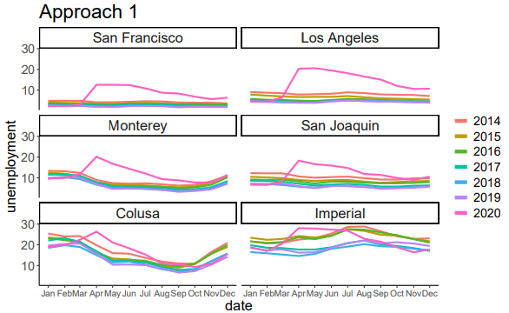
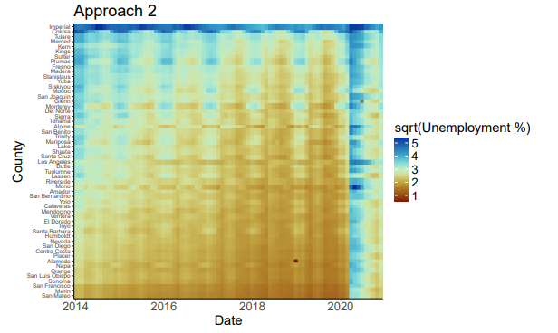
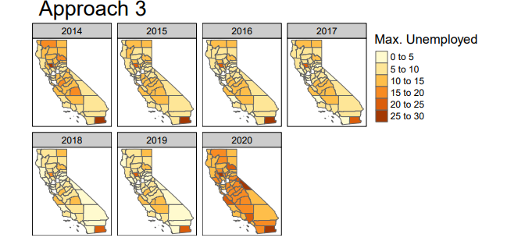
c. Provide code to answer: For each county and year, what was the maximum unemployment rate across all months?
d. Provide code to implement one of the figures above
You may assume the result from part (c) and do not need to match color or text themes.

- HIV Network [3 points]
8. [HIV Network] The code below reads in nodes and edges for a graph describing the similarity of 512 HIV samples collected across 32 countries. Two samples are linked if they have similar genetic sequences.
library(tidygraph)
nodes <- read_csv("https://github.com/krisrs1128/stat436_s25/raw/refs/heads/main/data/hiv_nodes.csv
edges <- read_csv("https://github.com/krisrs1128/stat436_s25/raw/refs/heads/main/data/hiv_edges.csv
G <- tbl_graph(nodes, edges)
G
## # A tbl_graph: 512 nodes and 1022 edges
## #
## # A directed simple graph with 1 component
## #
## # Node Data: 512 x 2 (active)
## sequence_id name
## <db> <chr>
## 1 1 Thailand
## 2 2 Mexico
## 3 3 Zimbabwe
## 4 4 Taiwan
## 5 5 India
## 6 6 Mexico
## 7 7 Guinea
## 8 8 Brazil
## 9 9 Taiwan
## 10 10 United States
## # i 502 more rows
## #
## # Edge Data: 1,022 x 2
## from to
## <int> <int>
## 1 1 511
## 2 2 114 ## 3 3 26
## # i 1,019 more rows

a. Provide code to generate a node-link visualization similar to that in Figure 11. Make at least one style customization that improves the visualization. Justify your choice.
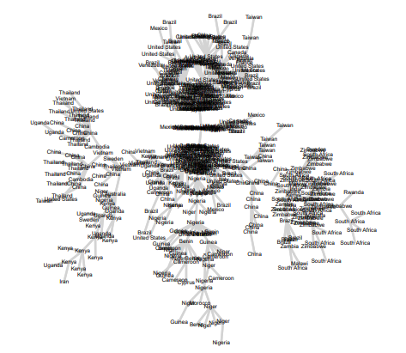
Figure 11: A network between HIV sequences, labeled by the country from which they originated.
b. The figure below shows the node-link visualization for a simple graph. Sketch its exact adjacency matrix.
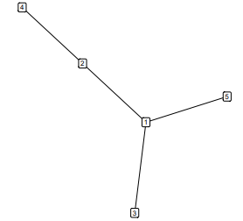

c. The figure below shows the node-link visualization for a more complex graph. How do you expect its corresponding adjacency matrix visualization to look? Provide a rough sketch and a one-sentence justification.
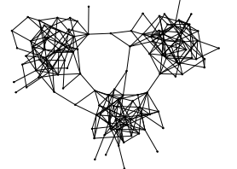

- Beijing Air Pollution (part a only) [2 points]

[Beijing Air Pollution] This problem studies daily air pollution and weather patterns in Beijing from 2010 to 2014. Each row in this dataset gives measurements for three variables, pollution, temp, and windspd over time for a single day, indexed by date. For example the temp_13 column gives the temperature at 1pm. Note that both pollution and windspd have been log (1 + x) transformed.

a. Cluster all the days using a hierarchical clustering. Be sure to scale the columns in advance, so that no single variable has undue influence on the result. Cut the tree so that we are left with 10 clusters, and provide a ribbon plot to visualize several quantiles associated with each cluster’s typical pollution, temperature, and windspeed trajectories. visualization to understand the centroids of each cluster. Briefly interpret the main patterns you observe.

- Food Nutrients [3 points]

8. [Food nutrients] This problem will use PCA to provide a low-dimensional view of a 14-dimensional nutritional facts dataset. The data were originally curated by the USDA and are regularly used in visualization studies.
nutrients <- read_csv("https://uwmadison.box.com/shared/static/nmgouzobq5367aex45pnbzgkhm7sur63.csv
a. Define a tidy models recipe that normalizes all nutrient features and specifies that PCA should be performed.
b. Visualize the top 6 principal components. What types of food do you expect to have low or high values for PC1 or PC2?
c. Compute the average value of PC2 within each category of the group column. Give the names of the groups sorted by this average.
d. Visualize the scores of each food item with respect to the first two principal components. Facet the visualization according to the group column, and sort the facets according to the results of part (c). How does the result compare with your guess from part (b)?

Discussion

- Code Diary (start this before the other exercises) [3 points]
27. [Code Diary] In this exercise, you will write a reflection on your experience of writing code over the next 48 hours. Prepare brief answers to the following questions:
a. What was your programming environment/workflow? For example, were you running code in an Rmarkdown notebook with Rstudio, or switching between a terminal and a code editor, . . . ?
b. What techniques did you use to plan your code? For example, did you write pseudocode, brainstorm ideas with a partner, or draw any guiding diagrams?
c. What kinds of bugs did you encounter? What steps did you take to resolve them?
d. If you were starting the programming task again, would you do anything differently?
We encourage you to share some problem solving techniques with others in the class and see whether others have approaches you might be able to borrow.
- Concept Map [3 points]. You may choose any week after week 7.
12. [Concept Map] Prepare a concept map to summarize the last week of reading material. An effective submission will include a thorough coverage of both abstract concepts and practical examples, summarized concisely into short phrases. It will also include well-justified links between nodes, with text explanations for edges whose interpretation might not be obvious at first

Grading Criteria

Each coding problem will be graded according to the following criteria,

- Attention to detail in visual design. Your design choices should demonstrate critical thinking around the appearance of graphical marks and the queries that they support.
- Elegant code style. The code you use to implement your visualizations should be readable, modular, and concise. You may find it helpful to check your code against the Tidyverse style guide.
- Thoughtful explanations, interpretations, and organization. Your justifications should be complete, your interpretations should draw creatively from relevant sources, and the submission overall should be well-organized and formatted.

Discussion problems will be evaluated based on only the last.

