**Prompt**

Determine whether the following statements about ggplot2 are TRUE or FALSE. For at least one statement, provide an explanation based on the Penguins dataset demo.

1. TRUE FALSE To use a custom color palette in a ggplot2 scatterplot, we can add a scale_color_manual layer.

TRUE

In ggplot2, you can use a custom color palette for a scatterplot by adding the scale_color_manual layer. This function allows you to manually specify the colors for the points in your plot. Here's an example:

**library(ggplot2)**

**# Example data**

**data <- data.frame(**

**x = 1:10,**

**y = rnorm(10),**

**group = factor(rep(c("A", "B"), each = 5))**

**)**

**# Scatterplot with custom color palette**

**ggplot(data, aes(x = x, y = y, color = group)) +**

**geom_point(size = 3) +**

**scale_color_manual(values = c("A" = "red", "B" = "blue"))**

1. TRUE FALSE A geom_boxplot layer can be used to simultaneously visualize a continuous variable against many levels of a categorical variable.

TRUE

A geom_boxplot layer in ggplot2 is specifically designed to visualize the distribution of a continuous variable across different levels of a categorical variable. It is an excellent way to compare multiple groups simultaneously.

library(ggplot2)

**# Example data**

**data <- data.frame(**

**category = factor(rep(c("A", "B", "C"), each = 50)),**

**value = c(rnorm(50, mean = 5), rnorm(50, mean = 7), rnorm(50, mean = 4))**

**)**

**# Boxplot to visualize a continuous variable across levels of a categorical variable**

**ggplot(data, aes(x = category, y = value)) +**

**geom_boxplot()**

1. TRUE FALSE A plot like the one shown below can be made using a geom_area layer.

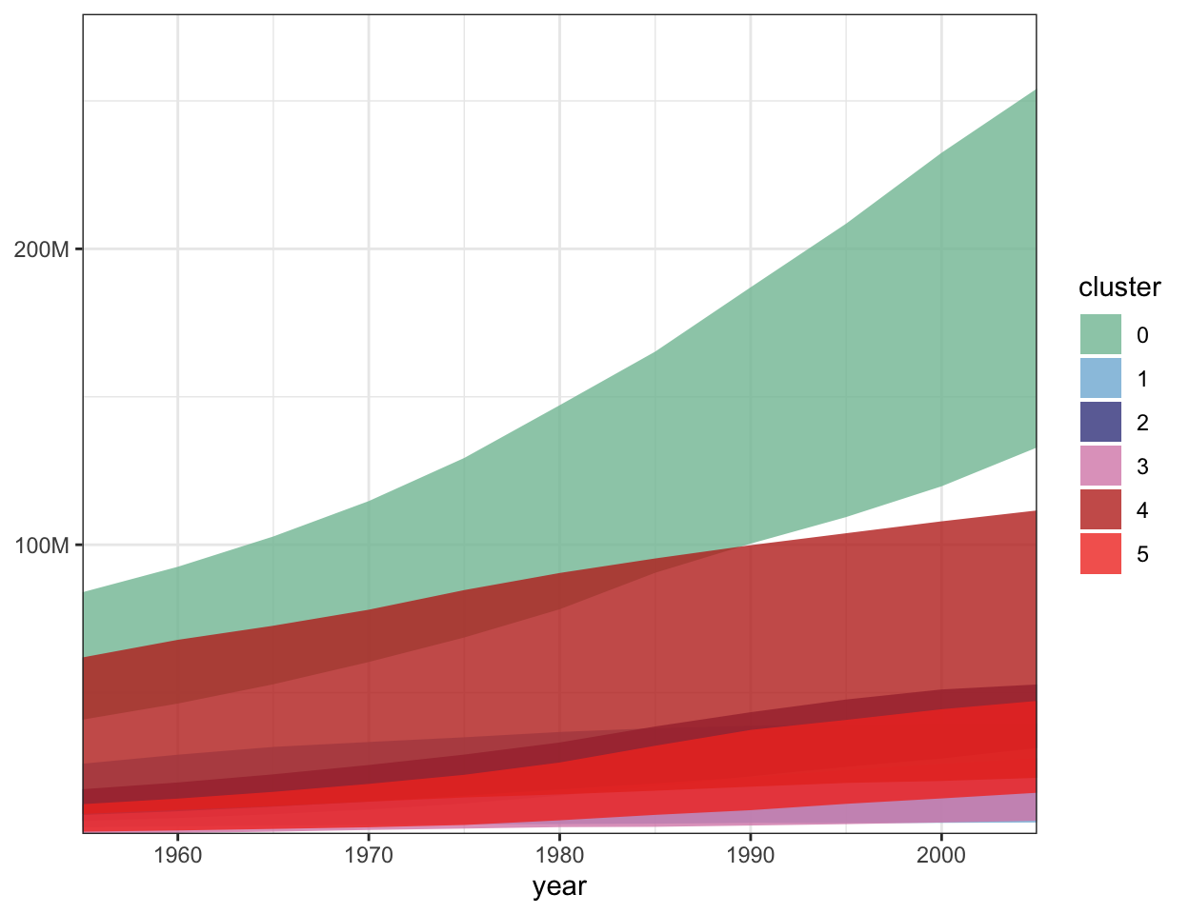

TRUE

Example:

library(ggplot2)

# Example data with multiple groups

data <- data.frame(

time = rep(1:10, 3),

value = c(rnorm(10, 5), rnorm(10, 7), rnorm(10, 3)),

group = rep(c("A", "B", "C"), each = 10)

)

# Stacked area plot

ggplot(data, aes(x = time, y = value, fill = group)) +

geom_area(position = "stack", alpha = 0.8) + # Stack areas on top of each other

labs(title = "Stacked Area Plot Example", x = "Time", y = "Value") +

theme_minimal()

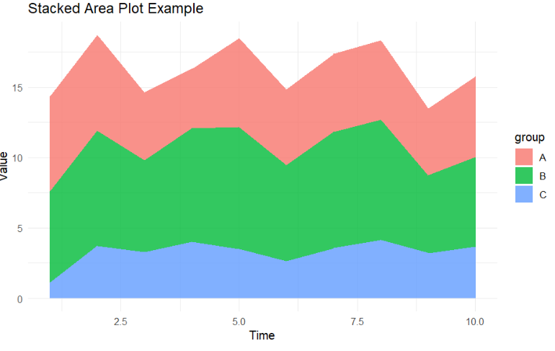

1. TRUE FALSE The aes() function maps values stored in the columns of a dataset into properties of graphical marks.

The aes() function in ggplot2 is used to map variables (columns) from a dataset to visual properties (aesthetics) of graphical marks, such as position, color, size, shape, etc. These mappings determine how the data is represented in the plot.

**TRUE**

The aes() function in ggplot2 is used to map variables (columns) from a dataset to visual properties (aesthetics) of graphical marks, such as position, color, size, shape, etc. These mappings determine how the data is represented in the plot.

**library(ggplot2)**

**# Example data**

**data <- data.frame(**

**x = 1:10,**

**y = rnorm(10),**

**group = factor(rep(c("A", "B"), each = 5))**

**)**

**# Scatterplot with aesthetics mapped to columns**

**ggplot(data, aes(x = x, y = y, color = group, size = y)) +**

**geom_point()**

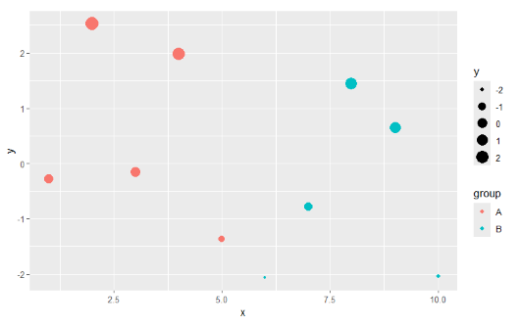

**Responses**

1. TRUE - slide 18 b) TRUE - slide 16 c) TRUE - slide 11 d) TRUE - slides: all💀
2. TRUE b) TRUE c) TRUE d) TRUE
3. TRUE (prof changed colors for penguin species) b) TRUE c) TRUE d) TRUE

TRUE b) TRUE c) TRUE d) TRUE - live lecture demo example, where the prof applied the bill_depth and bill_length across all layers of graphs on the figures (across geom_smooth, geom_point, etc.)

1. TRUE b) TRUE c) TRUE d) TRUE: Using color to show a third property in the dataset
2. TRUE b)TRUE c) TRUE d) TRUE
3. TRUE b) TRUE c) TRUE d) TRUE
4. True b) True c) True d) True
5. True b) True c) True d) True
6. True
7. True b) True c) True d) True
8. True b) True c) True d) True
9. TRUE b) TRUE c) TRUE d) TRUE

For a if we are writing this ggplot(penguins, aes(x = bill_length_mm, y = bill_depth_mm, color = species)) + geom_point() + scale_color_manual(values = c("Adelie" = "blue", "Gentoo" = "red", "Chinstrap" = "green")). Here scale_color_manual() overrides the default palette and applies the custom colors for each penguin species.

1. True b)TRUE c)True d(True
2. True b) True c)True d)True
3. TRUE b) TRUE c) TRUE d) TRUE