4-b

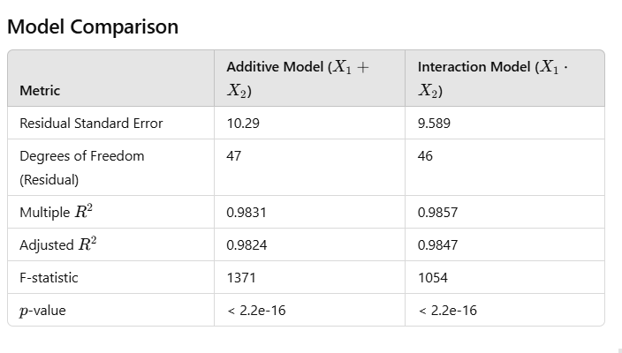

**Observations**

1. **Residual Standard Error**:

Decreased from **10.29** to **9.589**, indicating the interaction model explains more variability in YYY, leaving smaller residual errors.

1. **Degrees of Freedom**:

The interaction model uses an additional degree of freedom (46 vs. 47), as it adds the interaction term.

1. **R^2and Adjusted R^2**

R^2: Increased from **0.9831** to **0.9857**, showing a small improvement in the proportion of variance explained by the model.

* + Adjusted R^2: Increased from **0.9824** to **0.9847**, confirming that the improvement justifies the additional complexity.

1. **F-statistic**:
   * Decreased slightly from **1371** to **1054**, reflecting the increase in model complexity. However, the F-statistic remains very high, and both models are highly significant (p=2.2×10−16 < 0,05.)

**Interpretation**

1. **Significance of Interaction Term**:

The interaction term significantly improves model performance, as evidenced by the lower residual

standard error and higher R^2 values.

1. **Practical Improvement**:

The improvement from the interaction term is modest but noticeable. Whether this improvement is practically important depends on the context of the analysis.

**ANOVA Comparison:** use to test the significance of the interaction term:

Model 1: Y ~ X1 + X2

Model 2: Y ~ X1 * X2

Res.Df RSS Df Sum of Sq F Pr(>F)

1 47 4971.7

2 46 4229.8 1 741.95 8.0689 0.006687 **

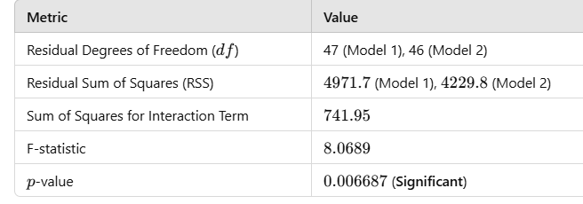

**Reduction in RSS**:

* The interaction model reduces the RSS from **4971.7** to **4229.8**, indicating that the interaction term improves model fit by explaining additional variance in Y.

**Sum of Squares for the Interaction Term**:

* The interaction term (X1⋅X2​) accounts for 741.95 units of the total variance, which is a moderate contribution.

**F-statistic and p-value**:

* The F-statistic for the interaction term is 8.0689, and the corresponding p-value is 0.006687. Since the p-value is below the typical threshold (0.05), the interaction term is statistically significant.

### 4.c Model Results Overview

Here are model improvements for the fitted model includes X1,X2​, X3​, and their interaction term (X1⋅X2​).

#### **1. Residual Analysis**

* **Residual standard error**: 1.031 Indicates that the typical deviation of the observed Y values from the predicted Y values is **small**, signifying good model fit.

#### **2. Model Fit**

* **Multiple R^2**: The model explains **99.98%** of the variance in Y. This is extremely high, indicating an almost perfect fit.
* **Adjusted R^2**: 0.9998 The adjusted R^2, which penalizes for adding predictors, remains very high, showing that the additional variables contribute meaningfully.

#### **3. Significance of Predictors**

* **All predictors (X1​, X2​, X3​, and X1⋅X2) are highly significant** (p-values < 0.001), meaning:
  + X1​, X2​, and X3​ individually have strong effects on Y.
  + The interaction term (X1⋅X2​) also significantly contributes to the model, capturing how the relationship between X1 and Y changes with different levels of X2​.

#### **4. Improvement Over Previous Models**

* **Reduction in Residual Standard Error**:
  + Previous models had residual standard errors of approximately 9.6 (interaction-only model) and 10.3 (additive model). The current model reduces the residual error to 1.031, a dramatic improvement.
* **Increase in R^2**:
  + Previous models had R^2 values around 0.983 to 0.9857. The new model achieves R^2 = 0.9998 a significant improvement.

#### **Justification**

* **Significance of the New Predictor (X3​)**:
  + Adding X3 and considering the interaction term improves model performance significantly. Both terms are highly statistically significant, showing that X3​ has a strong independent effect and that the interaction term further explains the variance.
* **Practical Improvement**:
  + The reduced residual error (1.031) and near-perfect R^2 suggest the model now captures almost all variation in Y. This is a substantial improvement over simpler models.

### ****Conclusion****

The new model improves dramatically, both statistically and practically. The inclusion of X3​ and the interaction term X1⋅X2​ is justified based on the data, as they contribute significantly to explaining Y. However, caution should be exercised as overfitting could be a concern given the very high R^2. Further validation (e.g., cross-validation) could ensure the model's generalizability.

**4.d**

### Interpretation of Results

1. **Significance of Higher-Order Terms**:
   * Look at the p-values for X32X_3^2X32​ and X33X_3^3X33​ in their respective models.
   * Terms with p-values <0.05< 0.05<0.05 indicate a significant contribution.
2. **Model Comparison**:
   * Evaluate Adjusted R2R^2R2: It should increase with meaningful higher-order terms.
   * Compare residual standard error: A lower RSE indicates a better fit.
   * Use ANOVA to test if the inclusion of higher-order terms significantly reduces the residual sum of squares (RSS).
3. **Practicality**:
   * Adding higher-order terms should be justified not only statistically but also based on theoretical or practical considerations (e.g., does X3X_3X3​ exhibit a non-linear relationship with YYY?).

lm(formula = Y ~ X1 * X2 + X3, data = data)

Residual standard error: **1.031** on 45 degrees of freedom

Multiple R-squared: **0.9998**, Adjusted R-squared: 0.9998

F-statistic: 6.935e+04 on 4 and 45 DF, p-value: < 2.2e-16

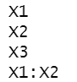 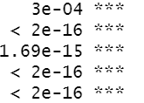

lm(formula = Y ~ X1 * X2 + X3 + X3_squared, data = data)

Residual standard error: **0.9921** on **44** degrees of freedom

Multiple R-squared: **0.9999**, Adjusted R-squared: **0.9998**

F-statistic: 5.993e+04 on 5 and 44 DF, p-value: < **2.2e-16**

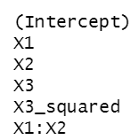 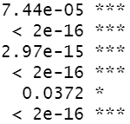

lm(formula = Y ~ X1 * X2 + X3 + X3_squared + X3_cubed, data = data)

Residual standard error: **0.9707** on 43 degrees of freedom

Multiple R-squared: **0.9999**, Adjusted R-squared: 0.9998

F-statistic: 5.216e+04 on 6 and 43 DF, p-value: < 2.2e-16

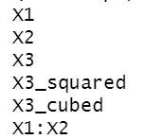 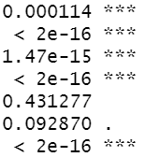

**Analysis of Variance Table**

Model 1: Y ~ X1 * X2 + X3

Model 2: Y ~ X1 * X2 + X3 + X3_squared

Res.Df RSS Df Sum of Sq F Pr(>F)

1 45 47.845

2 44 43.304 1 4.5414 4.6144 **0.03725** *

Model 1: Y ~ X1 * X2 + X3 + X3_squared

Model 2: Y ~ X1 * X2 + X3 + X3_squared + X3_cubed

Res.Df RSS Df Sum of Sq F Pr(>F)

1 44 43.304

2 43 40.521 1 2.7835 2.9538 **0.09287** .

Comparing the results last model according Residual standard error: **0.9707** is the best.

But analysis by variance show significant differences in Model 1: Y ~ X1 * X2 + X3

Model 2: Y ~ X1 * X2 + X3 + X3_squared in favor to Model 2. In the same time there is no significant differences among models 2 and 3.

Also in model 3 estimates squared X3 and cubed X3 are not significant.

So I will chose the model 1 that seems to me well enough, and not great need to build more complicated models with polynomial members