Step 2: Standard Deviation (Risk) of the Portfolio

The standard deviation of the portfolio, σp is calculated using the following formula:*0.



Where:

wA​=500/1000​=0.5 is the weight of Stock A,

wB=500/1000=0.5 is the weight of Stock B,

(ne mora da se deli so 1000. Ako ne se deli se dobivaat vrednosti vo $, ako se deli se dobivaat tezinski faktori)

* σA=0.01 is the standard deviation of Stock A,
* σB=0.04 is the standard deviation of Stock B,
* Cov(A,B)=ρA,B⋅σA⋅σB ​ is the covariance between Stock A and Stock B, where ρA,B=−0.65 is the correlation between Stock A and Stock B.

**Cov(A,B)=−0.65⋅*0.01*⋅0.04= −0.00026**

Now, substitute all values into the formula for σp​:

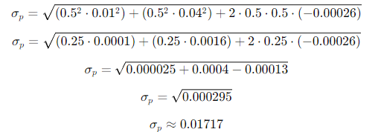

Thus, the standard deviation (or risk) of the portfolio is approximately **0.01717**, or **1.717%**.

**Znaci SD ima znacenjeto na rizik.** **Optimizacijata znaci minimalen rizik**

Since you are investing $1000, the standard deviation in dollars is:

Standard deviation in dollars=1000×0.01717=17.17

So, the standard deviation of the portfolio is **$17.17**

b. Give an expression for the standard deviation for a portfolio investing x in stock A and 1000-x in stock B.



Where:

* wA=**x/1000**​ is the weight of Stock A,
* wB**=(1000−x)/1000** is the weight of Stock B,
* σA=0.01 is the standard deviation of Stock A,
* σB=0.04 is the standard deviation of Stock B,
* Cov(A,B)=−0.65⋅0.01⋅0.04= −0.00026.

c. Find the value x **that minimizes this standard deviation**.

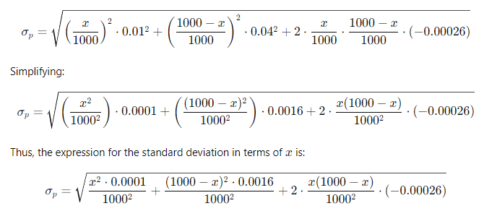

Part c: **Minimizing the Standard Deviation**

To find the value of x that minimizes the standard deviation, we need to **minimize σp**​. This can be done by taking the derivative of σp2the variance) with respect to x, setting it equal to zero, and solving for x.

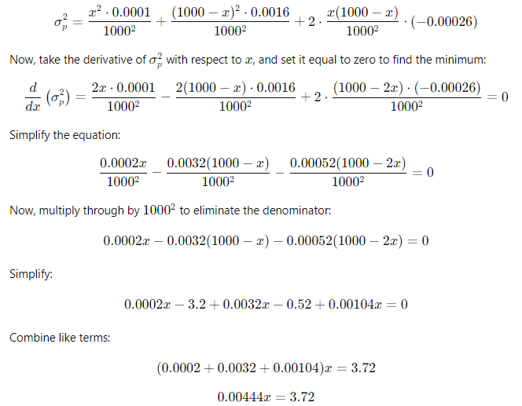



Thus, the value of x that **minimizes the standard deviation** is approximately **$837.84** invested in Stock A.

d. What is the expected return and standard deviation (in dollars) for the portfolio split you chose in part c?

**Expected Return:**

Now, using x=837.84 for Stock A and 1000−837.84=162.16 for Stock B, the expected return of the portfolio is:

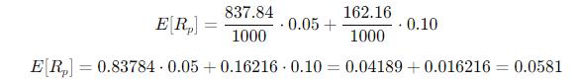

The expected return of the portfolio is approximately **5.81%**.0-A)Expected return in **dollars=1000×0.0581=58.10$2**

**Expected SD calculate x=837.84**

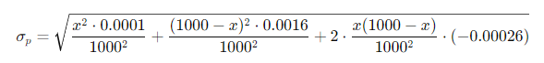**\***.0016) Find derivative on AA)0.00026-2A*0.0.00026 -2(1000-A)*0.0016)=0 0.0002*A-0.00052+0.00052*A-0.00052*A-3.2+0.0032A=0 -3.20052+0.0034A=0 =>A= =0 -3.20052+0.0034A=0 =>A= 941.33