K-nearest neighbors

Here's the strategy we wanted to use:

* Find a few similar listings.
* Calculate the average nightly rental price of these listings.
* Set the average price as the price for our listing.

The k-nearest neighbors algorithm is similar to this strategy. Here's an overview:

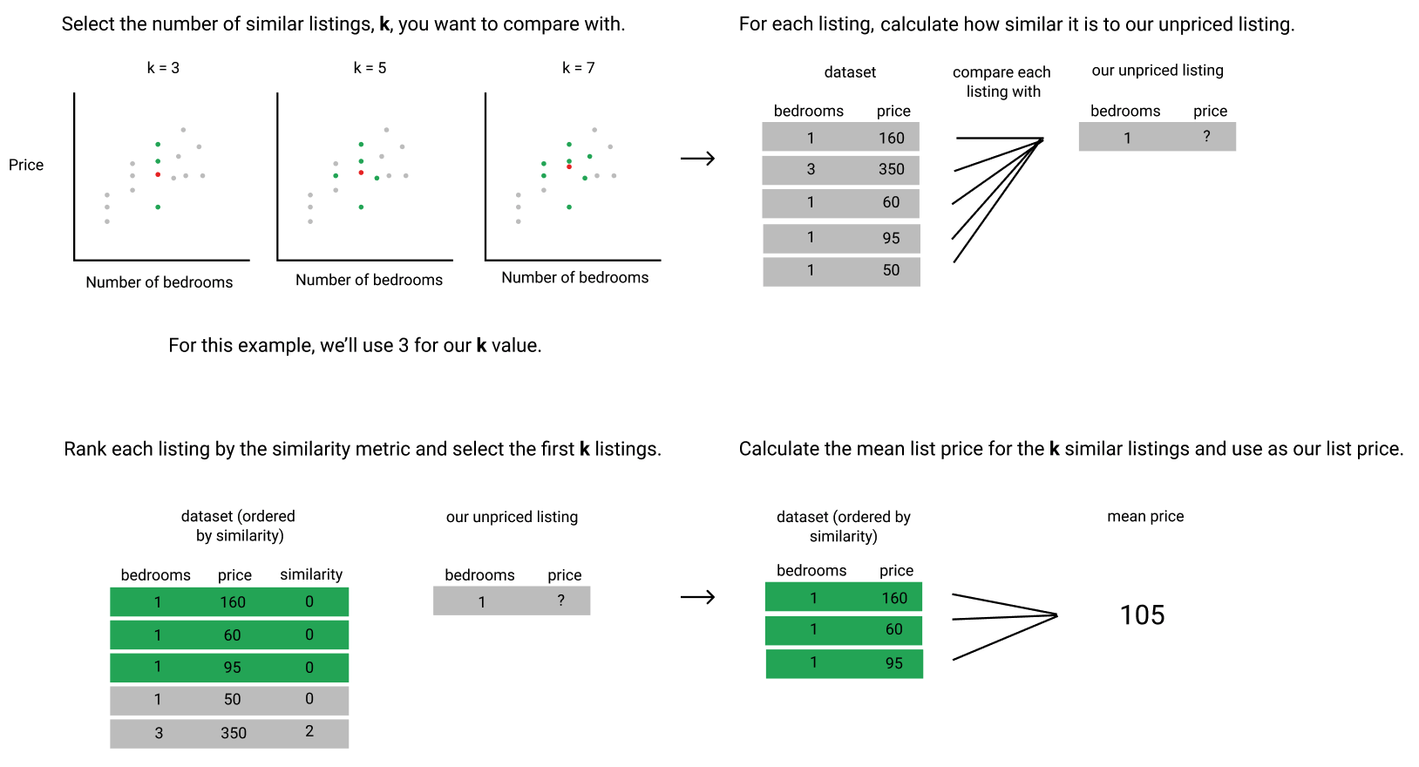

There are 2 things we need to unpack in more detail:

* the similarity metric
* how to choose the k value

In this mission, we'll define what similarity metric we're going to use. Then, we'll implement the k-nearest neighbors algorithm and use it to suggest a price for a new, unpriced listing. We'll use a k value of 5 in this mission. In later missions, we'll learn how to evaluate how good the suggested prices are, how to choose the optimal k value, and more.