Installation Guide for the TITAN Designer and TITAN Executor for the Eclipse IDE

Abstract
This document describes the detailed information of installing the TITAN Designer and Executor for the Eclipse IDE.
Copyright
© Ericsson AB 2000-2014. All rights reserved. No part of this document may be reproduced in any form without the written permission of the copyright owner.
Disclaimer
The contents of this document are subject to revision without notice due to continued progress in methodology, design and manufacturing. Ericsson shall have no liability for any error or damage of any kind resulting from the use of this document.

Contents
1 Introduction 3
1.1 Overview 3
1.2 Target Groups 3
1.3 Typographical Conventions 3
2 Requirements 4
2.1 Requirements for the TITAN Designer, Executor and Log Viewer plug-ins for the Eclipse IDE 4
2.2 Requirements for the Titanium Plugin 4
2.3 Cygwin on Windows 4
3 Installing prerequisites 5
3.1 Installing the TITAN TTCN–3 Toolset 5
3.2 Installing Eclipse 5
3.3 Installing POI and ANTLR Runtime 4.3.0 6
3.4 Installing JUNG 8
3.5 Installing Commons-Collections with Generics 9
4 Installation of the TITAN plug-ins 9
5 Post-Installation Steps 11
5.1 Turning-Off Automatic Building 11
6 Compatibility Issues 12
7 References 13

Introduction

Overview
This document describes the installation and configuration of the TITAN Designer, the TITAN Executor, the TITAN Log Viewer and the Titanium plug-ins for the Eclipse IDE (from now shortly TITAN plug-ins).

Target Groups
This document is intended for system administrators and users who intend to install and configure the TITAN Designer, Executor, Log Viewer and Titanium plug-ins for the Eclipse IDE.

Typographical Conventions
This document uses the following typographical conventions:
- Bold is used to represent graphical user interface (GUI) components such as buttons, menus, menu items, dialog box options, fields and keywords, as well as menu commands. Bold is also used with ’+’ to represent key combinations. For example, Ctrl+Click
- The ‘/’ character is used to denote a menu and sub-menu sequence. For example, File / Open.
- Monospaced font is used represent system elements such as command and parameter names, program names, path names, URLs, directory names and code examples.
- Bold monospaced font is used for commands that must be entered at the Command Line Interface (CLI), For example, mctr_gui

Requirements

Requirements for the TITAN Designer, Executor and Log Viewer plug-ins for the Eclipse IDE

- Eclipse 3.5 or later and all of its dependencies, for example, GTK2, must be installed
- ANTLR Runtime 4.3
- TITAN TTCN–3 Toolset installed. (Only needed if Eclipse is used for project compilation and test execution. Editing does not require it.)
- J2SE(TM) Runtime Environment 6.0 or later installed and set in Eclipse as the Java Runtime Environment
- Only Oracle Java Hotspot virtual machine is supported

Requirements for the Titanium Plugin

- TITAN Designer
- JUNG (Java Universal Network/Graph Framework)
Product No.: 2/CAX 105 4836, preferred version: R1A,
see http://jung.sourceforge.net/
- Commons-Collections with Generics
Product No.: 1/CAX 105 6260, preferred version: R1A
see http://commons.apache.org/proper/commons-collections/
- Apache POI 3.9.0

Cygwin on Windows
Using the Eclipse IDE on Windows is fully supported.
Installing Cygwin is optional and only needed if Eclipse is used for project compilation and test execution. TTCN-3 module editing is supported without Cygwin.
For detailed information on installing Cygwin and configuring the environment variables for TITAN to work, refer to Installation Guide for TITAN TTCN-3 Test Executor 1/1531-CRL 113 200/5 Uen.

Installing prerequisites

Installing the TITAN TTCN–3 Toolset
For detailed information on installing the TITAN TTCN-3 Toolset, and configuring the environment variables for TITAN to work, refer to Installation Guide for TITAN TTCN-3 Test Executor 1/1531-CRL 113 200/5 Uen.

Installing Eclipse
Download the latest 32- or 64-bit Eclipse package, according to your platform and OS version form https://www.eclipse.org/downloads/.
All Eclipse solution packages are suitable, but if you want to develop also adapters and/or external C/C++ functions, the "Eclipse IDE for C/C++ Developers" can be a good choice.
Note: The CDT package can also be added to any Eclipse installation later.
If you want to use/edit XML, XSD and/or JSON files, the Eclipse ecosystem provides tools for this.
For XML/XSD editing and validation you can use the Web Tool Platform (WTP) project's XML Editor; it is contained in Eclipse IDE for Java EE Developers by default, and in other Eclipse packages it can be added from the project's update site (for other Eclipse releases just replace "luna" with the name of your Eclipse release:
http://download.eclipse.org/webtools/repository/luna/
To validate your XSD or XML file(s), select the file(s), right-click on the selection and choose "Validate" from the pop-up menu. You can also validate your document by right clicking in the editor window and selecting "validate" from the pop-up menu.

To work with JSON, you can find an JSON editor at the Eclipse Marketplace (Help/Marketplace menu): type in the search field "JSON" and follow the instructions.

Decompress the downloaded file in a desired location, then run Eclipse with the executable, eclipse.exe or ./eclipse, for Windows or UNIX, respectively.
Note for Ericsson users only:
When using Eclipse from ECN, the HTTP proxy must be set, and internal Ericsson locations, for example the update site, must be added to proxy exceptions. An example of the proxy settings in Eclipse for ECN:
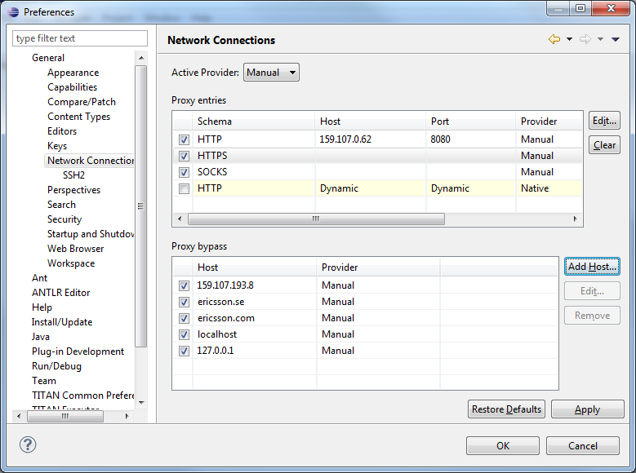

Installing POI and ANTLR Runtime 4.3.0
Install Apache POI and ANTLR Rutime 4.3.0 by performing the following steps:
- In Eclipse, open the Help scroll-down menu, and select the Install New Software option.
- Give the Eclipse Orbit update site in the URL field:
http://download.eclipse.org/tools/orbit/downloads/drops/S20150519210750/repository/
(The drop version shall be update, it changes very often. )
- Set "Group Item by category" (see the snapshot).

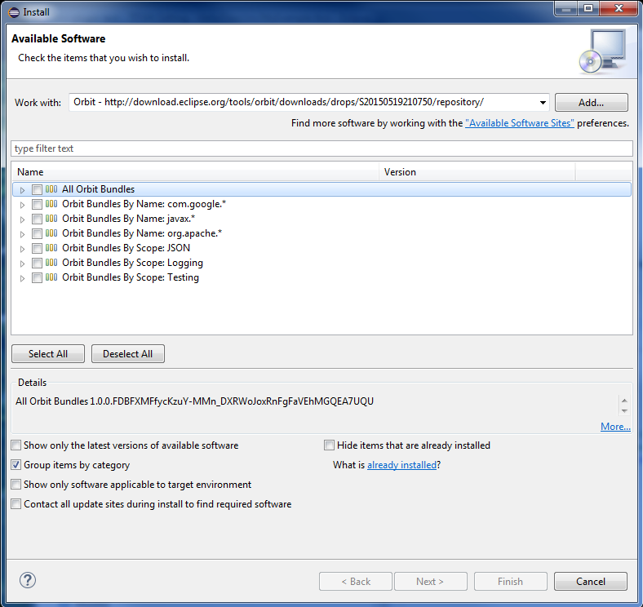
- Type "Apache POI" into the next entry field ("type filter text" filter field). (Apache POI is required only by titanium plug-in!)
- Select "Apache POI 3.9.0"
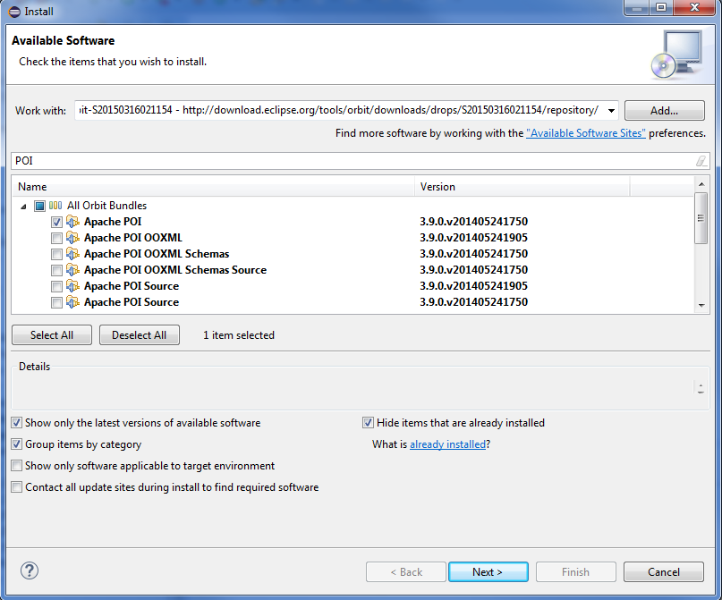
- Type "ANTLR Runtime" into the filter field.
- Select "ANTLR Runtime 4.3.0"
- Press button "Next". In the install details dialog two items will present:
- Press button Finish
- Restart Eclipse

Installing JUNG
Jung is needed only by Titanium plug-in.
After Eclipse is installed, install Jung performing the following steps:
- For Ericsson users only: Download the Jung plugin from this link http://ttcn.ericsson.se/download/third_party/edu.uci.ics.jung.zip
OR
for users outside Ericsson: Write to any contact person on site https://projects.eclipse.org/projects/tools.titan and ask the edu.uci.ics.jung.zip.
- Copy the unzipped jar files into the subdirectory “plugins” of your Eclipse folder (the place where Eclipse is installed or ~/.eclipse if You use shared Eclipse).
- Restart Eclipse.

Installing Commons-Collections with Generics
Common-Collection is needed only by Titanium plugin.
After Eclipse is installed, install Commons-Collections performing the following steps:
- Download Commons-Collections from http://commons.apache.org/proper/commons-collections/
- For Ericsson users only: Download the CommonsCollections plugin from http://ttcn.ericsson.se/download/third_party/commons.collections.zip
OR
for users outside Ericsson: Write to any contact person on site https://projects.eclipse.org/projects/tools.titan and ask the commons.collections.zip .
- Copy the unzipped jar files into the subdirectory “plugins” of your Eclipse folder.
- Restart Eclipse.

Installation of the TITAN plug-ins
For Ericsson users only: the TITAN plug-ins for Eclipse can be installed from the provided update site:
http://ttcn.ericsson.se/download/update_site .
For users outside Ericsson: please write to any contact person on the site https://projects.eclipse.org/projects/tools.titan and you will receive a zip. This replaces the download page. You can copy it to your machine and install it from Eclipse. It does not contain the prerequisites.

WARNING: If you have an earlier version than 4.2.0.CRL_113_200_4_R2A_20140902-1911 of TITAN plug-ins then any new installation should be preceded by uninstalling of the TITAN plug-ins or to start with a just installed Eclipse.

Perform the following steps:
- In Eclipse, open the Help scroll-down menu, and select the Install New Software option.
- Give the provided update site URL in the field.
- Select the TITAN plug-ins to be installed.
- It is advised to uncheck the “Contact all update sites…” box.
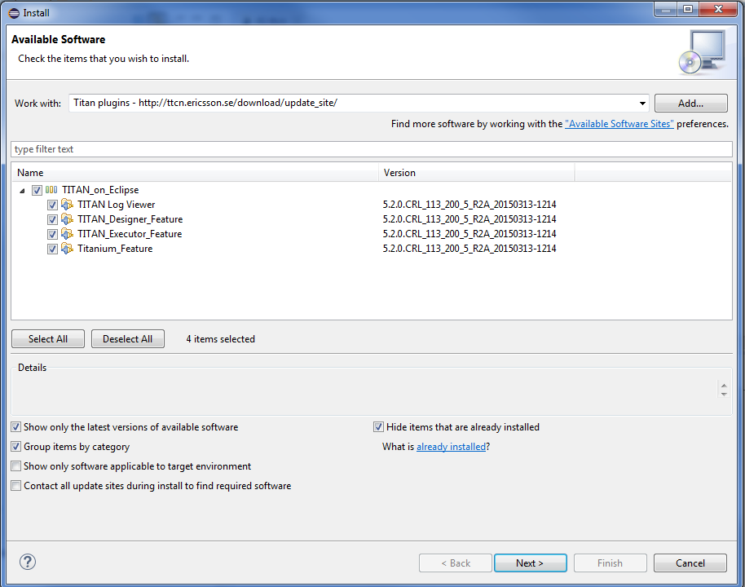
- Click Next.
- At this point “Security Warning” window appears indicating that the authenticity or validity of the plug-ins cannot be established.
It is safe to press the OK button here.
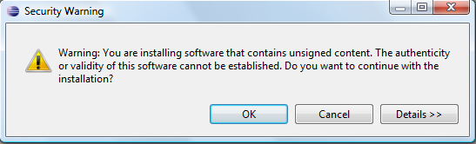

Post-Installation Steps
After installing the TITAN plug-ins in Eclipse, the locations of the installed TITAN TTCN-3 Toolset and the license file must be set.
Open the Window scroll-down menu, and open Preferences. In the pop-up window, open TITAN Preferences from the tree, and set the location of the TITAN installation path and License file (if label “License file” and text box exist in Your version).
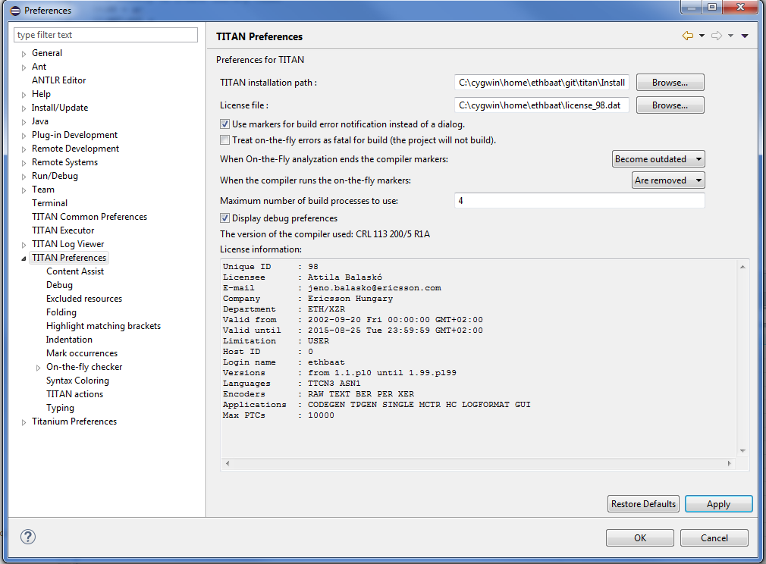

Turning-Off Automatic Building
By default a new installation of Eclipse will be set to automatically compile its projects. In the current build system this can take a lot of time, so it is advised to turn this feature off, and only enabling if the actual projects make it possible.
Open the Project scroll-down menu, and uncheck the Build automatically option.

Compatibility Issues
The plug-ins require the Java Runtime Environment to be version 5.0 or later, but significance speed increase can be gained by installing version 6.0 or 7.0.
Note that an actual version of the TITAN Designer plug-in is meant to be compatible with the same version of TITAN, but can be used with older TITAN releases, if:
- The additional features are not used (the makefile generator of TITAN is used to generate the makefile, so if a feature is used that is known by TITAN Designer, but is not known by the makefile generator, the makefile generation will fail)
- A special script is inserted into the actually used install directory’s bin directory. The role of this script is to convert the call to the makefile generator to valid call of the compiler. (The makefile generator and the compiler are separated from TITAN R7.0). It is important to note, that such a file must contain a path to the compiler to be called, so such a script is not expected to work without modifications. Please note that the compiler must be called with -M as the first parameter, and the other parameters must be redirected to the compiler.

References
- Installation Guide for TITAN TTCN-3 Test Executor
1/1531-CRL 113 200/5 Uen
- User Guide for TITAN TTCN-3 Test Executor
1/198 17-CRL 113 200/5 Uen
- User Guide for TITAN Designer for the Eclipse IDE
4/198 17-CRL 113 200/5 Uen
- User Guide for TITAN Executor for the Eclipse IDE
5/198 17-CRL 113 200/5 Uen
- Programmer´s Technical Reference for TITAN TTCN-3 Test Executor
2/198 17-CRL 113 200/5 Uen

