Lukáš Matěna, UX desinger October 2015, version 1.1

Family2family User Experience documentation
website and mobile application
Family2family is an open source project of a social web specially designed for families with children. The project will facilitate free hosting of families on the go by local families.

Family2family User Experience documentation
website and mobile application

Background
• • •
Family2family is a project of Witold and Matěna families who have been traveiling extensively with their children for more than a decade.
The need of a new social network specialized in travelling families was in mind of many users of major travel social networks and sites such as CouchSurfing or AirBnB.
Although the sites are notable by their scope and number of users, we´ve been reporting alarming changes in user terms, in user experience quality, in number of empty profiles and non-managed accounts and serious obstacles for traveling families.

Introduction
This document is an overview of the first User Experience design proposal based on dialogue between founders of the project, who have an extensive experience with using travelers’ social networks and also based on multiple users’ feedback on the previous web platform (based on WordPress). The project is targeted on whole families, making it a place to interact with other families and discover their way of living by visiting their homes.
In the first part, user basic requirements are outlined and web browsing flow presented, the second part contains the wireframes of main pages of website and screens of the mobile application and finally in the third part, user testing results will be presented (as soon as the testing is done.
Actual website and mobile app will be created based on this documentation and on the mockup version of the site.
The actual version of this User Experience documentation is available on the GitHub server of the project: https://github.com/matena/f2f/doc.

User requirements

Who are targeted website users?
From our experience and also statistically, resulting from the database of users who have profile in the previous WordPress website, our clients are mostly adults in productive age mostly from so said „developed world“ countries with usually at least some personal experience in social networking websites or apps. We would like to encourage children to interact, so the user experience design is shaped accordingly. We would like to encourage people from 3rd world countries to join the project, as membership can bring them direct cultural profit.

How do users access the project?
As a global trend, underlined by the fact, the site is aimed on people who travel, we expect the site to be accessed primarily from mobile device (smartphones, tablets), thus the F2F app is provided. The website is suggested to be done using responsive of mobile-first design.

What do they want?
Basic requirements include: secure, simple and intuitive, accessible on any device, fast. The security involves both personal and sensitive data protection and general protection against hackers.
Additionally the website and the mobile app should support multiple languages and offline access to recently visited profiles.
We have identified three recurring usage scenarios: „user is searching for a host in particular area“, „user is looking for interesting (matching) profiles without specifying precise location“, „user is using social features of the site (forum, blog, profile updates)“.
All three basic scenarios are covered in following use cases. However the use of the website/mobile app is not limited to those scenarios. We will measure which use cases prevail (when?).

What is the business need?
The founders of the website are looking to make the web the default platform for mutual visits of registered member families and beyond to make it a resource of information about travelling in family (with children). The monetization model will be confirmed, but non-disturbing ad placement, sponsored articles, affiliate programs for airlines and hotels providers and especially premium membership will be the financial resource to run the web and eventually to profit from it.
Main concern is the security. We will be handling data from families including sensitive content such as home directions, family members name and photographs.
Site availability: 95,0 % uptime is acceptable during the testing phase.

Use case diagram
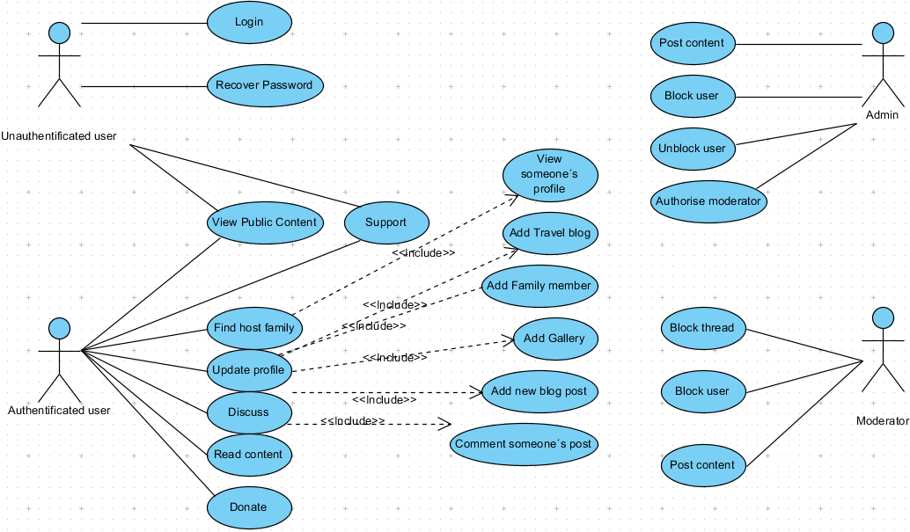

User scenarios

Personas and scenarios

Roberto and family - persona
Roberto from Spain has a wife, 3 children and is accessing internet from his home computer, he plans to access from tablet during travelling.
Roberto was using CouchSurfing.com website to find hosts for the planned 3 months trip through Europe, but founds it hard to find CouchSurfers hosting families. On the same site discussion group, he read about Family2family and is giving it a try.

Roberto and family – user scenario
He hopes to find families faster than on CouchSurfing. Still he needs to create a profile. He tries to skip as much as possible to go fast to try the search. He is a bit frustrated by having to do so. He is happy to see interesting families in destinations he wants to go and writes them a message (he is using almost the same text all the time).

Les DeRouge – persona
This family is from France and is used to randomly access the web via all the mobile and fixed devices. Madame DeRouge heard about Family2family from her colleague and invites the children (school age) to check it. She is keen Facebook user and founds the site via the Facebook link she got from her colleague.

Les DeRouge – user scenario
She uses social-sign-in. She did not about any other way of connecting. She has a look on the User Guide given on the website and invites children to create their profiles.
Then they try to search for member families in their neighborhood and finally try to find a host for summer vacation. She contacts one family from Spain, that was presented among the featured families in the dashboard.

Marcella Cukerberg – persona
Marcella from Australia, solo-mum is going to travel with her 3 years old boy for a year. It´s her first such adventure and she is searching advice, destination tips, tips on savings during travelling and eventually.

Marcella Cukerberg – user scenario
She learned about Family2family from a website. She created a full profile, payed for the membership without hesitating, because useful information is promised. She goes through the articles, profiles and discussions.

Scenario 0: first login and creating a profile
Coming through the landing page, the user clicks to be displayed the sign-in page. Two options follow: social login and standard profile creation. Social media login for the first time will create a profile automatically based on the information we can retrieve from the social media.
The user can now browse the website, but until the profile is fully filled (including at least one picture and information about hosting, if available), the user will be unable to send stay requests and will not be shown in the search results. Same restrictions will apply for users that did not login since three months.
User is reminded to complete his profile upon login and being prevented to do an action requiring full profile.

Scenario 1: host family search
Typically, user selects a town or region he wants to travel to and searches for best fitting host families.
He might narrow the search by using clickable buttons. Best results are selected. Later, with larger user base, we will be able to do smart match for full membership users. This is out-of-scope of the first version of the website. Number of resulting members is displayed, only active members are shown.
Results are also shown as pins on the map present in the search result. Search on map will also be available, if technically possible.

Scenario 2: information search
The website will provide authored content. The blog will provide updates on travel trends and on website improvements, featured articles will contain tips and stories.

Scenario 3: contacting host families
User has found a family he would like to visit. He will be shown a dialog window where he selects arrival day and departure date (by selecting dates in date-picker). A short request text will be required, prepared text might be stored on the server. E-mail will be sent to the contacted family. The mail Subject will be generated to provide maximum information (dates, user). Upon reception of such e-mail or after opening a notification, host can decide whether to accept or decline the request.

Scenario 4: bulk hosting request
User can contact all users in selected area (limit of nr. users contacted applied).
Such requests will be stored and every day an e-mail will be generated for each user that was contacted.

Scenario 5: reporting misuse
With every message, post, blog or profile view a Report button will be displayed in upper right corner.
Any message, post, blog or profile that would be reported by at least two users will be automatically frozen (invisible to other users) and reported to admin.

Key website requested features

Basic features
- Profile creation and view
- Placing pin on Google map (or other equivalent) to represent user´s location.
- Gallery (in carousel)
- References system
- Search profiles by keyword
- Search profiles by location, plus filters using svg buttons for the most common restrictions (e.g. WiFi availability) – restrictions apply for “free account” users. If possible, search on Google map with pins representing towns with families.
- Hosting request system
- Messaging system
- Featured articles and featured profiles (auto-suggest profiles with best match and using location). Some articles will be available only to “full” users.

Advanced features
- QR code to get host´s contacts to mobile device
- Offline
- App
- Photo for each reference

Multilanguage support
It should be easy to add supplementary languages of the webstite, without duplication of the website content.

Security
As discussed above, the security is one of our main concerns.
Strong password will be required (or generated).
All development should be done over secured connection.
No password, app id-keys etc. in the open source project on GitHub.

Website wireframes

Profile view

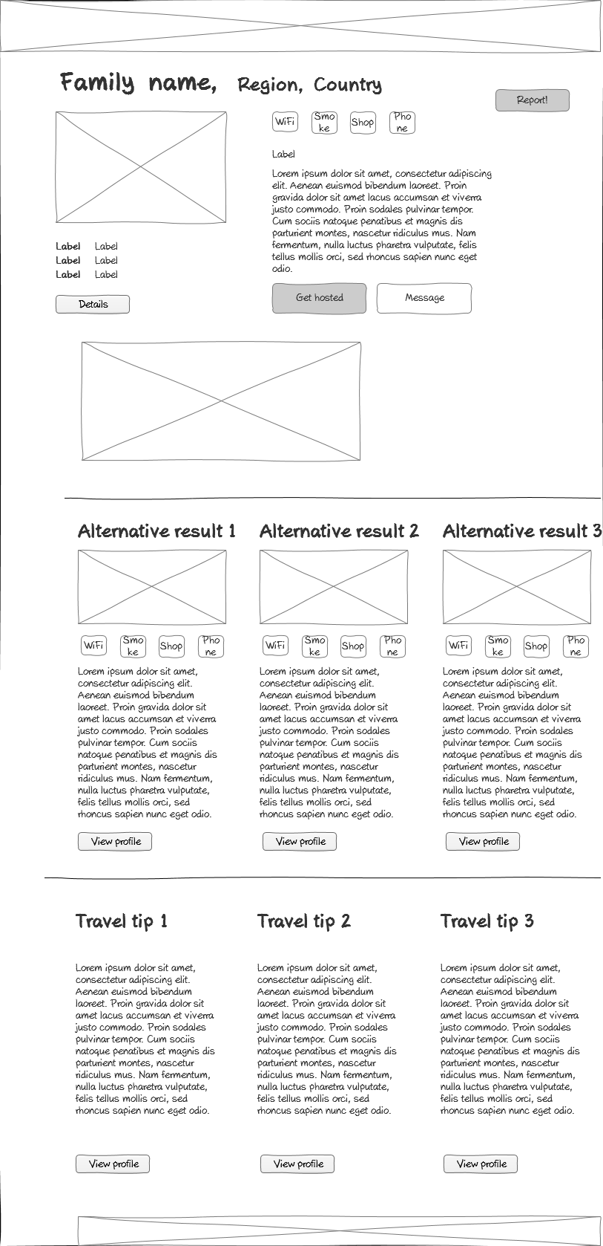

Website mockup
The website mockup is available on GitHub via https://github.com/matena/f2f/.

Landing page
A landing page which will encourage user to create a profile (or to login if already registered) will be shown for first 10 visits to the website.
Backround carussel, rollover highlight of the button, social media bar.
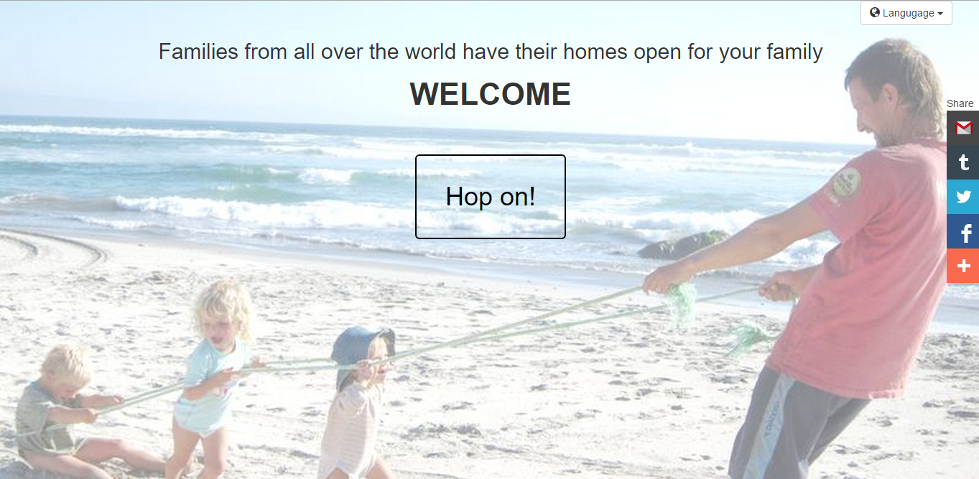

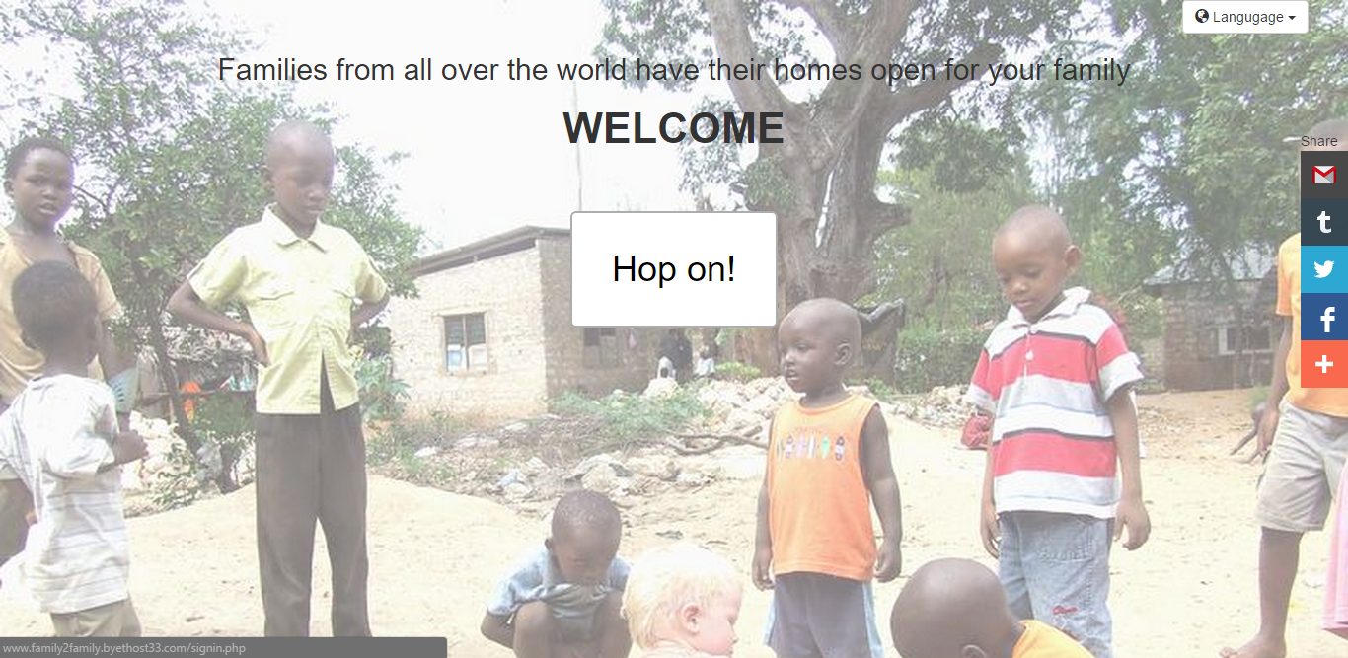

Sign-in page
Two column layout on large screen.
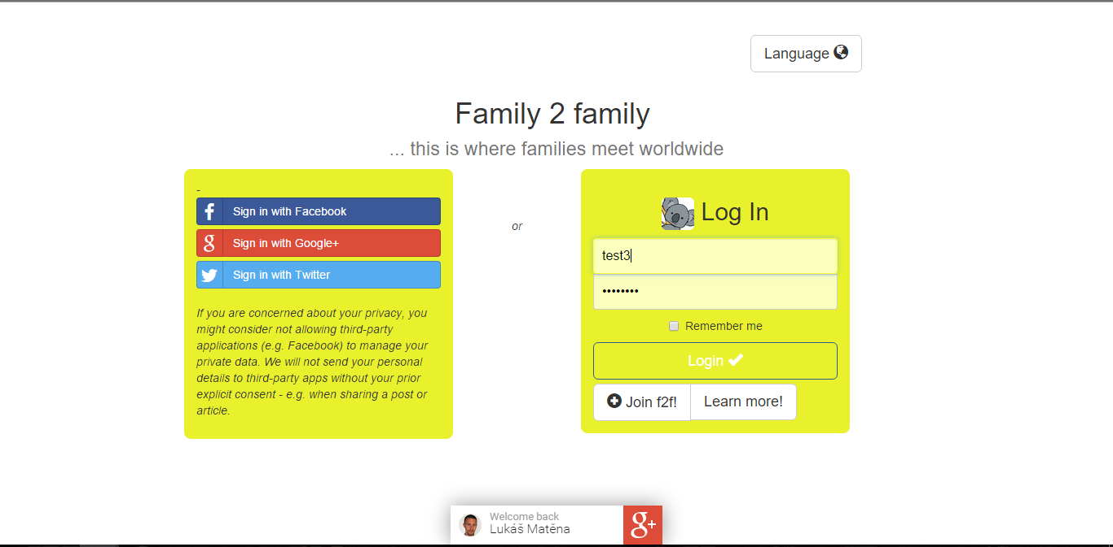

About and Sign-up page
Two-in-one information about the project is given for newcomers and with anchor directly one column registration form. The input is controlled during the sing-in and sign-up.

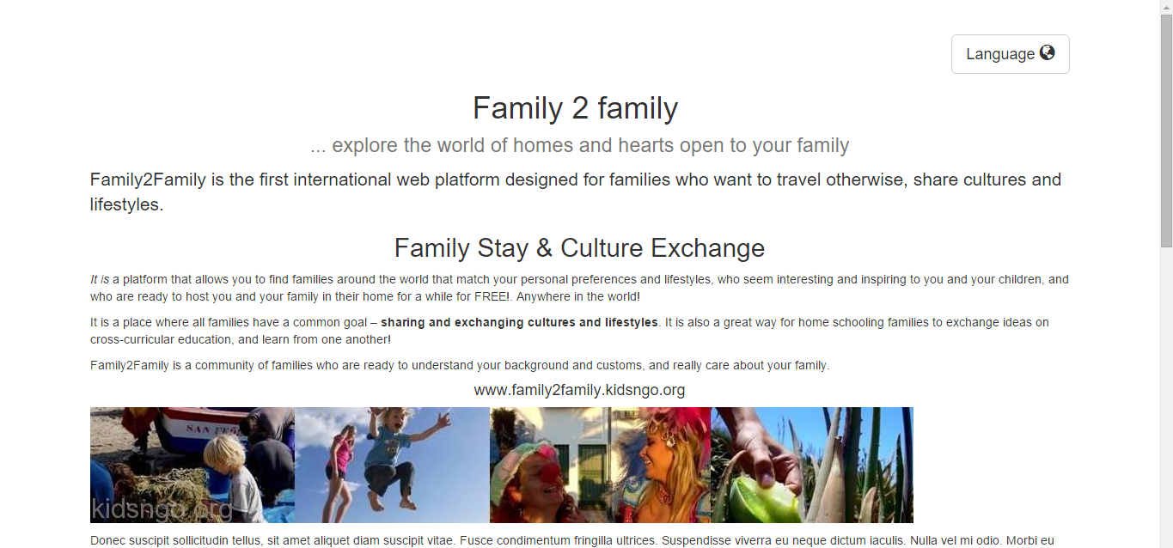
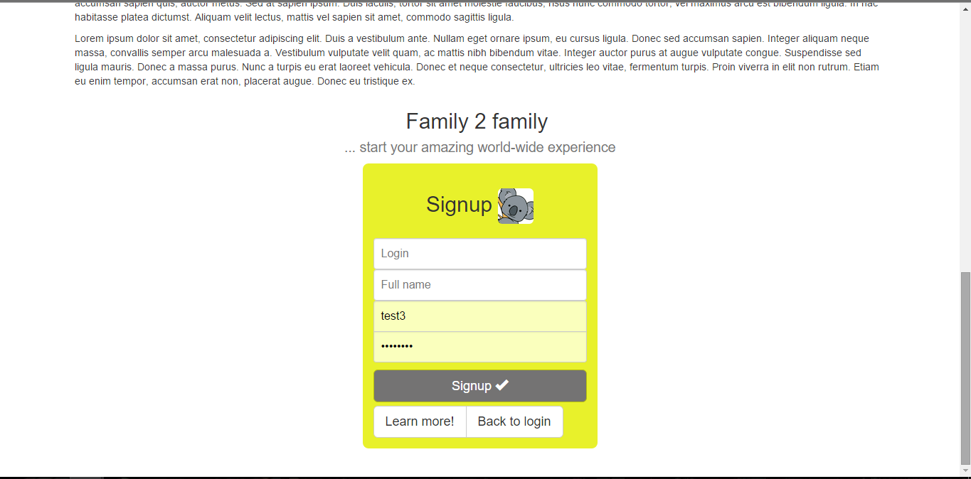

Dashboard
The main site accessible to logged-in users.

Information and link in the header:
- Link to profile view (with user name displayed)
- shows user´s current hosting availability
- shows information, alerts
- displays number of in-messages
- shows user´s current hosting availability
- link to site usage guide, information about membership options and donations
- language options
- search
- logout button
- Enforcement of respect of privacy of users
Information in the footer:
- Copyright (copyleft)
- Information about authors
- Enforcement of respect of privacy of users
- Contact

Main part of the page
If no search result is displayed:
- Map with close families
- Featured profiles (based on proximity, relevance, etc.)
- “Hot”discussions
- Featured articles and affiliate
- Ads (? To be discussed with f2f team)
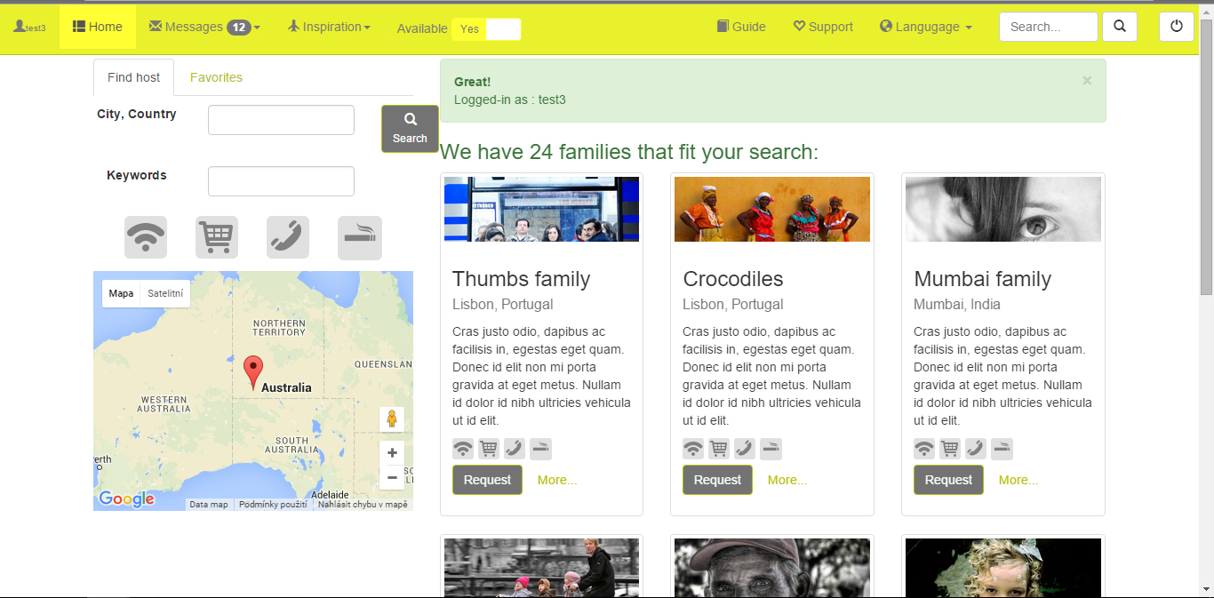
... bottom of the result page (max. 6 results shown at one time)
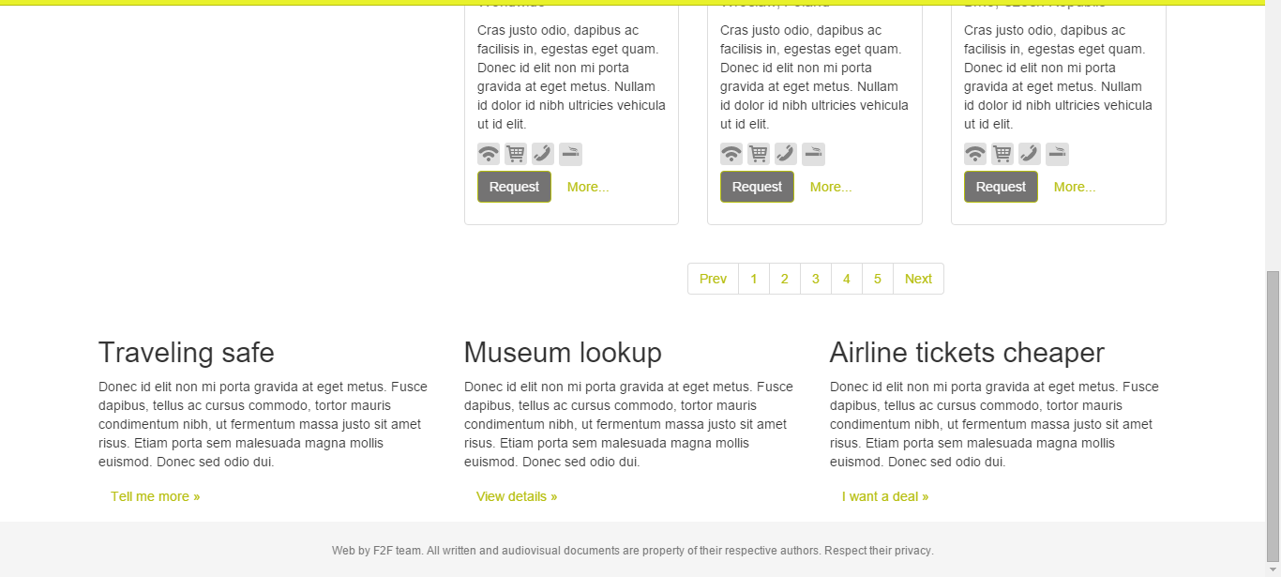

Profile view (basic)
The basic profile view is shown when a user opens a result search or clicks other user´s profile link somewhere else on the page. In the mockup, the location Google map is missing.
In case user opens his own profile:
- Information about last update of own profile will be shown to motivate the user to update often
- Edit marks (e.g. pen bootstrap icon) shown to direct access to edit information.
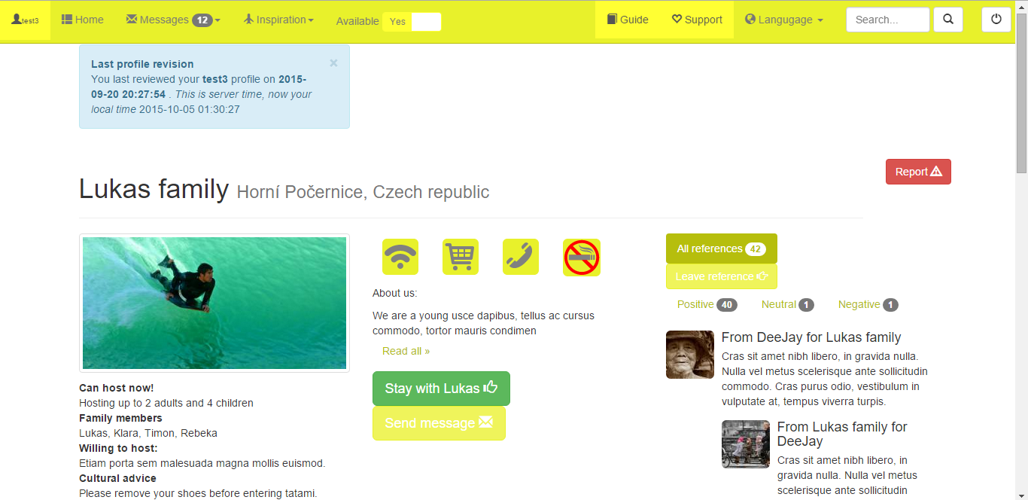
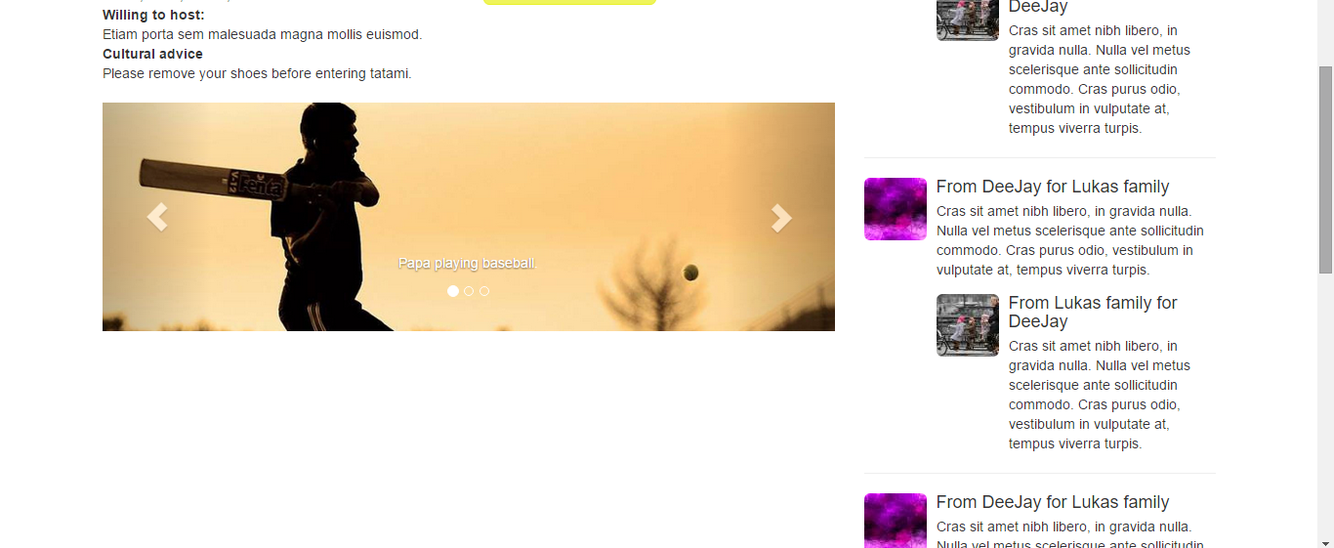

Profile view (detailed)
The basic profile view will have edit options in case it is opened by owner himself.

Annex A – Entity diagram
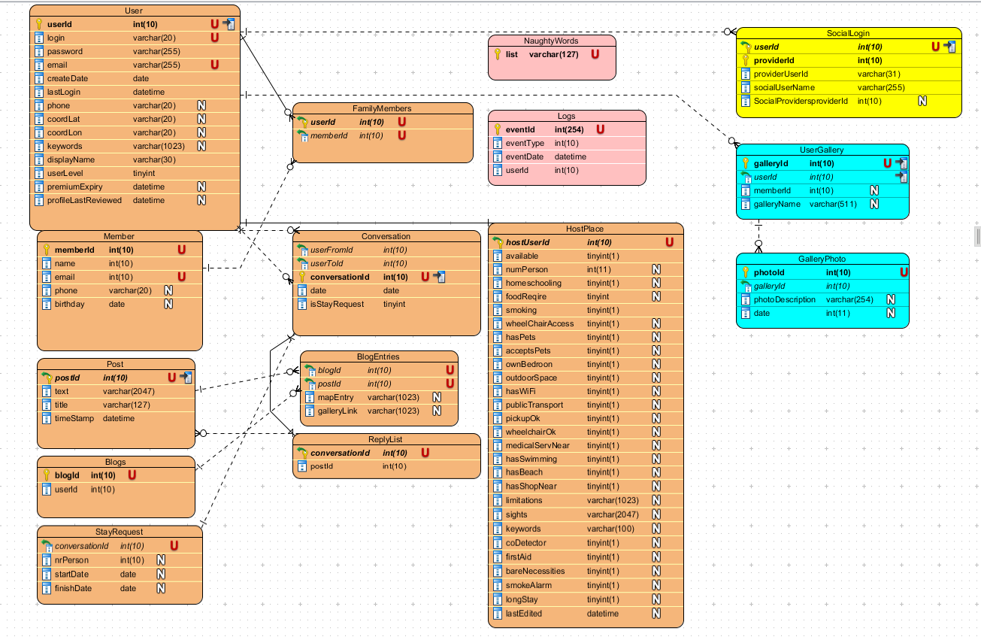

Annex B - UI Elements

Color palette
#747373 | #FFFFFF | #B6BE0D | #E8F12B | #717073

See bootstrap.css file for further reference.

Font
font-family: "Helvetica Neue", Helvetica, Arial, sans-serif;
font-size: 14px;
color: #333;

Clickable icons
A set of clickable icons will represent mostly searched qualities of the host’s place. Some icons are already done in the mockup. Set of desired icons will be specified and the icons will be delivered to developers, if they can use in this format
Selected Not - selected


Annex C – Implementation
Implementation details are not given in this document. Please confirm with F2F team before introducing a new framework.
For the mockup site following was used:
- PHP/MySQL
- Bootstrap 3.0
- HybridAuth (for social media interaction)
- Bootstrap Social (social buttons)
- SVG (clickable icons)

Contents
Background 1
Introduction 1
User requirements 2
Who are targeted website users? 2
How do users access the project? 2
What do they want? 2
What is the business need? 2
Use case diagram 3
User scenarios 3
Personas and scenarios 3
Roberto and family - persona 3
Roberto and family – user scenario 3
Les DeRouge – persona 3
Les DeRouge – user scenario 4
Marcella Cukerberg – persona 4
Marcella Cukerberg – user scenario 4
Scenario 0: first login and creating a profile 4
Scenario 1: host family search 4
Scenario 2: information search 5
Scenario 3: contacting host families 5
Scenario 4: bulk hosting request 5
Scenario 5: hacker attack 5
Key website requested features 5
Multilanguage support 5
Security 5
Wireframes 5
Web pages 5
Website wireframes 6
Web pages 6
Website mockup 7
Landing page 7
Sign-in page 8
About and Sign-up page 9
Dashboard 10
Profile view (basic) 2
Profile view (detailed) 2
Annex A – Entity diagram 3
Annex B - UI Elements 4
Color palette 4
Font 4
Clickable icons 4
Annex C – Implementation 4
Contents 5

