TPE – Metodologías de Desarrollo de Software I

Software Architecture Document

Version <1.0>

Revision History

|  |  |  |  |
| --- | --- | --- | --- |
| **Date** | **Version** | **Description** | **Author** |
| 13/06/2021 | <0.1> | Elaboración de los diagramas de secuencias, clases y actividades | Grupo 10 |
|  |  |  |  |
|  |  |  |  |
|  |  |  |  |

Table of Contents

1. Introduction 4

1.1 Purpose 4

1.2 Scope 4

1.3 Definitions, Acronyms, and Abbreviations 4

1.4 References 4

1.5 Overview 4

2. Use-Case Diagram 4

3. Structural Diagrams 5

3.1 Overview 5

3.2 Class Diagram 5

3.3 Deployment Diagram 5

4. Behavioral View 5

4.1 Overview 5

4.2 Activity Diagrams 6

4.3 Sequence Diagrams 7

Software Architecture Document

# Introduction

[The introduction of the **Software Architecture Document** provides an overview of the entire **Software Architecture Document**. It includes the purpose, scope, definitions, acronyms, abbreviations, references, and overview of the **Software Architecture Document**.]

## Purpose

This document provides a comprehensive architectural overview of the system, using a number of different architectural views to depict different aspects of the system. It is intended to capture and convey the significant architectural decisions which have been made on the system.

[This section defines the role or purpose of the **Software Architecture Document**, in the overall project documentation, and briefly describes the structure of the document. The specific audiences for the document is identified, with an indication of how they are expected to use the document.]

## Scope

[A brief description of what the Software Architecture Document applies to; what is affected or influenced by this document.]

## Definitions, Acronyms, and Abbreviations

[This subsection provides the definitions of all terms, acronyms, and abbreviations required to properly interpret the **Software Architecture Document**.  This information may be provided by reference to the project’s Glossary.]

## References

[This subsection provides a complete list of all documents referenced elsewhere in the **Software Architecture Document**. Identify each document by title, report number (if applicable), date, and publishing organization. Specify the sources from which the references can be obtained. This information may be provided by reference to an appendix or to another document.]

## Overview

[This subsection describes what the rest of the **Software Architecture Document** contains and explains how the **Software Architecture Document** is organized.]

# Use-Case Diagram

[This section lists use cases or scenarios from the use-case model if they represent some significant, central functionality of the final system, or if they have a large architectural coverage—they exercise many architectural elements or if they stress or illustrate a specific, delicate point of the architecture.]

# Structural Diagrams

## Overview

## En esta seccion se encuentran los diagramas estructurales, es decir, cómo esta formado el sistema

## https://cdn.discordapp.com/attachments/834784450734850072/857724815518466078/Diagrama_Clases_TPE.pngClass Diagram

## 

## Deployment Diagram

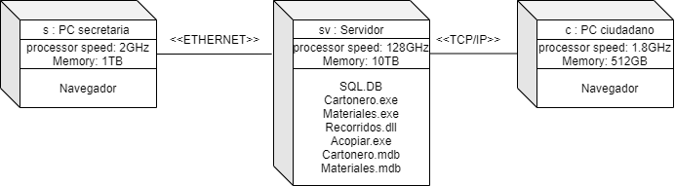

Archivos ejecutados por servidor:

* Cartoneros.exe: Alta, baja y modificación de los datos de los cartoneros.
* Materiales.exe: Alta, baja y modificación de los datos de los materiales.
* Recorridos.dll: Generación de la lista de recorridos para los cartoneros.
* Acopiar.exe: Acopio de materiales de cada cartonero.
* Cartonero.mdb y Materiales.mdb: Almacen de datos de cartoneros y materiales, respectivamente.

# Behavioral View

## Overview

En esta sección se encuentran los diagramas comportamentales del Sistema.

## Activity Diagrams

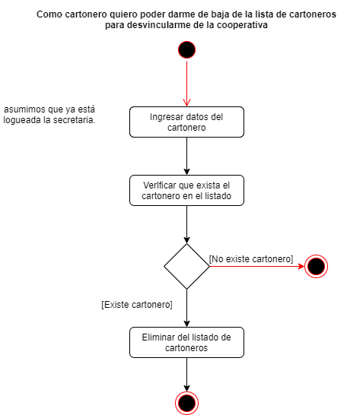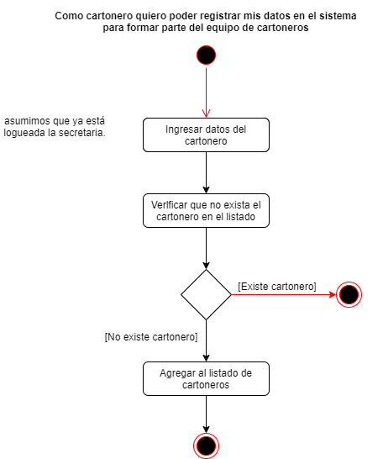A continuación se encuentran los diagramas de actividades junto a su respective caso de uso.

## C:\Users\Usuario\Desktop\Facultad\3er año 1er cuatri\Metod. de desarrollo de Software\Trabajo Practico Especial\Diagramas Sprint 2\Diagrama_Actividades_AcopiarMateriales.pngC:\Users\Usuario\Desktop\Facultad\3er año 1er cuatri\Metod. de desarrollo de Software\Trabajo Practico Especial\Diagramas Sprint 2\Diagrama_Actividades_Log-In.pngC:\Users\Usuario\Desktop\Facultad\3er año 1er cuatri\Metod. de desarrollo de Software\Trabajo Practico Especial\Diagramas Sprint 2\Diagrama_Actividades_Modificar_Cartonero.png

## Sequence Diagram

* Diagrama de secuencia para acopiar materiales

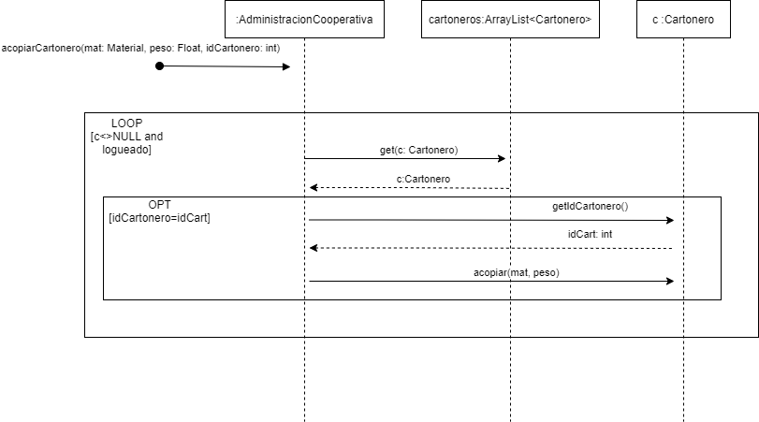

* Digrama de secuencia para acopiar materiales para un cartonero

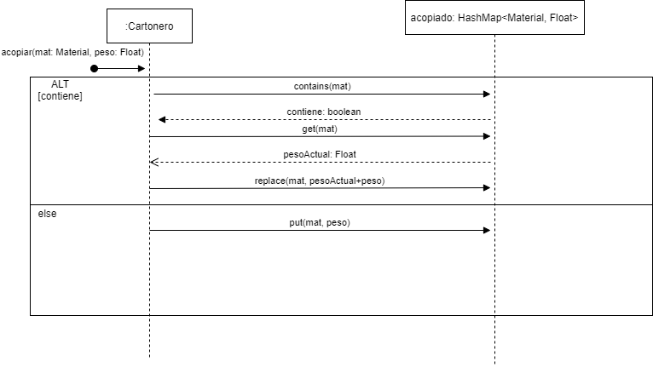

* Diagrama de secuencia para LogIn

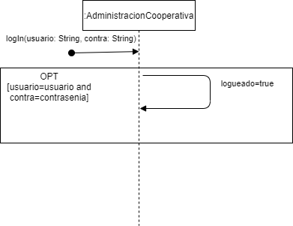

* Diagrama de secuencia para agregar un cartonero

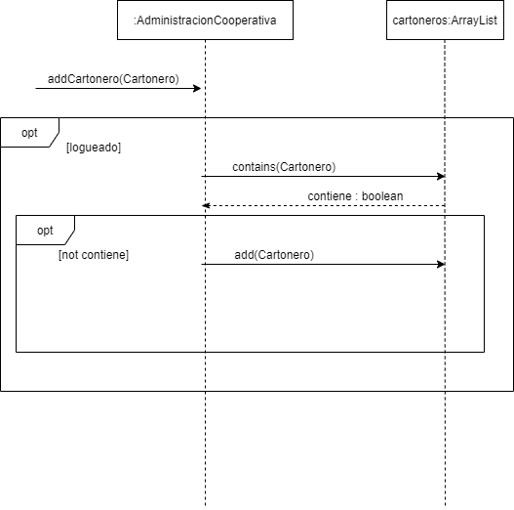

* Diagrama de secuencia para eliminar un cartonero

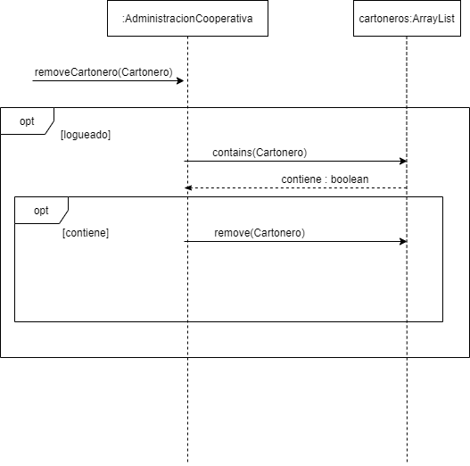

* Diagrama de secuencia para modificar un cartonero

