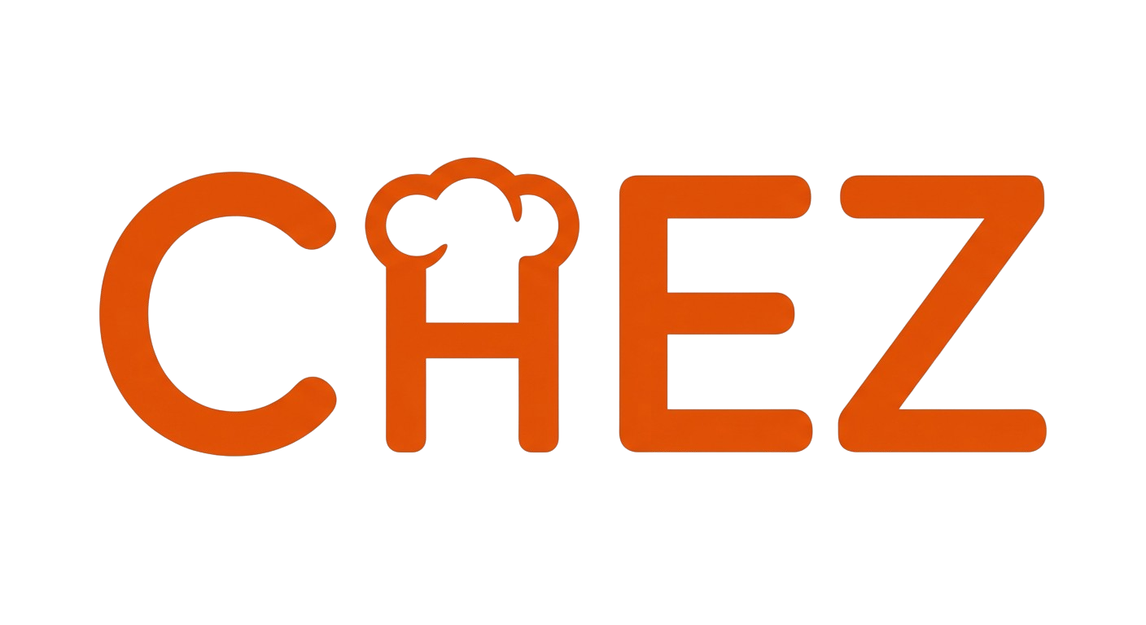
Technical Documentation
Shipyard Hackathon 2026
Mateo Daza

1. Architecture Overview

Chez is a native iOS app built with React Native (Expo SDK 54) and TypeScript. The backend runs entirely on Supabase: Postgres for data, Edge Functions (Deno/TypeScript) for server logic, and Row-Level Security for access control. Monetization is handled through RevenueCat with server-side webhook verification.

Layer | Technology
Mobile app | Expo + React Native, TypeScript
State | React local state + React Query (server)
Database | Supabase Postgres with Row-Level Security
Backend | Supabase Edge Functions (Deno)
AI models | Claude, GPT-4o Mini, Gemini Flash via OpenRouter
Embeddings | OpenAI text-embedding-3-small (1536 dimensions)
Vector search | pgvector with cosine similarity
Voice | OpenAI Whisper (STT) + TTS
Subscriptions | RevenueCat SDK + webhook
Analytics | Custom event tracking via Edge Function
2. Edge Functions

8 core production Edge Functions power the main user flow:

import-recipe
Extracts structured recipes from video URLs. Fetches transcripts via Supadata API (primary) with free fallback layers for YouTube (InnerTube API) and TikTok (oEmbed + page scraping). Runs transcript through Claude Sonnet 4 with a detailed extraction prompt that includes 60+ phonetic error corrections for speech-to-text artifacts. Includes server-side nonsense detection (vowel ratio, repeated characters) to reject garbage input before spending an API call. The manual entry flow adds a client-side check as well. Returns structured JSON with ingredients, steps, timing, and a confidence score. Rejects extractions below 0.3 confidence.

cook-chat-v2
The real-time cooking assistant. Uses a 3-tier smart model routing system to minimize cost while maintaining quality.

- Tier 1 (Gemini Flash, ~70%): Simple questions, timing, temperature. $0.30/$2.50 per 1M tokens.
- Tier 2 (GPT-4o Mini, ~25%): Substitutions, technique, scaling. $0.15/$0.60 per 1M tokens.
- Tier 3 (Claude Sonnet 4, ~5%): Complex troubleshooting only. $3/$15 per 1M tokens.

Intent classification is done locally via regex pattern matching (no API call, zero cost). 12 intent types with confidence scores. If confidence is below 0.7, the query escalates to GPT-4o Mini regardless of intent. If OpenRouter fails, the function falls back to direct Claude via the Anthropic SDK.
Result: 97% cost reduction vs Claude-only ($0.00066/msg average vs $0.02/msg).
embed-memory
Generates OpenAI text-embedding-3-small embeddings for user cooking memories. Called after memory creation to enable semantic retrieval.

whisper
Speech-to-text transcription via OpenAI Whisper-1. Accepts base64-encoded m4a audio, returns transcribed text.

confirm-source-link
Handles user decisions on the similar-recipe confirmation modal. Three actions: link video to existing recipe, create new recipe, or reject.

create-my-version
Creates “My Version” (v2) from cook session learnings. Starts from the original (v1), applies detected substitutions, timing changes, and additions, then upserts as v2. Always replaces existing v2 rather than creating v3, v4, etc.

revenuecat-webhook
Processes subscription lifecycle events from RevenueCat. Handles initial purchase, renewal, cancellation, expiration, billing issues, and product changes. Syncs tier to both user_rate_limits and users tables.

track-event
Logs analytics events to the database. Fails silently so analytics never breaks the app.

3. RAG and Memory System (pgvector)

The memory system uses pgvector for semantic search across user cooking history.
Storage
The user_cooking_memory table stores per-user memories with 1536-dimensional embeddings. Each memory has: content (text), memory_type (preference/cooking_note), label (substitution_used, technique_learned, preference_expressed, etc.), metadata (recipe title, learning type, step number), and the embedding vector.
Creation (Chef-only)
During cook-chat-v2, the system detects meaningful preferences via two methods:
- Direct intent-based: If the user’s message is classified as a preference_statement or modification_report with confidence ≥ 0.8, the learning is auto-saved.
- AI-suggested: The AI can return a structured learning block in its response, parsed via regex, with default confidence 0.75 (requires user confirmation).
Each saved memory gets an embedding generated via OpenAI text-embedding-3-small. Memories are also appended to the cook session’s detected_learnings JSONB array for the completion summary.
Retrieval (all tiers)
On every cook-chat message, the user’s question is embedded. Two RPCs run in parallel:
- match_user_memory — cosine similarity search on user_cooking_memory (threshold: 0.5, top 3)
- match_recipe_knowledge — searches global knowledge base (threshold: 0.7, top 3) for relevant intents

Retrieved context is injected into the AI’s system prompt before generating a response. Free users benefit from memory created during Chef sessions, creating an incentive to subscribe without degrading the free experience.
4. RevenueCat Implementation

SDK Setup
- Initialized in root layout (_layout.tsx) on app mount
- User identified via Purchases.logIn(supabaseUserId) after auth
- Real-time listener (addCustomerInfoUpdateListener) monitors changes
Entitlement
- Single entitlement: "chef"
- Products: chef_monthly ($9.99/mo), chef_annual
Client-side Hook
useSubscription returns: tier, isChef, expirationDate, willRenew, productId, isLoading. Lightweight variant useIsChef() for boolean checks. Updates in real-time.
Paywall Triggers
- After last free AI message (4.5s delay post-response in ChatModal)
- Import limit reached (3/month for free tier)
- Manual upgrade button on profile screen
Purchase Flow
PaywallContent fetches offerings, pre-selects annual. purchasePackage() handles App Store transaction. On success: tracks subscription_started event, calls refresh() to sync.
Server-side Verification
RevenueCat webhook sends events to the revenuecat-webhook Edge Function, which verifies the authorization secret. Events: INITIAL_PURCHASE, RENEWAL, CANCELLATION, EXPIRATION, BILLING_ISSUE, PRODUCT_CHANGE, NON_RENEWING_PURCHASE.
Updates user_rate_limits.tier and users.subscription_tier in Supabase. Client-side sync can only downgrade to “free.” Upgrades to “chef” must come through the webhook (service_role bypass), preventing tier spoofing.
Rate Limiting
Enforced via check_rate_limit Postgres function with atomic row-level locking. Free: 20 msgs/day, Chef: 500 msgs/day. Resets at midnight UTC. Single atomic UPDATE prevents race conditions.
5. Database Schema

Table | Purpose
users | Core user record with subscription_tier, imports_this_month, imports_reset_at
master_recipes | Recipe collection with title, mode, current_version_id, times_cooked
master_recipe_versions | Immutable version snapshots: ingredients (JSONB), steps (JSONB), times, servings. v1 = original, v2 = My Version
video_sources | Global transcript cache keyed by normalized URL. Reused across users
recipe_source_links | Maps user + video to master recipe. Stores extracted data for deferred creation
cook_sessions | Active cooking state with current_step, completed_steps, detected_learnings (JSONB)
cook_session_messages | Chat history with role, content, step context
user_cooking_memory | RAG memories with embedding vector(1536), labels, and metadata
recipe_knowledge | Global knowledge base with embeddings for technique, substitution, tip retrieval
user_rate_limits | Atomic rate limiting with tier, daily count, and reset date
grocery_lists / grocery_items | Per-user shopping lists with items categorized by aisle
ai_cost_logs | Per-message cost tracking: model, provider, tokens, cost, latency

All tables use Row-Level Security. User data is scoped per-user, with explicit exceptions for shared read access (e.g., recipe_knowledge, challenge completion counts). Service-role access is reserved for Edge Functions and webhook processing.
6. Cost Optimization

AI cost per message averages $0.00066 through smart model routing:

Traffic | Model | Cost (In/Out per 1M tokens)
~70% | Gemini Flash | $0.30 / $2.50
~25% | GPT-4o Mini | $0.15 / $0.60
~5% | Claude Sonnet 4 | $3.00 / $15.00

Intent classification is free (local regex, no API call). Token budgeting caps input at 3,000 tokens with smart context truncation. Every message’s cost is logged to ai_cost_logs for monitoring.
7. App Structure

Expo Router file-based navigation:

Route | Purpose
(auth)/ | Login/signup with OTP
(onboarding)/ | Welcome slides + cooking mode selection
(tabs)/ | Home, Recipes, Add, Grocery, Profile
cook/[id].tsx | Full-screen cook mode with step cards + chat
recipe/[id].tsx | Recipe detail with version toggle
challenge.tsx | Weekly challenge screen
paywall.tsx | Subscription upgrade screen

Key Libraries
- react-native-purchases — RevenueCat SDK v9.7.6
- @supabase/supabase-js — database + auth
- @tanstack/react-query — server state + caching
- react-native-reanimated — animations
- expo-router — navigation

