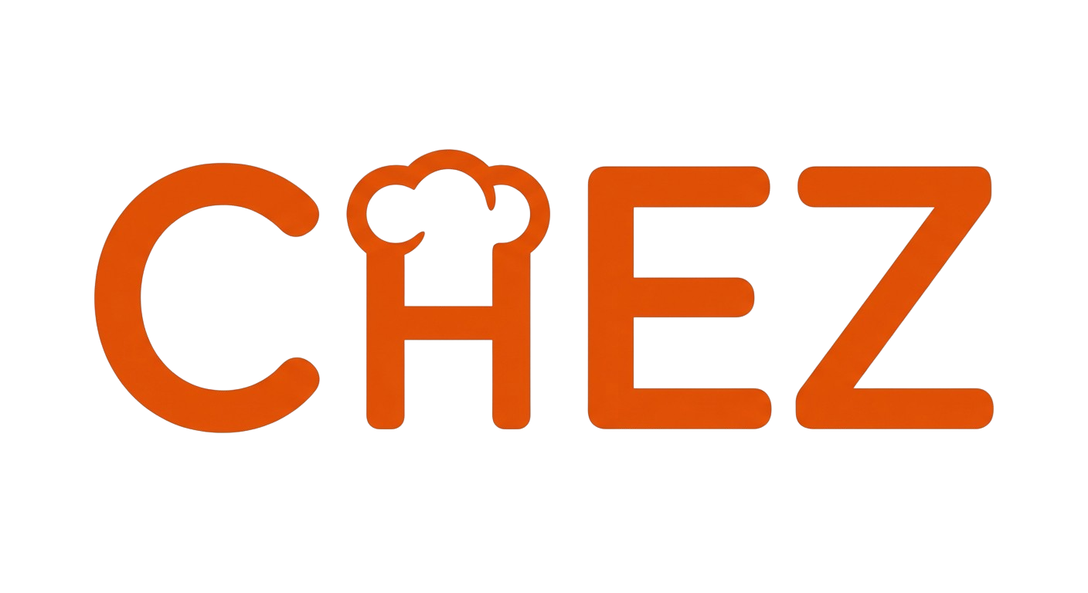
From saved recipe to dinner made

Written Proposal
Shipyard Hackathon 2026
Mateo Daza

1. The Problem

Eitan Bernath’s audience saves his recipes constantly. His TikTok and Instagram posts get millions of views, hundreds of thousands of saves. But saves don’t equal cooks. The gap between “I want to make this” and “I made this” is where most home cooks stall.
The reasons are predictable:
- Saved videos get buried in a feed alongside memes and music
- There’s no structured recipe to follow (just a 60-second video)
- Cooking alone with no guidance means one wrong step and you’re stuck
- Grocery shopping requires rewatching the video and guessing quantities

Eitan’s brief asked for the bridge: “From saved recipe to dinner made.” Chez is that bridge.
2. Target Audience

Chez is built for Eitan’s core audience: Gen Z and young millennial home cooks (18–28) who discover recipes on TikTok and Instagram but rarely follow through. They’re comfortable with mobile-first experiences, expect fast interactions, and are used to vertical swiping (TikTok-native UX).
These users:
- Save 5–10 recipe videos per week but cook 0–1 of them
- Don’t own cookbooks or follow traditional recipe blogs
- Want guidance but not hand-holding
- Will pay for tools that save time and reduce friction (this demographic already subscribes to Spotify, YouTube Premium, and fitness apps)
3. How Chez Solves It

Chez converts saved recipes into completed meals through a guided pipeline:

Import
Paste a TikTok, Instagram, or YouTube link. Chez extracts the transcript, runs it through AI, and produces a structured recipe with ingredients, steps, and timing. No manual entry needed.

Grocery List
One tap adds all ingredients to a shopping list sorted by aisle category (produce, dairy, meat, pantry, etc.). The list persists across recipes, so you can plan multiple meals in one trip.

Cook Mode
Swipeable full-screen step cards (vertical, TikTok-style) designed for use with messy hands. Each step shows what to do, how long it takes, and lets you check it off.

AI Chat
While cooking, ask anything. “Can I substitute mascarpone?” “How do I know when the oil is hot enough?” The AI knows your recipe, your current step, and (for Chef subscribers) your personal cooking history.

Learning & Memory
For Chef subscribers, Chez detects when you make changes during a cook (“I used balsamic instead of red wine vinegar”) and saves them automatically. Next time you cook anything, the AI remembers your preferences and adapts its advice.

Personal Versions
Your modifications save as “My Version” while the original stays untouched. You can toggle between versions anytime.

Weekly Challenges
Three curated recipes from creators, with progress tracking that resets weekly. Community completion counts encourage participation and drive repeat engagement.

4. Monetization Strategy

Chez uses a freemium model with a single subscription tier powered by RevenueCat.
Free Tier
- 20 AI messages per day
- 3 recipe imports per month
- Full cook mode and grocery list access
- AI memory recall (benefits from memories created during Chef sessions)
Chef Tier ($9.99/month or annual)
- 500 AI messages per day
- Unlimited recipe imports
- Personalized cooking memory (AI learns your preferences)
- Personal recipe versions created from your learnings
- Priority AI responses
Why This Model Works
The free tier is generous enough to complete a full cook session. A user can import a recipe, build a grocery list, cook it step by step, and ask questions along the way—all without paying. This means every free user experiences the full value loop before ever seeing a paywall.
The paywall surfaces naturally. After using your last free message during a cook, the paywall appears with a 4.5-second delay (enough time to read the AI’s response first). It never interrupts a cook in progress. This timing converts well because the user has just experienced the value and wants more.
The Chef tier compounds value over time. The memory system means the app gets better the more you use it. Switching away means losing your accumulated cooking knowledge. This creates natural retention without lock-in tactics.
Weekly challenges drive free users toward the limit. Challenge recipes encourage multiple cook sessions per week, naturally increasing message usage and surfacing the upgrade at exactly the right moment.
Revenue scales with engagement, not content. Unlike recipe apps that need to constantly produce new content, Chez’s value grows from user-generated cooking data. Every cook session makes the AI smarter for that user, which increases willingness to pay.
5. Why Chez Fits Eitan’s Audience

Eitan’s audience watches cooking content for entertainment but aspires to actually cook. Chez converts that aspiration into action:
- Import his exact recipes from TikTok links (no transcription errors, no guessing)
- Weekly challenges featuring his recipes create a direct content-to-cook pipeline
- The AI assistant fills the role Eitan plays in his videos: encouraging, knowledgeable, and practical
- Community completion counts on challenges create social proof (“412 people cooked this”)
- The vertical swipe UX matches the TikTok interaction model his audience already knows

For creators like Eitan, Chez offers something no platform currently provides: visibility into how many people actually cooked a recipe, not just how many saved it. The analytics foundation tracks imports, cook starts, completions, and ratings per recipe—ready for creator-facing dashboards.

