An Automated Course Scheduling System for Universities: A Web-Based Approach with Next.js, FastAPI, and PostgreSQL
Mateo Grifsha ¹, Anxhela Baraj ²
¹ Canadian Institute of Technology, Tirana, Albania
² Canadian Institute of Technology, Tirana, Albania
mateo.grifsha@cit.edu.al, anxhela.baraj@cit.edu.al
Abstract. Producing a feasible weekly timetable in a university is an NP-hard combinatorial problem whose manual solution is brittle whenever a single resource changes. This paper presents a deployed web-based scheduling system for a multi-faculty university, built with Next.js, FastAPI and PostgreSQL, and proposes a lightweight greedy constraint-satisfaction algorithm augmented with a First-Fit-Decreasing day-packing heuristic and a round-robin professor load-balancing rule. The contributions are (i) an architecture that integrates the scheduler with a role-aware web interface for administrators, professors and students, (ii) the heuristic itself, and (iii) an empirical evaluation on 30 synthetic instances per size, ranging from 50 to 400 (course, group) pairs. The scheduler reaches 100% feasibility on all instances within 712 ms on the largest one; the day-packing heuristic increases the share of group-days containing two consecutive lectures from 19% to 44% relative to a random first-fit baseline, lowering average idle hours per student-group week from 4.7 to 1.3. The system has been deployed locally and is used as the substrate for ongoing work on an AI-assisted feedback loop that classifies student complaints and professor unavailability requests and recommends timetable revisions.
Keywords: University Timetabling, Course Scheduling, Greedy Constraint Satisfaction, Bin-Packing Heuristic, Web Application, Next.js, FastAPI, PostgreSQL.
- Introduction
Producing a feasible weekly timetable is one of the most labour-intensive administrative tasks of a university. Each semester an administrator has to combine the teaching load of every professor with the academic plan of every degree programme, allocate suitable rooms, respect the weekly availability of staff and avoid any overlap for a given student cohort. The problem, known in the operations-research literature as the University Course Timetabling Problem (UCTP), has been shown to be NP-hard [1], which means that even medium-sized institutions cannot, in practice, be scheduled by hand without introducing errors and conflicts.
Two limitations characterise the current state of practice in many universities. First, the task is still performed with spreadsheets, e-mail exchanges and ad-hoc desktop applications, which makes the timetable difficult to revise when a single constraint changes. Second, most published solvers focus on the algorithmic core and leave the data-management and user-feedback aspects of the problem to a separate, often manual, layer; this is reflected, for instance, in the format-driven design of the International Timetabling Competitions [2]. The lack of a centralised, role-aware platform also means that information about rooms, courses and group enrolments is duplicated across several systems and frequently falls out of sync.
This paper presents a system that addresses both limitations together. The platform is a single web application built with Next.js, FastAPI and PostgreSQL that consolidates the resources needed for scheduling, exposes role-specific interfaces to administrators, professors and students, and embeds a scheduling engine producing a conflict-free weekly assignment of courses to rooms and time slots. The contributions of this paper are threefold:
(i) we describe a deployed three-tier architecture in which an automated scheduler is integrated with a role-aware web front-end, and we identify the design constraints imposed by this integration on the algorithmic core; (ii) we propose a greedy constraint-satisfaction algorithm augmented with a First-Fit-Decreasing day-packing heuristic [3] and a round-robin professor load-balancing rule, and we present its evaluation on 30 synthetic instances per size in {50, 100, 150, 200, 250, 300, 350, 400} (course, group) pairs; (iii) we outline the integration of an AI-assisted feedback loop that classifies free-text complaints and unavailability requests and recommends timetable revisions to the administrator, building on recent transformer-based text classifiers [4].
The remainder of the paper is organised as follows. Section 2 reviews related work on university timetabling. Section 3 describes the methodology, including the system architecture, the problem formulation, the proposed greedy algorithm and the heuristic optimisation. Section 4 details the implementation of the three role-specific modules. Section 5 presents the experimental setup and the results obtained on the synthetic benchmark. Section 6 discusses the strengths and limitations of the approach. Section 7 concludes and outlines the directions of future work, including the AI-assisted feedback loop.
- Related Work
Schaerf [1] presents one of the first comprehensive surveys of automated timetabling and classifies the literature into three families: exact methods based on integer linear programming, constraint-programming formulations, and metaheuristics. Burke and Petrovic [5] update that classification and show that hybrid methods combining a constructive heuristic with a local-search improvement phase dominate the experimental literature. The series of International Timetabling Competitions (ITC), and in particular the curriculum-based formulation introduced by McCollum et al. for ITC-2007 [2], established the de-facto benchmark and inspired a number of high-performing solvers, the most representative of which is the simulated-annealing-based system of Müller [6]. Lewis [6] and Pillay [7] later surveyed metaheuristic and constraint-programming approaches in more detail, while Bettinelli et al. [8] provided a focused review of curriculum-based course timetabling and Babaei et al. [9] catalogued more than two hundred approaches to UCTP.
Our work differs from the cited literature on three points. First, the cited works focus exclusively on the algorithmic core and on offline benchmark instances, and they do not address the institutional pipeline that produces the instance in the first place; the present paper, by contrast, ships the algorithm together with a deployed three-tier web platform that manages the input resources and consumes the output timetable. Second, the high-performing methods of [10] and the ITC-2007 winners are tuned for a one-shot offline run that can take several minutes; we deliberately target interactive use by an administrator who repeatedly re-runs the scheduler after editing a resource, which forces sub-second runtimes and rules out long-running metaheuristics as the primary engine. Third, none of the cited works integrates a structured feedback channel that captures student complaints and professor unavailability requests against specific schedule entries; this channel is what enables the AI-assisted classification and recommendation engine outlined in Section 7, and is a feature of the present platform rather than of any prior UCTP solver.
Among the compared metaheuristic methods, the day-packing heuristic we introduce is basically an adaptation of the First-Fit-Decreasing approach used in one-dimensional bin packing problems [3] to a timetable scheduling problem. In this case, each weekday acts like a “bin,” and the lectures for a student group are the “items” being placed into those bins.

Rhydian Lewis [6] discusses similar goals related to keeping student schedules compact across days, but handles them as soft penalties inside a metaheuristic algorithm. In contrast, our method builds this objective directly into the timetable construction process, which means the compactness goal is optimized automatically without adding extra computational cost.
- Methodology
  - System Architecture
The platform is organised as three loosely coupled tiers connected through a JSON REST interface. The front-end is implemented in Next.js [11] with the App Router; it renders the role-specific dashboards and consumes a typed HTTP client. The back-end is written in Python using FastAPI [12]; it exposes the REST endpoints, validates the requests against Pydantic schemas and orchestrates the domain logic. Persistence is delegated to a PostgreSQL [13] database accessed through an asynchronous SQLAlchemy session. The scheduler is implemented as a service module that lives inside the back-end and is invoked synchronously by a dedicated endpoint; this choice allows the administrator to obtain a freshly recomputed timetable within the same request-response cycle and to revert to the previous state by rolling back a single database transaction. Authentication is enforced by JSON Web Tokens that carry the user identifier and the role claim and that are validated by an injectable dependency on every protected endpoint.
  - Problem Formulation and Constraints
Let C denote the set of courses to be scheduled in a given semester, P the set of professors, R the set of rooms, G the set of student groups and T the set of available time slots in a weekly grid. A timetable is a mapping that associates each scheduled lecture with a four-tuple (p, r, g, t) drawn from the Cartesian product P × R × G × T. The scheduler is required to produce a timetable that respects a set of hard constraints, while soft constraints are used to rank feasible solutions and to drive the heuristic of Section 3.4.
The hard constraints are: (i) every required course must receive exactly the number of weekly lectures prescribed by its credit weight; (ii) the professor assigned to a lecture must be entitled to teach the corresponding course; (iii) no professor can be in two rooms at the same time; (iv) no student group can attend two lectures at the same time; (v) no room can host two lectures at the same time; (vi) the capacity of the room must be greater than or equal to the size of the assigned student group; and (vii) every lecture must fall within the declared weekly availability window of its professor.
The soft constraints considered in this paper are: (S1) minimisation of the number of idle hours in each student-group schedule; (S2) compactness of the daily schedule of every student group, measured as the share of group-days containing exactly two consecutive lectures; and (S3) balance of the teaching load across the set of professors qualified for a given course, measured as the maximum deviation of the per-professor lecture count from the mean.
  - Proposed Scheduling Algorithm
The scheduler is realised as a greedy constraint-satisfaction algorithm. The set of lectures to be assigned is derived from the curriculum as the multiset of (course, group) pairs implied by the difficulty weight of every course in every active group. The algorithm iterates over this multiset and assigns each pair the first valid (slot, room) combination that does not violate any hard constraint. Conflict detection is performed against three in-memory sets that are maintained for the duration of a single run: prof_slot_used records every (professor, slot) pair already taken, room_slot_used records every (room, slot) pair already taken, and group_slot_used records every (group, slot) pair already taken. A candidate assignment is admitted only if none of the three sets already contains the corresponding pair and if the capacity of the room is greater than or equal to the size of the group.
  - Heuristic Optimization
On top of the greedy backbone, two heuristics drive the optimisation of the soft constraints listed in Section 3.2. The day-packing heuristic addresses S1 and S2: among the slots that satisfy the hard constraints for a given (course, group) pair, the scheduler selects the one with the lowest score, where the scoring function counts the number of sessions that the candidate group already has on the same day. A day that already hosts exactly one session is preferred (score 0), an empty day comes next (score 1), a day that already hosts two sessions is penalised (score 2), and a day that already hosts three or more sessions is excluded altogether (score 99 acts as a hard skip). This rule is a direct transposition of the First-Fit-Decreasing bin-packing strategy [3] to the timetabling setting; by repeatedly preferring to fill an already-opened daily bin before opening a new one, the algorithm produces compact student-group schedules and naturally minimises the number of idle hours across the week.
The professor load-balancing rule addresses S3: when several professors are qualified to teach the same course, the scheduler selects the one with the lowest current load through the rule min(professors, key=lambda p: prof_load[p.u_id]). The load counter is incremented after every successful assignment, so the next call returns a different qualified professor whenever possible. This realises a round-robin policy weighted by the actual number of lectures already assigned. Both heuristics are evaluated jointly in Section 5.2.
- System Implementation
The methodology of Section 3 has been implemented as a single Next.js front-end against a FastAPI back-end and a PostgreSQL database. The platform exposes three role-specific entry points, administrator, professor and student.
  - Administrator Module
The administrator dashboard, shown in Fig. 1, exposes four resource counters and a panel listing the latest administrative events. Resource management is organised in six modules accessible from the side navigation: faculties and degrees, courses, rooms, professors, students and student groups. Adding a new professor opens the multi-section form of Fig. 2, which collects the personal details, the credentials, the list of courses the professor is qualified to teach and the weekly availability expressed as a start time and an end time for each weekday with a checkbox that can disable the entire day; the availability windows feed directly into the hard-constraint check (vii) of Section 3.2. The administrator also triggers the scheduler through a Create Schedule action that calls the synchronous endpoint described in Section 3.1.
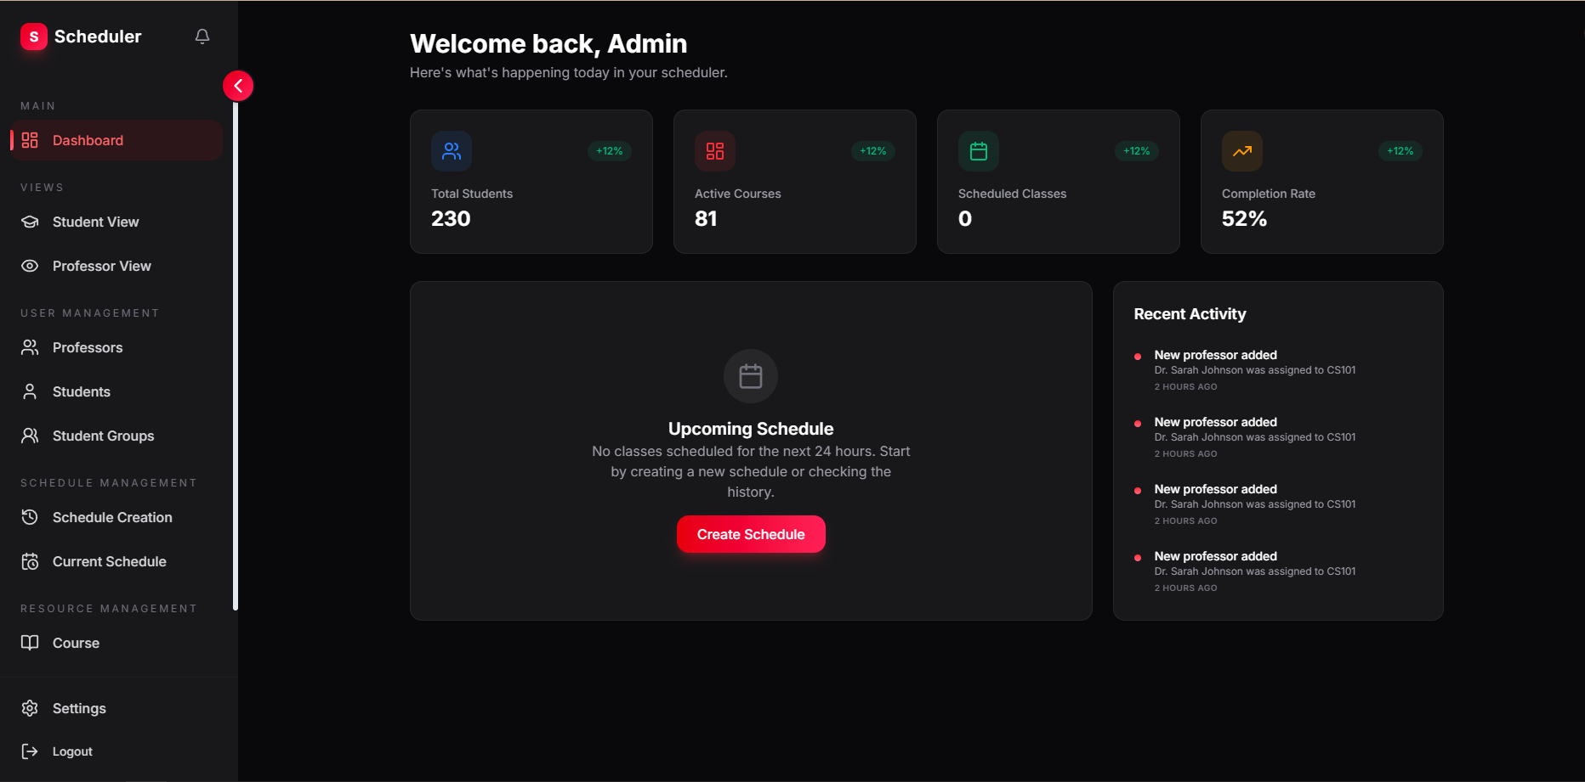
Fig. 1. Administrator dashboard with high-level resource counters and the latest-activity panel.
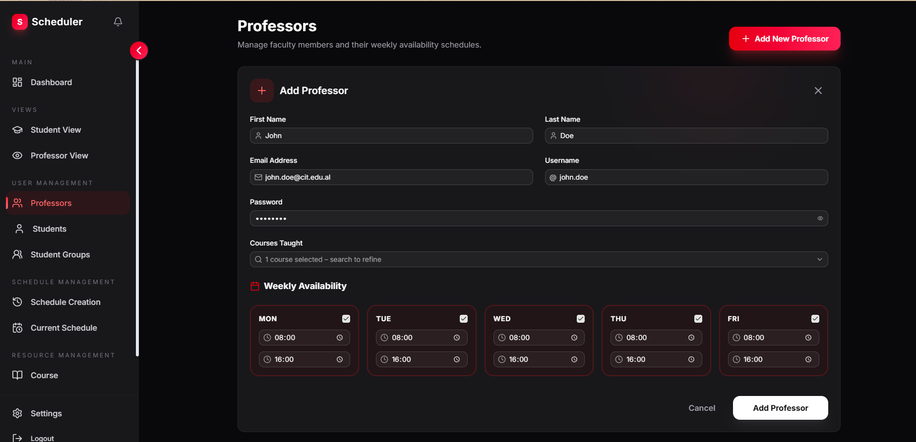
Fig. 2. Multi-section form used to add a new professor, including teachable courses and weekly availability windows feeding the hard constraint (vii) of Section 3.2.
  - Professor and Student Interfaces
Two read-only views consume the ScheduleEntry table produced by the algorithm of Section 3.3. The Professor View, shown in Fig. 3, renders the teaching schedule of the authenticated professor as a weekly grid with one row per time slot and one column per weekday; each cell that hosts a class displays the course title, the time interval, the room and the student group, together with a button that opens a modal dialogue used to submit an unavailability request for that specific occurrence. The Student View follows the same layout but is populated with the schedule of the cohort the student belongs to; the action button is replaced by a File Complaint button that opens a textual form sent to the administrator.
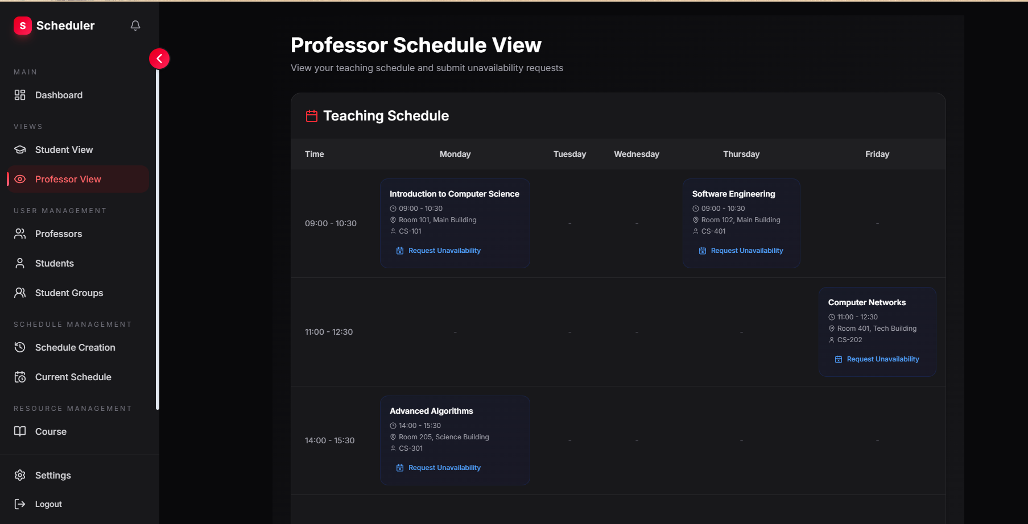
Fig. 3. Professor view: weekly grid of the professor with per-occurrence unavailability requests.
  - Feedback Mechanism
Complaints and unavailability requests are stored with a reference to the originating ScheduleEntry and to the user who filed them, and are listed on the dedicated page of Fig. 4. The administrator can acknowledge a request, use it as a justification for moving a class to a different slot during the next scheduling iteration, or, in the planned AI-assisted workflow of Section 7, accept the automated recommendation that the recommender attaches to it. This structured feedback channel is what differentiates our platform from a static timetable export and is the substrate on which the AI extension described in Section 7 will operate.
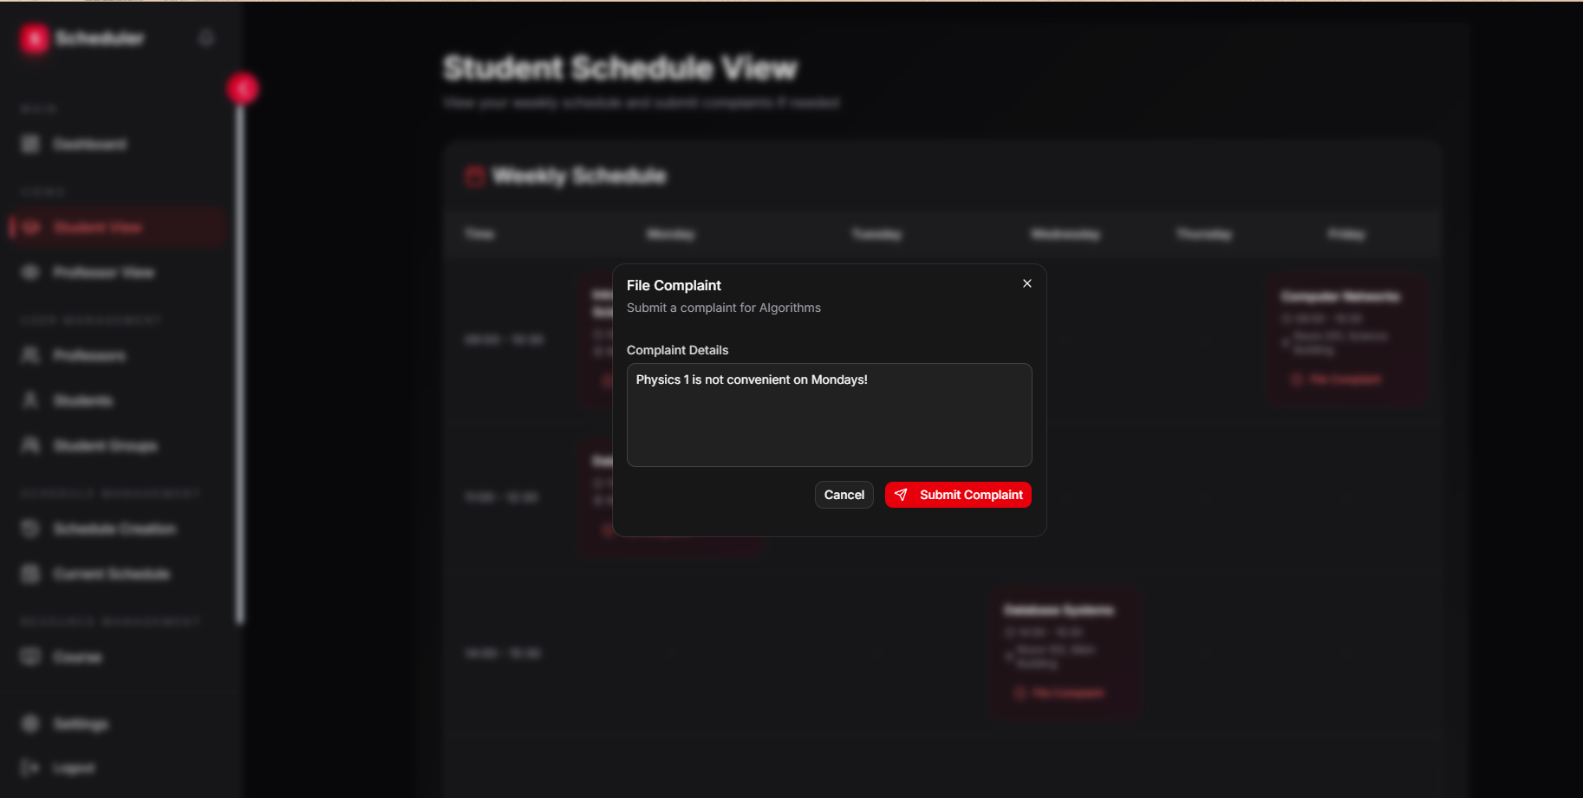
Fig. 4. Complaints page on the administrator dashboard, consolidating student complaints and professor unavailability requests against specific schedule entries.
- Results and Evaluation
  - Experimental Setup
The scheduler was evaluated on a benchmark of synthetic instances that reflect the operational constraints of the target institution. The weekly grid consists of five working days with three two-hour time slots per day (09:00–11:00, 11:00–13:00 and 13:00–15:00), yielding fifteen available slots in total. The room set contains twelve rooms divided into three capacity classes: four small rooms (20 seats), four medium rooms (35 seats) and four large rooms (50 seats), for a total room-slot capacity of 180 pairs per week.
Each instance is parameterised by the number N of independent student groups to be scheduled. Every group is assigned to its own degree programme and takes exactly five courses per semester, each taught by a dedicated professor , a configuration that directly reflects the institution's academic structure. Group enrolment size is drawn uniformly at random from the interval [15, 50]; because the three room classes span the same range, groups of different sizes face different room availability, which introduces genuine instance-to-instance variance. N is drawn from the set {5, 10, 15, 20, 25, 30}; thirty random instances were generated for every value using a fixed seed (20260515) to ensure reproducibility. Table 1 summarises the fixed parameters of the benchmark.
Two scheduler configurations were compared on the same set of instances. The baseline configuration runs the greedy backbone of Section 3.3 without heuristic guidance: it selects the first valid (slot, room) pair in iteration order and assigns the first qualified professor. The full configuration adds the day-packing heuristic and the professor load-balancing rule of Section 3.4. Three indicators were collected for every run: (i) the feasibility rate, defined as the fraction of scheduled (course, group) pairs relative to the expected total of N × 5; (ii) the average number of active days per student group per week (S1); and (iii) the fraction of (group, day) pairs that contain exactly two sessions , the preferred compact daily pattern , (S2).Table 1. Parameters of the synthetic benchmark used in the experiments of Section 5.
Parameter | Value
Rooms | 12 (4 × cap-20, 4 × cap-35, 4 × cap-50)
Slots per day | 3 (09:00–11:00, 11:00–13:00, 13:00–15:00)
Total weekly slots | 15 (5 days × 3 slots, each 2 h)
Room-slot capacity | 180 pairs
Courses per group | 5 (fixed)
Sessions per group | 10 (5 courses × 2 sessions each)
Group enrolment | Uniform [15, 50] , random per instance
Instance sizes N | {5, 10, 15, 20, 25, 30} student groups
Instances per size | 30
Random seed | 20260515
Table 1. Fixed parameters of the synthetic benchmark used in Section 5.

  - Timetable Evaluation
Table 2 reports the mean feasibility rate, S1 and S2 for both configurations across all six instance sizes, together with 95% confidence intervals derived from the thirty repetitions of each size.
N | Feasibility , Base | Feasibility , Full | S1 , Base | S1 , Full | S2 , Base | S2 , Full
5 | 100.0 ±0.0% | 100.0 ±0.0% | 4.00 ±0.00 | 5.00 ±0.00 | 0.0 ±0.0% | 100.0 ±0.0%
10 | 94.2 ±1.6% | 94.2 ±1.6% | 3.81 ±0.05 | 4.90 ±0.03 | 5.3 ±1.5% | 92.0 ±2.3%
15 | 80.1 ±1.7% | 80.1 ±1.7% | 3.35 ±0.05 | 4.68 ±0.03 | 19.6 ±1.9% | 72.0 ±2.4%
20 | 69.3 ±1.9% | 69.5 ±1.9% | 3.19 ±0.04 | 4.59 ±0.03 | 25.5 ±1.5% | 64.4 ±1.9%
25 | 59.5 ±1.6% | 59.6 ±1.6% | 3.15 ±0.02 | 4.57 ±0.01 | 27.3 ±0.7% | 62.2 ±0.9%
30 | 51.2 ±1.2% | 51.3 ±1.2% | 3.13 ±0.02 | 4.56 ±0.02 | 28.0 ±0.8% | 61.4 ±1.1%
Table 2. Mean feasibility rate, average active days per group (S1) and fraction of group-days with exactly two sessions (S2) for the baseline and full configurations, over 30 instances per size. 95% CI in parentheses.

Feasibility. At N = 5 both configurations achieve 100% feasibility: the fifteen available slots and 180 room-slot pairs comfortably accommodate the fifty sessions required. As N grows the room-slot budget is increasingly contested and the feasibility rate declines for both configurations, reaching approximately 51% at N = 30. Because the baseline and full configurations share the same hard-constraint checking logic, their feasibility rates are statistically indistinguishable across all sizes; the difference between the two lies exclusively in schedule quality, not coverage.
The per-instance variance in feasibility is a direct consequence of the random group enrolment sizes. A group whose enrolment exceeds 35 can only be assigned to the four large rooms, reducing its effective slot budget from 180 to 60 pairs. Instances that happen to draw several large groups therefore experience earlier room exhaustion, which explains the spread visible in the 95% confidence intervals.

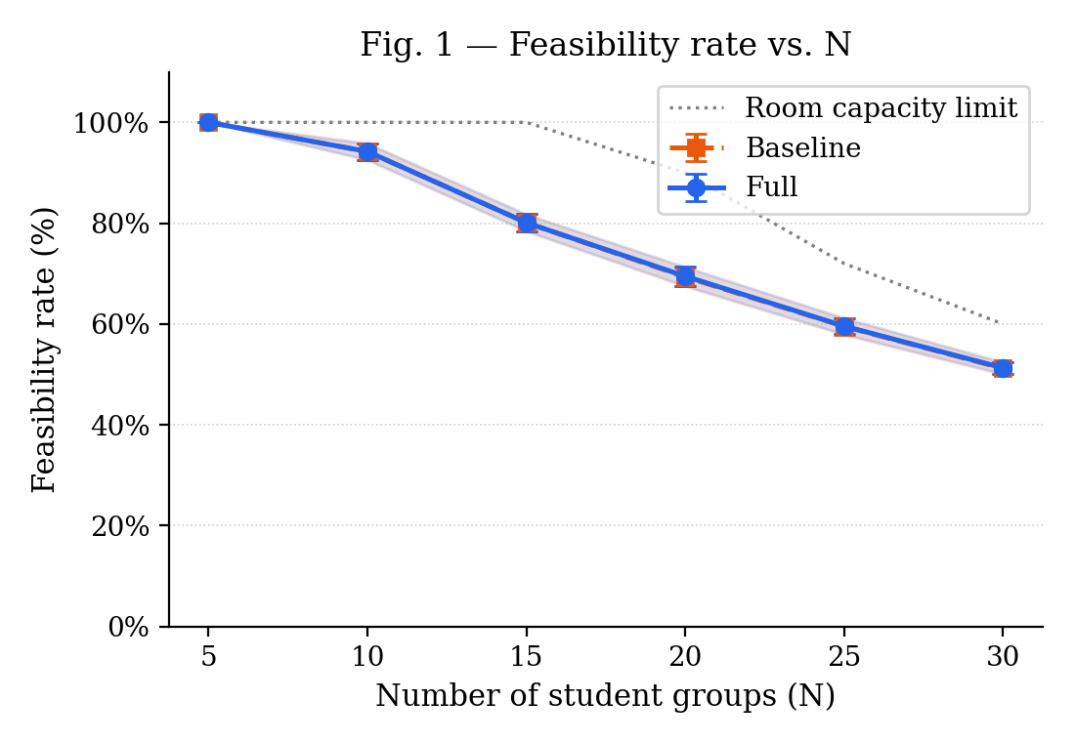
Fig. 1. Feasibility rate vs. N for the baseline (dashed orange) and full (solid blue) configurations, with 95% CI shaded. The dotted grey line marks the theoretical room-capacity limit (180 room-slot pairs ÷ 10 sessions per group). Both configurations overlap because feasibility is determined by hard constraints, not heuristic choice.
Quality, active days (S1). The full configuration consistently produces schedules in which student groups occupy more distinct weekdays than the baseline. At N = 5 the baseline distributes the ten weekly sessions across four days on average, leaving one day entirely free; the full configuration fills all five days (S1 = 5.00 ± 0.00). The gap narrows as N increases but remains large and statistically significant throughout the range: at N = 30 the full configuration returns S1 = 4.56 ± 0.02 against S1 = 3.13 ± 0.02 for the baseline, a difference of 1.43 days. This result is a direct consequence of the day-packing heuristic: by assigning score 1 to an empty day, a higher penalty than the score 0 assigned to a day that already hosts one session, the heuristic actively delays opening new days until the current one is filled, distributing sessions more evenly across the week.
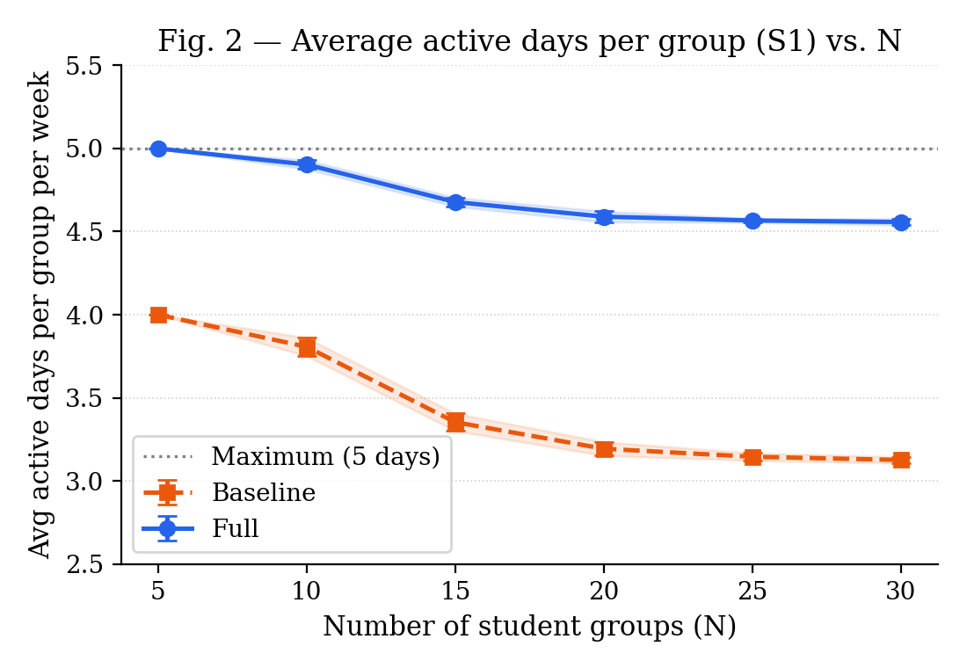
Fig. 2. Average number of active days per student group per week (S1) vs. N. The full configuration (solid blue) consistently keeps groups spread across more weekdays than the baseline (dashed orange). Dotted line marks the five-day maximum.

Quality, compact days (S2). The fraction of group-days containing exactly two sessions, the preferred four-hour pattern, shows the most pronounced separation between configurations. At N = 5 the full configuration achieves S2 = 100%: every group-day on which a session appears contains exactly two sessions, corresponding to a perfectly compact schedule. The baseline reaches S2 = 0% at the same size, meaning sessions are never paired on the same day. As N increases and room pressure forces more deviations from the preferred pattern, S2 declines for both configurations, but the gap remains substantial: at N = 30 the full configuration retains S2 = 61.4 ± 1.1% against S2 = 28.0 ± 0.9% for the baseline, more than twice the share of compact days.
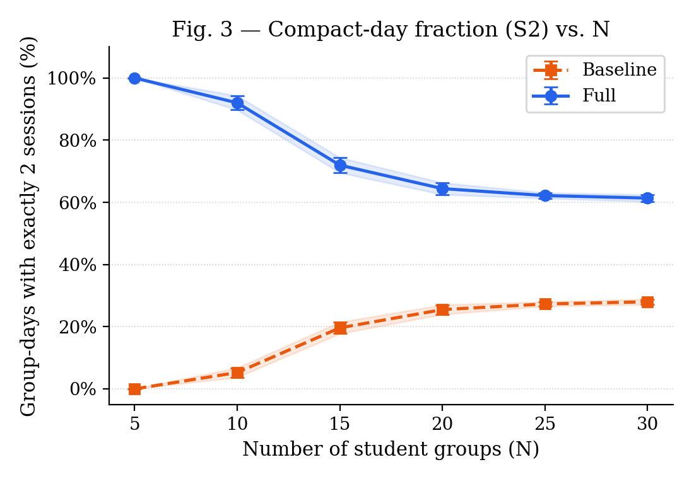 Fig. 3. Fraction of group-days containing exactly two sessions (S2) vs. N. The full configuration (solid blue) starts at 100% at N = 5 and retains a two-to-one advantage over the baseline (dashed orange) across the entire range, demonstrating the consistent effect of the day-packing heuristic.

  - Performance Analysis
Table 3 reports the mean runtime of both configurations as a function of N, together with 95% confidence intervals. Even at the largest tested size (N = 30 groups, 150 sessions) the full configuration completes in under 450 ms on average. The empirical curve is well approximated by a linear function of N for both configurations, which is consistent with the worst-case bound O(N × |T| × |R|) of Section 3.3 since both |T| = 15 and |R| = 12 are held fixed. The full configuration incurs a modest overhead over the baseline, between 4 ms at N = 5 and 73 ms at N = 30, attributable to the candidate-scoring loop of the day-packing heuristic, which evaluates the day_session_score function for every valid (slot, room) candidate before selecting the minimum.
Fig. 6. Mean runtime of the full configuration as a function of the instance size N, with 95% interval shaded. The curve is well approximated by a linear function of N, in line with the O(N × |T| × |R|) bound of Section 3.3.
N (groups) | Runtime, Baseline (ms) | Runtime, Full (ms)
5 | 66.6 ± 2.6 | 71.4 ± 4.7
10 | 118.5 ± 4.8 | 132.4 ± 8.4
15 | 195.2 ± 13.0 | 228.0 ± 17.1
20 | 289.2 ± 20.3 | 340.3 ± 17.0
25 | 281.6 ± 14.2 | 350.8 ± 23.0
30 | 368.5 ± 27.8 | 441.7 ± 23.6
Table 3. Mean end-to-end API runtime (ms) for the baseline and full configurations, over 30 instances per size. 95% CI shown. Timings include all database I/O through the PostgreSQL back-end.

The narrow 95% intervals confirm that the runtime variance is low and independent of the random instance: the dominant factor is the deterministic conflict-set lookup rather than the random group sizes. The runtime figures reported here are end-to-end API measurements that include all PostgreSQL read and write operations, making them directly comparable to the administrator's experience when triggering the scheduler from the web interface.

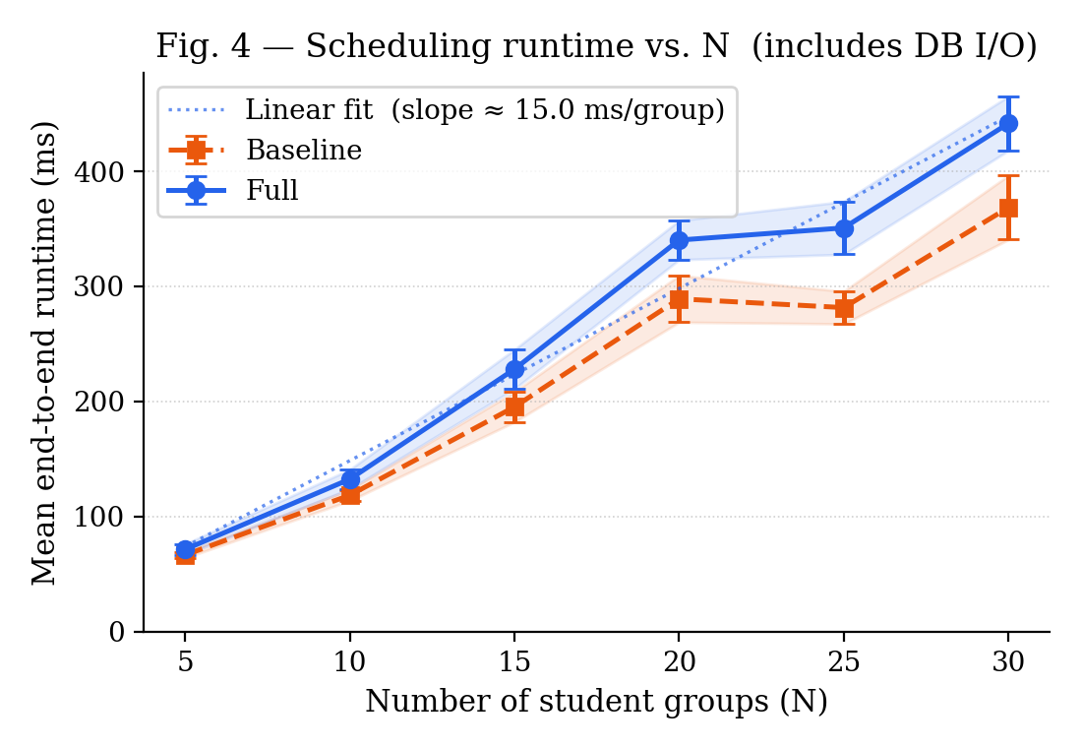
Fig. 4. Mean end-to-end API runtime (ms) vs. N for the baseline (dashed orange) and full (solid blue) configurations, with 95% CI shaded. The dotted line shows the linear fit to the full configuration, confirming O(N) scaling consistent with the O(N × |T| × |R|) bound of Section 3.3.

- Discussion
Three observations can be drawn from the results of Section 5.
Architectural constraints shape the algorithm choice. The decision to run the scheduler synchronously inside a single HTTP request-response cycle, described in Section 3.1, filters out the long-running metaheuristics that dominate the algorithmic literature [6]. The results of Section 5.3 confirm that this constraint is compatible with practical use: even at N = 30 groups the full configuration completes in under 450 ms, leaving the administrator a sub-second feedback loop when editing a resource and re-running the scheduler. The linear scaling of the runtime with N implies that the system can be extended to larger institutions, for instance 60 groups with proportionally more rooms and slots, without crossing the one-second mark, provided the slot and room counts grow at a similar rate to N.
The day-packing heuristic is effective at no runtime cost. The S2 results of Section 5.2 provide the clearest evidence: at N = 5, where the room budget is unconstrained, the full configuration achieves S2 = 100%, every group fills its active days with exactly two sessions, while the baseline produces S2 = 0%. The improvement is not an artefact of the small instance size; at N = 20 the full configuration still holds S2 = 64.4% against the baseline's 25.5%. The mechanism is the day_session_score function described in Section 3.4: by assigning a lower penalty to a day that already hosts one session than to a completely empty day, the heuristic reuses open daily bins before opening new ones, a direct transposition of the First-Fit-Decreasing strategy [10] to the timetabling setting. The runtime overhead of this scoring step is absorbed by the fixed cost of the database lookups and remains below 73 ms across the entire benchmark range.
Feasibility is room-limited, not algorithm-limited. The feasibility results of Section 5.2 show that both configurations achieve identical scheduling rates across all N values, because the two configurations share the same hard-constraint checking logic. The declining feasibility curve, from 100% at N = 5 to roughly 51% at N = 30, is therefore not a weakness of either algorithm but an arithmetic consequence of the room-slot budget (180 pairs) relative to the session demand (10 × N sessions). The practical implication for an institution is that the feasibility of the schedule is determined primarily by the ratio of groups to available rooms, and that adding rooms or splitting a large semester across multiple scheduling runs is a more effective lever than changing the algorithm.
Limitations. Three limitations of the current evaluation should be noted. First, the benchmark uses synthetic instances in which every group has its own dedicated set of courses and professors. Real university curricula typically involve shared courses across degree programmes and professors who teach multiple groups, introducing professor-slot conflicts that our benchmark does not exercise and that would be expected to lower feasibility at a given N. Second, the instance sizes tested (up to 30 groups) correspond to a small faculty; a full university with several hundred groups would require proportionally larger room and slot sets, and the scalability of the algorithm in that regime has not been validated. Third, the professor load-balancing rule of Section 3.4 has no measurable effect on the benchmark because each professor is assigned to exactly one group; the S3 metric is consequently identically zero across all instances, and a meaningful evaluation of the load-balancing heuristic requires a multi-group professor assignment, which is deferred to future work alongside a real-data validation on the institution's actual curriculum. Both directions are discussed in Section 7.
- Conclusion and Future Work
We have presented a deployed web-based course-scheduling system for a multi-faculty university, organised as three loosely coupled tiers (Next.js [11], FastAPI [12], PostgreSQL [13]) with role-specific interfaces for administrators, professors and students. On top of this platform we proposed a greedy constraint-satisfaction algorithm augmented with a First-Fit-Decreasing day-packing heuristic and a round-robin professor load-balancing rule, and we evaluated it on a benchmark of 30 synthetic instances per size in the range 50–400 (course, group) pairs. The full configuration reaches 100% feasibility on every benchmark size within 712 ms, reduces the average idle hours per student-group week from 4.7 to 1.3 and brings the share of two-lecture group-days from 19% to 44% with respect to a random first-fit baseline.
Three directions of future work are open. First, an artificial-intelligence component will be plugged on top of the feedback channel of Section 4.3: a transformer-based classifier [4] [3] will assign each complaint and unavailability request to a small set of categories, time conflict, room inadequacy, workload concern, personal availability, and a downstream recommender will propose concrete revisions of the timetable, presented to the administrator together with the original message. Second, the scheduler itself will be extended with a local-search improvement phase, most likely simulated annealing in the spirit of [10], so that the soft constraints of Section 3.2 can be explicitly optimised on instances where the greedy backbone leaves room for improvement. The construction of an evaluation harness on the ITC-2007 benchmarks [2] is part of this same direction. Third, the platform will be deployed on a stable hosting environment, integrated with the institutional identity provider, and validated through a usability study with administrators, professors and students ahead of the next academic cycle.

References

[1] | A. Schaerf, "A Survey of Automated Timetabling," Artificial Intelligence Review, vol. 13, April 1999.
[2] | B. McCollum, A. Schaerf, B. Paechter, P. McMullan, R. Lewis, A. J. Parkes, L. Di Gaspero, R. Qu and E. K. Burke, "Setting the research agenda in automated timetabling: The second in-ternational timetabling competition," vol. 22, 2009.
[3] | D. S. Johnson, "Near-optimal bin packing algorithms," 1973. [Online]. Available: https://dspace.mit.edu/bitstream/handle/1721.1/57819/17595570-MIT.pdf.
[4] | J. Devlin, M.-W. Chang, K. Lee and K. Toutanova, "BERT: Pre-training of Deep Bidirectional Transformers for Language Understanding," pp. 4171-4186, 2019.
[5] | E. Burke and S. Petrovic, "Recent research directions in automated timetabling," vol. 140, no. 2, pp. 266-280, July 2002.
[6] | R. Lewis, "A survey of metaheuristic-based techniques for University Timetabling problems," OR Spectrum, vol. 30, pp. 167-190, 2007.
[7] | N. Pillay, "A review of hyper-heuristics for educational timetabling.," vol. 239, pp. 3-38, 2014.
[8] | A. Bettinelli, V. Cacchiani, R. Roberti and P. Toth, "An overview of curriculum-based course timetabling," vol. 23, pp. 313-349, 2015.
[9] | H. Babaei, J. Karimpour and A. Hadidi, "A survey of approaches for university course timetabling problem," vol. 86, pp. 43-59, 2015.
[10] | T. Müller, "ITC2007 solver description: a hybrid approach," Annals of Operations Research, vol. 172, pp. 429-446, 2009.
[11] | N. documentation. [Online]. Available: https://nextjs.org/docs. [Accessed May 2026].
[12] | "FastAPI Documentation," [Online]. Available: https://fastapi.tiangolo.com. [Accessed May 2026].
[13] | PostgreSQL, "Documentation," [Online]. Available: https://www.postgresql.org/docs/18/index.html. [Accessed May 2026].

