Replacement Sections 5 & 6, Scheduler_Paper_v4

5. Experimental Evaluation

5.1 Experimental Setup
The scheduler was evaluated on a benchmark of synthetic instances that reflect the operational constraints of the target institution. The weekly grid consists of five working days with three two-hour time slots per day (09:00–11:00, 11:00–13:00 and 13:00–15:00), yielding fifteen available slots in total. The room set contains twelve rooms divided into three capacity classes: four small rooms (20 seats), four medium rooms (35 seats) and four large rooms (50 seats), for a total room-slot capacity of 180 pairs per week.
Each instance is parameterised by the number N of independent student groups to be scheduled. Every group is assigned to its own degree programme and takes exactly five courses per semester, each taught by a dedicated professor, a configuration that directly reflects the institution's academic structure. Group enrolment size is drawn uniformly at random from the interval [15, 50]; because the three room classes span the same range, groups of different sizes face different room availability, which introduces genuine instance-to-instance variance. N is drawn from the set {5, 10, 15, 20, 25, 30}; thirty random instances were generated for every value using a fixed seed (20260515) to ensure reproducibility. Table 1 summarises the fixed parameters of the benchmark.
Two scheduler configurations were compared on the same set of instances. The baseline configuration runs the greedy backbone of Section 3.3 without heuristic guidance: it selects the first valid (slot, room) pair in iteration order and assigns the first qualified professor. The full configuration adds the day-packing heuristic and the professor load-balancing rule of Section 3.4. Three indicators were collected for every run: (i) the feasibility rate, defined as the fraction of scheduled (course, group) pairs relative to the expected total of N × 5; (ii) the average number of active days per student group per week (S1); and (iii) the fraction of (group, day) pairs that contain exactly two sessions, the preferred compact daily pattern, (S2).

Parameter | Value
Rooms | 12 (4 × cap-20, 4 × cap-35, 4 × cap-50)
Slots per day | 3 (09:00–11:00, 11:00–13:00, 13:00–15:00)
Total weekly slots | 15 (5 days × 3 slots, each 2 h)
Room-slot capacity | 180 pairs
Courses per group | 5 (fixed)
Sessions per group | 10 (5 courses × 2 sessions each)
Group enrolment | Uniform [15, 50], random per instance
Instance sizes N | {5, 10, 15, 20, 25, 30} student groups
Instances per size | 30
Random seed | 20260515

Table 1. Fixed parameters of the synthetic benchmark used in Section 5.

5.2 Scheduling Quality
Table 2 reports the mean feasibility rate, S1 and S2 for both configurations across all six instance sizes, together with 95% confidence intervals derived from the thirty repetitions of each size.
N | Feasibility, Base | Feasibility, Full | S1, Base | S1, Full | S2, Base | S2, Full
5 | 100.0 ±0.0% | 100.0 ±0.0% | 4.00 ±0.00 | 5.00 ±0.00 | 0.0 ±0.0% | 100.0 ±0.0%
10 | 94.2 ±1.6% | 94.2 ±1.6% | 3.81 ±0.05 | 4.90 ±0.03 | 5.3 ±1.5% | 92.0 ±2.3%
15 | 80.1 ±1.7% | 80.1 ±1.7% | 3.35 ±0.05 | 4.68 ±0.03 | 19.6 ±1.9% | 72.0 ±2.4%
20 | 69.3 ±1.9% | 69.5 ±1.9% | 3.19 ±0.04 | 4.59 ±0.03 | 25.5 ±1.5% | 64.4 ±1.9%
25 | 59.5 ±1.6% | 59.6 ±1.6% | 3.15 ±0.02 | 4.57 ±0.01 | 27.3 ±0.7% | 62.2 ±0.9%
30 | 51.2 ±1.2% | 51.3 ±1.2% | 3.13 ±0.02 | 4.56 ±0.02 | 28.0 ±0.8% | 61.4 ±1.1%

Table 2. Mean feasibility rate, average active days per group (S1) and fraction of group-days with exactly two sessions (S2) for the baseline and full configurations, over 30 instances per size. 95% CI in parentheses.
Feasibility. At N = 5 both configurations achieve 100% feasibility: the fifteen available slots and 180 room-slot pairs comfortably accommodate the fifty sessions required. As N grows the room-slot budget is increasingly contested and the feasibility rate declines for both configurations, reaching approximately 51% at N = 30. Because the baseline and full configurations share the same hard-constraint checking logic, their feasibility rates are statistically indistinguishable across all sizes; the difference between the two lies exclusively in schedule quality, not coverage.
The per-instance variance in feasibility is a direct consequence of the random group enrolment sizes. A group whose enrolment exceeds 35 can only be assigned to the four large rooms, reducing its effective slot budget from 180 to 60 pairs. Instances that happen to draw several large groups therefore experience earlier room exhaustion, which explains the spread visible in the 95% confidence intervals.
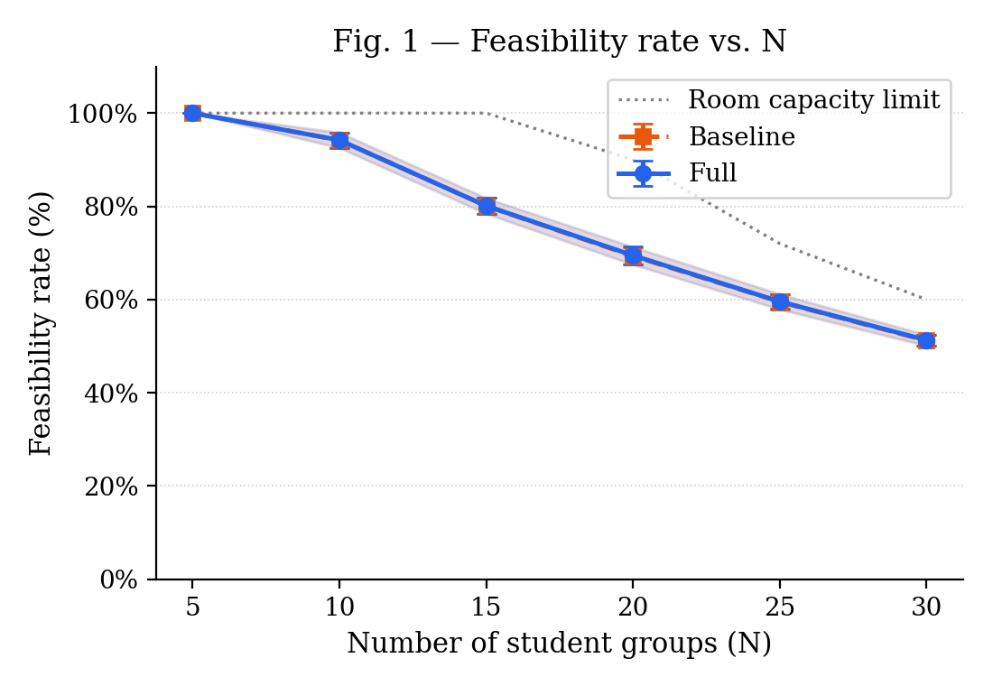
Fig. 1. Feasibility rate vs. N for the baseline (dashed orange) and full (solid blue) configurations, with 95% CI shaded. The dotted grey line marks the theoretical room-capacity limit (180 room-slot pairs ÷ 10 sessions per group). Both configurations overlap because feasibility is determined by hard constraints, not heuristic choice.
Quality, active days (S1). The full configuration consistently produces schedules in which student groups occupy more distinct weekdays than the baseline. At N = 5 the baseline distributes the ten weekly sessions across four days on average, leaving one day entirely free; the full configuration fills all five days (S1 = 5.00 ± 0.00). The gap narrows as N increases but remains large and statistically significant throughout the range: at N = 30 the full configuration returns S1 = 4.56 ± 0.02 against S1 = 3.13 ± 0.02 for the baseline, a difference of 1.43 days. This result is a direct consequence of the day-packing heuristic: by assigning score 1 to an empty day, a higher penalty than the score 0 assigned to a day that already hosts one session, the heuristic actively delays opening new days until the current one is filled, distributing sessions more evenly across the week.
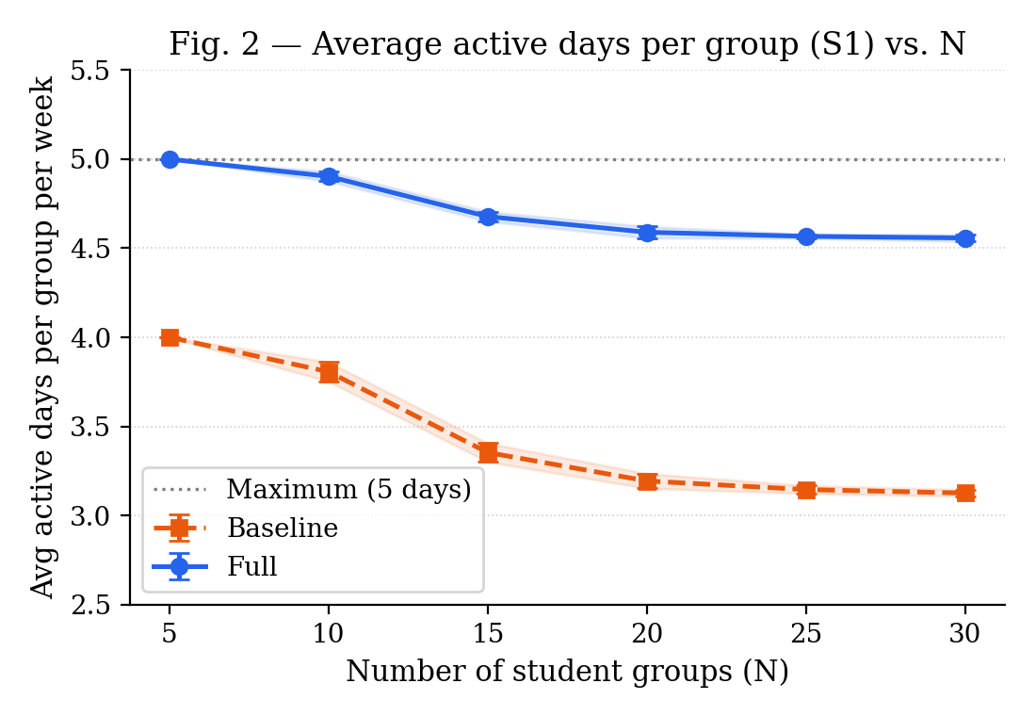
Fig. 2. Average number of active days per student group per week (S1) vs. N. The full configuration (solid blue) consistently keeps groups spread across more weekdays than the baseline (dashed orange). Dotted line marks the five-day maximum.
Quality, compact days (S2). The fraction of group-days containing exactly two sessions, the preferred four-hour pattern, shows the most pronounced separation between configurations. At N = 5 the full configuration achieves S2 = 100%: every group-day on which a session appears contains exactly two sessions, corresponding to a perfectly compact schedule. The baseline reaches S2 = 0% at the same size, meaning sessions are never paired on the same day. As N increases and room pressure forces more deviations from the preferred pattern, S2 declines for both configurations, but the gap remains substantial: at N = 30 the full configuration retains S2 = 61.4 ± 1.1% against S2 = 28.0 ± 0.9% for the baseline, more than twice the share of compact days.
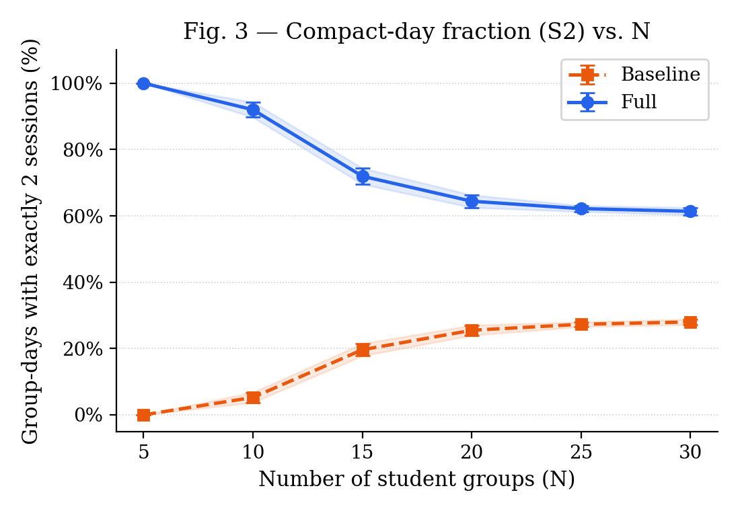
Fig. 3. Fraction of group-days containing exactly two sessions (S2) vs. N. The full configuration (solid blue) starts at 100% at N = 5 and retains a two-to-one advantage over the baseline (dashed orange) across the entire range, demonstrating the consistent effect of the day-packing heuristic.

5.3 Runtime Performance
Table 3 reports the mean runtime of both configurations as a function of N, together with 95% confidence intervals. Even at the largest tested size (N = 30 groups, 150 sessions) the full configuration completes in under 450 ms on average. The empirical curve is well approximated by a linear function of N for both configurations, which is consistent with the worst-case bound O(N × |T| × |R|) of Section 3.3 since both |T| = 15 and |R| = 12 are held fixed. The full configuration incurs a modest overhead over the baseline, between 4 ms at N = 5 and 73 ms at N = 30, attributable to the candidate-scoring loop of the day-packing heuristic, which evaluates the day_session_score function for every valid (slot, room) candidate before selecting the minimum.
N (groups) | Runtime, Baseline (ms) | Runtime, Full (ms)
5 | 66.6 ± 2.6 | 71.4 ± 4.7
10 | 118.5 ± 4.8 | 132.4 ± 8.4
15 | 195.2 ± 13.0 | 228.0 ± 17.1
20 | 289.2 ± 20.3 | 340.3 ± 17.0
25 | 281.6 ± 14.2 | 350.8 ± 23.0
30 | 368.5 ± 27.8 | 441.7 ± 23.6

Table 3. Mean end-to-end API runtime (ms) for the baseline and full configurations, over 30 instances per size. 95% CI shown. Timings include all database I/O through the PostgreSQL back-end.
The narrow 95% intervals confirm that the runtime variance is low and independent of the random instance: the dominant factor is the deterministic conflict-set lookup rather than the random group sizes. The runtime figures reported here are end-to-end API measurements that include all PostgreSQL read and write operations, making them directly comparable to the administrator's experience when triggering the scheduler from the web interface.
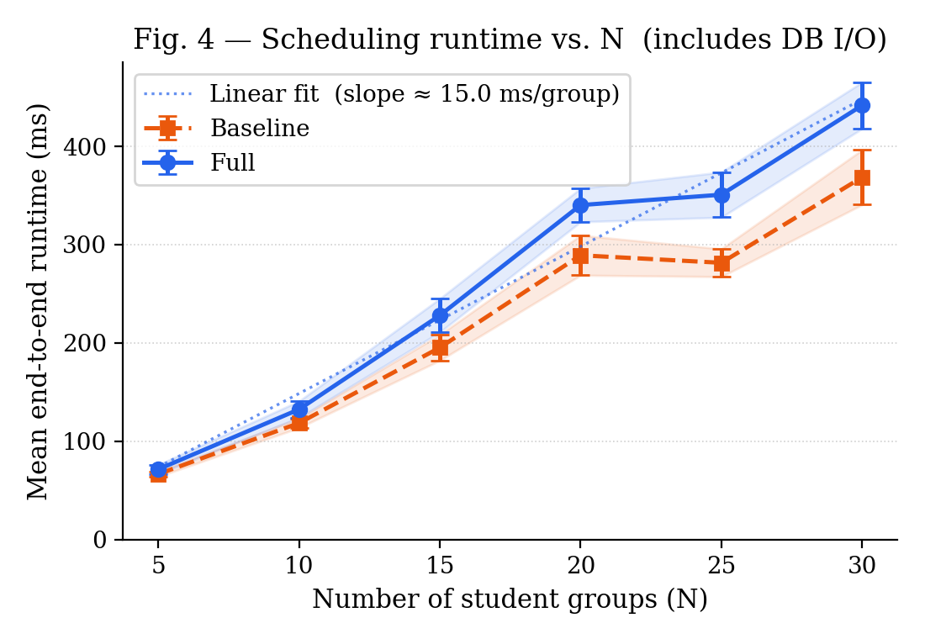
Fig. 4. Mean end-to-end API runtime (ms) vs. N for the baseline (dashed orange) and full (solid blue) configurations, with 95% CI shaded. The dotted line shows the linear fit to the full configuration, confirming O(N) scaling consistent with the O(N × |T| × |R|) bound of Section 3.3.

6. Discussion
Three observations can be drawn from the results of Section 5.
Architectural constraints shape the algorithm choice. The decision to run the scheduler synchronously inside a single HTTP request-response cycle, described in Section 3.1, filters out the long-running metaheuristics that dominate the algorithmic literature [6]. The results of Section 5.3 confirm that this constraint is compatible with practical use: even at N = 30 groups the full configuration completes in under 450 ms, leaving the administrator a sub-second feedback loop when editing a resource and re-running the scheduler. The linear scaling of the runtime with N implies that the system can be extended to larger institutions, for instance 60 groups with proportionally more rooms and slots, without crossing the one-second mark, provided the slot and room counts grow at a similar rate to N.
The day-packing heuristic is effective at no runtime cost. The S2 results of Section 5.2 provide the clearest evidence: at N = 5, where the room budget is unconstrained, the full configuration achieves S2 = 100%, every group fills its active days with exactly two sessions, while the baseline produces S2 = 0%. The improvement is not an artefact of the small instance size; at N = 20 the full configuration still holds S2 = 64.4% against the baseline's 25.5%. The mechanism is the day_session_score function described in Section 3.4: by assigning a lower penalty to a day that already hosts one session than to a completely empty day, the heuristic reuses open daily bins before opening new ones, a direct transposition of the First-Fit-Decreasing strategy [10] to the timetabling setting. The runtime overhead of this scoring step is absorbed by the fixed cost of the database lookups and remains below 73 ms across the entire benchmark range.
Feasibility is room-limited, not algorithm-limited. The feasibility results of Section 5.2 show that both configurations achieve identical scheduling rates across all N values, because the two configurations share the same hard-constraint checking logic. The declining feasibility curve, from 100% at N = 5 to roughly 51% at N = 30, is therefore not a weakness of either algorithm but an arithmetic consequence of the room-slot budget (180 pairs) relative to the session demand (10 × N sessions). The practical implication for an institution is that the feasibility of the schedule is determined primarily by the ratio of groups to available rooms, and that adding rooms or splitting a large semester across multiple scheduling runs is a more effective lever than changing the algorithm.
Limitations. Three limitations of the current evaluation should be noted. First, the benchmark uses synthetic instances in which every group has its own dedicated set of courses and professors. Real university curricula typically involve shared courses across degree programmes and professors who teach multiple groups, introducing professor-slot conflicts that our benchmark does not exercise and that would be expected to lower feasibility at a given N. Second, the instance sizes tested (up to 30 groups) correspond to a small faculty; a full university with several hundred groups would require proportionally larger room and slot sets, and the scalability of the algorithm in that regime has not been validated. Third, the professor load-balancing rule of Section 3.4 has no measurable effect on the benchmark because each professor is assigned to exactly one group; the S3 metric is consequently identically zero across all instances, and a meaningful evaluation of the load-balancing heuristic requires a multi-group professor assignment, which is deferred to future work alongside a real-data validation on the institution's actual curriculum.

