AA4.1 – Explain how a website is properly tested 7 marks Validate your work - https://validator.w3.org/ 2 marks 2 correct test cases performed and documented. Below is a sample test case you can follow.

Case 1: About US page 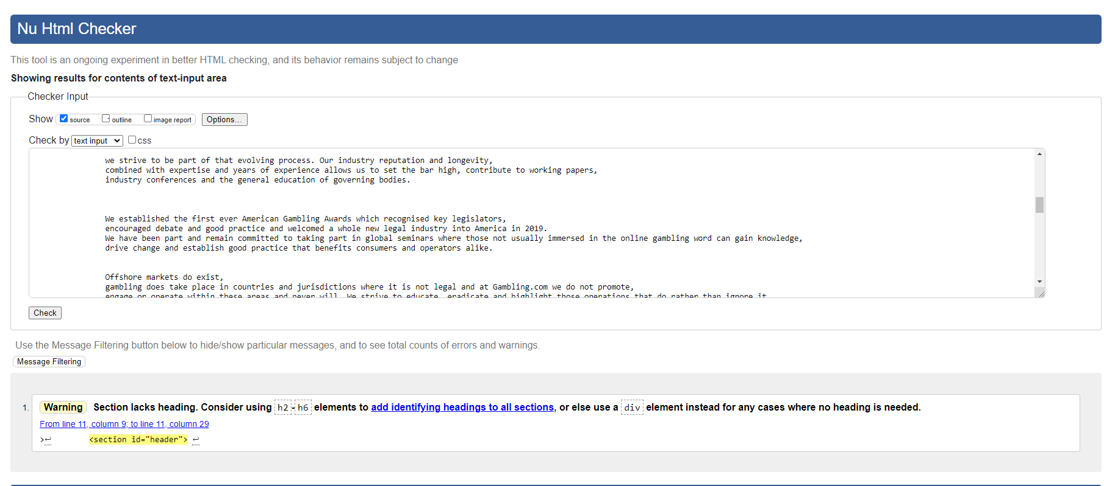

Case 2: Contact us Page

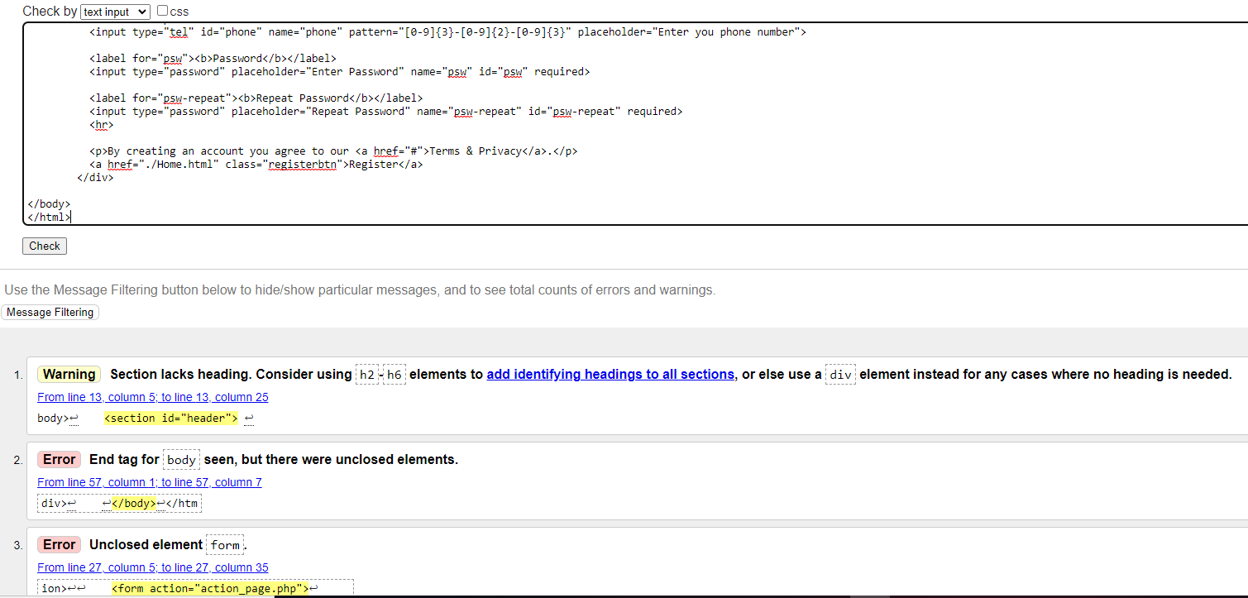

**SE4.4 – Assess how the usability of the website can be improved**  10 marks

Critical reflection: a critical reflection is that it needs a better implementation stage like tuning, making the text fade down or up.

Future work: in the future I want to fix the Home Page by creating more games, more animations on the buttons, and titles.

Improvements: some improvements that need to be made are making the carousel work, the phone and tablet resolution needs to be fixed.