Sorting Algorithms

Insertion Sort

Insertion sort is an algorithm that takes an element and compares it with the previous elements in the array, if the previous element is greater than the current element it gets shifted back and then it is compared against the previous again until the previous is less that the current element, then the current element gets inserted into that position. To achieve this you will need a pointer to keep track of the position being checked and a variable to store the current value to check. This algorithm has a O(n²) complexity in the worst case scenario.

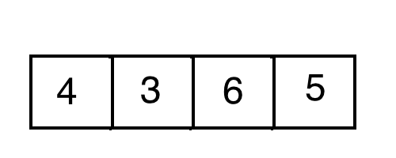

Insertion Sort Pseudo Code

- Get the current element to be checked.
- Get the position of that element. Initially it will be the second position of the array.
- Check the previous position to see if it is greater or less than the current element.
- If it is greater move the previous element to the current position and then decrease the position by one. Do the next iteration.
- If it is less than the current element, insert the current element into the current position and exit the loop
- If the current position is zero the insert the current element anyway because there is nowhere else to go.
- Repeat with each element of the array until you reach the end of it.

Quick Sort

Quick sort is an algorithm that takes one element of the array (pivot) and then sorts the rest of the elements relative to that pivot into 2 different arrays: the left array gets all the elements that are less than the pivot. The right array gets all the elements that are greater than the pivot.
You repeat this process until you have one element arrays and the form a new array [left, pivot, right].
In the worst case scenario it has a O(n²) time complexity. The pivot is usually selected from the last element or the first element of the array.

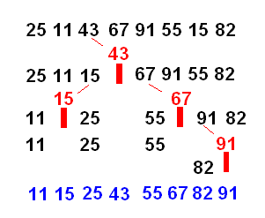

Quick Sort Pseudo Code

The quick sort algorithm is perfect to use recursion on

- Select the pivot element either from the start or the end of the array.
- Create the left array with the elements that are less than the pivot.
- Create the right array with the elements that are greater than the pivot.
- Recursion: Repeat the process with the left and right arrays.
- Base Case: If the array has one or no elements return the array.
- Create a new array with left pivot, right and return it.

