JAVASCRIPT DOM

The DOM is a representation of the web-page that can be manipulated with JavaScript. It is a tree like representation where you have nodes and they are related to each other depending on how deep they are in the tree and where they come from.

This representation can be seen as parent-children representation where an HTML element can have a parent, meaning the element that contains it, can also have siblings, all the other elements that are contained by the same element, and can have children, all the objects it contains.
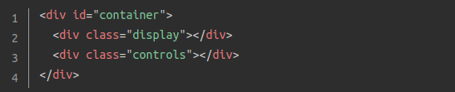

In the example above we can get all the type of relations previously described. The “container” div is the parent for both the “display” div and the “controls” div, meaning that both of those divs are children of the “container” div, and the “display” and “controls” divs are siblings to each other because they have the same parent.

Having this in mind you can use JavaScript selectors, that refer to this relationship (like firstElementChild or previousElementSibling), to point directly at a specific element and then change its attributes and contents. You can also use tags, classes and ids to select the item or items you want to manipulate (Like getElementById, getElementsByTagName or getElementByClassName).

Methods

When a browser gets your HTML code it is converted into the DOM with the nodes previously described, and each node turns into an object that has many properties and methods inside it, these are the ones that we are going to use with JavaScript to make anything that we want.

Query Selector

The query selector is used to get one or more specific objects that meet a certain selector. It has mainly two methods: element.querySelector(selector) that returns the first element that matches that selector and the element.querySelectorAll(selectors) that returns a list of all the elements that match the selectors, this doesn’t return an array, so if that is what you need, you can use the Array.from() method or the spread operator to do that.
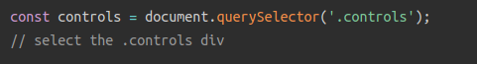
This gets the first element on the page with the class of controls

This gets the element in the page with the id of container

Create Elements

The document.createElement(‘element’) method is used to layout an element that you want to put into the page, so you can set its properties (styles, classes, id) and contents, but it doesn’t actually puts it into the page, to do that you need another method that we will see ahead.
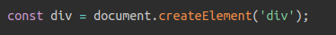
Insert and Remove Elements

These methods are the ones that actually put the element created before inside the page. To do that first you have to have a parent node selected so it can be inserted as a child of that node:
- parentNode.appendChild(childnode): The child node inserted as the last child of the parent.
- parentNode.insertBefore(newchildnode, referencechildnode): The newchildnode gets inserted before the reference child node inside that parent, for this you will need to select that child node as well.

There are some methods or ways that will help inserting elements in a different way.
- parentNode.append(childnode 1,……., childnode N): This will let you append several children at once to the same parent.
- parentNode.insertBefore(newchildnode, referencechildnode.nextSibling): Since there is no method to insert an element after another element, this way you can achieve that.

To remove elements from the web-page you can use the parentnode.removeChild(childnode) method, but you have to select both the parent and the child before hand.

Editing elements properties

After you created an element or even after selecting an existing element form the web-page, you can edit any of the properties that it has by accessing them like it was an object. While CSS uses kebab case for its property names, JavaScript uses camel case for everything. To add an inline style, I can be done in several ways. Using the element.style.propertyName access that specific property and you can assign a value. You use a method called .setAttribute(attribute, value) to do it as well, this one is really useful to set ids and classes on elements.

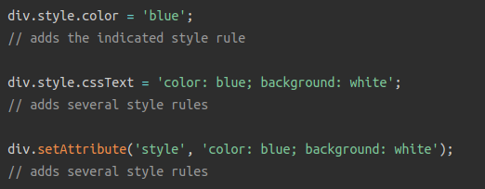
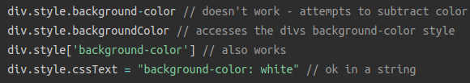
You can get attributes the same way that setting them by using the class notation with the dot, but you can also use the getAttribute(attribute) method to get the value of a certain attribute or use the removeAttibute(attribute) method to remove one completely.

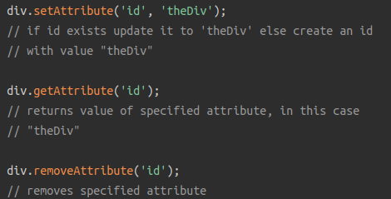
There are some classes that can be used with elements, the most useful one is the classList because of the methods that comes in it. You can add classes with the .add(classname) method, you can delete a particular class with the .remove(classname) method and the most useful one is the .toggle(classname) method because it adds the class if the element doesn’t have it and removes it if it does, this is useful to hide elements in your web-page.

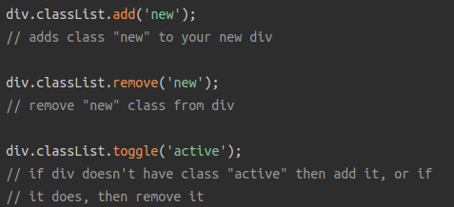

Text or inner contents can also be added to the selected element using the .textContent property to edit just the text inside it or you can actually fill the inside with HTML code by using the property .innerHTML

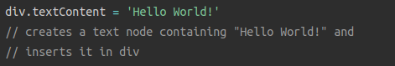
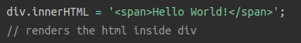

Events

You can also can add events to the web-page so a function is called when they happen (callback function). The most common element to have a event attached to it are the buttons. There are three ways to declare an event on a button:
- Directly on the element as an attribute: there you use the event that will trigger the callback as an attribute on the element itself, the onclick=”callbackfunction” will associate the click event for that button with the provided callback function or action.
- With the .eventName property: for using this you have to give it a class or an id so you can select it accurately and then call the property on the selected element to assign the callback. element.onclick = callbackfunction.
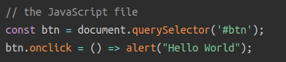

- With .addEventListener property: In this you have to say the name of the event and the name of the callback to use. element.addEventListener(event, callbackfunction).
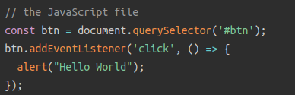
The callback can be a single line instruction that you can put in there like giving an alert, you can used declared functions in your code and just put their name in the callback argument or you can use what is called anonymous functions that are blocks of code that don’t have a name and only live there as the callback for that event triggered by that element, these are declared by function(arguments) => { instructions }. If you give the callback function or the anonymous function just a single argument it is going to get all the information from the event, including the element that triggered the event and all its attributes, this element is stored in the object target form the event object that is passed. The event object still has a lot more information like type of event, states from system variables and more.

