JAVASCRIPT

Basics

Array

An array is a compilation of values inside the same name, each value can be identified by an index, that indicates its position inside the array. JS is, like most of the programming languages, zero base index which means that the first element of the array is at index 0 and the last element is at position length–1.

JS has something particular and that is that every element of the array can be different data types, this allows to construct objects and basic structures for data storage.

To declare an array you just have to use the square brackets ([ ]) and separate each element by a coma.
let myarray= [1,’a’, false, 500];

To reference a single item of the array the only thing needed is the name of the array and the index inside the square brackets.
Myarray[1]; will return ‘a’

There are several methods to manipulate an array and what it stores inside:
- push(element): Inserts the element passed as an argument in the end of the array, incrementing its length by one.
Myarray.push(1)
- unshift(element): Inserts the element passed as an argument at the beginning of the array, and it also increments the length by one.
Myarray.unshift(‘b’)
- Pop(): Takes out one element from the end of the array. You can capture the popped element by making a variable assignment to the instruction where the pop is called.
Myarray.pop()
- Shift(): Takes out one element from the beginning of the array. It has the same properties as pop.
Myarray.shift()
- Splice(start_index, #_elements): This method is used to eliminate more than one item at the time from any position in the array. It asks for a start index, from where it is going to begin eliminating items, and a number of items to be eliminated. It returns an array with the removed items and modifies the original array. It can take a “third” parameter that is really a collection of items (separated by comas like any other parameter) to be replaced or inserted after the other ones are deleted.
Myarray.splice(2,3)
myarray.splice(2,2,14,’c’,’done’)
- slice(start_index, end_index): It copies a segment of the array into a new array. It takes 2 parameters, and index where it is going to start copying and an end index where it is going to stop but doesn’t includes the element at that index.
Myarray.slice(2,5)
- spread operator (…): The spread operator allows you to take all the elements of one array an insert them into another array anywhere you decide.
Otherarray = [1, 2, 3, ...myarray, 4, ’z’]
- indexOf(element): This method gets the index of the element passed as a parameter if it is inside the array, if the element is not in the array it returns -1.
myarray.indexOf(‘x’)

Objects

You can create objects in a similar way that arrays are created, but instead of using the square brackets you use the curly brackets ({ }) for it. The objects have the ability of storing keys (like fixed variable names) and values (the actual value of a key). There are two ways to access these values stored in an object: The first one is the dot notation, where you just call the object name dot the key name. This is the most recognized notation from other languages but since the key name can be anything in JS the most recommended notation is the bracket notation to access any value you want, in this you treat the key name as an index in an array putting it inside square brackets.
DOT notation BRACKET notation
myobject.name; myobject[name]; Both get the value of the name key

You can add additional properties (keys) to the object by just calling it with either notation and assigning it a value.
myobject.country= “Colombia” myobject[country]= “Colombia” Creates a country key inside myobject

As with arrays objects can store anything inside them, and is very common to store other objects inside. To access those objects and their properties you need to nest the notations in order to get to the depth level you actually want.

You can remove properties form an object pretty easy by using the delete and calling the property after it.
delete myobject.name; deletes that key and its value from myobject

To check if an object has a specific key inside them you can do it with either the .hasOwnProperty method or with the in keyword and they will return true or false depending on if it has it or not.
myobject.hasOwnProperty(‘country’); ‘country’ in myobject;

To itarate through an object you can use a for loop special for this, it is called a for ... in statement that works pretty similar to the .each method in Ruby.
for(let k in myobject) gets all the keys one by one and puts them in the k variable

You can also get all the keys from an object and put them into an array with the .keys() method, this will return an array with string representing the name of each property. When using this to check an object it is mandatory to use the bracket notation when referring to a key from the array.

Constructor functions

Constructors are functions made to create new objects, in them you can set their properties names, values and behaviors for that object, they are like a blueprint for the object. Constructors are defined with a capital letter to distinguish them from other functions and they use the keyword this inside them to set the properties of the object. They don’t return any values, they just set the object so it can be used.

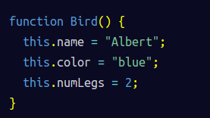
To create objects from constructors you have to use the keyword new to make an instance of the object, if this keyword is not used then the code could have inexplicable bugs that are really difficult to trace because the “this” keyword is not pointing at what it should. But using it will transfer all the properties in the constructor to the instance name and will work fine, and like with any object its properties can be changed.
Constructors can also receive parameters so you can set the variables with the information you need when the instance is created.
You can also verify which constructor does your instance belongs to with the keyword instanceof, it will return true if the instance name provided was actually created with the constructor name provided.

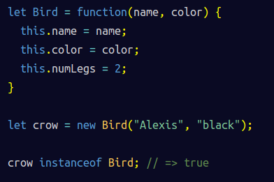
The hasOwnProperty method will let you know if an instance has a certain property. You can even get an array of the properties by doing something like this.

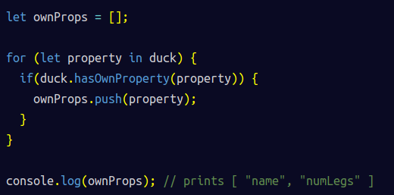
Everytime you make an instance you will copy all the properties specified in the constructor and assign them to a new variable, this wastes a lot of space if one of the properties is the same for all the instances, like number of legs in the example. To avoid this we will use the prototype for the object instead of using the constructor. The properties inside the prototype will be shared among all instances. To add something to the prototype just use the .prototype.property_name from the constructor name.



With this all instances from bird will have access to the property numLegs from the prototype as if it was their own but they are actually prototype properties and they will be different when you use the method hasOwnProperty like we did before.

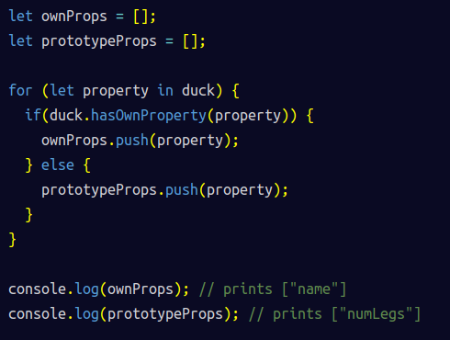
You can add several properties at once by setting the prototype property as an object that contains all the methods and properties needed.
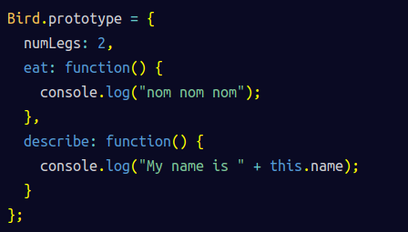
By doing this there is a side effect, the constructor property gets deleted, so you have to include it inside your block.
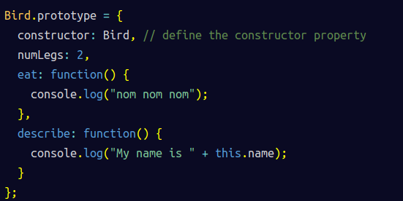

Loops

for loop

The for loop is really useful to iterate a limited number of times, and it is almost always used to check each element of an array. The general syntax is:
for(let counter_var; stop_condition; increment of counter_var)
{
Instructions;
}

But the most common syntax is the one for the arrays that is the following
for(let i=0; i<myarray.length; i++)
{
Instructions
}

There are similar methods that can be used in arrays like .every(), .forEach() or .map(), but the most popular and flexible way to iterate through an array is with a for loop.

Debugging

The most useful way to debug is to print variables to the console in different stages of your code. For this you can use the console.log(anything_is_needed) method to print whatever you might need into the browser console. The console for chrome is located in the same developer tools that are used to view the HTML code and properties, the console is located in one of the tabs for those developer tools.

If you want to clear the contents of the console before or after something is executed you can do it with console.clear().

Another interesting tool is the typeof keyword, this will let you know what datatype is the variable you are inspecting. This is very useful when you are doing mathematical operations on different variables and the result is not what you expected, the reason might be that one of the variables is a different type like a string and that is causing the problem. The recognized data types for JavaScript are: Boolean, Null, Undefined, Number, String, Symbol and Object. Technically arrays are part of the Object type.

Variables

You can declare variables using two key words: Var is less used because it can overwrite another variable with the same name without you even knowing about it, this is extremely dangerous in large code bases where you don’t have access to all the code or simply don’t know it all. Let was introduced in ES6 to attempt to fix this dangerous behavior of var and prevent the introduction of very hard to detect bugs in a large code base, when you attempt to declare a variable with the same name it will throw an error in the console, and goes as far that when using strict mode with use strict; it throws an error when a variable is not declared with a keyword.
There is also the keyword const that is meant to be used to declared read only variables, meaning their value will never be reassigned, even when you attempt to change it will throw an error. If you are using constants in you code is a good practice to name then in all caps and words separated by an underscore so you know it is a constant. But declaring objects, like arrays and functions, can still be changed by reassigning the values individually. To prevent this from happening you have to use the Object.freeze(object) method, this way your object’s contents won’t be able to change ever but if you try to change one value it won’t rise an error, the changes will be discarted.

Function declaration

anonymous functions

Some functions can be nameless in javascript if you are not reusing them after. To do this you have two options for declaration.
const myFunct = function(arg1,….,argn) { instructions }
const myFunct = (arg1,….,argn) => { instructions } (ES6 declaration)

Setters and Getters functions in classes

These methods are made to access the value (getter) or change the value (setter) of a object variable with the regular object notation form other languages. To declare one of this type of methods you have to use the get or set keywords before declaring the function. It is best practice to start the mane of an object variable with an underscore, but doing it doesn’t mean that JavaScript knows that it is a object variable.

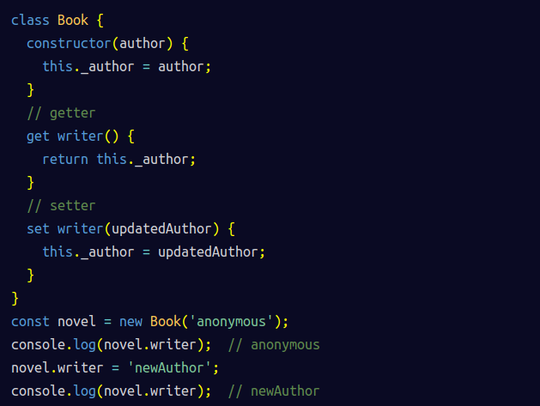

Destructuring

It is an easy way to extract the values form an object into individual variables by just naming them as the keys inside the object. Assuming we have an object user declared const user = { id: 1, name: “John”, age: 34 };, the instruction const {name, age} = user; will get the values from the name and age keys only, ignoring the information in the id key, and store them in the name and age variables. If you want to use a different variable name to the one in the key you have to map it with a colon like this const { name: userName, age: userAge } = user;

To apply destructuring to a nested object you need to specify the object that you want to target, so if we change the user object to:
const user = {
johnDoe: {
age: 34,
email: ‘mail@mail.com’
}
};
Then to destructure it you will need to say which object you are selecting like this: const {johnDoe: {age, email}} = user; this way you will get the email and age stored only in the johnDoe object inside the user object. The same rules as before apply if you want to get the values into a different named variables.

You can also use destructuring in arrays by assigning values starting form the first element in the array and moving from there, and if you want to skip one of the values you can just put a coma and no variable name to not take it like this:
const [a, b] = [1, 2, 3, 4, 5]; gets a = 1 and b = 2
const [a, b,,,c] = [1, 2, 3, 4, 5]; gets a = 1, b = 2 and c = 5

On top of what we have seen with destructuring you can get the rest of the elements of an array using the spread operator, getting something similar to the slice function, using this syntax:
const [a, b, ...myarr] = [1, 2, 3, 4, 5];

String interpolation

You can use this property thanks to ES6 to dynamic strings in a very easy way, the interpolation happens wherever a ${variable} is encountered in a string and the variable there is replaced by it value in the final string. But in order to tell javascript that the string will contain an interpolation you have to use backticks `` ,instead of single or double quotes, and using this you can also make the string multi line without any special characters, just by making an actual new line in the string.

Modules

Classes

