GIT

Introduction

Git is a version control software that lets you track the progress of a project by keeping track of all the changes made to it. It’s widely used in the industry to manage projects in conjunction with cloud repository systems like git-hub, git-lab or bit-bucket so you can access your code anywhere.

Git uses a command line to do its operations. On Linux systems the command line is the same as the terminal and just using the “git” instruction is enough. On Windows there are several way to access git, the first one is the git bash program that is installed by the manager when get git. The second is either through the cmd (command prompt) or the windows terminal (from the windows store). The windows terminal and the git bash use “Linux like” commands (pwd, cd, clear,….) and the cmd uses its own set of commands, so it is recommended to use either the terminal or the git bash when in Windows.

Inner works

Git uses a local file called repository to keep track of the changes made to the project and each project folder has its own git. You can select which files will be tracked by using a .gitignore file, this file is a hidden file so if you want to edit it you will have to set you viewing settings for the folders to “show all”.
The local flow of git can be represented by the following figure:
Working
Directory
Staging
Area
Local
Repository
Git add
Git commit
Git checkout

Working with a remote repository

In git-hub or any other provider you can create remote repositories that will be stored in the cloud. You can move a local repository to the cloud or you can create it in the cloud service and then download (clone) it to your local drive so you can work on it. In git-hub when you create a new repository it will show you the git commands on how to clone it and work with it (basics) and you can create the README.md and other files form there.
When working with git-hub the flow looks different because you have an additional repository to consider. In the following figure you can see how it is.

Local
Repository
(.git file)

Master
- Commit #1
- Commit #2
- Commit #3
Git push
Git pull
Remote
Repository
(git-hub)

Master
- Commit #1
- Commit #2
- Commit #3

Git ignore file

The .gitignore file is a file that contains the names and extensions of the files you don’t want to be added to the repository. You can have specific file names in there to exclude them in an individual basis or you can have wildcards to group several files in one line. The git ignore file has to be in the root of the project along with the README.md.
$> touch .gitignore// This command creates the file in the current folder
After it is created you can open it and put the names of the files or folders you want to ignore. To use the wild card you just put it to replace the general name, e.g. *.pdf ignores all the pdf files of the project.

How to install git

To install git it will depend on the Linux distribution that you are using and on the base core it uses. For Debian based distributions like Ubuntu or mint you can use the following commands on the terminal but for other distros the commands can be different.

Open a terminal and type the following commands:

First you have to run a system update:
$> sudo apt-get update// This gets the latest information to update the installed software
$> sudo apt-get upgrade// This actually applies the update to the system
Then you actually install git. Some distros already have git installed since linux uses it for its own benefit, you can check if it is installed with this command:
$> git --version// If it returns a version number it means that git is already installed
If you don’t have git installed the you have to run the following commands:
$> sudo apt-get install git -y// This installs git and says YES to any prompt of the installation
After installing you can check the version that is in your system to see if the installation was successful.

To install on windows you just go to https://git-scm.com/downloads and download the corresponding installer.

Git Configuration

General configuration

Next is the configuration for git to work with your git-hub credentials. To do it run the following commands.
$> git config –global user.name “your github user name”
$> git config –global user.email “your github registered email”
$> git config –global color.ui auto//Sets the colorful output for git

To check that everything was configured correctly set up correctly you can run the following commands.
NOTE: All the dashes before the global and get parameters are double dashes.
$> git config –get user.name//Should show you your git-hub username
$> git config –get user.email//Should show you your registered email

SSH Authentication with git-hub

Git-hub has the option to authenticate your via https or ssh, with the https protocol you will need to enter your user name and password every time you do a push request. The ssh gets rid of this problem by sending your ssh key stored in your computer every time you do a push. To create this key you will need to complete the following steps.
If the result of those commands is “No such file or directory” it means that the computer doesn’t have a rsa ssh key created. To create it follow the next set of commands.
$> ls ~/.ssh/id_rsa.pub
//If the command above doesn’t work you can use the following
$> sudo ls /root/.ssh/id_rsa.pub
It will show you a default location for the creation of the file, if you want to change it enter the new location there, if you want to keep it as it is you press Enter. Then it will ask you for a password to protect the key, it is not required, if you don’t want to give it a password just press Enter twice. After the process is complete it will prompt you with a prompt like this.
$> ssh-keygen -C your-registered-github-email
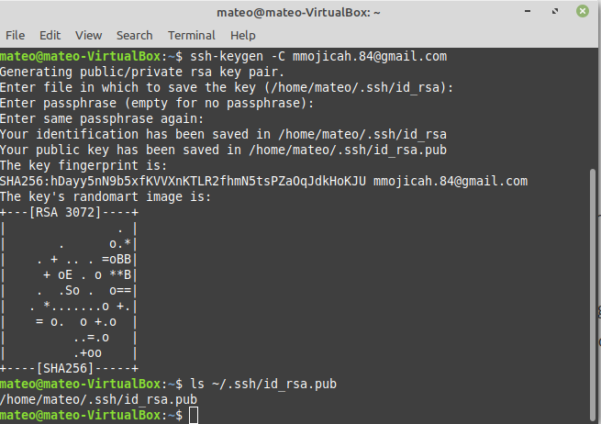

After successfully generating the ssh key you have to go to your git-hub account and enter the settings section.
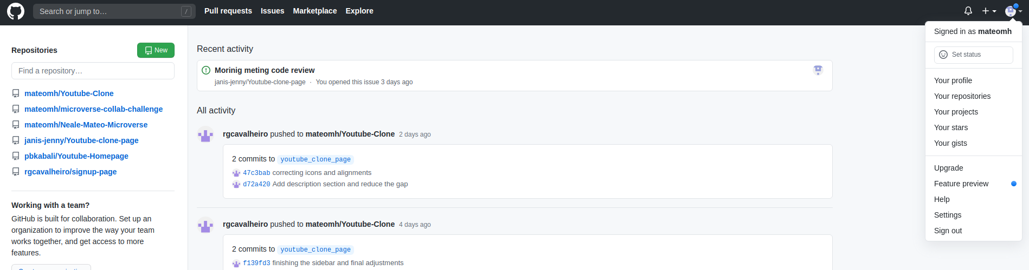

Then go to SSH and GPG keys and select new SSH key
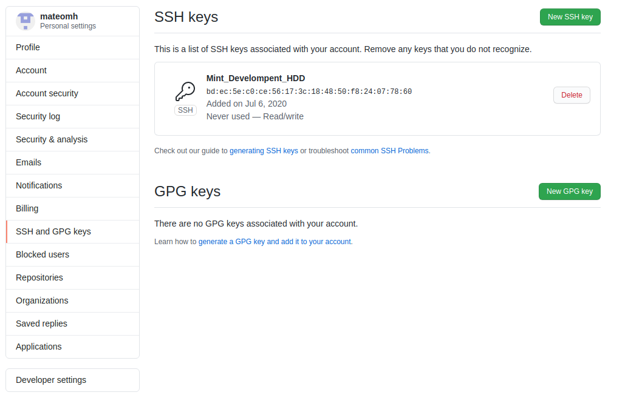
To get the key value you have to run the following command in the terminal. If for some reason it says that you don’t have permission to read the file just use the sudo command in front of it. Remember that the copy and paste shortcut keys don’t work in the terminal you have to highlight the text and then right click copy to get it.
Verify the email at the end of it and copy it to paste it to the git-hub window. After that give it a name and hit “add SSH key” and you are ready to go.
$> cat ~/.ssh/id_rsa.pub//Shows the contents of the file specified in the path

To test your ssh key just go to the terminal and type the following command
$> ssh -T git@github.com//tries to make a ssh connection to github
When it prompts you with “Are you sure you want to continue connecting?” say yes and if everything is done correctly it should greet you with your git-hub user name and add the site to the trusted site list.

Git Commands

There are several commands to git and it is impossible to cover them all but a good site for reference is https://www.atlassian.com/git/tutorials or the git page itself https://git-scm.com/book/en/v2/Getting-Started-About-Version-Control. But some of the most used commands will be covered here.

Basics
The following commands are the basics to work with the local repository.
$> git init//Makes your current directory a git repository
$> git status//Shows the status of the files, which ones are tracked and the stage they are in
$> git add filename//Adds that file to the staging area
$> git add . //Adds all the files in the folder to the staging area
$> git commit -m “Comments”//Adds everything that is in the staging area to the local repo
$> git log//Shows all the commits and their info
Remote repository interaction
For the git-hub operations the following are some of the most used commands
$> git remotename URL//Makes a remote repo URL with the given name,
//if no name is provided it saves it under origin name
$> git clone URL //Brings everything from that remote repository and
//saves the URL under the name origin

$> git push origin//Puts the local repo with all the commits up to that point to github,
//to the master branch

$> git push remotename branchname//It is a general form of the push command you can select
//which repo to push and which branch to put it in

$> git ignore filename //Ignores the file and doesn’t push it to the remote repo

$> git pull origin//Brings the repo form github to your computer form the master branch

$> git pull remotename branchname//It is the general form of the pull command,
//you can select the remote repo to pull from and the
//branch you want to pull in your computer
Branches
To make branches the most used commands are as follows
$> git branch//Shows all the branches in your repo, the one with the * is the current branch
$> git branch branchname//Creates the branch with the selected name
$> git checkout branchname //Changes the current branch to the specified one
$> git checkout -b branchname //It creates the branch if it doesn’t exist and puts it as current
Rename a branch
To rename a branch in your local repository, you can use the following commands in the terminal
$> git branch -m oldname newname//Changes the name of the branch
After that you can use the following commands to push it to git-hub (not tested yet)
$> git push origin :oldname_on_github//Not tested yet
$> git push origin newname_on_local//Not tested yet
//This can be summarized on the following command
$>git push origin :oldbranch_github newbranch_local
//The general rule for these commands is as follows
$> git push <remote> <local_branch>:<remote_branch>//Not tested yet
There is an alternate syntax for the deletion of branches on git-hub that can be used
$> git push origin –delete remote branch//deletes the remote branch (it has double dash)
To push a new branch to git-hub you can use the following command
$> git push –set-upstream oriogin newbranch//Pushes the new branch to github and tracks it

Merge
To merge branches the commands are as follows:

First you have to be on the branch that you want all the files into, so make sure you are on it
$> git checkout master//Selects the master branch as current
Next you merge the feature branch into the master
$> git merge branchname//Puts all the contents of the feature branch into the master
NOTE: Remember that the master branch has to have ready to go content only, all the work has to be done on feature branches

Remove
To remove files from tracking or the staging area some commands are as follows
$> git rm filename//Removes the file from git tracking and from all the stages

Git-Hub

git hub is one of the remote repository sites available to work with developers all over the world, is not used only for coding but for data and even writing material. Next we will show how to set up a remote repository and grant access to different collaborators.

New repository
To create a remote repository it can be directly from the git-hub page following these steps. In the repository page you will find a new button or in the nav bar there is a plus button where you can create new repositories

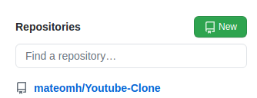

After clicking the new button you will see the creation page where you can enter all the information regarding the repository like name, description and privacy setting. Last you can select to initialize with the some files like the README.md or the .gitignore.

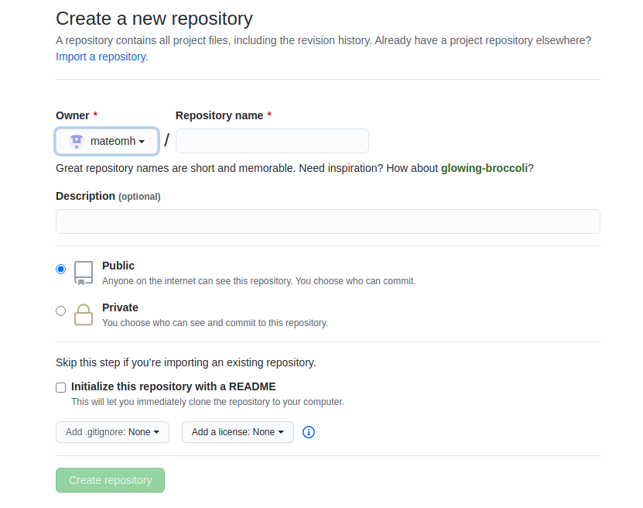
NOTE: If you are going to put a existing local repository into git-hub you create it without any files not even the read-me

NOTE: If possible CREATE the git-hub repository FIRST and then clone it and work from that to prevent any conflicts after the fact

After creating your remote repository now you can start seeing all the statistics from it and you can control it as well. To select who can contribute to it you have to go to the settings tab on your repo, from there go to the manage access tab and find a collaborator either by username or by email address.
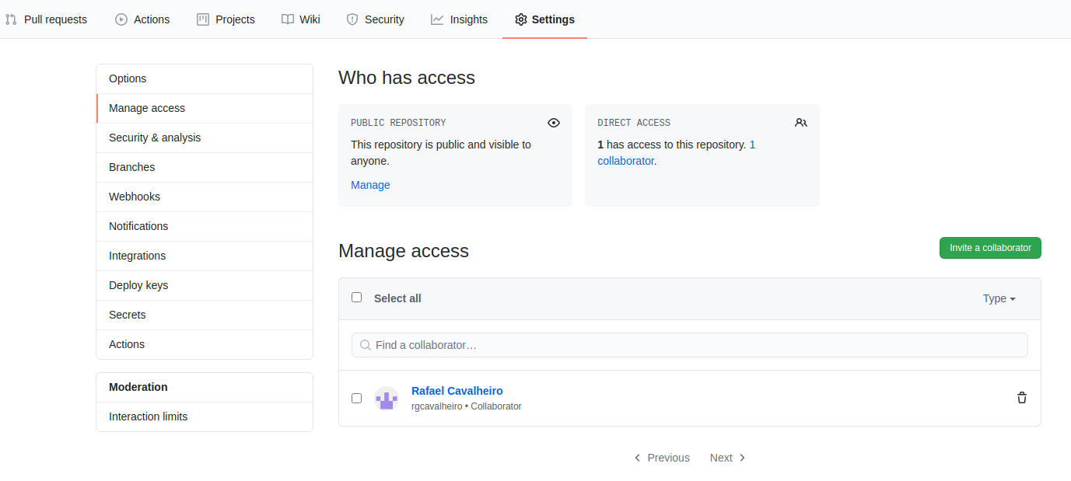
Finally after all these steps are done the selected collaborators will get an email asking them to accept the invitation, when they do that they can start pushing and pulling from the repo. If someone doesn’t have a collaborator invitation but wants to contribute to the repo the only thing that they can do is to fork the repo and when the want to contribute make a pull request to the original repo.

