Project 4: Momentum Views in a Black-Litterman Portfolio
Quantitative Finance · Prof. Ruy Ribeiro · Insper

1. What we built
We build a long-only portfolio of our 30-stock universe that starts from market-cap weights and tilts toward stocks with strong cross-sectional momentum. Each month, momentum scores are turned into a single Black-Litterman relative view (recent winners will outperform recent losers), blended with market-implied expected returns, and passed to a mean-variance optimizer. We compare the result with (a) the market-cap benchmark and (b) a naive momentum portfolio that is long the top decile and short the bottom decile.

2. Design choices
- Universe and data. The 30 stocks from Projects 1–3, daily adjusted (total-return) prices from Yahoo Finance, 2016–2025. Risk-free rate: daily return on BIL. Market caps are current shares outstanding times each day’s price.
- Rebalancing and timing. Monthly, on the first trading day of each month, using prices only up to the previous close (one-day lag). The first rebalance is February 2017, after one year of history; the backtest has 107 rebalances through December 2025.
- Signal. 12–1 momentum: the cumulative return from 12 months ago to one month ago (trading days t−253 to t−22), skipping the most recent month to avoid short-term reversal.
- Covariance. Ledoit-Wolf shrunk sample covariance of the trailing 252 daily returns, annualized.
- Prior. Market-implied excess returns Π = γΣw_{mkt}, with γ = S / σ_{mkt} and an assumed market Sharpe ratio S = 0.40. With no views, the optimizer returns the market-cap weights exactly.
- View. One relative view per month: the equal-weighted top 10 stocks by momentum outperform the equal-weighted bottom 10 by Q = 0.10 × (average past return of the top 10 − average past return of the bottom 10). Q therefore scales with the dispersion of the signal: when winners and losers are far apart, the view is larger. Over the sample Q averaged 5.0% a year (range 2.3% to 9.3%).
- τ and Ω. τ = 1/60, as if the prior were estimated from five years of monthly data. Ω = P(τΣ)P′, so the view is exactly as uncertain as the prior and receives half weight (w = 1/2 in the course notation). We report a sensitivity analysis with Ω divided by 0.25 and by 4.
- Optimization and constraints. Maximize μ′w − (γ/2)w′Σw subject to full investment, no short sales and a 25% cap per stock. The cap is above the largest market-cap weights (Apple and Microsoft reach about 20%), so it binds only for the strongest tilts.
- Transaction costs. 10 basis points per side on the value traded at each rebalance, deducted from returns. Turnover is half the sum of absolute weight changes per rebalance, annualized (× 12).
- Benchmarks. (a) Market-cap benchmark: the 30 stocks held at market-cap weights. (b) Naive momentum: long the top 3 (top decile) and short the bottom 3 (bottom decile), equal-weighted, rebalanced monthly. Because it is a zero-investment portfolio, its Sharpe ratio uses its return without subtracting the risk-free rate.
All parameters were fixed before running the backtest; the design was run once, and the confidence sensitivity in Section 4 is the only variation reported.

3. Performance
Feb 2017 – Dec 2025, net of costs | BL momentum | Market-cap | Naive momentum
Annualized return | 17.8% | 19.0% | 2.0%
Annualized volatility | 20.2% | 19.7% | 32.7%
Sharpe ratio | 0.80 | 0.87 | 0.22
Maximum drawdown | −29.4% | −28.7% | −60.0%
Annualized turnover | 201% | 0% | 357%
Tracking error vs market-cap | 5.8% | – | –
Information ratio vs market-cap | −0.16 | – | –
Gross of costs, the BL portfolio earned 18.3% a year, so costs took about 0.5 percentage points.
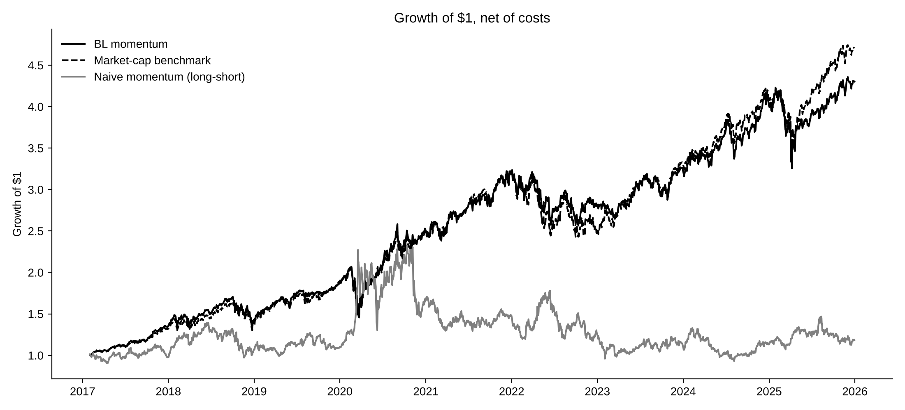
Figure 1. Growth of $1, net of costs.
Naive momentum was a poor strategy in this universe and period: 2.0% a year with 33% volatility and a 60% drawdown: it gained sharply in 2020, gave most of it back in the rotation at the end of that year, and drifted lower afterwards. This is not specific to our 30 stocks: the Ken French momentum factor earned only 3.8% a year over the same period (t = 0.6). The Black-Litterman portfolio, by contrast, behaved much like the benchmark: similar volatility and drawdown, slightly lower return, and a Sharpe ratio of 0.80 against 0.87.

4. What Black-Litterman adds, and what it does not
It turns a noisy signal into a controlled tilt. The naive portfolio puts all its capital into six stocks. The BL portfolio starts from the market and moves only as far as the view justifies: on average it held 30 percentage points more than market weight in the top 10 momentum stocks and 19.5 points less in the bottom 10 (Figure 2). Volatility stayed at the market’s level, the drawdown was half the naive portfolio’s, and turnover was 201% a year instead of 357%.
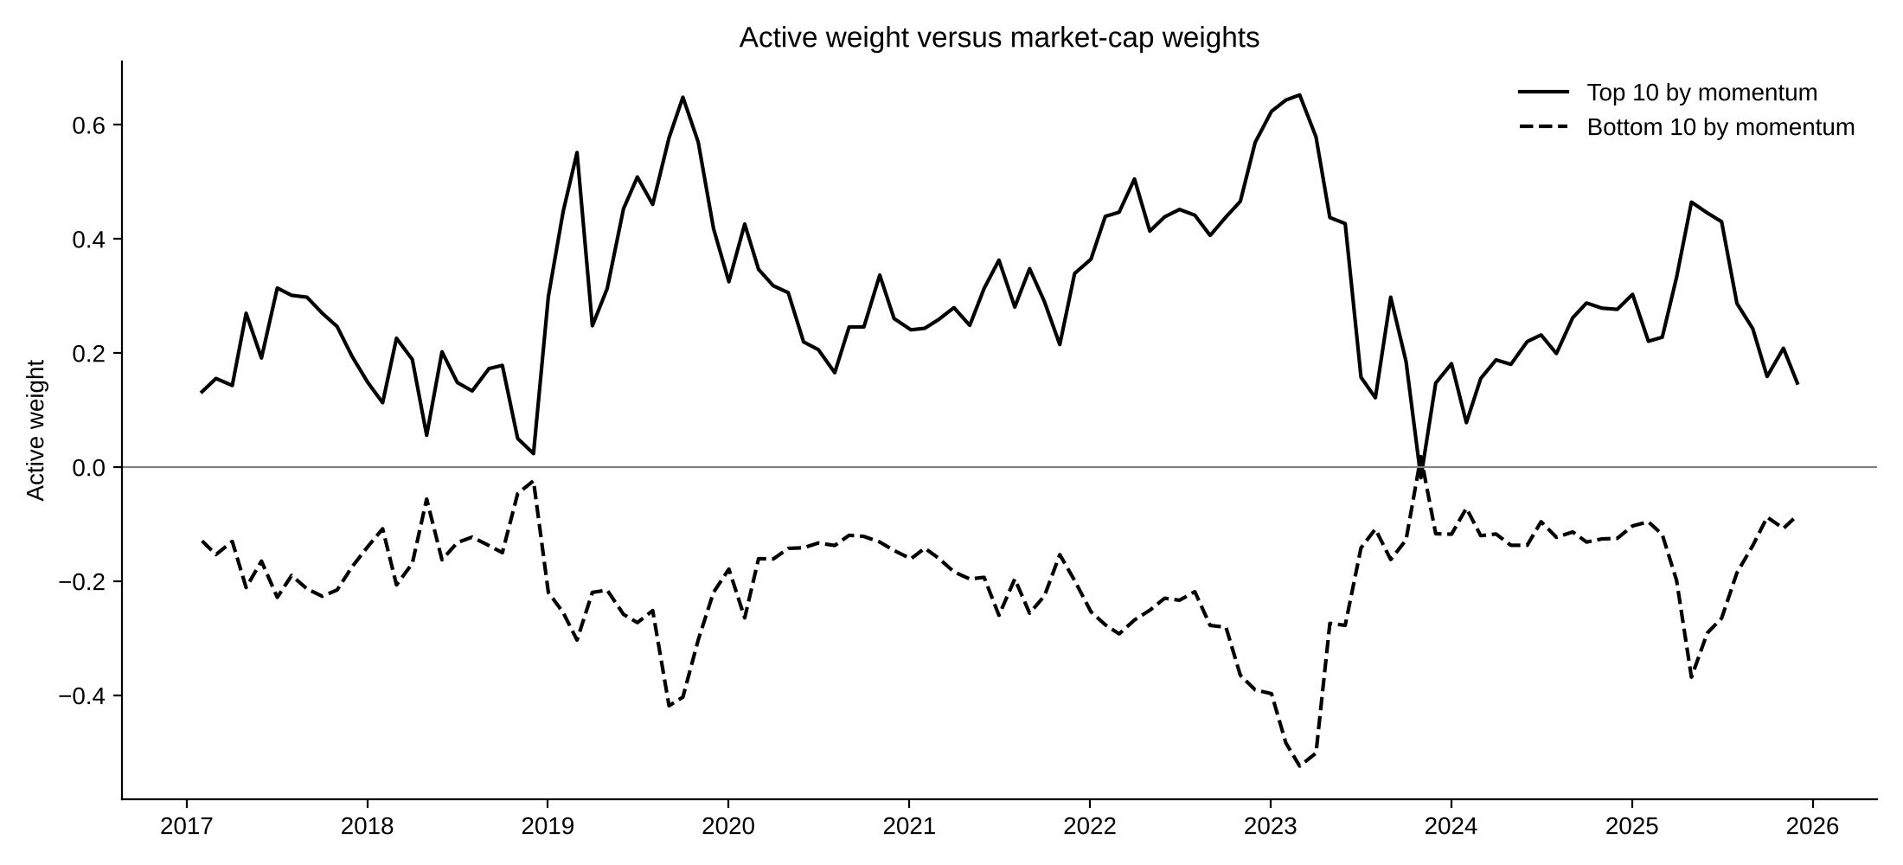
Figure 2. Active weight of the BL portfolio in the top 10 and bottom 10 stocks by momentum.
It sizes the bet by confidence. Raising or lowering Ω moves the portfolio smoothly between the market and a strong momentum tilt, as the table shows.
View confidence | × 0.25 | × 1 (base) | × 4
Annualized return | 18.8% | 17.8% | 17.3%
Sharpe ratio | 0.85 | 0.80 | 0.77
Tracking error vs market-cap | 2.9% | 5.8% | 7.9%
Information ratio vs market-cap | −0.06 | −0.16 | −0.16
Annualized turnover | 110% | 201% | 259%
Ω is divided by the confidence multiplier: × 4 means four times more confidence in the view.
It does not create alpha. Black-Litterman controls how much of a view enters the portfolio; it cannot make a weak view profitable. Because momentum had no edge in 2017–2025, every tilt toward it cost return relative to the benchmark, and more confidence made results slightly worse (information ratio −0.06 to −0.16). The framework did its job: it kept a losing signal from doing serious damage, which the naive portfolio did not.

5. Conclusion and limitations
Combining momentum with Black-Litterman produced a portfolio that tracked the market closely, with sensible weights, moderate turnover and a drawdown close to the benchmark’s (−29.4% against −28.7%), while the naive momentum portfolio fell 60% from its peak. It did not beat the market-cap benchmark, because momentum itself did not pay in this period. The value of Black-Litterman here is risk control and disciplined sizing, not return.
The main limitations are: (i) market caps use current shares outstanding, so early weights of firms with large buybacks (such as Apple) are understated; (ii) 30 stocks make the momentum ranking thin, especially for the naive decile portfolio; (iii) the evaluation covers one nine-year sample with a weak momentum premium, and the conclusion could differ in a period when momentum works; (iv) the parameters S, τ, the view scale and the 25% cap are judgment calls, which is why we report the confidence sensitivity.

