Description Case 1:
A 78-year-old man presented with rectal bleeding. Colonoscopy revealed a semicircumferential necrotic mass extending from the dentate proximally into the rectum, measuring 4cm in length. Biopsy of the lesion was positive for poorly differentiated squamous cell carcinoma. Positron emission tomography – computed tomography revealed the anorectal mass with intense hypermetabolic activity, a1.3-cm hypermetabolic left inguinal node, and a hypermetabolic lesion in the sacrum (Fig 1). Sacral biopsy confirmed metastatic, poorly differentiated squamous cell cancer. The patient has a history of low-risk prostate cancer treated with low-dose-ratebrachy therapy seed implant monotherapy (total dose,144Gy) in 2009.
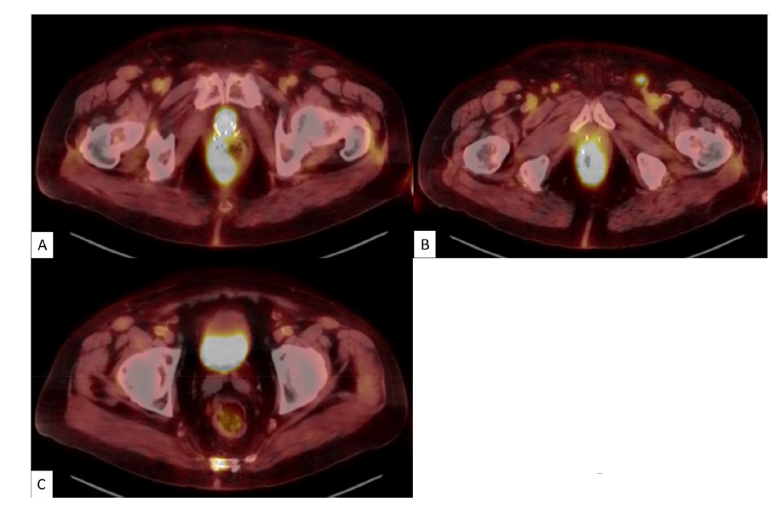
Caption: Fig.1. Axial images from the patient’s positron emission tomography−computed tomography scan depicting (A) the primary anal canal mass, (B) the left inguinal node metastasis, and (C)the sacral metastasis.
Questions case 1:
1. What would be your approach to this patient? Would you offer this patient systemic therapy?
2. If you would offer this patient radiation, what would your dose, fractionation, and target volumes be?
3.Would you treat the sacral metastasis first, concurrently, or after treating the primary tumor? What would be your dose and fractionation?
4. Does the previous seed implant affect your management?
5. Do you think the previous brachy therapy treatment resulted in the patient’s subsequent development of anal cancer?

Description Case 9:
A 58-year old man with a history of arterial hypertension and hypercholesterolemia, for which he receives medical treatment, was referred to a urologist after an elevated prostate-specific antigen (PSA) level of 18 ng/mL was detected on PSA screening. Further workup with multiparametric magnetic resonance imaging, prostate biopsies, and a computed tomography (CT) scan and bone scintigraphy revealed a prostate adenocarcinoma with a Gleason score of 5+4=9 and clear extra capsular extension on multiparametric magnetic resonance imaging, but no clinically visible adenopathies nor distant metastases. Final staging was as follows: cT3a cN0 cM0. Primary treatment consisted of a radical prostatectomy with extended pelvic lymph node dissection. Definitive pathologic examination confirmed the Gleason score and revealed seminal vesicle invasion (pT3b) and positive section margins over a length of 2mm. All removed lymph nodes (n=14) were negative. The patient developed minor postoperative incontinence (National Cancer Institute Common Terminology Criteria for Adverse Events v4 grade 2), for which he was referred to the physiotherapist. The case was discussed at the multidisciplinary tumor board, and it was decided to follow up and perform early salvage radiation therapy if necessary(Q1).
Seven months later, the patient presents with a PSA rise of 0.21 ng/mL. The patient is referred to you, the radiation oncologist, for early salvage radiation therapy (Q2). After a discussion with your colleagues, you decide to perform a prostate-specific membrane antigen positron emission tomography/CT before radiation therapy. It shows no evidence of locoregional recurrence; however, a hypermetabolic lymph node is seen in the supraclavicular region of the neck on the left side (Fig. 1) (Q3).
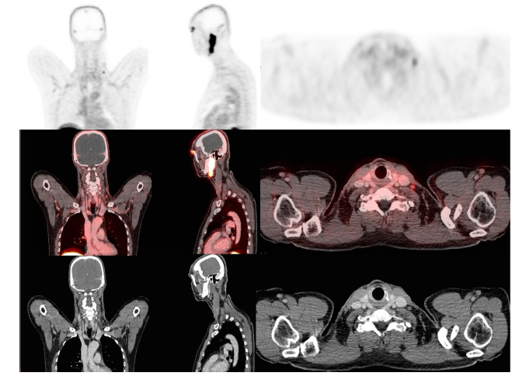
Caption: Fig.1. 18F-PSMA PET/CT imaging of thepatient showing a hypermetabolic lymph node supraclavicular on the left side. Abbreviations: CT = computed tomography; PET= positron emission tomography; PSMA=prostate-specific membrane antigen.
Questions case 9:
1. The tumor board chose early salvage treatment. Would you have agreed on this strategy in this patient?
2. Do you perform a prostate-specific membrane antigen positron emission tomography/CT at this moment, or do you immediately proceed with early salvage radiation therapy? In the case of radiation, do you add hormonal treatment, and if so, what is the optimal duration that you advise?
3. What do you advise to your patient?

Description Case 12:
A 32-year-old female nonsmoker with no known family history of cancer presented to her primary care physician after a non-healing wound in her tongue for 5 months that did not respond to conservative measures. A computed tomography scan of the neck revealed a 0.8 cm enhancing mass within the right mid to posterior tongue. There was no palpable lymphadenopathy or enlarged nodes on imaging. The patient underwent a right partial glossectomy and right neck dissection of levels 2 through 4. Pathology revealed a 1.5 cm x 0.7 cm (DOI) keratinizing squamous cell carcinoma with areas of moderate dysplasia. The closest margin was 0.8 cm. No lymphovascular invasion or perineural invasion was seen histologically. Right neck dissection revealed one 1.1 cm right level 2 node out of a total of 22 nodes without extranodal extension.

Questions case 12:
1.Would you recommend post operative radiation therapy?
2.If you recommended radiation therapy, would you treat the primary? Unilateral neck or bilateral neck?
3.Would you consider adding systemic therapy for this patient or enrollment on a clinical trial such as Radiation Therapy Oncology Group 0920?

Description Case Grayzone:
A 73-year-old man with coronary artery disease, type 2 diabetes mellitus, obesity class 3, and oligometastatic transverse colon adenocarcinoma in remission off systemic therapy for 5 years, underwent a surveillance fluorodeoxyglucose (1⁸F) positron emission tomography/computed tomography. Imaging demonstrated a 2.1 cm mass straddling the distal left mainstem bronchus and proximal left upper lobar bronchus, deemed ultracentral owing to abutment of the left mainstem bronchus, and no other lesions (Fig. 1).¹ Its medial border was 2.75 cm from the trachea and 3.10 cm from the esophagus, measuring 14.0 cm3. He had no prior radiation therapy, and his systemic therapy did not include vascular endothelial growth factor inhibitors. An endobronchial ultrasound/biopsy demonstrated tumor cells positive for CK20/CDX-2 and negative for CK7/TTF-1, consistent with colon adenocarcinoma, an extremely radioresistant metastatic histology to the lung.² Owing to the lesion’s ultracentral location and the patient’s comorbidities, thoracic surgery did not recommend resection.
The patient tolerated 60 Gy/12 fractions volumetric modulated arc therapy very well, without any acute, subacute, or chronic side effects. However, 3 years later, he experienced progressive hemoptysis. A positron emission tomography/computed tomography demonstrated a hypermetabolic mass superolateral to the original site (Fig. 2). He underwent an interventional bronchoscopy with mechanical debulking confirming recurrence, but his hemoptysis worsened, even after repeating the procedure twice. In Pulmonary Tumor Board, a decision was made to offer salvage reirradiation (Question 4).

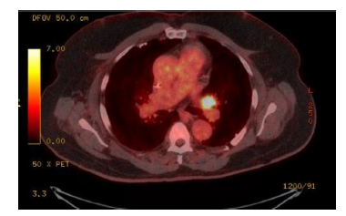
Caption: Fig.1. Fluorodeoxyglucose (1⁸F) positron emission tomography/computed tomography on initial presentation.
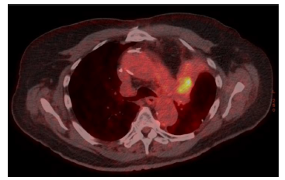
Caption: Fig. 2. Fluorodeoxyglucose (1⁸F) positron emission tomography/computed tomography demonstrating recurrence superolateral to the original tumor.
References
1. Tekatli H, Haasbeek N, Dahele M, et al. Outcomes of hypofractionated high-dose radiotherapy in poor-risk patients with “ultracentral” non-small cell lung cancer. J Thorac Oncol 2016;11:1081-1089.
2. Binkley MS, Trakul N, Jacobs LR, et al. Colorectal histology is associated with an increased risk of local failure in lung metastases treated with stereotactic ablative radiation therapy. Int J Radiat Oncol Biol Phys 2015;92:1044-1052.

Questions case Grayzone:
1. What dose, fractionation, and treatment volumes would you recommend?
2. Would the treatment incorporate systemic therapy?
3. What risks of high-grade toxicity would you discuss with the patient?
4. How would you treat this isolated recurrence?

