# GANPAT UNIVERSITY

# B. Tech SEMESTER: III (CE / IT)

# 2CEIT304: Data Structures

**Assignment – 2**

1. Write an algorithm to perform binary search for an element in the sorted sequence.
2. Explain the algorithm for Selection sort and bubble sort with a suitable example.
3. Sort following using Quicksort 11, 4, 20, 45, 32, 60, 98, 70
4. Build a Max-heap for the following list of number and write the algorithm for Heapify.

31 52 26 57 85 99 77 60 32 41

1. Discuss the best case and worst case time complexity for the following algorithms:
   1. Selection sort
   2. Bubble sort
   3. Insertion sort
   4. Quick sort
2. Sort the following list using Merge Sort and write the algorithm for Merging 2 lists.

45, 70,30, 60, 15,75,35,55,20,85,80

1. What is Binary Search Tree? Construct a binary search tree for the following elements

11,6,14,8,12,15,16,7,9,23

1. The Preorder traversal of the tree is: 7, 1, 0, 3, 2, 5, 4, 6, 9, 8, 10 The in-order traversal of the tree is : 0, 1,2,3,4,5,6,7,8,9,10 What is the post-order traversal?
2. Define following terms:

Digraph, path, height of tree, cycle, weighted graph, isolated node, Threaded Binary Tree, Adjacency Matrix

1. Which are the basic traversing techniques of the Graph? Write the algorithm for Depth First Search and find traversal sequence for the following graph. Consider node G as root.

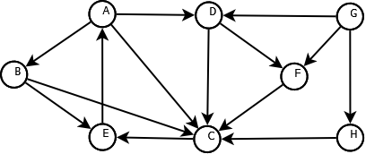

1. Write an algorithm to insert a new node after the specified node in circular linked list.
2. Consider a doubly linked list in which FIRST and LAST denotes the first and last nodes of it respectively. List out the advantages of doubly linked list. Write the user defined functions/algorithms to perform the following. The algorithm/code must be able to maintain the first and last node of doubly circular linked list.
   1. Insert at First
   2. Insert at last
   3. Delete at first
   4. Delete at last
3. Explain what is hashing and any 2 Hashing Techniques in detail with neat diagram.
4. List and explain any 2 collision resolution techniques in Hashing.

**Last date for submission: 20/11/2020**