GANPAT UNIVERSITY
U. V. Patel College of Engineering
B. Tech. CE/IT– Semester –III
2CEIT303: Database Management System

Assignment-1

- Discuss disadvantages of file processing systems.
- Explain Instances and Schema in detail.
- Explain Database Users.
- Explain in detail the duties of DBA.
- Define the Following Terms.
- DBMS.
- Entity.
- Super key.
- Candidate key
- Primary Key.
- Foreign Key.
- Atomic domain.
- Join & its types.
- Attributes & its types.
- We want to design a database for storing the information of U.S. athletes and their participations in Olympic Games.
- An athlete has his/her SSN, the name, and the birth date.
- Each Olympiad has the year, the country, and the city. For example, the 2008 Olympic game was held in Beijing, China.
- An athlete can participate in several sports in an Olympiad. For example, Michael, Armstrong participated in the swimming, diving, and water polo events.
- Every athlete in our database participated in at least one Olympiad. Every Olympiad has at least one athlete (and actually, several thousands).
Draw an ER diagram for this database. Make sure to indicate primary keys, cardinality, constraints, weak entities (if any), and participation constraints.

- Find output of following relational expressions for relations given below.
(P= project, R= Select)
- PName(RAge>25(User))
- RId>2∨Age!=31(User)
- RUser.OccupationId=Occupation.OccupationId(User X Occupation)
- User ⋈ Occupation ⋈ City
- PName,Gender(RCityName=”Boston”(User ⋈ City))
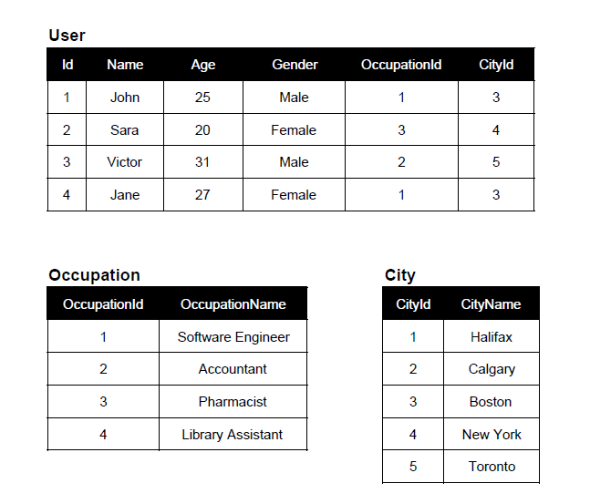
- Give the relational algebra expressions for given relations.
Suppliers(sid, sname, address)
Parts(pid, pname, color)
Catalog(sid, pid, cost)
- Find the names of suppliers who supply red part.
- Find the IDs of suppliers who supply red or green part.
- Find the IDs of suppliers who supply red part OR are based at 21 George Street.
- Find the total cost for each supplier.
- Count the no of parts based on color.

- Write SQL queries for the following tables.
T1 ( Empno, Ename , Salary, Designation)
T2 (Empno, Deptno)
(1) Display all rows for salary greater than 5000.
(2) Add a new column deptname in table T2.
(3) Change the designation of ename=’dcs’ from ‘clerk’ to ‘senior clerk’.
(4) Find the total salary of all the rows.
(5) Display annual salary of employee where empno=E103.
(6) Display all the record of T1 Salary wise.
(7) Delete data of employee E001.
(8) Delete the table T1.

- Explain Generalization, Specialization and aggregation with example.

SUBMISSION DATE: ON OR BEFORE 10/09/2020

