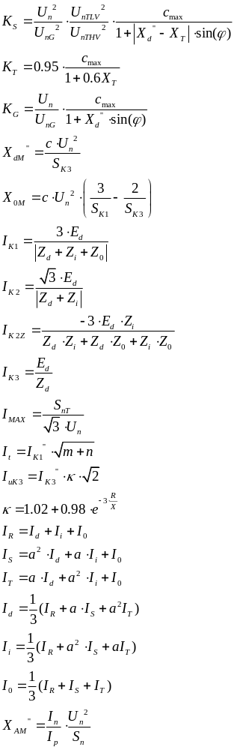
ZAKRETI KUTOVA NAPONA I STRUJA:
Ydk, direktni: VN -> NN -30k°
NN -> VN 30k°
Ydk, inverzni: VN -> NN 30k°
NN -> VN -30k°
Dyk, direktni VN -> NN -30k°
NN -> VN 30k°
Dyk, inverzni VN -> NN 30k°
NN -> VN -30k°
Yy6, direktni VN -> NN -180°
NN -> VN 180°
Yy6, inverzni VN -> NN 180°
NN -> VN -180°

