Fizika lasera

Domaća zadaća [2014.]

Davor Grdić

0036450559

## Tekst zadatka 1

Izračunajte vrijednosti faktora ekstrakcije *δ* i omjere *R1/L* i *R2/L* za pozitivnu i negativnu granu. Povećanje *m* neka se mijenja od 0 do 5 s korakom 0.1. Rezultate prikažite tablicom.

## Rješenje

|  |  |
| --- | --- |
| faktor ekstrakcije |  |

|  |  |
| --- | --- |
| pozitivna grana |  |
|  |

|  |  |
| --- | --- |
| negativna grana |  |
|  |

|  |  |  |  |  |  |  |  |  |  |  |  |  |  |  |  |  |  |  |  |  |  |  |  |  |  |  |  |  |  |  |  |  |  |  |  |  |  |  |  |  |  |  |  |  |  |  |  |  |  |  |  |  |  |  |  |  |  |  |  |  |  |  |  |  |  |  |  |  |  |  |  |  |  |  |  |  |  |  |  |  |  |  |  |  |  |  |  |  |  |  |  |  |  |  |  |  |  |  |  |  |  |  |  |  |  |  |  |  |  |  |  |  |  |  |  |  |  |  |  |  |  |  |  |  |  |  |  |  |  |  |  |  |  |  |  |  |  |  |  |  |  |  |  |  |  |  |  |  |  |  |  |  |  |  |  |  |  |  |  |  |  |  |  |  |  |  |  |  |  |  |  |  |  |  |  |  |  |  |  |  |  |  |  |  |  |  |  |  |  |  |  |  |  |  |  |  |  |  |  |  |  |  |  |  |  |  |  |  |  |  |  |  |  |  |  |  |  |  |  |  |  |  |  |  |  |  |  |  |  |  |  |  |  |  |  |  |  |  |  |  |  |  |  |  |  |  |  |  |  |  |  |  |  |  |  |  |  |  |  |  |  |  |  |  |  |  |  |  |  |  |  |  |  |  |  |  |  |  |  |  |  |  |  |  |  |  |  |  |  |  |  |  |  |  |  |  |  |  |  |  |  |  |  |  |  |  |  |  |  |  |  |  |  |  |  |  |  |  |  |
| --- | --- | --- | --- | --- | --- | --- | --- | --- | --- | --- | --- | --- | --- | --- | --- | --- | --- | --- | --- | --- | --- | --- | --- | --- | --- | --- | --- | --- | --- | --- | --- | --- | --- | --- | --- | --- | --- | --- | --- | --- | --- | --- | --- | --- | --- | --- | --- | --- | --- | --- | --- | --- | --- | --- | --- | --- | --- | --- | --- | --- | --- | --- | --- | --- | --- | --- | --- | --- | --- | --- | --- | --- | --- | --- | --- | --- | --- | --- | --- | --- | --- | --- | --- | --- | --- | --- | --- | --- | --- | --- | --- | --- | --- | --- | --- | --- | --- | --- | --- | --- | --- | --- | --- | --- | --- | --- | --- | --- | --- | --- | --- | --- | --- | --- | --- | --- | --- | --- | --- | --- | --- | --- | --- | --- | --- | --- | --- | --- | --- | --- | --- | --- | --- | --- | --- | --- | --- | --- | --- | --- | --- | --- | --- | --- | --- | --- | --- | --- | --- | --- | --- | --- | --- | --- | --- | --- | --- | --- | --- | --- | --- | --- | --- | --- | --- | --- | --- | --- | --- | --- | --- | --- | --- | --- | --- | --- | --- | --- | --- | --- | --- | --- | --- | --- | --- | --- | --- | --- | --- | --- | --- | --- | --- | --- | --- | --- | --- | --- | --- | --- | --- | --- | --- | --- | --- | --- | --- | --- | --- | --- | --- | --- | --- | --- | --- | --- | --- | --- | --- | --- | --- | --- | --- | --- | --- | --- | --- | --- | --- | --- | --- | --- | --- | --- | --- | --- | --- | --- | --- | --- | --- | --- | --- | --- | --- | --- | --- | --- | --- | --- | --- | --- | --- | --- | --- | --- | --- | --- | --- | --- | --- | --- | --- | --- | --- | --- | --- | --- | --- | --- | --- | --- | --- | --- | --- | --- | --- | --- | --- | --- | --- | --- | --- | --- | --- | --- | --- | --- | --- | --- | --- | --- | --- | --- | --- | --- | --- | --- | --- | --- | --- | --- | --- | --- | --- | --- | --- | --- | --- | --- | --- | --- | --- | --- | --- | --- | --- | --- | --- |
| |  |  |  |  |  |  | | --- | --- | --- | --- | --- | --- | |  |  | **pozitivna grana** | | **negativna grana** | | | **m** | **δ** | **R1/L** | **R2/L** | **R1/L** | **R2/L** | | **0,000** | -∞ | 0,000 | 2,000 | 0,000 | 2,000 | | **0,100** | -99,000 | -0,222 | 2,222 | 0,182 | 1,818 | | **0,200** | -24,000 | -0,500 | 2,500 | 0,333 | 1,667 | | **0,300** | -10,111 | -0,857 | 2,857 | 0,462 | 1,538 | | **0,400** | -5,250 | -1,333 | 3,333 | 0,571 | 1,429 | | **0,500** | -3,000 | -2,000 | 4,000 | 0,667 | 1,333 | | **0,600** | -1,778 | -3,000 | 5,000 | 0,750 | 1,250 | | **0,700** | -1,041 | -4,667 | 6,667 | 0,824 | 1,176 | | **0,800** | -0,563 | -8,000 | 10,000 | 0,889 | 1,111 | | **0,900** | -0,235 | -18,000 | 20,000 | 0,947 | 1,053 | | **1,000** | 0,000 | 2,000 | 0,000 | 1,000 | 1,000 | | **1,100** | 0,174 | 22,000 | -20,000 | 1,048 | 0,952 | | **1,200** | 0,306 | 12,000 | -10,000 | 1,091 | 0,909 | | **1,300** | 0,408 | 8,667 | -6,667 | 1,130 | 0,870 | | **1,400** | 0,490 | 7,000 | -5,000 | 1,167 | 0,833 | | **1,500** | 0,556 | 6,000 | -4,000 | 1,200 | 0,800 | | **1,600** | 0,609 | 5,333 | -3,333 | 1,231 | 0,769 | | **1,700** | 0,654 | 4,857 | -2,857 | 1,259 | 0,741 | | **1,800** | 0,691 | 4,500 | -2,500 | 1,286 | 0,714 | | **1,900** | 0,723 | 4,222 | -2,222 | 1,310 | 0,690 | | **2,000** | 0,750 | 4,000 | -2,000 | 1,333 | 0,667 | | **2,100** | 0,773 | 3,818 | -1,818 | 1,355 | 0,645 | | **2,200** | 0,793 | 3,667 | -1,667 | 1,375 | 0,625 | | **2,300** | 0,811 | 3,538 | -1,538 | 1,394 | 0,606 | | **2,400** | 0,826 | 3,429 | -1,429 | 1,412 | 0,588 | | **2,500** | 0,840 | 3,333 | -1,333 | 1,429 | 0,571 | | **2,600** | 0,852 | 3,250 | -1,250 | 1,444 | 0,556 | | **2,700** | 0,863 | 3,176 | -1,176 | 1,459 | 0,541 | | **2,800** | 0,872 | 3,111 | -1,111 | 1,474 | 0,526 | | **2,900** | 0,881 | 3,053 | -1,053 | 1,487 | 0,513 | | **3,000** | 0,889 | 3,000 | -1,000 | 1,500 | 0,500 | | **3,100** | 0,896 | 2,952 | -0,952 | 1,512 | 0,488 | | **3,200** | 0,902 | 2,909 | -0,909 | 1,524 | 0,476 | | **3,300** | 0,908 | 2,870 | -0,870 | 1,535 | 0,465 | | **3,400** | 0,913 | 2,833 | -0,833 | 1,545 | 0,455 | | **3,500** | 0,918 | 2,800 | -0,800 | 1,556 | 0,444 | | **3,600** | 0,923 | 2,769 | -0,769 | 1,565 | 0,435 | | **3,700** | 0,927 | 2,741 | -0,741 | 1,574 | 0,426 | | **3,800** | 0,931 | 2,714 | -0,714 | 1,583 | 0,417 | | **3,900** | 0,934 | 2,690 | -0,690 | 1,592 | 0,408 | | **4,000** | 0,938 | 2,667 | -0,667 | 1,600 | 0,400 | | **4,100** | 0,941 | 2,645 | -0,645 | 1,608 | 0,392 | | **4,200** | 0,943 | 2,625 | -0,625 | 1,615 | 0,385 | | **4,300** | 0,946 | 2,606 | -0,606 | 1,623 | 0,377 | | **4,400** | 0,948 | 2,588 | -0,588 | 1,630 | 0,370 | | **4,500** | 0,951 | 2,571 | -0,571 | 1,636 | 0,364 | | **4,600** | 0,953 | 2,556 | -0,556 | 1,643 | 0,357 | | **4,700** | 0,955 | 2,541 | -0,541 | 1,649 | 0,351 | | **4,800** | 0,957 | 2,526 | -0,526 | 1,655 | 0,345 | | **4,900** | 0,958 | 2,513 | -0,513 | 1,661 | 0,339 | | **5,000** | 0,960 | 2,500 | -0,500 | 1,667 | 0,333 | |  |

## 

## Tekst zadatka 2

Grafički prikazati *m = f(δ)*, *Ri/L = f(δ)* za pozitivnu i negativnu granu.

## Rješenje

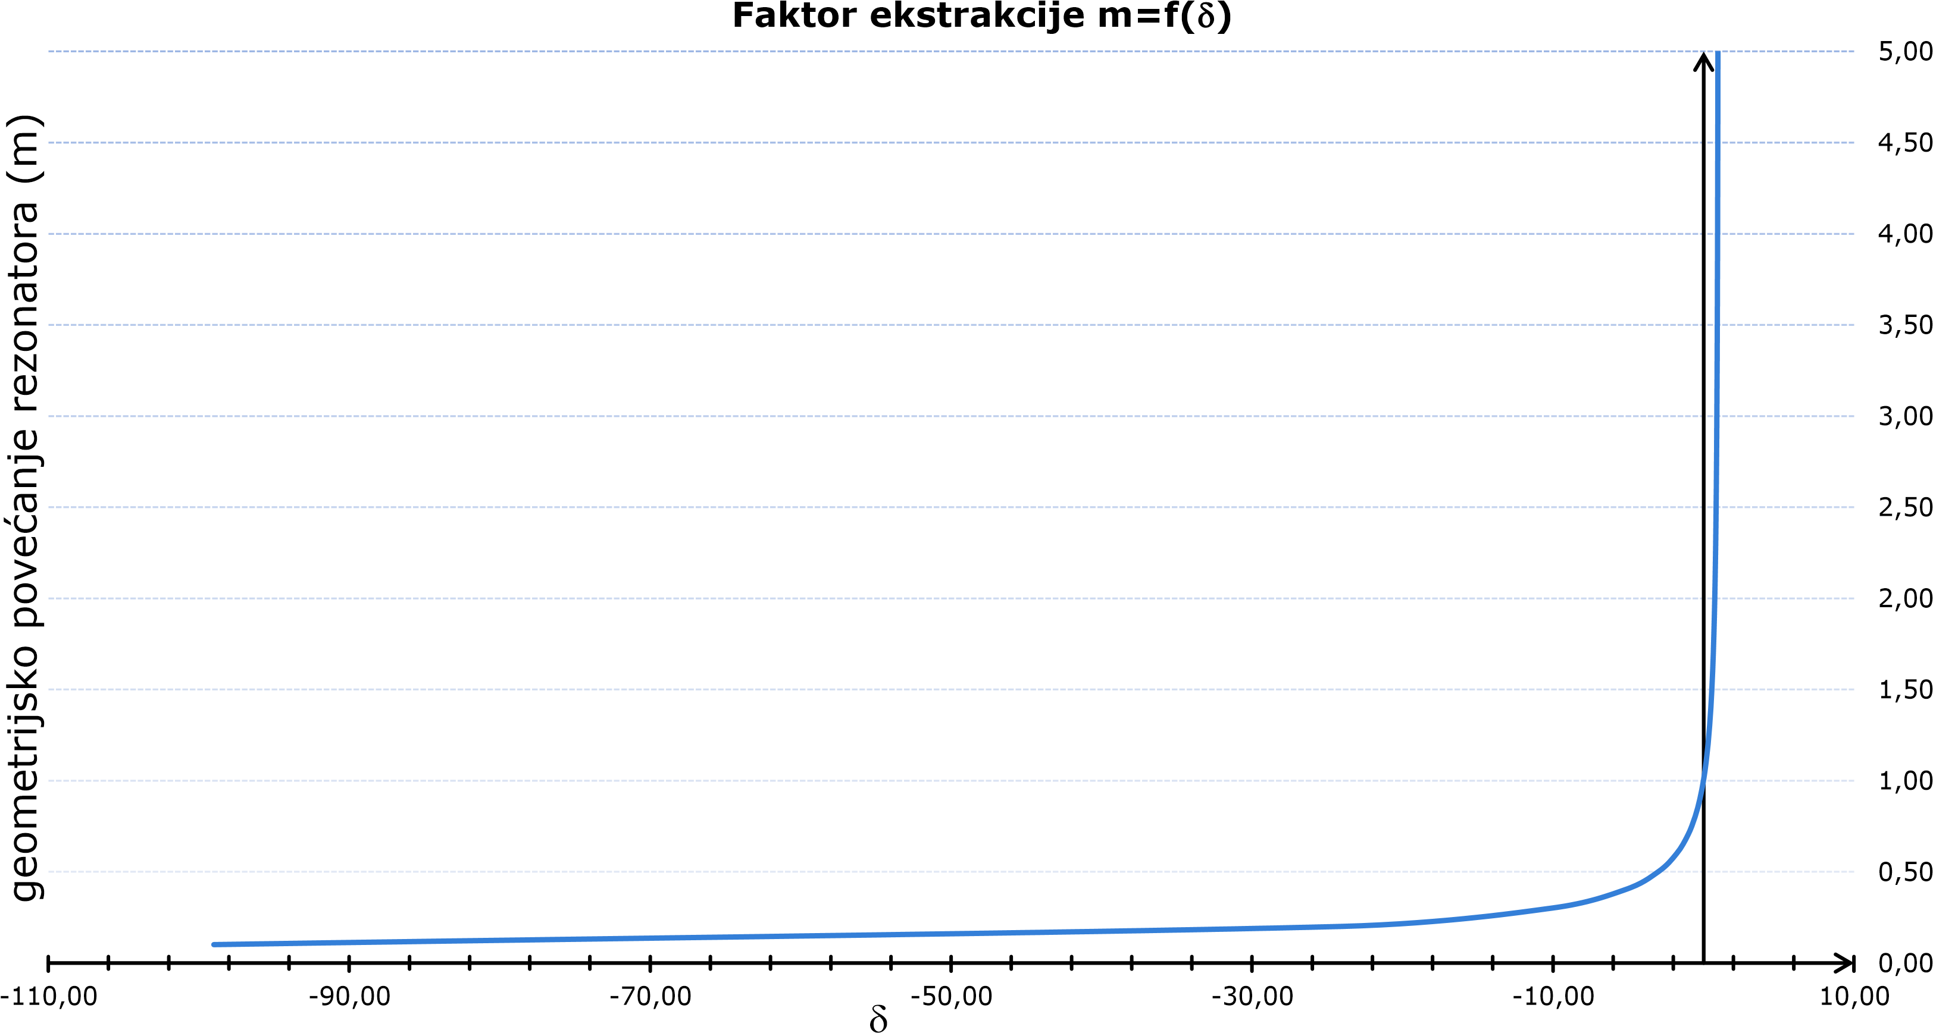

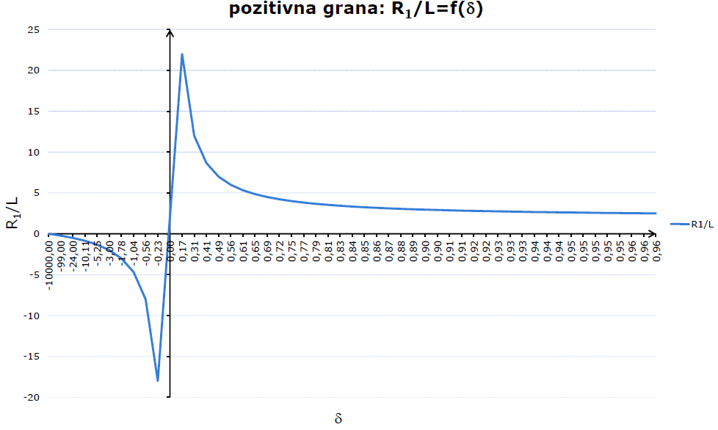

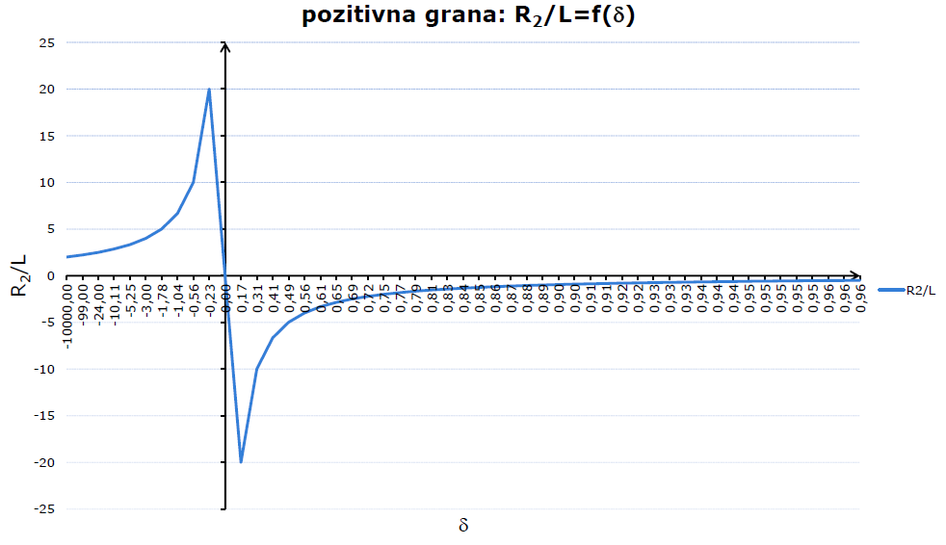

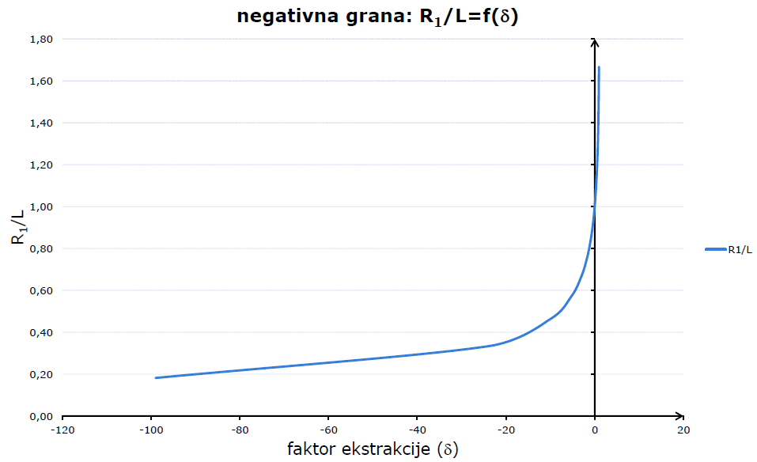

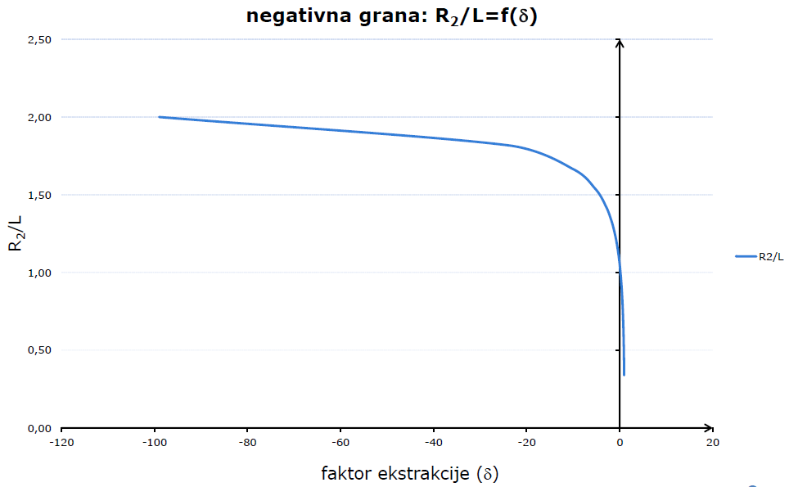

## Tekst zadatka 3

Izračunajte (za *L = 2000mm*, *a1 = 25mm* uz uvjet konfokalnosti (1) i *R1 = 6400mm*) *g1*, *g2*, *g1g2*, *δ* i osjetljivost faktora ekstrakcije *dδ/dRi* za pozitivnu granu.

## Rješenje

$$R_{1}=\frac{2m}{m-1}∙L → m=\frac{8}{3}$$

$$g_{1}=\frac{m+1}{2m}=0.6874$$

$$g_{2}=\frac{m+1}{2}=1.8335$$

$$g_{1}∙g_{2}=\frac{{\left(m+1\right)}^{2}}{4m}=1.2603$$

$$δ=1-{\left(\frac{1}{m}\right)}^{2}=0.8549$$

$$\frac{dδ}{dR_{1}}=\frac{m-1}{m^{3}∙L}=0.0440 m^{-1}$$

$\frac{dδ}{dR_{2}}=\frac{m-1}{m^{2}∙L}=0.1171 m^{-1}$