**Testing**

End to end (E2E) testing is done using CypressJS ([Cypress](https://www.cypress.io)) and Github Actions ([Features • GitHub Actions](https://github.com/features/actions)). Documentation specific to the merging of these two technologies can be found here: [GitHub Actions | Cypress Documentation](https://docs.cypress.io/guides/continuous-integration/github-actions).

In the root folder you will find a ‘main.yml’ file in ‘./github/workflows’. Whenever you push this repo to GitHub it will scan this file and execute the tests that it points to. These tests can be found in ‘./cypress/e2e/’. For more information on the technology specifics, see the original documentation above as well as comments found in the test files themselves as seen below:

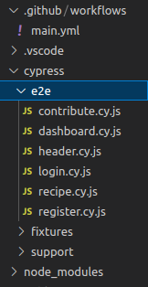

| // finds all links in the page that aren't  // mail or external links and clicks them  // and checks if they direct to the correct URL  // and checks that they don't load the 404 page  it("check all links to sites", () => {  cy.viewport("macbook-15");  cy.visit("/");  cy.get('a:not([href*="mailto:"])')  .not('[target*="_blank"]')  .each((page) => {  const href = page.prop("href");  cy.visit(href);  cy.url().should("include", href);  cy.get('[data-cy="404"]')  .should("not.exist");  cy.go("back");  });  }); |
| --- |