Benchmarking Accelerator
Complete Technical Architecture, Multi-Agent Workflows & Visual Diagrams
Executive Summary: The Benchmarking Accelerator is an AI-powered enterprise platform designed to automate competitive feature analysis, live web evidence mining, strategic synthesis, and executive report generation. It operates using an orchestrated Multi-Agent System (MAS) architecture equipped with live Google Search Grounding and a 1-Pass Quality Review & Decision Loop.

1. System Architecture Overview & Component Diagram
The application is structured into three clean decoupled layers: a React Single-Page Application (SPA) frontend, a Multi-Agent Service Layer, and Google GenAI Cloud Infrastructure.
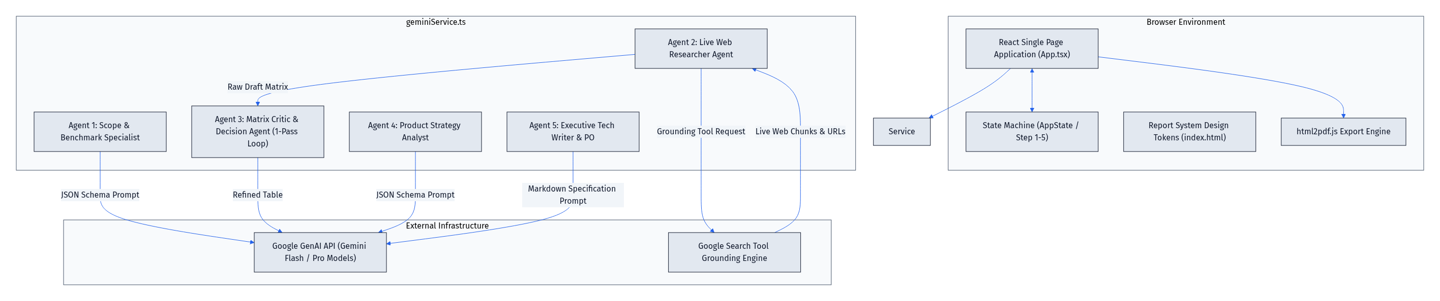
Figure 1: High-Level System Architecture & Component Interactions
Layer | Component / Module | Primary Responsibility
Client Layer (UI) | Index.html / App.tsx | Interactive 5-step React state machine, Report System CSS tokens, html2pdf.js engine.
Service Layer (Agents) | geminiService.ts | Orchestrates 5 specialized Agent Skills, manages prompt schemas, and handles API keys.
AI Cloud Layer | Google GenAI API | Executes Gemini models (Flash / Pro) with live Google Search Tool Grounding.

2. End-to-End Multi-Agent Sequence Workflow
The multi-agent pipeline operates via 5 specialized agents. Step 3 incorporates a 1-pass Critic & Decision Agent loop to audit factual completeness and tag formatting:
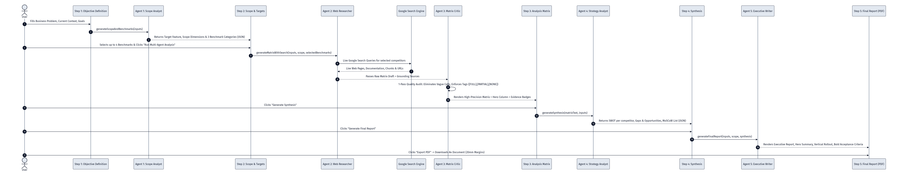
Figure 2: End-to-End Multi-Agent Sequence Workflow & Data Pipeline
2.1 1-Pass Critic Review & Decision Sub-Loop Sequence
The diagram below details the 1-Pass Review Sub-Loop executed during Step 3. Agent 1 mines web evidence, and Agent 2 (Critic) performs an instant 1-pass quality audit to refine vague text and validate tags:
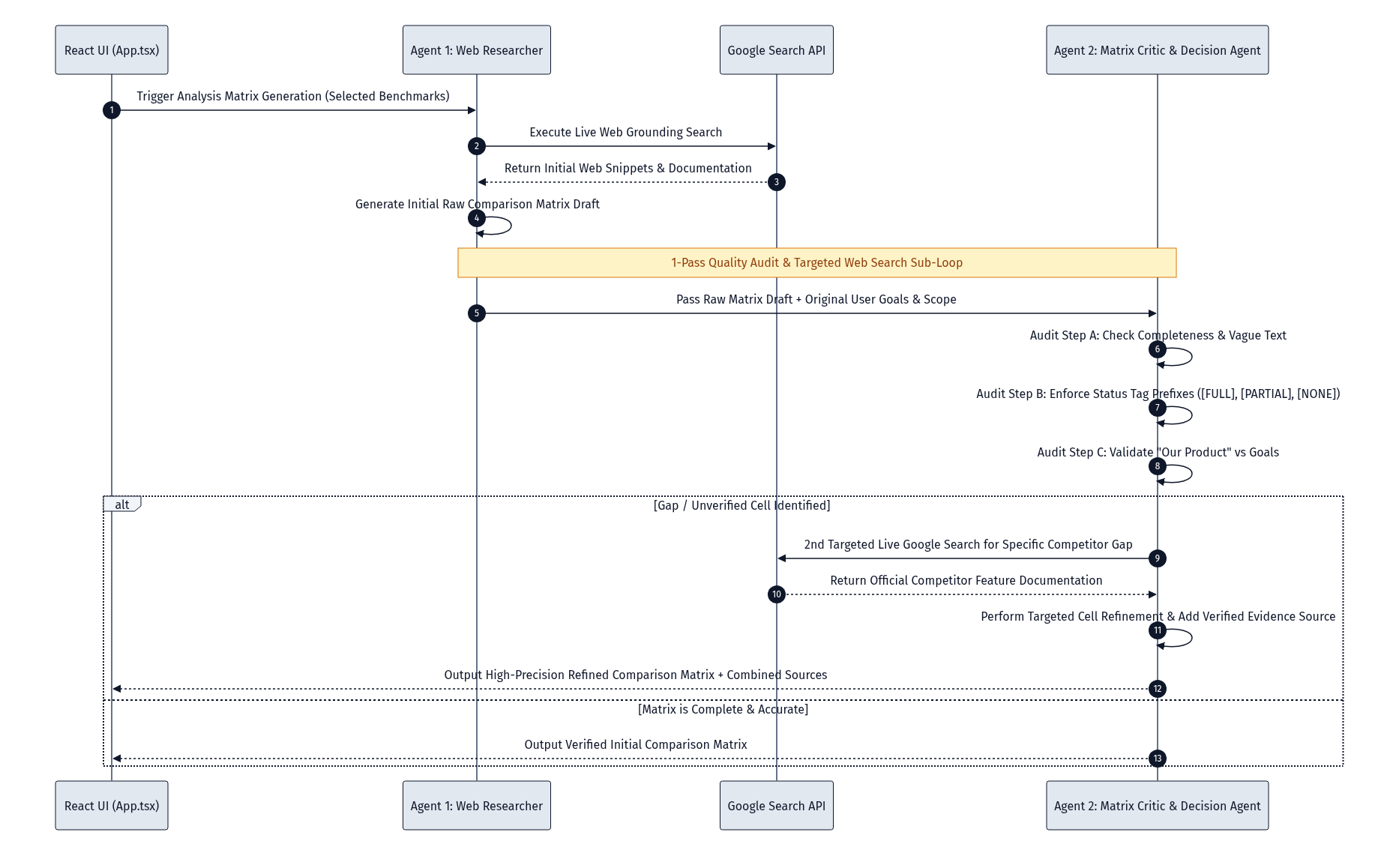
Figure 3: 1-Pass Quality Audit & Refinement Sub-Loop Sequence Diagram
• Agent 1: Scope & Benchmark Specialist: Analyzes business goals, outputting a 5-dimension analysis scope and 3 benchmark categories (Direct, Market, Adjacent).
• Agent 2: Live Web Researcher Agent: Performs real-time Google Search queries for each competitor to mine evidence, features, and official documentation.
• Agent 3: Matrix Critic & Decision Agent (1-Pass Loop): Audits Agent 2's matrix draft in a 1-pass review to eliminate vague text, enforce status tag formatting ([FULL], [PARTIAL], [NONE]), and validate Our Product comparison.
• Agent 4: Product Strategy Analyst: Synthesizes the audited matrix into competitor SWOT analysis, business gaps & opportunities, and MoSCoW prioritization.
• Agent 5: Executive Tech Writer & PO: Generates the final Executive Recommendation Report, vertical rollout plan, and actionable User Stories with bolded Acceptance Criteria.

3. Agent Skill Specifications (Prompts & Schemas)
Agent 1: Scope & Benchmark Definition Skill
# SKILL: Scope & Benchmark Definition
Based on the provided benchmarking inputs, define the scope of analysis and suggest benchmarks.
CRITICAL: Ensure the suggested benchmarks are highly relevant to the provided Business Problem and Goals.
Business Problem: {businessProblem}
Current Context: {currentContext}
Goals: {goals}
Output Schema (JSON):
{
"scope": {
"targetFeature": "Specific feature to analyze",
"analyzedFlow": "User flow being analyzed",
"impactedUser": "Target persona or user type",
"usageScenario": "Scenario/context of usage",
"testingMethod": "Methodology to test competitors"
},
"benchmarks": {
"direct": ["Competitor A", "Competitor B"],
"market": ["Market Leader 1"],
"adjacent": ["Adjacent Reference 1"]
}
}

Agent 2: Live Web Research Skill
# SKILL: Live Web Research & Evidence Gathering
MANDATORY REQUIREMENT: You MUST perform live Google searches for each of the selected competitors ({competitorsToAnalyze}) to find real, up-to-date evidence, features, official product pages, and documentation regarding: "{targetFeature}".
Business Problem: {businessProblem}
Current Product Context: {currentContext}
What We Are Looking For (Goals): {goals}
Target Feature: {targetFeature}
Executive Table Evaluation Rules:
1. Output ONLY as a Markdown table.
2. Columns MUST be: Criterion | Our Product | followed by one column for each competitor ({competitorsToAnalyze}).
3. OUR PRODUCT EVALUATION: Compare "Current Product Context" against "What We Are Looking For". Tag missing goals as [NONE] or [PARTIAL].
4. EXECUTIVE CONCISENESS: Each cell MUST begin with status tags: [FULL], [PARTIAL], [NONE] followed by max 20 words per cell.
5. CRITICAL: Plain text inside cells with the status tag prefix only.

Agent 3: Matrix Critic & Decision Agent Skill (1-Pass Loop)
# SKILL: Matrix Critic & Quality Audit (1-Pass Refinement)
You are Agent 3: Matrix Critic & Executive Decision Agent.
Your job is to audit and perform a 1-pass refinement of the comparison matrix produced by Agent 2 (Web Researcher).
Target Feature: "{targetFeature}"
Business Problem: "{businessProblem}"
Current Product Context: "{currentContext}"
What We Are Looking For: "{goals}"
Competitors: "{competitorsToAnalyze}"
Agent 2 Initial Matrix Draft: {rawMatrix}
Critic Audit & Refinement Instructions:
1. REVIEW COMPLETENESS: Ensure every cell is clear, factual, and actionable. Replace any vague text with specific feature capabilities.
2. ENFORCE TAG FORMATTING: Ensure EVERY data cell starts with exactly one status tag ([FULL], [PARTIAL], [NONE]).
3. OUR PRODUCT VALIDATION: Double check "Our Product" column. Tag missing goals as [NONE] or [PARTIAL].
4. COLUMN HEADERS: Column 1 MUST be "Criterion", Column 2 MUST be "Our Product", followed by competitor columns.
5. Output ONLY the finalized, refined Markdown table.

Agent 4: Strategic Synthesis Skill
# SKILL: Strategic Synthesis & MoSCoW Prioritization
Based on the comparison matrix and our original goals, perform a strategic synthesis.
Goals: {goals}
Matrix: {matrixText}
Output Schema (JSON):
{
"swot": [{ "competitor": "Name", "strengths": [], "weaknesses": [], "reuse": [], "avoid": [] }],
"gaps": [{ "need": "Business Need", "gap": "Product Gap", "opportunity": "Improvement Opportunity" }],
"prioritization": [{ "item": "Feature Name", "priority": "Must Have | Should Have | Could Have | Won't Have", "reason": "Rationale" }]
}

Agent 5: Executive Recommendation & User Story Writing Skill
# SKILL: Executive Recommendation & User Story Writing
Generate an Executive Recommendation Report and User Stories adhering to the official Report System Design Specification.
Context: {businessProblem}
Current Product Context: {currentContext}
Goals: {goals}
Target Feature: {targetFeature}
Prioritized Items: {prioritizationJSON}
Formatting Rules (Markdown):
1. Start with a single H1: # Executive Benchmarking & Recommendation Report
2. Add a subtitle line: *Official Product Analysis & Feature System Specification*
3. Start Section 1 with a Blockquote (> Executive Summary...) for Hero Card rendering.
4. Use H2 (##) for main headings:
- ## 1. Executive Summary
- ## 2. Key Gaps & Strategic Opportunities
- ## 3. Recommendations & Phased Implementation Roadmap
- ## 4. Actionable User Stories & Acceptance Criteria
5. Use color icons directly for MoSCoW priorities: 🔴 Must Have, 🟡 Should Have, 🔵 Could Have, ⚪ Won't Have.
6. CRITICAL RULE FOR PHASE ROLLOUT PLAN: Always present the Phased Rollout Plan vertically as a sequential list (Phase 1, Phase 2, Phase 3 on separate vertical lines).
7. ALWAYS format "Acceptance Criteria" in BOLD: **Acceptance Criteria:** when defining user stories.

