Benchmarking Accelerator
Platform User Operations Manual & Step-by-Step Guide
1. Platform Overview & API Key Setup
Platform Overview:
The Benchmarking Accelerator is an AI-driven multi-agent platform designed to automate competitive feature benchmarking, strategic SWOT syntheses, and executive feature specifications. All executions run in direct client-side mode with 100% privacy protection.

Before starting an analysis, ensure you have configured your Google AI Studio API Key in the upper-right corner of the application interface. If the key is empty or invalid, the platform will block execution and display a protective red alert banner.
2. Step-by-Step Operational Guide
Step 1: Define the Objective
In this step, fill out the three objective fields to define the problem statement, product context, and target goals. Below are the official benchmark example inputs:
Input Field | Example Operational Content
What business problem are we trying to solve? | Elderly users often struggle with the complexity of Smart TV interfaces and settings, reducing their independence and requiring frequent assistance from family members or caregivers for everyday tasks.
Current Product Context | Our Current Smart TV interfaces and configuration workflows can be difficult for elderly users to navigate, making simple actions such as changing channels, adjusting settings, or opening applications unnecessarily challenging when they are home alone.
What are we looking for? | Develop an AI-powered virtual assistant that enables elderly users to control and interact with their Smart TV using simple voice commands, making common tasks more intuitive while increasing their autonomy and reducing the need for external assistance.

Step 2: Analysis Scope & Target Feature
Agent 1 automatically analyzes your objective and generates 5 analysis scope dimensions alongside 3 benchmark competitor categories (Direct Competitors, Market Leaders, and Adjacent Solutions). Select the competitors you wish to benchmark against and click 'Generate Analysis Matrix'.
Step 3: Competitor Benchmark Matrix & 1-Pass Quality Review
Agent 2 mines live Google Search web evidence, and Agent 3 executes an automated 1-Pass Quality Audit with a 2nd targeted Google Search sub-loop to verify unverified cells. Each capability cell is tagged with FULL, PARTIAL, or NONE, and cited web sources are displayed at the bottom.
Step 4: Strategic Synthesis & Prioritization
Agent 4 compiles competitor Strengths & Weaknesses, identifies critical Product Gaps & Opportunities, and assigns MoSCoW priorities using standard color circle icons:
- 🔴 Must Have: Critical foundation features required for basic product operation.
- 🟡 Should Have: High-value enhancements that significantly improve accessibility and friction.
- 🔵 Could Have: Advanced or predictive capabilities for enterprise management.
- ⚪ Won't Have: Out-of-scope features deferred for future considerations.
Step 5: Executive Report & Export
Agent 5 formats the complete Executive Benchmarking & Recommendation Report featuring a Hero Executive Summary card, vertical Phased Rollout Plan, and User Stories with bolded Acceptance Criteria. Click 'Export PDF' to download the official A4 PDF document with 20mm margins.
3. System Architecture & Diagram Figures
Figure 1: System Architecture & Multi-Agent Pipeline (White Background)
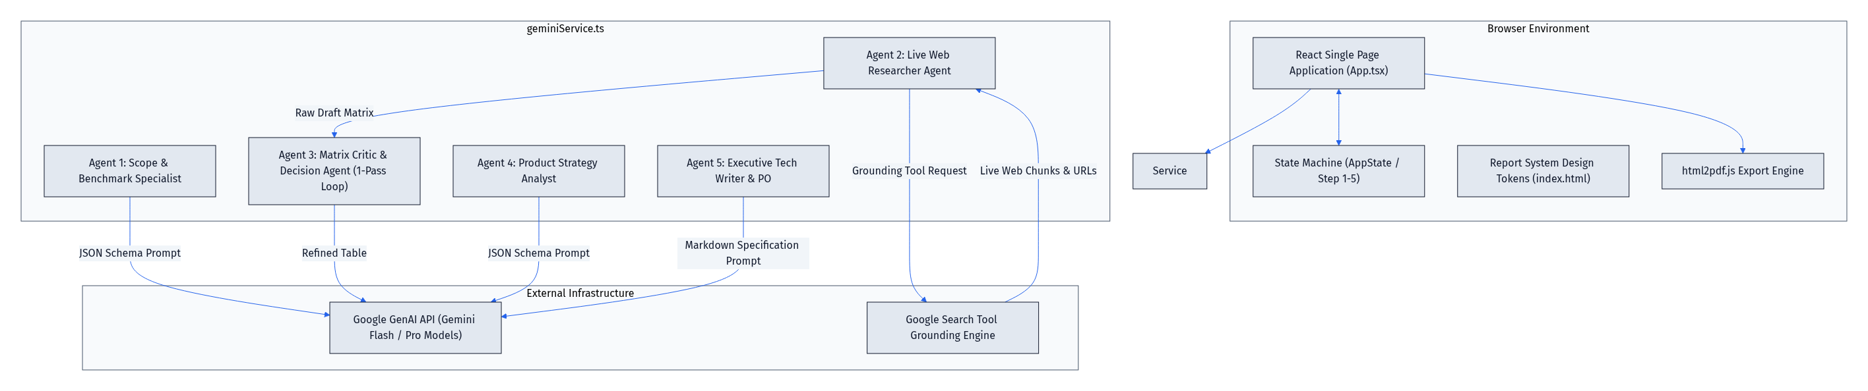

Figure 2: End-to-End Multi-Agent Sequence Workflow (White Background)
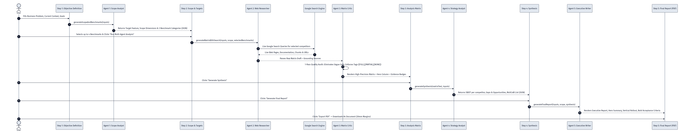

Figure 3: 1-Pass Critic Review & Refinement Sub-Loop (White Background)
