3/18/2026
- 2 Provider
  - Have the first caregiver in the providers tab be pre-loaded as myself in a neutral grey color
- 3 affordability
  - Have them put the percentage open. Include instruction: if you don’t know exactly, you can put an approximation
- 4 effort
  - Have them put minutes openly instead of choosing
  - Last question “how difficult” -> do not have not applicable as 0
  - For every question, include a side-option as “Don’t’know/Not applicable”
- 5 child dev
  - Not allowing me to click any of the multiple choice questions in this section. There might be something wrong with the questions settings here.
- 11 review and submit:
  - Do not show summary like that, leave it open for now
- Weekly check in
  - Exclude new waitlist question
  - For “removed from waitlist question”. Phrase it differently like “did you get off of any waitlists, as in, got a spot in a new childcare option where you were previously on a waitlist?
    - If yes, ask if any other potential “confounders” also changed and thus led to getting of the waitlist like “got a new job”, “got a raise”, “moved to a new home”, etc.
  - Do not display review or computed metrics to participant
- Other edits:
  - I edited the file structure, now there is not parent folder anymore, it is just the childcare-precarity-tool folder.
  - I excluded some files and moved some to a folder called archive. Please have github ignore and not synchronize this folder, I want it locally only

3/17/2026
- Entry and exit ~30 minutes
  - Demographics
  - Access + precarity (full on entry)
  - Parent emotional
  - Child emotional
  - Child Cognition
  - Parent cognition

- Weekly ~ 5 minutes
  - Access + precarity (calendar)
  - Child emotional
  - Parent emotional
  - Waitlist status

- Access + precarity
  - Affordability:
    - % of income
    - Subsidy?
    - Income bracket, family size, zip code
  - Reasonable effort:
    - geographical location + location of each provider
    - having trouble finding? On waitlist? [improve]
    - transportation [improve]
  - supports child dev [for each provider]
    - accredited? Provider has degree?
    - Head start?
    - School-based?
    - Language
  - Meet parents’ needs
    - Is this your “preferred” care? [improve]
    - Does it work well with work schedule? [improve]
  - Precarity/instability
    - Calendar

- Demographics (full on entry)
  - WAITLIST status
  - Urbanicity
  - Age of child
  - Race/ethnicity
  - HH income
  - Languages spoken
  - Homelessness
  - Welfare involvement
  - Parental employment
  - Household structure

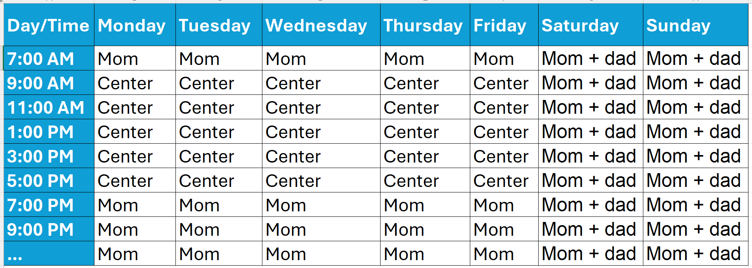

5/20/2025
https://wuyee.org/
- Idea for class:
  - Timing as IV
  - Priming experiment within that to drive salience point
- For real:
  - Partner with childcare entities to get parents ON WAITLIST
  - Within-person design (people are their own control group)
    - Getting off the waitlist is the within-person treatment
    - Look for how to include CHILDREN direct assessments
      - Something with pupils? Or heart rate? Or phone games?
      - Etc
- Measures
  - Parents: precarity (instability + smth), work-status, stress, cognition?
    - Once weekly at least instability
  - Kids: once at study entry, once right after getting spot, once 3-6 months afterwards
- Think about design carefully: how much time, when to measure, how long should the study be, etc.

New thoughts 12/5/2024
Phil said to go community based, make it useful, blablabla
Idea: basically, a calendar app JUST for childcare
- We ask them to plan at the beginning of each week, they can use to orient themselves, just like a regular calendar
- Every time an arrangement CHANGES, we ask them to put it in.
- Maybe at the end of the day? End of the week?
- They change. All data gets funneled to calculate:
  - Instability
  - Multiplicity
  - Unpredictability
  - Search
  - Etc.
- Eventually, if they are searching, we can even help them FIND IT.

