**Tableau 1st Dashboard – Summary**

**Database:** PostgreSQL 14.2

**Database schema:**

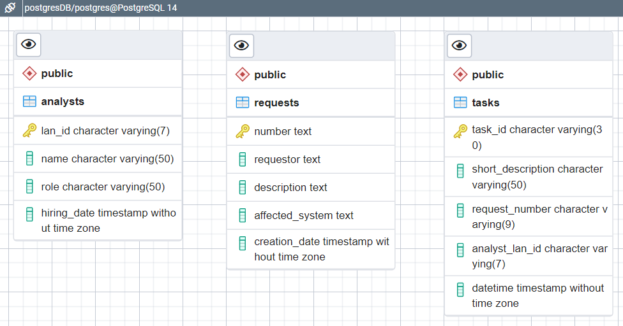

**Artificial data generation (using Python):**

Please check the following scripts:

|  |  |
| --- | --- |
|  | artificial_data_PostgreSQL.py |
|  | data_generation.py |
|  | database.py |

**Tableau Prep Builder (loading and adding features):**

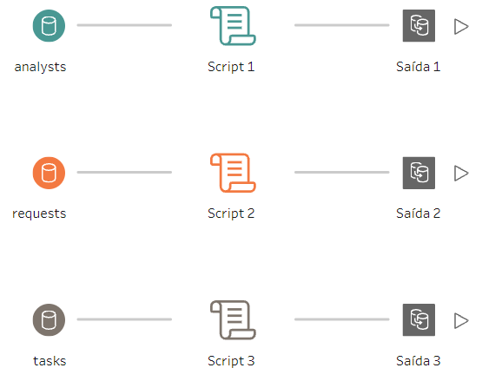

Please check the following scripts:

|  |  |
| --- | --- |
|  | tabpy_scripts\script_1.py |
|  | tabpy_scripts\script_2.py |
|  | tabpy_scripts\script_3.py |

**Temporary output (.hyper file) (no Tableau Server to store the view):**

|  |  |
| --- | --- |
|  | temp\output_1.hyper |
|  | temp\output_1.hyper |
|  | temp\output_1.hyper |

**Tableau Desktop (basic data visualization):**

|  |  |
| --- | --- |
|  | dashboard.pptx |

