Capstone Project - The Battle of Neighborhoods

1. Introduction
In a globalized world, It is very common for a company to transfer an employee to another city or even country, offering better career prospects or salary increase. Or someone could find a better job in other company in other city. No matter the reasons, moving to other city is always very stressful, and people are afraid about not get used with the new city . The problem is worse when the person is married with children. To minimize the problems, it is better to move a place similar to his last location, with compatible venues, like schools, restaurants, swimming pools, gyms, coffee-shops, supermarkets, etc. To help people in this situation, the goal of this project is to develop a system to find out which neighborhoods are similar to the current location. We will simulate a situation where a person is moving from New York to Toronto and vice versa.

2. Data Preparation

2.1 New York City Data
New York city Neighborhood has a total of 5 boroughs and 306 neighborhoods. In order to segment the neighborhoods and explore them, we will essentially need a dataset that contains the 5 boroughs and the neighborhoods that exist in each borough as well as the the latitude and longitude coordinates of each neighborhood.
Luckily, this dataset exists for free on the web and here is the link to the dataset: https://geo.nyu.edu/catalog/nyu_2451_34572. New York data can be downloaded from this link. This data would be json format and it can be transformed into pandas dataframe. New York datataset is showed in the figure 1, and the location are represented in the figure 2.

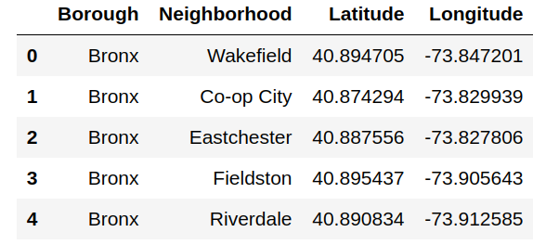

Figure 1 – New York city dataset samples

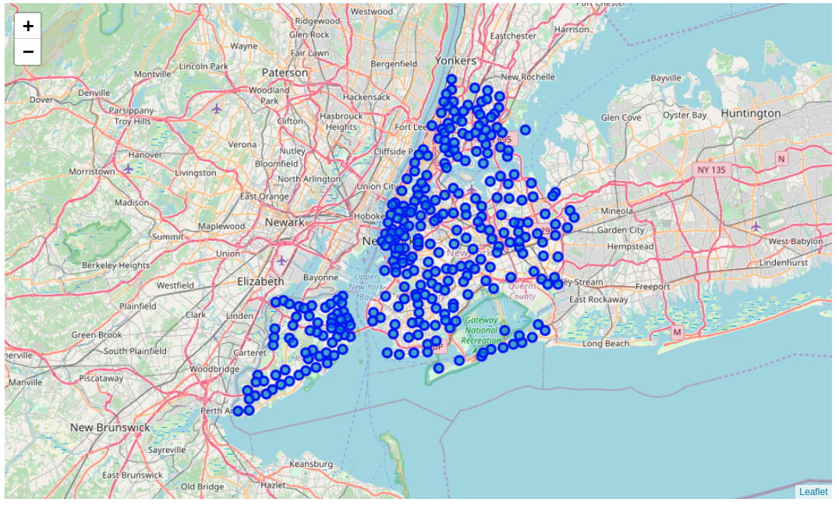
Figure 1 – New York city neighborhoods location

2.2 Toronto City Data
Unlike New York, the neighborhood data is not readily available on the internet. So we needed to use a notebook to build the code to scrape the following Wikipedia page, https://en.wikipedia.org/wiki/List_of_postal_codes_of_Canada:_M, in order to obtain the data that is in the table of postal codes and to transform the data into a pandas dataframe. We have to scrape the Wikipedia page and wrangle the data, clean it, and then read it into a pandas dataframe so that it is in a structured format like the New York dataset. There are some rows where “Not assigned” is written. Drop the rows where borough is “Not assigned” (only). If Neighborhood is “Not assigned” but Borough is assigned then make corresponding Borough as Neighborhood. We Merged the rows if Postal Code and Borough of two or more rows are the same and merged neighborhood will be separated by comma “,”. Latitude and longitude information can be downloaded from here. We tried to use Geocode but it was not working! So I used pgeocode. I preferred to do this instead of loading the file from the link. pgeocode failed to find the M7R coordinates. So, I got the coordinates from Google and inserted in the table.
Finally this data and Toronto data can be merged together. After both data are ready we used Foursquare API to get the venues near each neighborhood.
Toronto datataset is showed in the figure 3, and the location are represented in the figure 4.

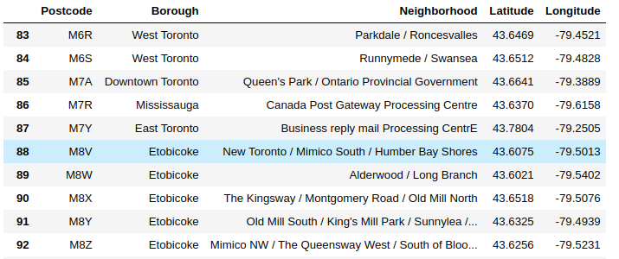
Figure 3 – Toronto Dataset samples

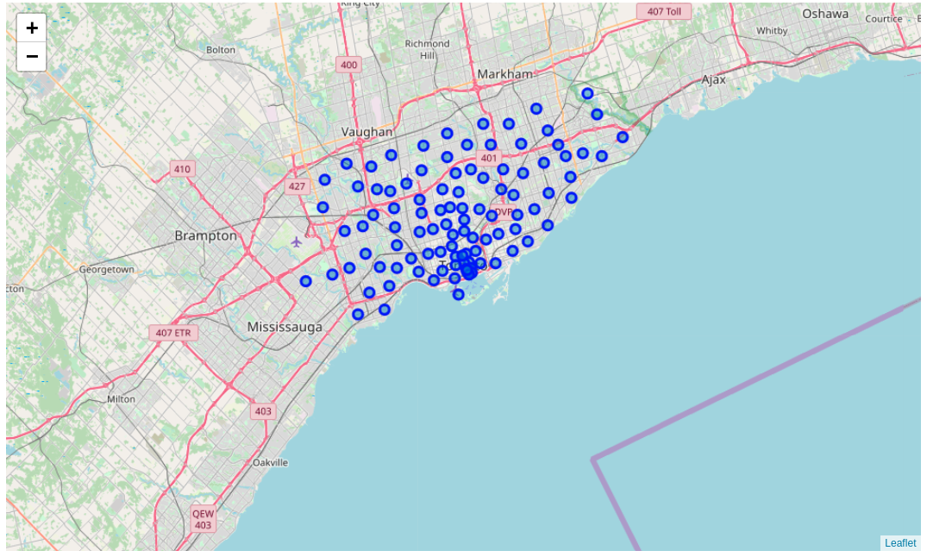
Figure 4 – Toronto city neighborhoods location (just postcode with M)

2.3 Using Foursquare to Get Venue Data
Foursquare was used to get venues information from each neighborhood. First, it has been necessary to obtain the client ID and the secret to get access to the online API. Figures 5 and 6 show samples of the New York and Toronto venues summary, respectively.

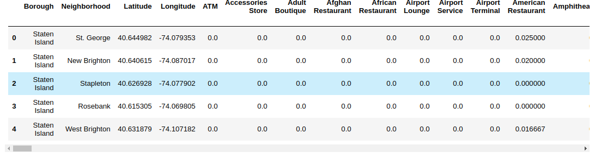
Figure 5 – New York Venues dataset
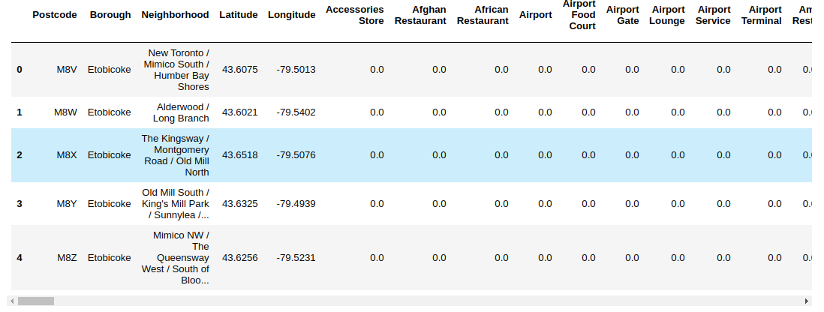
Figure 6 – Toronto Venues dataset

3. Methodology
New York and Toronto dataset are very similar, but some columns are different. First, it was analyzed how many venue categories are common in both cities dataset. The result was:
- Number of common venue categories in both data are :312
- Number of different venue categories in New York city are : 164
- Number of different venue categories in Toronto city are : 31
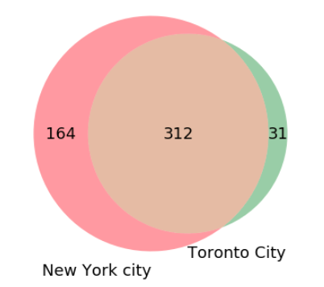

Figure 7 - Venn-Diagram of Venue Categories. 312 categories are the same
As we had 312 common categories, we used only these categories to compare the venues of both cities.
The measure the similarity of the locations, we used the Cosine similarity.

4. Results
We had implemented a function where the input are the current city , current borough current neighborhood and the number of most similar locations.
First, we simulated the case where someone is moving from Moving from Wingate, Brooklyn, NY, to Toronto. The result is represented in the figure 8 and 9.
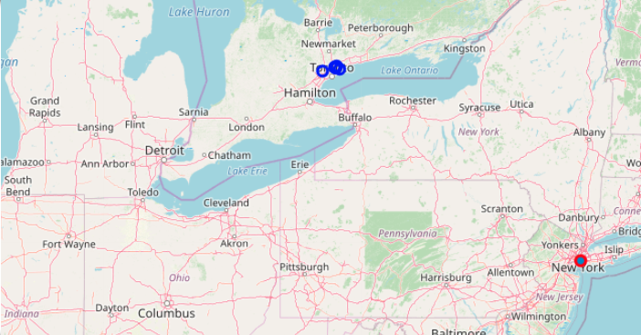

Figure 8 – Five most similar locations In Toronto
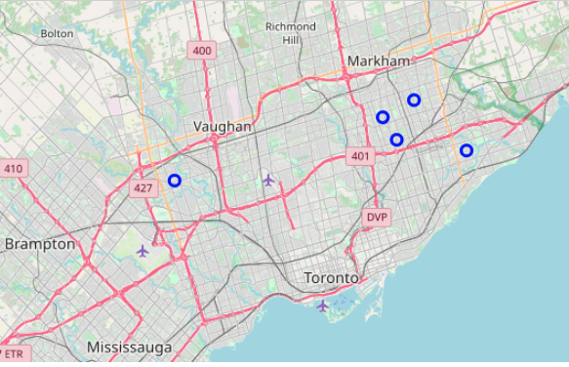

Figure 9 – Five most similar locations in Toronto (zoom)

The finded locations were:
- South Steeles / Silverstone / Humbergate / Jamestown / Mount Olive / Beaumond Heights / Thistletown / Albion Gardens
- Steeles West / L'Amoreaux West
- Milliken / Agincourt North / Steeles East / L'Amoreaux East
- Clarks Corners / Tam O'Shanter / Sullivan
- Woburn
Finally, we simulated the case where someone is moving from Moving from Woburn, Scarborough, to New York .The result is represented in the figure 10 and 11.

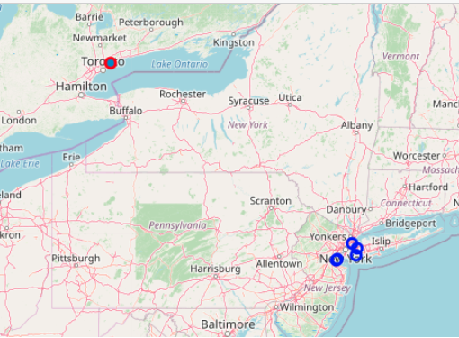
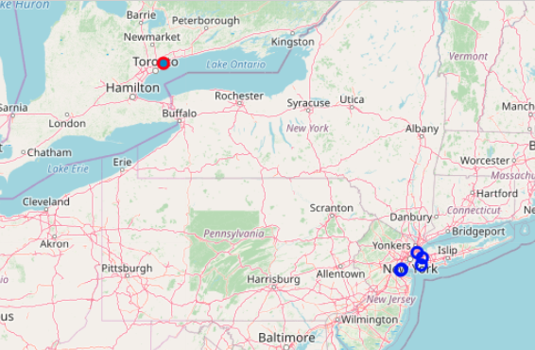

Figure 10 – Five most similar locations in New York

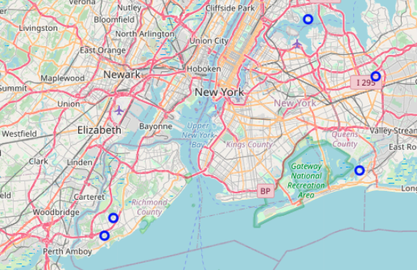

Figure 11– Five most similar locations in New York (zoom)

The finded locations were:
- Clason Point
- Prince's Bay
- Bayswater
- Bellaire
- Arden Heights

5. Discussion
This project used several data analysis tools to help someone to choose a new place to live. The first challenge was to find useful data, and in this case we used location data. Location data is data describing places and venues, such as their geographical location, their category, working hours, full address, and so on, such that for a given location given in the form of its geographical coordinates (or latitude and longitude values) one is able to determine what types of venues exist within a defined radius from that location. A lot of effort was spent to prepare the data in a suitable format, from different sources. Then, online information provided by Foursquare was used, to complement the data about the venues. Besides that, Folium was useful to show the locations, giving a overview of the locations. Finally, cosine similarity to measure the similarity between the locations. This is a very simple method, and in future works someone could try to implement more sophisticated methods.

6.Conclusion

This software is able to help someone who will move to a new city and would like to find a place to live similar to the his hometown. However, first it is necessary to find the right in formations about both the cities. Fortunately, in most of the cases, the data about the neighborhood localization can be found in the internet. Besides that, with the help of the Foursquare API, information about the venues can be download as a dataset. Then, with some adaptations, the comparison can be performed, and the most similar cities determinated.

