**Software Requirements**

**Specification**

**for**

**Producers-Consumers Economic Relationships Model**

**Version 1.0**

**Prepared by Mateusz Golab**

**Cranfield University**

**School of Engineering**

**AMAC**

**27th March 2012**

**Table of Contents**

1. Introduction 3

1.1. Purpose 3

1.2. Document Conventions 3

1.3. Intended Audience and Reading Suggestions 3

1.4. Project Scope 4

1.5. References 4

2. Overall Description 4

2.1. Product Perspective 4

2.2. Product Features 4

2.3. User Classes and Characteristics 4

2.4. Operating Environment 4

2.5. Design and Implementation Constraints 5

2.6. User Documentation 5

2.7. Assumptions and Dependencies 5

3. System Features 6

3.1. Model creation 6

3.1.1. Description and Priority 6

3.1.2. Stimulus/Response Sequences 6

3.1.3. Functional Requirements 6

3.2. Simulation 7

3.2.1. Description and Priority 7

3.2.2. Stimulus/Response Sequences 7

3.2.3. Functional Requirements 7

3.3. Results presentation 7

3.3.1. Description and Priority 7

3.3.2. Stimulus/Response Sequences 7

3.3.3. Functional Requirements 7

4. External Interface Requirements 8

5. Other Nonfunctional Requirements 8

5.1. Performance Requirements 8

5.2. Safety Requirements 8

5.3. Security Requirements 8

5.4. Software Quality Attributes 8

Appendix A : Glossary 8

Appendix B: Analysis Models 9

1. Use case diagrams 9

1.1. System use case diagram 9

1.2. Model creation use case diagram 10

1.3. Simulation use case diagram 11

1.4. Results presentation use case diagram 12

2. Sequence diagrams 13

2.1. Simulation Sequence diagram 13

3. State machine diagrams 14

3.1. Consumer State Machine Diagram 14

3.2. Factory State Machine Diagram 15

Appendix C: Issues List 15

**Revision History**

|  |  |  |  |
| --- | --- | --- | --- |
| **Name** | **Date** | **Reason for changes** | **Version** |
| Mateusz Golab | 29/03/2012 | Document created | 1.0 |
|  |  |  |  |

# Introduction

## Purpose

The purpose of this document is to provide full software requirements specification for the Producers – Consumers Economic Relationships Model. The document includes functional and non-functional requirements and use cases diagrams. All requirements specified in following document concern system version 1.0 .

## Document Conventions

|  |  |
| --- | --- |
| OE- | Operation environment requirement |
| CS- | Design and implementation constraint |
| AS- | Assumption |
| FR- | Functional requirement |
| PR- | Performance requirement |
| TBD- | “To be defined “ . Issue which is not precisely defined and must be clarified |

## Intended Audience and Reading Suggestions

This project is intended for following readers :

* ***Project manager*** - as a person responsible for whole project
* ***Architects*** – whose overall architecture must meet the requirements specified in this document
* ***Developers*** – whose software components must implements the requirements specified in this document
* ***Testers*** – who must ensure developed software quality and correctness according to requirements specified in this document
* ***Client*** – as the users of the system, should go through this document to check if functional requirements meet their needs.

## Project Scope

The purpose of this project is to provide software which is capable of performing simulations. The aim of these simulations is to show economical interactions between producers and customers. Performing several cycles within each simulation can be very helpful in terms of better understanding economic relationships between producers and consumers. This software is intended to answer questions addressed by the client.

## References

[1] *Advanced Software Engineering Lecture Notes,* *Academic Year 2010/2011* , Dr. Stuart Barnes

[2] *Software Requirements Specification Template,* Karl E. Wiegers 2002

[3] *IEEE Recommended Practice for Software Requirements Specifications, IEEE Std 830-1998,* IEEE Computer Society

# Overall Description

## Product Perspective

* The project is a self-contained product.
* No additional systems or sub-systems are required.
* It is designed to run on local desktop machine.
* System is accessible via text console user interface.

## Product Features

* Creating producers – consumers economic model based on user parameters
* Performing simulation of prepared model
* Presenting simulation results to the user

## User Classes and Characteristics

Client is the only user who will use this product. Producers-Consumers Economic Relationships Model represents dedicated application, which is provided to the specific client.

## Operating Environment

OE-1. Computer with x86 family processor

OE-2. Windows family operating system (XP, Vista, 7). Windows 7 preferred.

## Design and Implementation Constraints

CS-1. Software shall be implemented in C++ programming language.

CS-2. Software shall be designed according to Object Oriented Paradigm.

CS-3. Software shall provide possibility for the user to input simulation parameters from the text console.

CS-4. Unit testing framework shall be used in software development process.

CS-5. Static code analysis tool shall be used to evaluate code coverage.

## User Documentation

Documents delivered along with the software are as follows :

* Software Requirements Specification
* Software Design Descriptions
* Test Plan Document

All documents are in *pdf* format.

## Assumptions and Dependencies

AS-1 Number of producers has to be greater than number of consumers (see TBD-1)

AS-2 Producer cannot sell a factory. (see TBD-2)

AS-3 Consumer cannot sell a product. (see TBD-3)

AS-4 User requests to start simulation, Simulation Manager starts simulation. (see TBD-4)

AS-5 Producer increases product’s price every 10 cycles. (see TBD-5)

AS-6 There is no time required for building a factory. It is ready to work in the same cycle it was requested. (see TBD-6)

AS-7 Simulation Manager chooses Product to buy randomly. (see TBD-7)

AS-8 Customer’s salary can be set by the user . (see TBD-8)

AS-9 Once order was accepted by the Producer it stays until being completed. (see TBD-9)

AS-10 Customer always orders maximum number of particular product he/she can afford. (see TBD-10)

AS-11 Product’s cost increase relates to final product’s price. (see TBD-11)

AS-12 Order’s threshold is the maximum number of orders in a queue. It can be set by the user, default value equals 100 products. (see TBD-12)

AS-13 Order’s threshold is exactly the same for all Producers. (see TBD-13)

AS-14 Producer can build no more than one new factory during a single cycle. (see TBD-14)

AS-15 Customer has to wait for his order to be placed before making another order. (see TBD-15)

AS-16 Destruction of the factory is not associated with any cost. (see TBD-16)

AS-17 Factory can become idle after first cycle without manufacturing products. (see TBD-17)

AS-18 Start-up cost of the factory can be set by the user , default value equals 15. (see TBD-18)

AS-19 Default number of producers is 15 and consumers 1000. (see TBD-19)

AS-20 Default initial cash per producer equals 10000 and 150 per consumer. (see TBD-20)

AS-21 Default manufacturing cost of each product type equals 5 and default number of cycles to manufacture a product equals 5 for every product type as well. (see TBD-21)

AS-22 Producer is paying factory running costs even if it is in idle state. (see TBD-22)

AS-23 Factory’s efficiency is set randomly in range [1.0 , 4.0] when it is built. (see TBD-23)

AS-24 Producer can produce products only when order was made. (see TBD-24)

# System Features

Includes main features of the system.

## Model creation

### Description and Priority

To perform the simulation, model has to be created. This activity requires :

* Default parameters
* Parameters provided by the user
* System specific values and constants.

**Priority = Medium**

System can run using default parameters.

### Stimulus/Response Sequences

Stimulus : User requests to specify particular parameter.

Response : System receives user parameter and replace default one.

### Functional Requirements

FR-1. Model can be created using default parameters.

FR-2. The user can set model parameters.

FR-2.1. The user can set a number of consumers

FR-2.2. The user can set a number of producers

FR-2.3. The user can set an initial cash of each producer

FR-2.4. The user can set an initial cash of each consumer

FR-2.5. The user can set a manufacturing cost for each product.

FR-2.6. The user can set a length of time to manufacture a product.

FR-2.7. The user can set an initial factory running cost.

FR-2.8. The user can set an idle factory start-up cost.

FR-2.9. The user can set a factory construction cost.

FR-3. Model can be created using user specified parameters.

## Simulation

### Description and Priority

Simulation is the main feature of the system. Provides results for prepared model.

**Priority = High**

### Stimulus/Response Sequences

Stimulus : User requests to perform simulation.

Response : System performs simulation using prepared model.

### Functional Requirements

FR-4. The user can start Producers-Consumes Economic Relationships model simulation.

FR-5. Simulation Manager can stop the simulation when some Producer is declared bankrupt.

FR-6. System performs simulation

FR-6.1. Consumer can buy products.

FR-6.2. Consumer receives salary.

FR-6.3. Producer can manufacture different kinds of products using factories.

FR-6.4. Producer can build new factories.

FR-6.5. Producer receives money from sold products.

FR-6.6. Producer can be declared bankrupt if runs out of cash.

FR-6.7. Producer can determine products prices.

FR-6.8. Consumer pays for the products when the order is placed.

FR-6.9. User randomly chooses a product to buy.

FR-6.10. Simulation Manager can destroy unused factory.

FR-6.11. Producer must pay start-up cost for manufacturing in an idle factory.

## Results presentation

### Description and Priority

This feature makes simulation’s results available for the user.

**Priority = High**

### Stimulus/Response Sequences

Stimulus : System finishes simulation.

Response : Results are presented on the screen.

### Functional Requirements

FR-7. System can present simulation’s results on the screen after each cycle

FR-7.1. System can show number of orders per producer

FR-7.2. System can show the number of orders completed per producer

FR-7.3. System can show the number of factories per producer

FR-7.4. System can show the number of completed orders per factory (per producer)

FR-7.5. System can show the cash reserves per producer

FR-7.6. System can show the average cash reserves for all the consumers

# External Interface Requirements

No external requirements specified except display device. Any possible screen format can be used.

# Other Nonfunctional Requirements

## Performance Requirements

PR-1. System should provide simulation’s results in real time .

PR-2. System should perform simulation with several hundreds of consumers and producers.

## Safety Requirements

No safety requirements specified .

## Security Requirements

No security requirements specified .

## Software Quality Attributes

Following quality attributes will be assured. Details are provided in Test Plan Document.

* Availability
* Correctness
* Reliability
* Testability

# Appendix A : Glossary

|  |  |
| --- | --- |
| Bankruptcy | State in simulation, which represents lack of cash of some Producer. |
| Consumer | Internal actor of the system, takes part in simulation. Buys products. |
| Cycle | Period of time in simulation. Each activity in simulation is measured in cycles. |
| Factory | Takes part in simulation. Can be built by Producer. Manufactures products. |
| Offer | Contains information about the price of particular product type |
| Order | Takes part in simulation. Represents state of products being booked by the customer. |
| Producer | Internal actor of the system, takes part in simulation. Produces and sells products. |
| Product | Takes part in simulation, has many different kinds and properties. Can be manufactured, sold and bought. |
| Simulation manager | Internal actor of the system, responsible for controlling simulation process. |
| User | User of the system, main external actor. |

# Appendix B: Analysis Models

## Use case diagrams

### System use case diagram

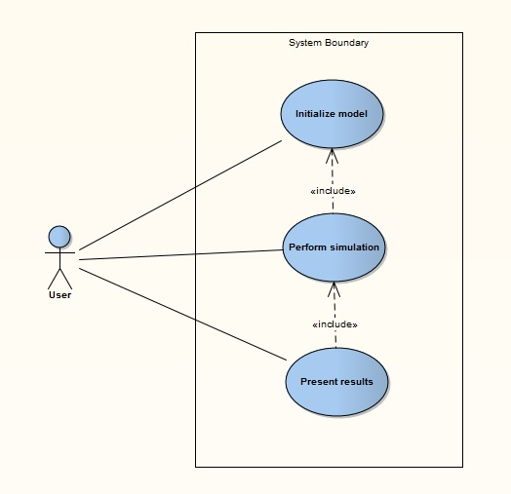

### Model creation use case diagram

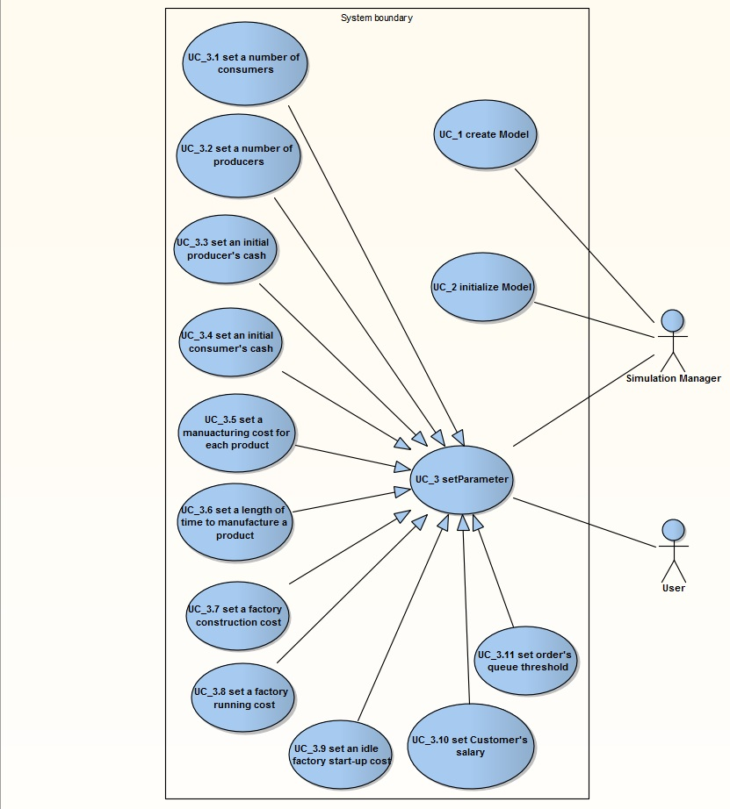

### Simulation use case diagram

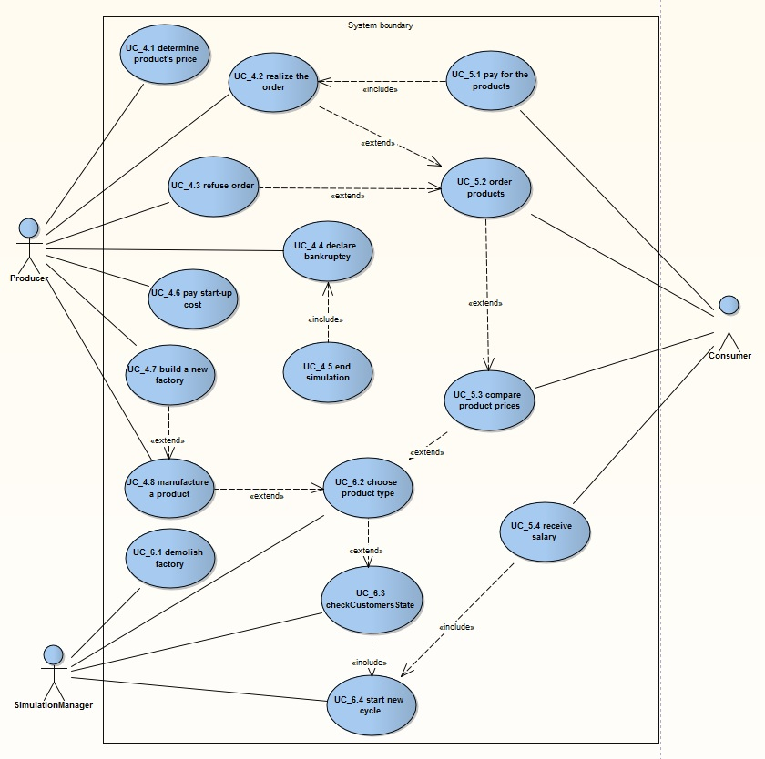

### Results presentation use case diagram

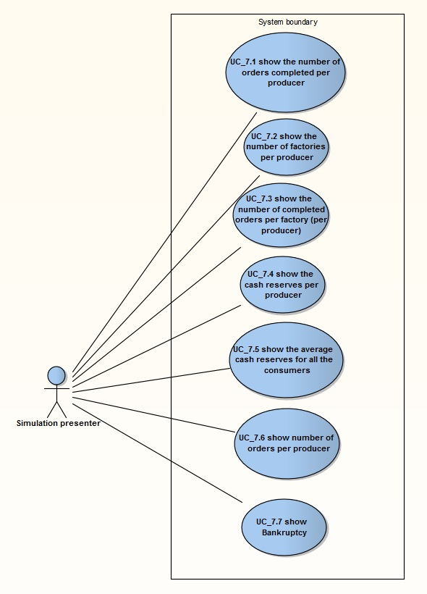

## Sequence diagrams

### Simulation Sequence diagram

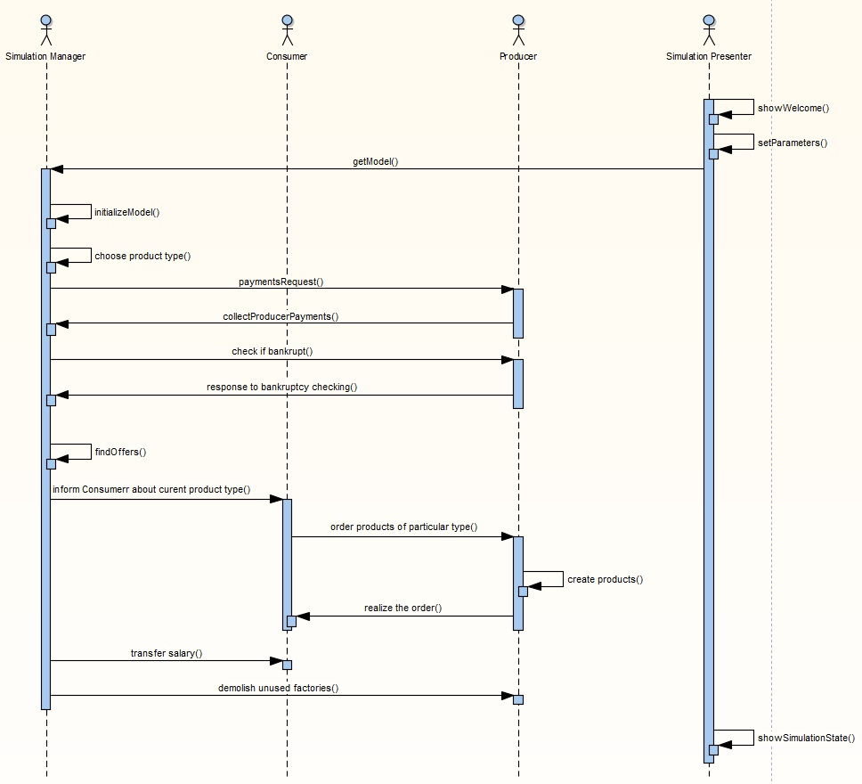

## State machine diagrams

### Consumer State Machine Diagram

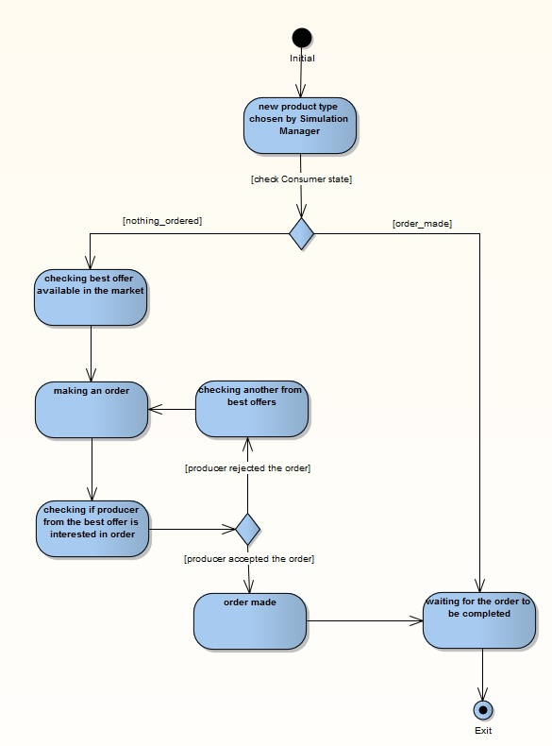

### Factory State Machine Diagram

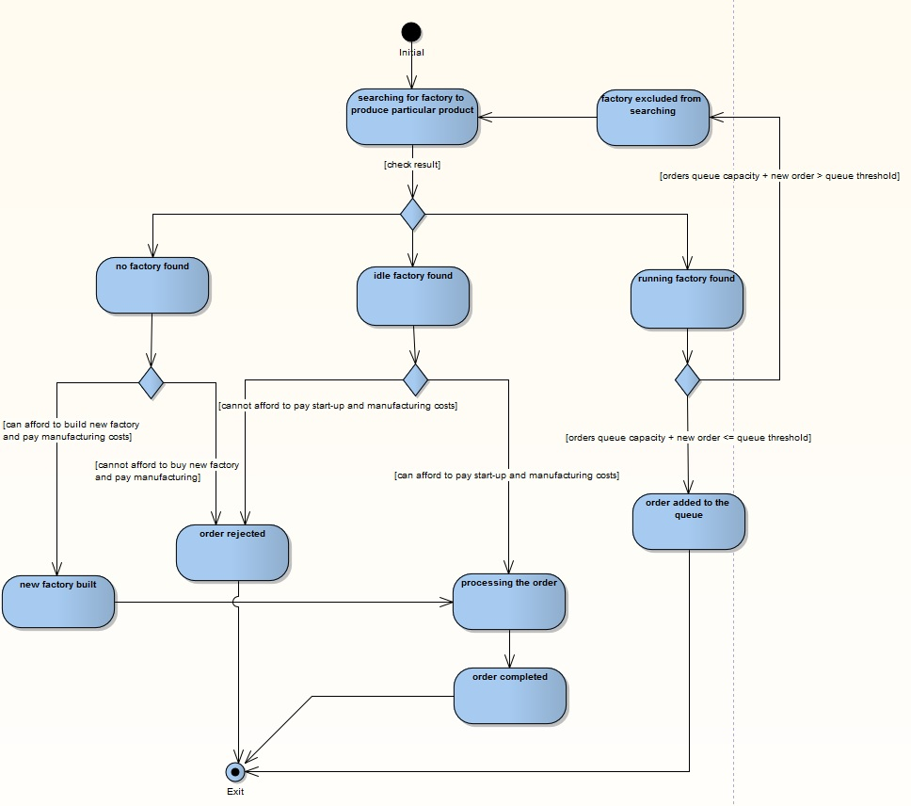

# Appendix C: Issues List

TBD-1 Is it possible to have more consumers than producers ?

TBD-2 Is it possible for Producer to sell a factory ?

TBD-3 Is it possible for Consumer to sell a bought product ?

TBD-4 Who should start simulation ?

TBD-5 Who should increase products costs ?

TBD-6 How much time does it take to build new factory ?

TBD-7 Who should choose particular product to buy for Consumers?

TBD-8 How much money Customer receives as a salary ?

TBD-9 How long an order can wait in a queue ?

TBD-10 Should Customer always buy maximum possible number of products he/she can afford?

TBD-11 Does increase in product’s cost relate to manufacturing cost or final price of a product ?

TBD-12 What is the value of order’s threshold ?

TBD-13 Is order’s threshold value exactly the same for all Producers ?

TBD-14 How many factories can be built by a single producer during one cycle ?

TBD-15 Is it possible for the Customer to make an order if one from previous cycle has not been placed yet ?

TBD-16 How much does it cost to demolish a factory ?

TBD-17 How many cycles are required for the factory to become idle ?

TBD-18 How much does it cost to start-up a factory ?

TBD-19 What are the default values for number of producers and consumers

TBD-20 What are the default initial cash amounts for producer and consumer ?

TBD-21 What is the default cost and number of cycles to produce of the product ?

TBD-22 Is producer paying factory running cost when it is idle ?

TBD-23 How efficiency of a factory is determined ?

TBD-24 Can producer produce any products in advance, without any order ?