LAB 3 CHALLENGE

Group 3, Shift 1: Casti, Disarò, Grandin, Maritan

**CONTROL STRUCTURE AND STRATEGY**

The goal of the challenge is to design a controller that ensures asymptotic tracking of step references with an overshoot smaller than 30% and with the smallest possible settling time, ts,5% .

We have decided to use a frequency-shaped LQR with integral action in the controller in order to be able to track asymptotically with null error the step references, as requested. Moreover, we chose this approach because we can reduce the oscillation of the beam and, consequently, the “kick” experienced by the hub and the overshoot of the response. In addition to the frequency-shaped LQR we added a small component of anti-windup to compensate for the saturation of the input.

First of all, the resonant frequency in our system is $ω_{o}=41 rad/s$.

We choose as frequency dependent weight $q_{22}={\left(0.585π/36\right)}^{-2}$.

For the state space realization of $H_{Q}\left(s\right)$ we use that one suggested in the assignment except for the matrix $D_{Q}=diag{(\left(1.25/180*π\right)}^{-1},0,\sqrt{6.6},0)$.

From these values we obtain the matrix $Q_{A}$ and we impose $R_{A} = 0.1.$

We then construct the augmented state space as described in the assignment where in the new matrix $Q_{e}$ we impose the weight of the integrator state equal to $q_{I}=0.1$, while for the new matrix $R_{e}$, which is actually a scalar in this case, we use the same value of $R_{A}$.

For the anti-windup we used a constant $K_{w}=0.092.$

By exploiting the routine lqr of MATLAB we obtain the following $K_{e}$:

$K_{e}=\left[1 , 1.45023e+02, 92.12687, 9.68514,1.03974, 7.38879e+04 , -1.83028e+03\right]$.

We report also the Simulink scheme of the controller in *Figure 1*.

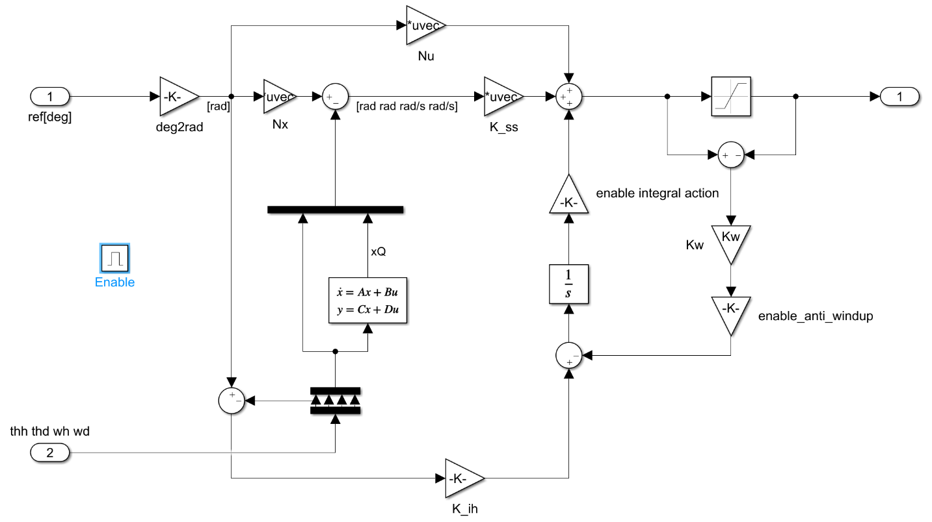

*Figure 1: Simulink scheme of the controller*

**EXPERIMENT RESULTS AND TEST ON THE BLACKBOX MODEL**

To test this control scheme we use as input of our Simulink model a step reference with amplitude 50 degrees and we set the *friction model* to *Karnopp* in the black box.

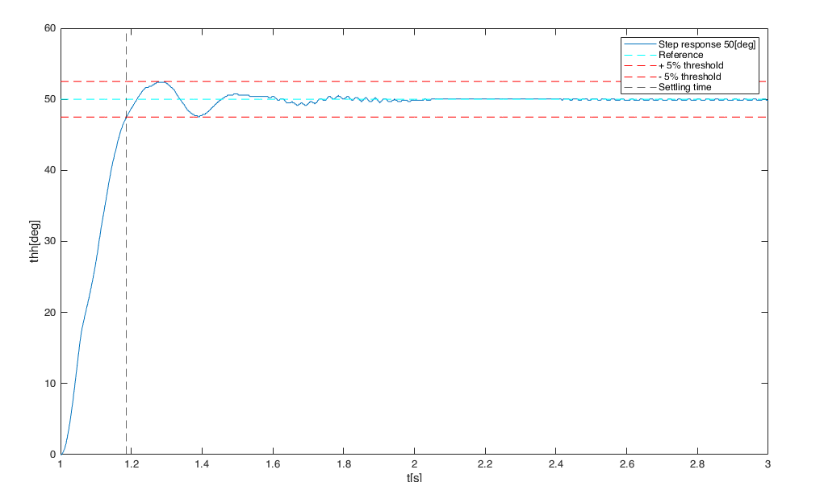We plot the response that we report in *Figure 2.*

*Figure 2: Response of the controlled system to a step of amplitude 50 degrees*

Finally, using the routine stepinfo of MATLAB we obtain the following parameters for the response.

|  |  |
| --- | --- |
| Rise time | 0.139 s |
| Settling time | 0.186 s |
| Overshoot | 4.76 % |