OutfitShare
Web Development Project Report

Mathieu Stutz
S00295668
Angular · Node.js / Express · MongoDB Atlas · AWS S3 & EC2
Academic Year 2025–2026

http://outfit-share.s3-website-eu-west-1.amazonaws.com/

PART 1

Project Proposal

1.1 Concept Overview
OutfitShare is a community-driven fashion platform designed to bridge the gap between inspiration and acquisition. Unlike traditional social networks that focus solely on visual sharing, OutfitShare allows users to post photographs of their outfits and digitally tag individual clothing items directly within the image. Each tag is linked to metadata — brand, price, condition, and a purchase link — enabling other users to recreate the looks that inspire them.
The platform targets fashion enthusiasts who wish to share their personal style, discover new trends, and access purchase information for specific items, all within a single application.

1.2 Core Features and External API Integration

- Interactive outfit posts: Users upload outfit photographs and place interactive hotspot tags on specific garments. Each tag stores metadata including brand, price, and a direct hyperlink to the retailer.
- Dynamic currency conversion: To serve a global user base, the platform integrates a live currency exchange API (ExchangeRate-API and frankfurter.app). Tagged item prices are automatically converted into the user’s local currency in real time.
Prior to implementation, the structure and shape of the data from these external APIs were extensively tested and analysed using Postman, ensuring a seamless integration with the Angular data models
- User engagement: Each post supports a fully functional comment section and a like system, encouraging community interaction.
- Algorithmic feed: The main feed is ordered using a custom time-decay algorithm that calculates a visibility score for each post, preventing older content from permanently dominating the feed.

1.3 Algorithmic Complexity — The Time-Decay Feed
To demonstrate advanced backend logic, the core feed mechanism is driven by a time-decay gravity algorithm. The server dynamically computes a visibility score for each post before serving it to the client:

Score = ( Likes + (Comments × 2) ) ÷ ( HoursAge + 2 )

This formula ensures that a recent post with moderate engagement can outrank an older post with many likes, giving new creators a fair opportunity to surface on the feed. The exponent on age means that visibility decays non-linearly over time, matching the behaviour observed on major social platforms.

1.4 Technical Stack

Frontend | Angular (Standalone Components architecture)
Backend | Node.js with Express — RESTful API
Database | MongoDB with Mongoose ODM
Deployment | AWS — S3 (frontend) and EC2 (backend)
External APIs | ExchangeRate-API · frankfurter.app

1.5 Anticipated Technical Challenges

- Designing a MongoDB schema capable of representing nested relationships between users, posts, embedded item tags, comments, and notifications.
- Implementing the time-decay sorting algorithm efficiently on the backend, using JavaScript array methods to compute and rank posts at query time.
- Integrating and parsing asynchronous data streams from third-party currency APIs within Angular components, while ensuring the UI remains responsive during network calls.
- Managing secure file uploads (avatar and outfit images) using multipart form data across the Angular–Express boundary.

Please note that any UI/UX wireframes provided at this stage represent early prototypes and are subject to change during the development lifecycle.

PART 2

Implementation

2.1 Backend Architecture
Technology Stack
The server-side architecture follows a RESTful design built on three core technologies. Node.js provides the runtime environment, Express handles route definition and request processing, and MongoDB Atlas — a cloud-hosted NoSQL database — handles all data persistence. This combination provides the flexibility required to store the complex, nested document structures that the application demands.

Data Modelling with Mongoose
Three Mongoose schemas are defined to model the application’s core entities:
- User: Stores profile information, biography, avatar path, and the social graph (followers and following arrays).
- Post: Stores the outfit photograph, an embedded array of item objects (itemSchema) each containing brand, category, condition, price, and X/Y tag coordinates, as well as a likes counter and a comments sub-document array.
- Notification: Stores interaction events (new followers, likes, and comments) with a boolean isRead flag that drives the notification badge in the UI.

Security and Authentication
Authentication is handled through a stateless JWT-based mechanism. Passwords are hashed with bcrypt before storage, ensuring that plaintext credentials are never persisted. On a successful login, the server issues a signed JWT that the Angular client stores in localStorage. A dedicated auth.js middleware intercepts every request to a protected route and verifies the token from the Authorization header, blocking any unauthorised access before it reaches the route handler.

2.2 Frontend Architecture
Angular Standalone Components
The frontend is built with Angular using the Standalone Component architecture, which removes the need for NgModules and reduces boilerplate significantly. The project is organised into four directories:
- components/: Contains all page-level views (Feed, Login, Register, Profile, etc.) and shared UI elements such as the Navbar.
- services/: Centralises all business logic and HTTP communication with the Express API.
- models/: Defines TypeScript interfaces (User, Post, IItem) to enforce strong typing throughout the application.
- guards/: Contains the AuthGuard that protects private routes from unauthenticated access.

Routing and Route Protection
The routing configuration in app.routes.ts defines a clear navigation hierarchy. Public routes (/login, /register) are accessible to all visitors. All other routes — the feed, profile pages, post creation, and notifications — are guarded by an AuthGuard. Any unauthenticated navigation attempt is intercepted and redirected to the login page.

Services and API Communication
All HTTP communication is managed through Angular services using the HttpClient module. Data flows are modelled as Observables, allowing components to subscribe and react to changes asynchronously:
- AuthService: Manages user login, registration, JWT storage and retrieval, and profile updates. It exposes an isLoggedIn$ Observable that the Navbar subscribes to, enabling the navigation links to appear and disappear reactively based on the session state.
- PostService: Handles all CRUD operations for posts: fetching the community feed, submitting new posts with multipart form data, and managing social interactions (likes and comments).
- NotificationService: Retrieves and updates notification records from the backend.
- Responsive Web Design: The entire application is fully responsive. By utilising a combination of custom CSS media queries and flexible architectures (such as the pure CSS Masonry Grid), the user interface adapts fluidly to mobile, tablet, and desktop viewports, guaranteeing an optimal experience across all devices

2.3 Tree of Components
The application is composed of eleven Angular standalone components. Each has a clearly defined responsibility and communicates with the backend exclusively through the dedicated service layer.

1 — LoginComponent
This component serves as the entry point for returning users. It uses a Template-Driven Form with the [(ngModel)] directive to bind the email and password inputs to TypeScript variables. On submission, the credentials are forwarded to the AuthService; on success, the router redirects the user to the feed. If the server returns an error, a message is displayed dynamically via *ngIf without a page reload.

2 — RegisterComponent
This component handles the creation of new user accounts, including avatar upload. Unlike the login form, it is built with Reactive Forms (FormBuilder and FormGroup), allowing more robust synchronous validation logic to be defined in the TypeScript class. A native email validator and a minimum password-length validator are applied alongside a custom passwordMatchValidator that confirms the password and confirmation fields are identical. The avatar image is sent via a FormData object, which packages binary file data alongside text fields for the multipart HTTP request.

3 — SettingsComponent
This component allows authenticated users to view and update their account information. On initialisation, it calls getProfile() on the AuthService to pre-populate the form. It also provides a real-time file name preview when the user selects a new avatar, so they can confirm their selection before submitting the update.

4 — CreatePostComponent
This is the core content creation interface, built on a Reactive Form that uses a FormArray (items) to allow users to add or remove clothing item entries dynamically. Each item group contains fields for brand, category, condition, and price. On submission, the component orchestrates two data streams simultaneously: the outfit photograph (captured via a file input and previewed in real time using a FileReader) and the serialised item array (converted to a JSON string). Both are packaged in a FormData object and sent as a multipart HTTP request. Strict validation prevents submission if the image is absent or any required field is incomplete.

5 — NotifComponent
This component displays the social interaction centre, showing new followers, likes, and comments. On initialisation it subscribes to the NotificationService. Unread notifications are visually distinguished using Angular’s dynamic class binding ([class.unread]). When a notification is clicked, markAsRead() updates the database asynchronously while simultaneously decrementing the unread counter in the UI, delivering an immediate, reactive user experience.

6 — CurrencyWidgetComponent
This utility component demonstrates the application’s ability to consume third-party APIs independently. It makes HTTP GET requests to the frankfurter.app API to retrieve live exchange rates (EUR to USD, GBP, and JPY). As a fully standalone component with no dependencies on the rest of the application, it can be embedded anywhere in the UI without side effects.

7 — ProfileComponent
This component renders the personal space of any user, displaying their biography, avatar, follower and following counts, and a gallery of their published posts. It uses Angular’s ActivatedRoute service to extract the userId parameter from the URL, meaning the same component handles both the authenticated user’s own profile and any other member’s public profile. Follow and unfollow actions trigger an HTTP request via the service, with the button label and follower count updated instantly in the UI to simulate real-time feedback.

8 — PostCardComponent
This is a presentational component responsible for rendering a single post. It receives its data exclusively through the @Input() decorator (post!: IPost), making it entirely reusable. Both the feed and the profile page render posts by including <app-post-card> and passing the post object, eliminating all code duplication. Internally, the component manages its own like toggle and an expandable comment section that can be shown or hidden to keep the feed clean.

9 — NavbarComponent
The navigation bar is persistent across all views of the Single Page Application. It subscribes to the isLoggedIn$ Observable from the AuthService, meaning the links for the Feed, Notifications, and Logout are injected into the DOM only once a valid session is confirmed. Navigation uses routerLink for seamless client-side transitions, and routerLinkActive applies a visual active class to the link matching the current route.

10 — HomeComponent
This is the main feed page, aggregating all community posts. Its template is intentionally minimal: it delegates all display complexity to PostCardComponent, iterating over the posts array using Angular’s @for syntax. The layout uses a pure-CSS Masonry Grid (columns: 3) rather than a standard Bootstrap grid, allowing images of varying aspect ratios to interlock visually — similar to the layout found on Pinterest — for a modern, professional appearance.

11 — PostDetailsComponent
This is the most technically complex component in the application. It uses ActivatedRoute to extract the post ID from the URL and fetch the full post document from the backend. Its defining feature is an interactive image mapping system: clothing item tags are overlaid directly on the outfit photograph, with their positions computed as percentage-based coordinates ([style.left.%] and [style.top.%]) from the X/Y values stored in MongoDB. This ensures tags remain correctly placed regardless of screen size. The component also makes parallel asynchronous calls to the exchangerate-api.com API to convert item prices from USD to EUR, GBP, and JPY, demonstrating the management of multiple concurrent data streams.

PART 3

Deployment and Hosting

3.1 Frontend — AWS S3
The compiled Angular application is deployed as a static website on an AWS S3 bucket. The bucket is configured to serve index.html as the entry point, which allows Angular’s client-side router to manage all navigation without requiring server-side rendering. S3 static hosting ensures high availability and low-latency asset delivery without the overhead of managing a dedicated web server.

3.2 Backend — AWS EC2
The Node.js/Express API runs on an AWS EC2 instance (Ubuntu). The instance listens for HTTP requests from the Angular client and communicates with the MongoDB Atlas cluster over a secure connection. The decoupled hosting strategy — frontend on S3, backend on EC2 — separates concerns cleanly and allows each tier to be scaled independently.

3.3 Architecture Diagram
The diagram below illustrates the data flow across all system tiers:
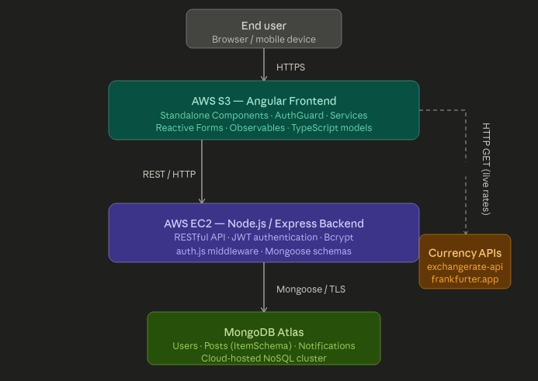
PART 4

Reflection
This project provided a comprehensive end-to-end web development experience, covering architecture design, full-stack implementation, and cloud deployment. Working with Angular’s Standalone Component architecture from the outset proved beneficial: it removed module-related complexity and naturally enforced a clear separation of concerns between components, services, and data models.

The most technically demanding feature was the interactive image tagging system in PostDetailsComponent. Storing tag positions as relative percentage coordinates in MongoDB, and translating them into accurate CSS positioning at render time regardless of screen dimensions, required careful alignment between the data model, the API response, and the Angular template binding.

Managing multiple asynchronous data streams simultaneously — combining calls to the local Express API with calls to the external currency APIs — reinforced the importance of structured Observable handling in Angular services. Ensuring that component templates remained responsive while waiting for parallel HTTP responses was a recurring consideration throughout development.

One area identified for improvement is the HTTP Interceptor pattern. Currently, each service method manually appends the Authorization header to outgoing requests. Centralising this logic in a single Angular HTTP Interceptor would reduce code duplication and make authentication handling more maintainable as the number of API endpoints grows.

The implementation of the time-decay scoring algorithm on the backend was a rewarding challenge. Applying the gravity formula efficiently during query processing, without introducing significant latency on the feed endpoint, required balancing algorithmic correctness with practical performance considerations.

Overall, the project successfully demonstrates a production-grade architecture: from secure authentication and flexible NoSQL data modelling through to standalone component design, third-party API integration, and dual-tier cloud deployment.

PART 5

Application Screenshots
The following screenshots illustrate the key views of the OutfitShare application running in a live environment.

5.1 Main Feed — HomeComponent
The main feed displays community posts in a CSS Masonry Grid layout (columns: 3), allowing images of varying aspect ratios to interlock naturally. The Navbar shows the OutfitShare branding alongside a search bar and Sign In / Sign Up call-to-action buttons for unauthenticated visitors.
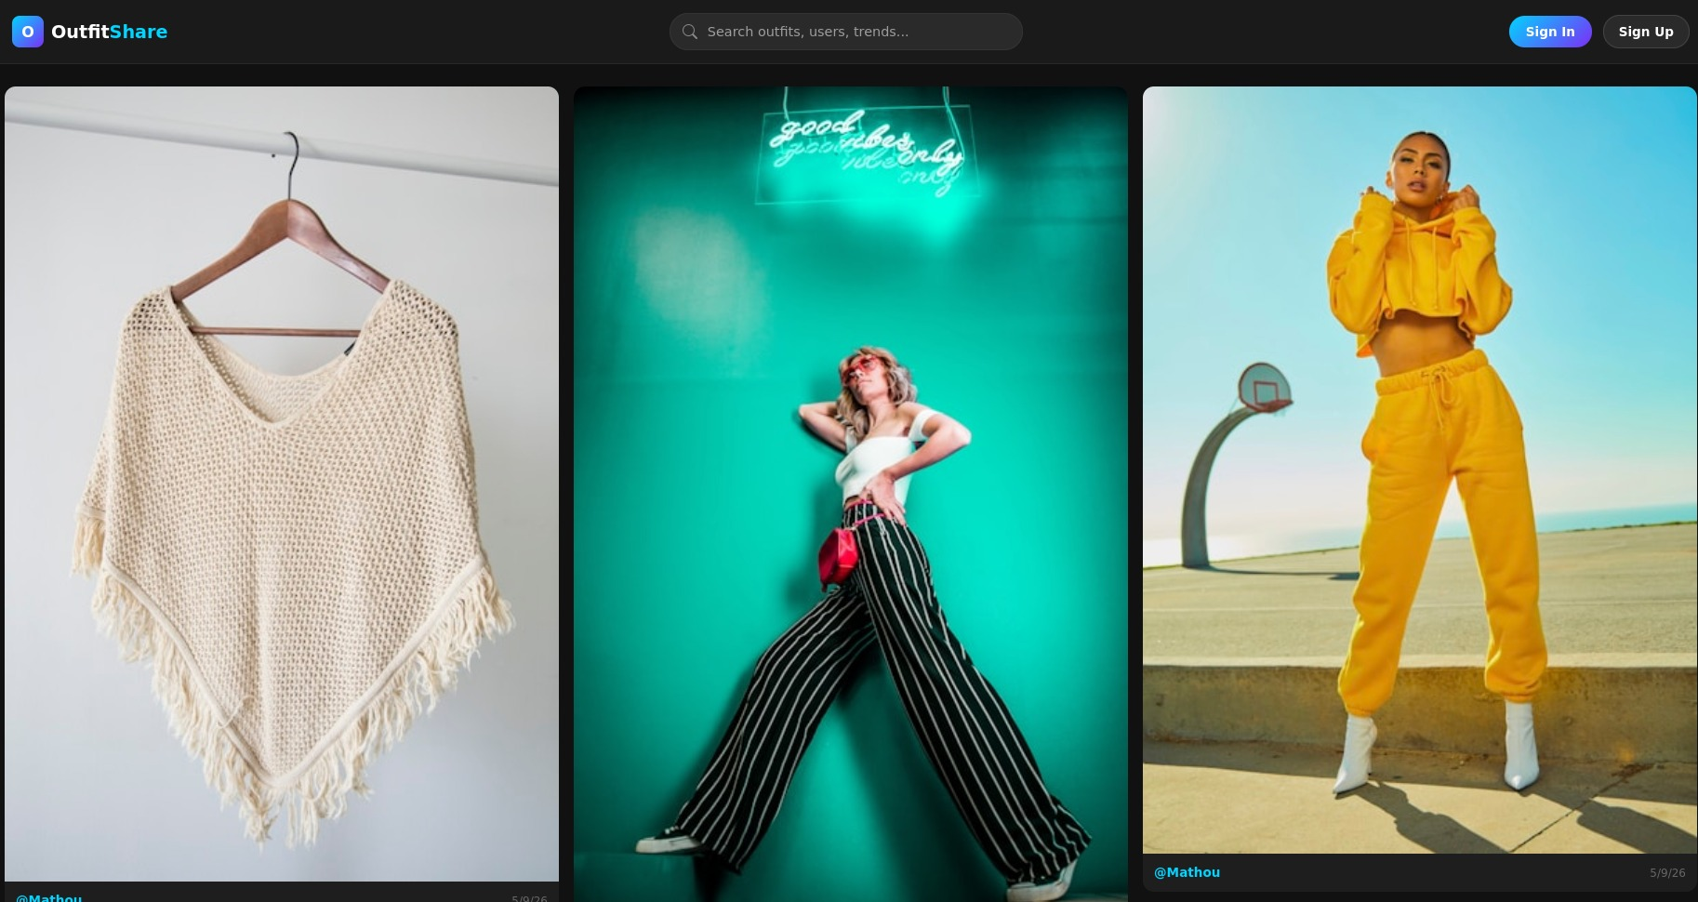
Figure 1 — Main feed with Masonry Grid layout (HomeComponent)

5.2 Post Detail View — PostDetailsComponent (1)
The post detail view renders the outfit photograph alongside a sidebar showing the author, post date, and a live Visibility Score computed by the time-decay algorithm. The cyan ‘+’ hotspots on the image indicate interactive clothing item tags. Clicking a tag opens a tooltip card displaying the item name, its price in USD, and the converted price in EUR via the ExchangeRate-API. A currency selector allows the user to switch between EUR, GBP, and JPY.
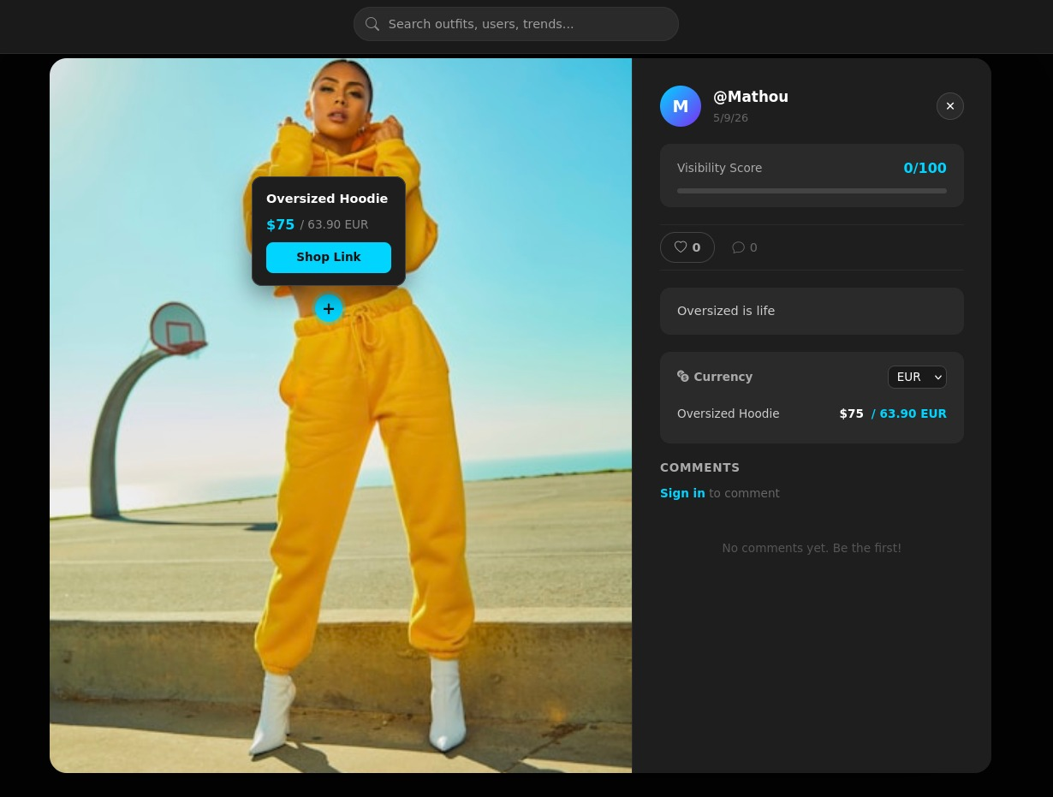
Figure 2 — Post detail with interactive image tag and currency conversion (PostDetailsComponent)

5.3 Post Detail View — PostDetailsComponent (2)
This screenshot demonstrates the comment system in action. The post displays two clothing items in the currency panel (Leather Jacket and Black Jeans, both converted to EUR). The comments section shows two user comments rendered below a live input field, illustrating the fully functional social interaction layer.
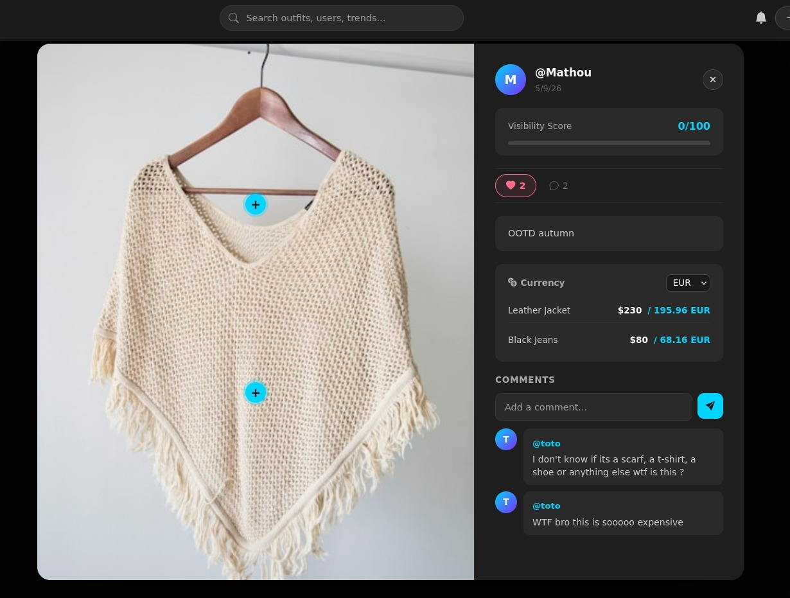
Figure 3 — Post detail with multiple items, currency conversion, and live comments

5.4 User Profile — ProfileComponent
The profile page displays the user’s avatar, username, and social statistics (Posts, Followers, Following). Below, the user’s published outfits are displayed in a responsive three-column grid. A Follow button is visible for other users’ profiles, and clicking it triggers an immediate UI update via the follow/unfollow logic implemented with Observables.
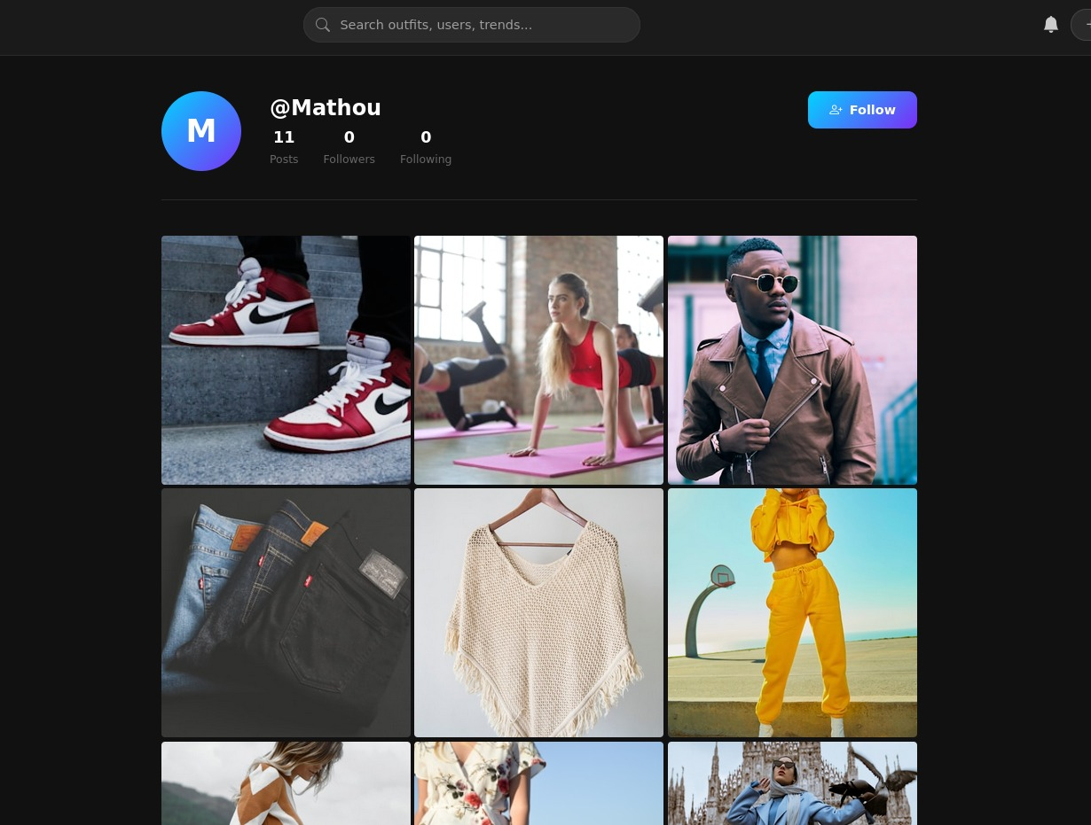
Figure 4 — User profile with post gallery and Follow button (ProfileComponent)

5.5 Post Creation — CreatePostComponent
The post creation interface provides a clean dark-themed form where users can enter a username, describe their outfit, and provide an image. The full implementation includes a dynamic FormArray allowing users to add multiple item entries (brand, category, condition, price) and an image file upload with real-time preview, as described in Section 2.3.
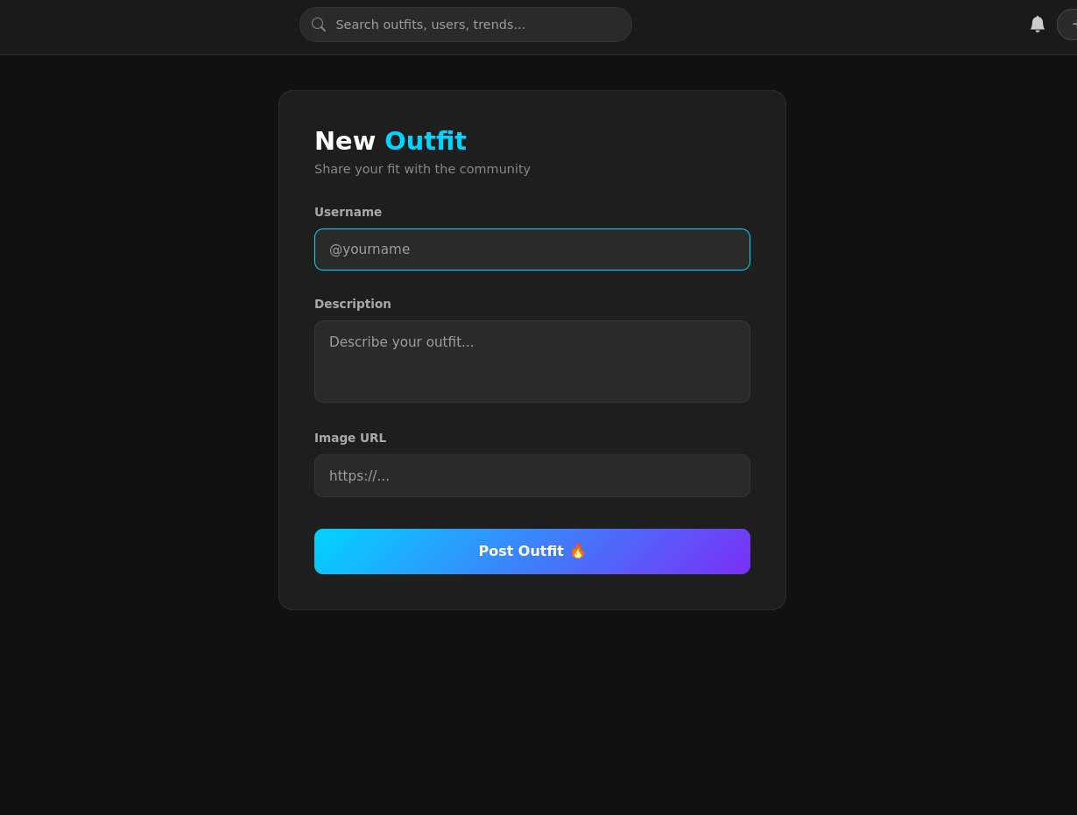
Figure 5 — Post creation form (CreatePostComponent)

5.6 Quick view from the Wireframe to the final Product
Please find on moodle the project proposal video showing more detailed wireframe

 wireframe screenshot



Final Product

NOTE

Note to the Examiner
The AWS EC2 instance hosting the backend API is subject to the student’s cloud account quotas and may be paused between evaluation sessions to manage costs. If the Angular frontend (hosted on S3) appears to load without returning any data, it is likely that the EC2 instance has been temporarily stopped. In this case, please contact Mathieu Stutz directly by email so that the instance can be restarted promptly, enabling full evaluation of all CRUD operations and live features.

