Supplementary material

Decoding Allosteric Effects of Missense Variations in Drug Metabolism: Afrocentric CYP3A4 Alleles Explored

Rehema Mukami Mwaniki¹, Wayde Veldman¹, Allan Sanyanga¹, Chiratidzo Chamboko¹, Özlem Tastan Bishop^{1, 2, #}

¹Research unit in Bioinformatics (RUBi), Department of Biochemistry, Microbiology and Bioinformatics, Rhodes University
² National Institute for Theoretical and Computational Sciences (NITheCS), South Africa

# Corresponding author: o.tastanbishop@ru.ac.za

Table S1: Parameter and coordinate files for both heme & cysteine-iron cluster model B3LYP/6-31G* containing optimized coordinates and derived atomic partial charges, and AMBER parameter files:
- Heme coordinated and derived atomic charges (HM1.mol2)
- Proximal cysteine ligand (CM1.mol2)
- Metal iron (FE1.mol2)
- An AMBER parameter file (cyp_mcpbpy.frcmod)
- An AMBER parameter file (HM1.frcmod)

a) Heme penta-coordinate and its derived atomic charges.
HM1.mol2

@<TRIPOS>MOLECULE
HM1
72 76 1 0 0
SMALL
RESP Charge

@<TRIPOS>ATOM
1 CHA 28.8420 -26.4120 21.9150 ce 1 HM1 -0.107886
2 CHB 28.1240 -22.5430 19.1660 ce 1 HM1 -0.132210
3 CHC 23.7610 -22.0540 21.0850 ce 1 HM1 -0.104151
4 CHD 24.4900 -25.8350 23.9750 ce 1 HM1 -0.113733
5 C1A 29.0240 -25.4180 20.9620 cc 1 HM1 -0.046020
6 C2A 30.2410 -25.2260 20.2230 cc 1 HM1 -0.060367
7 C3A 30.0120 -24.1540 19.4180 cd 1 HM1 0.044454
8 C4A 28.6690 -23.6770 19.6880 cd 1 HM1 -0.083823
9 CMA 30.9420 -23.5210 18.4340 c3 1 HM1 -0.087306
10 CAA 31.5260 -26.0260 20.2600 c3 1 HM1 -0.015727
11 CBA 31.4850 -27.1980 19.3600 c3 1 HM1 -0.002095
12 CGA 32.8450 -27.9130 19.3580 c 1 HM1 0.613312
13 O1A 33.2880 -28.2590 20.4690 o 1 HM1 -0.685354
14 O2A 33.4970 -28.0620 18.2770 o 1 HM1 -0.759218
15 C1B 26.8550 -22.0180 19.4870 cc 1 HM1 -0.049733
16 C2B 26.2760 -20.8540 18.8720 cc 1 HM1 0.064844
17 C3B 24.9970 -20.7470 19.3390 cd 1 HM1 -0.013194
18 C4B 24.8780 -21.8170 20.3360 cd 1 HM1 -0.074865
19 CMB 26.9580 -19.9770 17.8190 c3 1 HM1 -0.102791
20 CAB 23.9670 -19.7240 19.2120 cf 1 HM1 -0.108086
21 CBB 23.9840 -18.7080 18.4300 c2 1 HM1 -0.432903
22 C1C 23.5440 -23.0480 22.0300 cc 1 HM1 -0.095792
23 C2C 22.3210 -23.2740 22.7120 cc 1 HM1 0.129042
24 C3C 22.5690 -24.3020 23.6250 cd 1 HM1 -0.145545
25 C4C 23.9080 -24.7600 23.3880 cd 1 HM1 -0.021318
26 CMC 21.0560 -22.4050 22.5450 c3 1 HM1 -0.024739
27 CAC 21.6710 -25.0270 24.5220 cf 1 HM1 -0.048715
28 CBC 20.3910 -25.1020 24.2310 c2 1 HM1 -0.425319
29 C1D 25.7970 -26.2580 23.6330 cc 1 HM1 -0.191417
30 C2D 26.4180 -27.4130 24.2840 cc 1 HM1 0.091633
31 C3D 27.6370 -27.5740 23.7220 cd 1 HM1 -0.075410
32 C4D 27.7260 -26.4930 22.7180 cd 1 HM1 -0.065820
33 CMD 25.8760 -28.2600 25.3980 c3 1 HM1 -0.111505
34 CAD 28.6830 -28.6510 24.0590 c3 1 HM1 -0.053444
35 CBD 28.5050 -29.7740 23.0770 c3 1 HM1 -0.089698
36 CGD 29.4750 -30.9040 23.3670 c 1 HM1 0.730546
37 O1D 29.1550 -32.0770 23.1650 o 1 HM1 -0.770425
38 O2D 30.5650 -30.6900 23.8730 o 1 HM1 -0.728950
39 NA 28.0970 -24.4690 20.6410 Y2 1 HM1 -0.170023
40 NB 25.9860 -22.5310 20.3200 Y3 1 HM1 -0.188667
41 NC 24.4210 -23.9740 22.3550 Y4 1 HM1 -0.150165
42 ND 26.5780 -25.8160 22.5960 Y5 1 HM1 -0.064278
43 HMA1 30.4290 -23.1160 17.7180 hc 1 HM1 0.020584
44 HMA2 31.5320 -24.1970 18.0660 hc 1 HM1 0.020584
45 HMA3 31.4690 -22.8390 18.8790 hc 1 HM1 0.020584
46 HMB1 26.2860 -19.5900 17.2360 hc 1 HM1 0.026274
47 HMB2 27.5690 -20.5170 17.2940 hc 1 HM1 0.026274
48 HMB3 27.4520 -19.2670 18.2590 hc 1 HM1 0.026274
49 HMC1 21.3140 -21.4950 22.3310 hc 1 HM1 -0.002496
50 HMC2 20.5480 -22.4110 23.3710 hc 1 HM1 -0.002496
51 HMC3 20.5100 -22.7630 21.8280 hc 1 HM1 -0.002496
52 HMD1 26.2200 -29.1630 25.3150 hc 1 HM1 0.028391
53 HMD2 24.9070 -28.2780 25.3500 hc 1 HM1 0.028391
54 HMD3 26.1500 -27.8870 26.2510 hc 1 HM1 0.028391
55 HBB1 23.2400 -18.0860 18.4270 ha 1 HM1 0.127563
56 HBB2 24.7410 -18.5620 17.8410 ha 1 HM1 0.127563
57 HBC1 19.7870 -25.5810 24.8200 ha 1 HM1 0.140846
58 HBC2 20.0510 -24.6790 23.4270 ha 1 HM1 0.140846
59 HBA1 31.2590 -26.9150 18.4600 hc 1 HM1 -0.009844
60 HBA2 30.7900 -27.8110 19.6470 hc 1 HM1 -0.009844
61 HAA1 31.6930 -26.3240 21.1680 hc 1 HM1 0.011941
62 HAA2 32.2680 -25.4540 20.0090 hc 1 HM1 0.011941
63 HBD1 28.6450 -29.4460 22.1750 hc 1 HM1 0.012781
64 HBD2 27.5940 -30.1050 23.1200 hc 1 HM1 0.012781
65 HAD1 28.5640 -28.9700 24.9670 hc 1 HM1 0.019702
66 HAD2 29.5800 -28.2860 24.0010 hc 1 HM1 0.019702
67 HHA 29.5070 -27.0550 22.0160 ha 1 HM1 0.239468
68 HHB 28.6330 -22.0740 18.5440 ha 1 HM1 0.144466
69 HHC 23.0500 -21.4710 20.9430 ha 1 HM1 0.108158
70 HHD 24.0170 -26.3080 24.6210 ha 1 HM1 0.160089
71 HAB 23.1860 -19.8220 19.7790 ha 1 HM1 0.144246
72 HAC 22.0160 -25.4490 25.3240 ha 1 HM1 0.097621
@<TRIPOS>BOND
1 1 5 1
2 1 32 1
3 1 67 1
4 2 8 1
5 2 15 1
6 2 68 1
7 3 18 1
8 3 22 1
9 3 69 1
10 4 25 1
11 4 29 1
12 4 70 1
13 5 6 1
14 5 39 1
15 6 7 1
16 6 10 1
17 7 8 1
18 7 9 1
19 8 39 1
20 9 43 1
21 9 44 1
22 9 45 1
23 10 11 1
24 10 61 1
25 10 62 1
26 11 12 1
27 11 59 1
28 11 60 1
29 12 13 1
30 12 14 1
31 15 16 1
32 15 40 1
33 16 17 1
34 16 19 1
35 17 18 1
36 17 20 1
37 18 40 1
38 19 46 1
39 19 47 1
40 19 48 1
41 20 21 1
42 20 71 1
43 21 55 1
44 21 56 1
45 22 23 1
46 22 41 1
47 23 24 1
48 23 26 1
49 24 25 1
50 24 27 1
51 25 41 1
52 26 49 1
53 26 50 1
54 26 51 1
55 27 28 1
56 27 72 1
57 28 57 1
58 28 58 1
59 29 30 1
60 29 42 1
61 30 31 1
62 30 33 1
63 31 32 1
64 31 34 1
65 32 42 1
66 33 52 1
67 33 53 1
68 33 54 1
69 34 35 1
70 34 65 1
71 34 66 1
72 35 36 1
73 35 63 1
74 35 64 1
75 36 37 1
76 36 38 1
@<TRIPOS>SUBSTRUCTURE
1 HM1 1 TEMP 0 **** **** 0 ROOT

b) Proximal cysteine ligand and its derived atomic charges.
CM1.mol2

@<TRIPOS>MOLECULE
CM1
10 9 1 0 0
SMALL
RESP Charge

@<TRIPOS>ATOM
1 N 27.4140 -28.2580 18.2540 N 1 CM1 -0.415700
2 H 27.8970 -27.6830 17.5780 H 1 CM1 0.246376
3 CA 26.5600 -27.5910 19.1840 CX 1 CM1 -0.035100
4 HA 27.0370 -27.5740 20.1650 H1 1 CM1 0.072756
5 CB 26.3110 -26.1610 18.7130 CT 1 CM1 -0.145822
6 HB2 27.2440 -25.5990 18.6450 H1 1 CM1 0.098096
7 HB3 25.8340 -26.2200 17.7510 H1 1 CM1 0.098096
8 SG 25.1360 -25.3170 19.7890 Y1 1 CM1 -0.503849
9 C 25.2600 -28.3350 19.2500 C 1 CM1 0.597300
10 O 24.5800 -28.5200 18.2410 O 1 CM1 -0.567900
@<TRIPOS>BOND
1 1 2 1
2 1 3 1
3 3 4 1
4 3 5 1
5 3 9 1
6 5 6 1
7 5 7 1
8 5 8 1
9 9 10 1
@<TRIPOS>SUBSTRUCTURE
1 CM1 1 TEMP 0 **** **** 0 ROOT

c) Iron metal and its derived atomic charges
FE1.mol2

@<TRIPOS>MOLECULE
FE1
1 0 1 0 0
SMALL
RESP Charge

@<TRIPOS>ATOM
1 FE 26.2680 -24.2560 21.4580 M1 1 FE1 0.564325
@<TRIPOS>BOND
@<TRIPOS>SUBSTRUCTURE
1 FE1 1 TEMP 0 **** **** 0 ROOT

d) An AMBER parameter file.
cyp_mcpbpy.frcmod

REMARK GOES HERE, THIS FILE IS GENERATED BY MCPB.PY
MASS
M1 55.85 Fe ion
Y1 32.06 2.900 S in cystine
Y2 14.01 0.530 Sp2 N in non-pure aromatic systems, identical to nc
Y3 14.01 0.530 Sp2 N in non-pure aromatic systems, identical to nc
Y4 14.01 0.530 Sp2 N in non-pure aromatic systems, identical to nc
Y5 14.01 0.530 Sp2 N in non-pure aromatic systems, identical to nc

BOND
Y1-M1 71.8 2.3068 Created by Seminario method using MCPB.py
Y2-M1 66.1 2.0017 Created by Seminario method using MCPB.py
Y3-M1 61.8 2.0072 Created by Seminario method using MCPB.py
Y4-M1 46.5 2.0166 Created by Seminario method using MCPB.py
Y5-M1 49.0 1.9970 Created by Seminario method using MCPB.py
CT-Y1 237.0 1.810 changed from 222.0 based on methanethiol nmodes
cc-Y2 525.4 1.3172 SOURCE3_SOURCE5 4612 0.0083
cc-Y3 525.4 1.3172 SOURCE3_SOURCE5 4612 0.0083
cc-Y4 525.4 1.3172 SOURCE3_SOURCE5 4612 0.0083
cc-Y5 525.4 1.3172 SOURCE3_SOURCE5 4612 0.0083
cd-Y2 441.1 1.3694 SOURCE1_SOURCE5 2269 0.0086
cd-Y3 441.1 1.3694 SOURCE1_SOURCE5 2269 0.0086
cd-Y4 441.1 1.3694 SOURCE1_SOURCE5 2269 0.0086
cd-Y5 441.1 1.3694 SOURCE1_SOURCE5 2269 0.0086

ANGL
CT-Y1-M1 105.38 109.45 Created by Seminario method using MCPB.py
Y1-M1-Y2 74.86 102.56 Created by Seminario method using MCPB.py
Y1-M1-Y3 73.14 93.75 Created by Seminario method using MCPB.py
Y1-M1-Y4 77.14 88.94 Created by Seminario method using MCPB.py
Y1-M1-Y5 72.51 96.62 Created by Seminario method using MCPB.py
Y2-M1-Y3 121.58 89.84 Created by Seminario method using MCPB.py
Y2-M1-Y4 97.88 168.49 Created by Seminario method using MCPB.py
Y2-M1-Y5 131.53 88.84 Created by Seminario method using MCPB.py
Y3-M1-Y4 130.92 89.64 Created by Seminario method using MCPB.py
Y3-M1-Y5 106.17 169.58 Created by Seminario method using MCPB.py
Y4-M1-Y5 126.93 89.60 Created by Seminario method using MCPB.py
cc-Y2-M1 161.27 128.42 Created by Seminario method using MCPB.py
cc-Y3-M1 150.89 127.49 Created by Seminario method using MCPB.py
cc-Y4-M1 153.72 126.90 Created by Seminario method using MCPB.py
cc-Y5-M1 159.42 127.21 Created by Seminario method using MCPB.py
cd-Y2-M1 161.33 127.33 Created by Seminario method using MCPB.py
cd-Y3-M1 161.15 127.23 Created by Seminario method using MCPB.py
cd-Y4-M1 151.38 127.72 Created by Seminario method using MCPB.py
cd-Y5-M1 155.80 128.39 Created by Seminario method using MCPB.py
CX-CT-Y1 50.0 108.60 AA cys (was CT-CT-SH)
Y1-CT-H1 50.0 109.50 AA cyx changed based on NMA nmodes
Y2-cc-cc 71.6 112.56 SOURCE3 141 4.2871
Y3-cc-cc 71.6 112.56 SOURCE3 141 4.2871
Y4-cc-cc 71.6 112.56 SOURCE3 141 4.2871
Y5-cc-cc 71.6 112.56 SOURCE3 141 4.2871
cc-Y2-cd 71.8 105.49 CORR_SOURCE5 1810 1.9032
cc-Y3-cd 71.8 105.49 CORR_SOURCE5 1810 1.9032
cc-Y4-cd 71.8 105.49 CORR_SOURCE5 1810 1.9032
cc-Y5-cd 71.8 105.49 CORR_SOURCE5 1810 1.9032
cd-cd-Y2 67.6 121.98 CORR_SOURCE5 141 1.9633
cd-cd-Y3 67.6 121.98 CORR_SOURCE5 141 1.9633
cd-cd-Y4 67.6 121.98 CORR_SOURCE5 141 1.9633
cd-cd-Y5 67.6 121.98 CORR_SOURCE5 141 1.9633
ce-cc-Y2 68.1 121.70 CORR_SOURCE5 58 1.4179
ce-cc-Y3 68.1 121.70 CORR_SOURCE5 58 1.4179
ce-cc-Y4 68.1 121.70 CORR_SOURCE5 58 1.4179
ce-cc-Y5 68.1 121.70 CORR_SOURCE5 58 1.4179
ce-cd-Y2 68.7 123.98 SOURCE4_SOURCE5 10 2.4097
ce-cd-Y3 68.7 123.98 SOURCE4_SOURCE5 10 2.4097
ce-cd-Y4 68.7 123.98 SOURCE4_SOURCE5 10 2.4097
ce-cd-Y5 68.7 123.98 SOURCE4_SOURCE5 10 2.4097

DIHE
X -cc-Y2-X 2 9.5 180.0 2.0 statistic value from parm94
X -cc-Y3-X 2 9.5 180.0 2.0 statistic value from parm94
X -cc-Y4-X 2 9.5 180.0 2.0 statistic value from parm94
X -cc-Y5-X 2 9.5 180.0 2.0 statistic value from parm94
X -cd-Y2-X 2 9.5 180.0 2.0 statistiv value from parm94
X -cd-Y3-X 2 9.5 180.0 2.0 statistiv value from parm94
X -cd-Y4-X 2 9.5 180.0 2.0 statistiv value from parm94
X -cd-Y5-X 2 9.5 180.0 2.0 statistiv value from parm94
CT-Y1-M1-Y2 3 0.00 0.00 3.0 Treat as zero by MCPB.py
CT-Y1-M1-Y3 3 0.00 0.00 3.0 Treat as zero by MCPB.py
CT-Y1-M1-Y4 3 0.00 0.00 3.0 Treat as zero by MCPB.py
CT-Y1-M1-Y5 3 0.00 0.00 3.0 Treat as zero by MCPB.py
CX-CT-Y1-M1 3 0.00 0.00 3.0 Treat as zero by MCPB.py
M1-Y1-CT-H1 3 0.00 0.00 3.0 Treat as zero by MCPB.py
M1-Y2-cc-cc 3 0.00 0.00 3.0 Treat as zero by MCPB.py
M1-Y3-cc-cc 3 0.00 0.00 3.0 Treat as zero by MCPB.py
M1-Y4-cc-cc 3 0.00 0.00 3.0 Treat as zero by MCPB.py
M1-Y5-cc-cc 3 0.00 0.00 3.0 Treat as zero by MCPB.py
Y1-M1-Y2-cc 3 0.00 0.00 3.0 Treat as zero by MCPB.py
Y1-M1-Y2-cd 3 0.00 0.00 3.0 Treat as zero by MCPB.py
Y1-M1-Y3-cc 3 0.00 0.00 3.0 Treat as zero by MCPB.py
Y1-M1-Y3-cd 3 0.00 0.00 3.0 Treat as zero by MCPB.py
Y1-M1-Y4-cc 3 0.00 0.00 3.0 Treat as zero by MCPB.py
Y1-M1-Y4-cd 3 0.00 0.00 3.0 Treat as zero by MCPB.py
Y1-M1-Y5-cc 3 0.00 0.00 3.0 Treat as zero by MCPB.py
Y1-M1-Y5-cd 3 0.00 0.00 3.0 Treat as zero by MCPB.py
Y3-cc-ce-cd 4 4.0 180.0 2.0 same as X -ce-ce-X , penalty score=136.0
Y4-cc-ce-cd 4 4.0 180.0 2.0 same as X -ce-ce-X , penalty score=136.0
Y5-cc-ce-cd 4 4.0 180.0 2.0 same as X -ce-ce-X , penalty score=136.0
Y5-cd-ce-cc 4 26.6 180.0 2.0 same as X -ce-cf-X , penalty score=136.0
cc-Y2-M1-Y3 3 0.00 0.00 3.0 Treat as zero by MCPB.py
cc-Y2-M1-Y4 3 0.00 0.00 3.0 Treat as zero by MCPB.py
cc-Y2-M1-Y5 3 0.00 0.00 3.0 Treat as zero by MCPB.py
cc-Y3-M1-Y2 3 0.00 0.00 3.0 Treat as zero by MCPB.py
cc-Y3-M1-Y4 3 0.00 0.00 3.0 Treat as zero by MCPB.py
cc-Y3-M1-Y5 3 0.00 0.00 3.0 Treat as zero by MCPB.py
cc-Y4-M1-Y2 3 0.00 0.00 3.0 Treat as zero by MCPB.py
cc-Y4-M1-Y3 3 0.00 0.00 3.0 Treat as zero by MCPB.py
cc-Y4-M1-Y5 3 0.00 0.00 3.0 Treat as zero by MCPB.py
cc-Y5-M1-Y2 3 0.00 0.00 3.0 Treat as zero by MCPB.py
cc-Y5-M1-Y3 3 0.00 0.00 3.0 Treat as zero by MCPB.py
cc-Y5-M1-Y4 3 0.00 0.00 3.0 Treat as zero by MCPB.py
cc-ce-cd-Y2 4 26.6 180.0 2.0 same as X -ce-cf-X , penalty score=136.0
cc-ce-cd-Y3 4 26.6 180.0 2.0 same as X -ce-cf-X , penalty score=136.0
cc-ce-cd-Y4 4 26.6 180.0 2.0 same as X -ce-cf-X , penalty score=136.0
cd-Y2-M1-Y3 3 0.00 0.00 3.0 Treat as zero by MCPB.py
cd-Y2-M1-Y4 3 0.00 0.00 3.0 Treat as zero by MCPB.py
cd-Y2-M1-Y5 3 0.00 0.00 3.0 Treat as zero by MCPB.py
cd-Y3-M1-Y2 3 0.00 0.00 3.0 Treat as zero by MCPB.py
cd-Y3-M1-Y4 3 0.00 0.00 3.0 Treat as zero by MCPB.py
cd-Y3-M1-Y5 3 0.00 0.00 3.0 Treat as zero by MCPB.py
cd-Y4-M1-Y2 3 0.00 0.00 3.0 Treat as zero by MCPB.py
cd-Y4-M1-Y3 3 0.00 0.00 3.0 Treat as zero by MCPB.py
cd-Y4-M1-Y5 3 0.00 0.00 3.0 Treat as zero by MCPB.py
cd-Y5-M1-Y2 3 0.00 0.00 3.0 Treat as zero by MCPB.py
cd-Y5-M1-Y3 3 0.00 0.00 3.0 Treat as zero by MCPB.py
cd-Y5-M1-Y4 3 0.00 0.00 3.0 Treat as zero by MCPB.py
cd-cd-Y2-M1 3 0.00 0.00 3.0 Treat as zero by MCPB.py
cd-cd-Y3-M1 3 0.00 0.00 3.0 Treat as zero by MCPB.py
cd-cd-Y4-M1 3 0.00 0.00 3.0 Treat as zero by MCPB.py
cd-cd-Y5-M1 3 0.00 0.00 3.0 Treat as zero by MCPB.py
cd-ce-cc-Y2 4 4.0 180.0 2.0 same as X -ce-ce-X , penalty score=136.0
ce-cc-Y2-M1 3 0.00 0.00 3.0 Treat as zero by MCPB.py
ce-cc-Y3-M1 3 0.00 0.00 3.0 Treat as zero by MCPB.py
ce-cc-Y4-M1 3 0.00 0.00 3.0 Treat as zero by MCPB.py
ce-cc-Y5-M1 3 0.00 0.00 3.0 Treat as zero by MCPB.py
ce-cd-Y2-M1 3 0.00 0.00 3.0 Treat as zero by MCPB.py
ce-cd-Y3-M1 3 0.00 0.00 3.0 Treat as zero by MCPB.py
ce-cd-Y4-M1 3 0.00 0.00 3.0 Treat as zero by MCPB.py
ce-cd-Y5-M1 3 0.00 0.00 3.0 Treat as zero by MCPB.py
ha-ce-cc-Y2 4 4.0 180.0 2.0 same as X -ce-ce-X , penalty score=136.0
ha-ce-cc-Y3 4 4.0 180.0 2.0 same as X -ce-ce-X , penalty score=136.0
ha-ce-cc-Y4 4 4.0 180.0 2.0 same as X -ce-ce-X , penalty score=136.0
ha-ce-cc-Y5 4 4.0 180.0 2.0 same as X -ce-ce-X , penalty score=136.0
ha-ce-cd-Y2 4 16.0 180.0 2.0 same as X -cc-cd-X , penalty score=136.0
ha-ce-cd-Y3 4 16.0 180.0 2.0 same as X -cc-cd-X , penalty score=136.0
ha-ce-cd-Y4 4 16.0 180.0 2.0 same as X -cc-cd-X , penalty score=136.0
ha-ce-cd-Y5 4 16.0 180.0 2.0 same as X -cc-cd-X , penalty score=136.0

IMPR
Y3-cd-cd-ce 1.1 180.0 2.0 Using the default value
Y4-cd-cd-ce 1.1 180.0 2.0 Using the default value
Y2-cd-cd-ce 1.1 180.0 2.0 Using the default value
Y4-cc-cc-ce 1.1 180.0 2.0 Using the default value
Y5-cc-cc-ce 1.1 180.0 2.0 Using the default value
Y2-cc-cc-ce 1.1 180.0 2.0 Using the default value
Y5-cd-cd-ce 1.1 180.0 2.0 Using the default value
Y3-cc-cc-ce 1.1 180.0 2.0 Using the default value

NONB
M1 1.4090 0.0172100000 IOD set for Fe2+ ion from Li et al. JCTC, 2013, 9, 2733
Y1 2.0000 0.2500 W. Cornell CH3SH and CH3SCH3 FEP's
Y2 1.8240 0.1700 OPLS
Y3 1.8240 0.1700 OPLS
Y4 1.8240 0.1700 OPLS
Y5 1.8240 0.1700 OPLS

e) An AMBER parameter file.
HM1.frcmod

Remark line goes here
MASS

BOND

ANGLE

DIHE
cd-cd-ce-cc 4 26.600 180.000 2.000 same as X -ce-cf-X , penalty score=136.0
nd-cd-ce-cc 4 26.600 180.000 2.000 same as X -ce-cf-X , penalty score=136.0
cc-cc-ce-cd 4 4.000 180.000 2.000 same as X -ce-ce-X , penalty score=136.0
cc-cc-ce-ha 4 4.000 180.000 2.000 same as X -ce-ce-X , penalty score=136.0
cd-cd-ce-ha 4 16.000 180.000 2.000 same as X -cc-cd-X , penalty score=136.0
nd-cc-ce-cd 4 4.000 180.000 2.000 same as X -ce-ce-X , penalty score=136.0
cc-cd-cf-c2 4 4.000 180.000 2.000 same as X -cf-cf-X , penalty score=136.0
cc-cd-cf-ha 4 4.000 180.000 2.000 same as X -cf-cf-X , penalty score=136.0
cd-cd-cf-c2 4 4.000 180.000 2.000 same as X -cf-cf-X , penalty score=136.0
cd-cd-cf-ha 4 4.000 180.000 2.000 same as X -cf-cf-X , penalty score=136.0
nd-cc-ce-ha 4 4.000 180.000 2.000 same as X -ce-ce-X , penalty score=136.0
nd-cd-ce-ha 4 16.000 180.000 2.000 same as X -cc-cd-X , penalty score=136.0

IMPROPER
cc-cd-ce-ha 1.1 180.0 2.0 Same as X -X -ca-ha, penalty score= 46.8 (use general term))
cc-ce-cc-nd 1.1 180.0 2.0 Using the default value
c3-cc-cc-cd 1.1 180.0 2.0 Using the default value
c3-cc-cd-cd 1.1 180.0 2.0 Using the default value
cd-ce-cd-nd 1.1 180.0 2.0 Using the default value
c3-o -c -o 1.1 180.0 2.0 Using general improper torsional angle X- o- c- o, penalty score= 3.0)
cc-cd-cd-cf 1.1 180.0 2.0 Same as c2-ca-ca-ca, penalty score=304.0)
c2-cd-cf-ha 1.1 180.0 2.0 Same as X -X -ca-ha, penalty score= 46.8 (use general term))
cf-ha-c2-ha 1.1 180.0 2.0 Same as X -X -ca-ha, penalty score= 47.1 (use general term))

NONBON

Table S2: Geometric representation (%) of the clusters (C) in all the systems.
 | C1 | C2 | C3 | C4 | C5 | C6 | C7 | C8 | C9
REF1 | 96.756 | 2.207 | 0.827 | 0.111 | 0.091 | 0.007 | 0.002
REF2 | 99.987 | 0.013
REF3 | 99.387 | 0.531 | 0.067 | 0.016
*3-M445T | 99.582 | 0.227 | 0.191
*8-R130Q | 93.189 | 4.253 | 1.271 | 0.655 | 0.504 | 0.093 | 0.018 | 0.013 | 0.002
*10-D174H | 98.964 | 0.864 | 0.129 | 0.031 | 0.009 | 0.002
*11-T363M | 94.825 | 3.453 | 1.693 | 0.024 | 0.002 | 0.002
*12-L373F | 96.149 | 2.678 | 1.033 | 0.100 | 0.036 | 0.004
*13-P416L | 98.371 | 0.931 | 0.693 | 0.004
*15-R162Q | 99.707 | 0.193 | 0.100
*17-F189S | 99.838 | 0.160 | 0.002
*18-L293P | 98.758 | 0.849 | 0.238 | 0.133 | 0.0156 | 0.007
*23-R162W | 100.0
*24-Q200H | 99.602 | 0.340 | 0.042 | 0.013 | 0.002
*32-I335T | 91.422 | 7.895 | 0.564 | 0.082 | 0.026 | 0.009
*38-T363M  M445T | 93.840 | 4.815 | 1.038 | 0.289 | 0.016 | 0.002

Figure S1: RMSD analysis with fluctuating loops excluded in calculations. A) RMSD line plots of all the systems compared to the reference structures from 0-500ns and B) violin plots of these RMSDs at different timestamps. The reference structure RMSD violin plots are coloured blue while the variants are coloured grey.

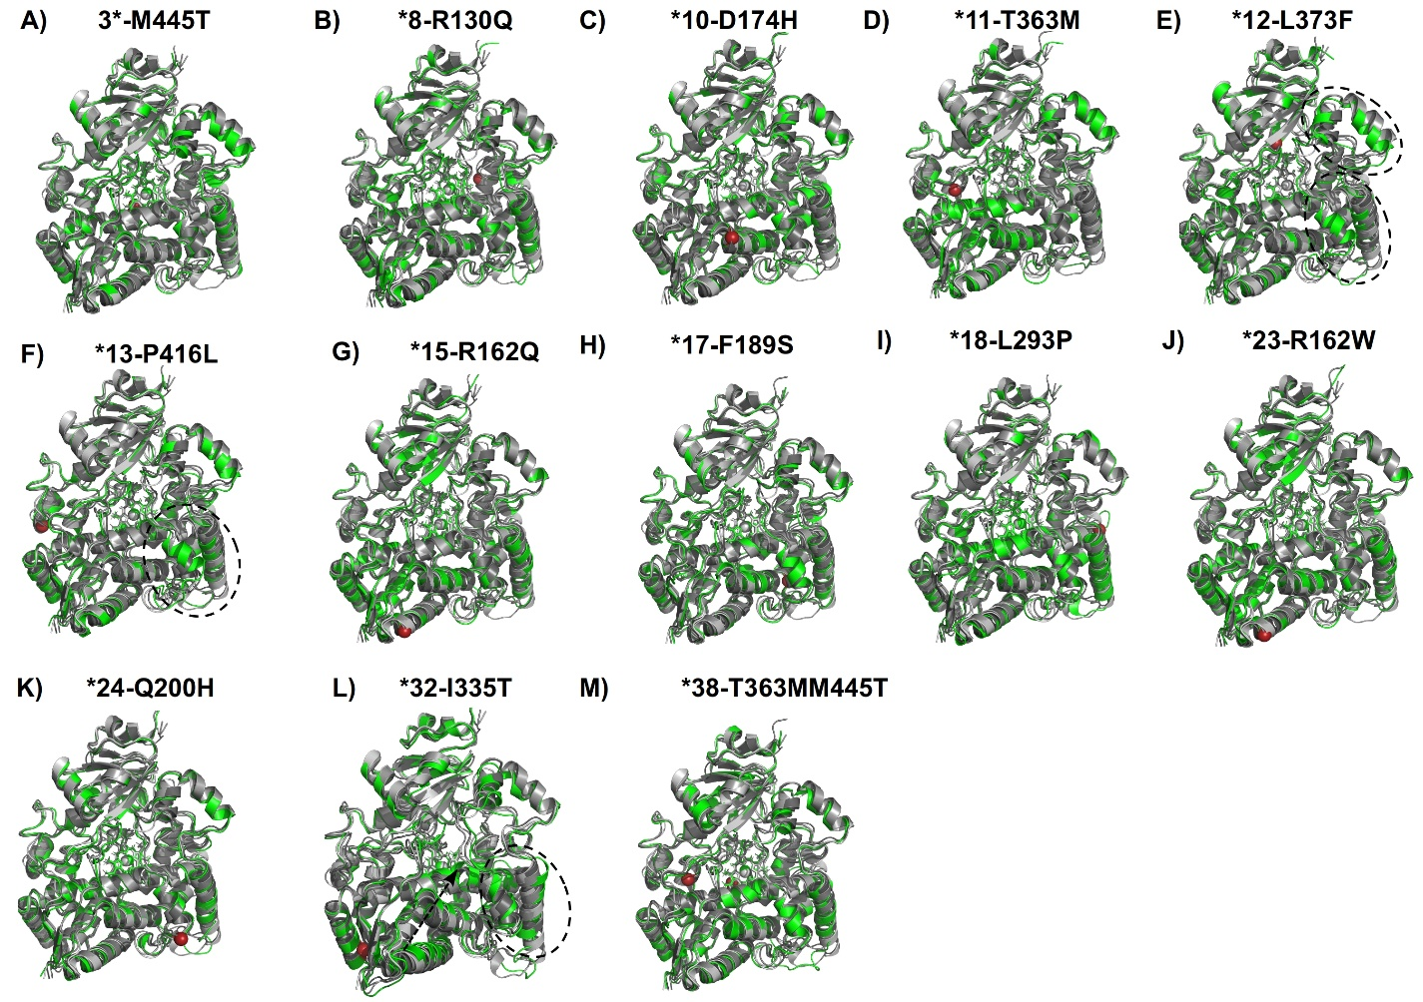

Figure S2: Superposed reference and variant C1 structures. REF1, REF2 and REF3 are coloured grey40, grey60 and grey80 respectively while the variant is coloured green. Changing secondary structures in *12, *13 and *32 have been circled and/or pointed in dotted lines

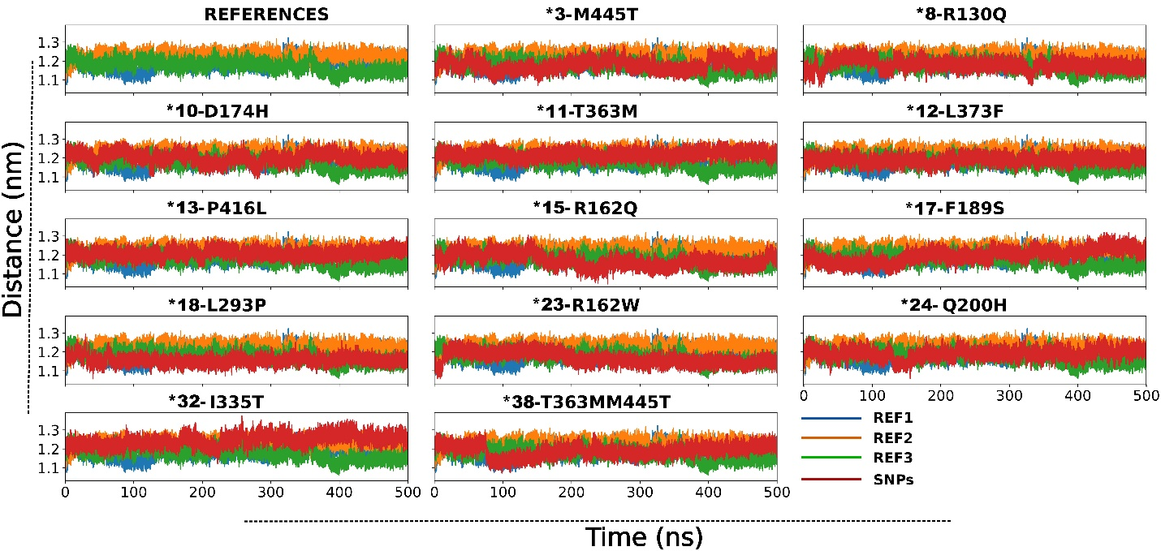
Figure S3: Line plots of the heme and active site COM distances along the trajectories.

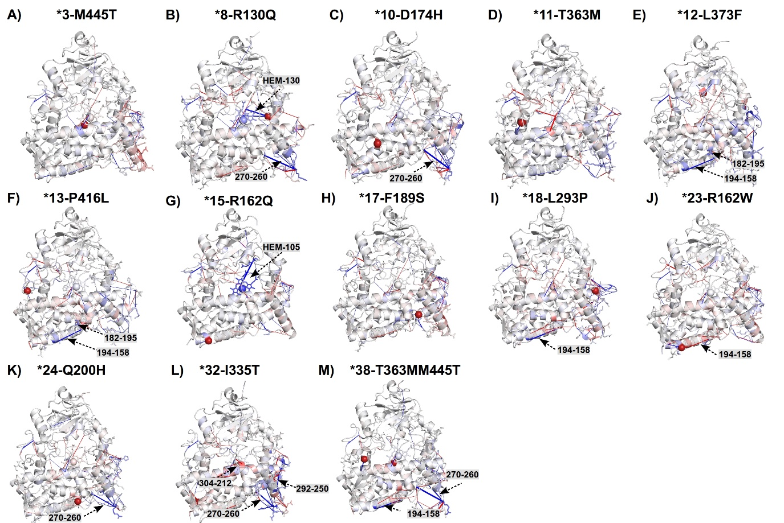

Figure S4: Structural mapping of the heatmap values from delta hydrogen analysis coloured under the same spectrum. Residue pairs involved in delta change shown as sticks and connected with red or blue coloured lines if they experience increased or decreased interaction respectively. The thickness of the lines is dependent on the frequency of the loss or gain of interaction. Interactions significantly changing compared to the major reference interactions are labelled according to the participating residue pairs. The position of mutation is represented as a firebrick coloured CA sphere.

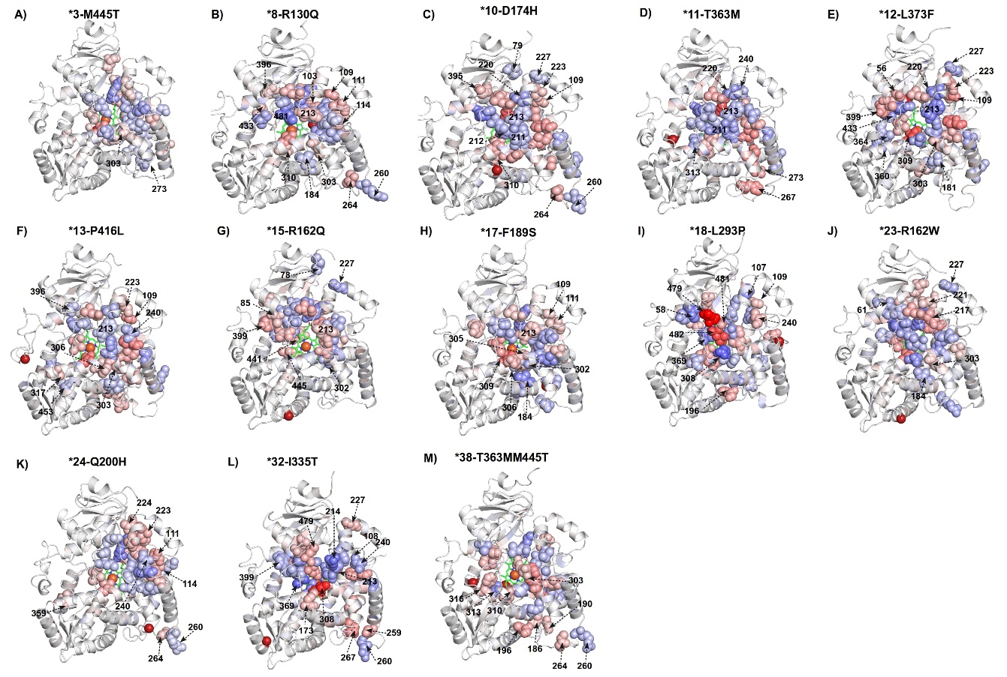
Figure S5: Structural mapping of the heatmap values of ΔBC analysis coloured under the same spectrum. Residues with top and bottom 3% ΔBC values are shown as spheres and labelled if they are significant while the rest of the structure is represented as a white cartoon. Heme is represented as balls and sticks and is coloured according to element. The position of the mutation is show as a firebrick coloured CA sphere.

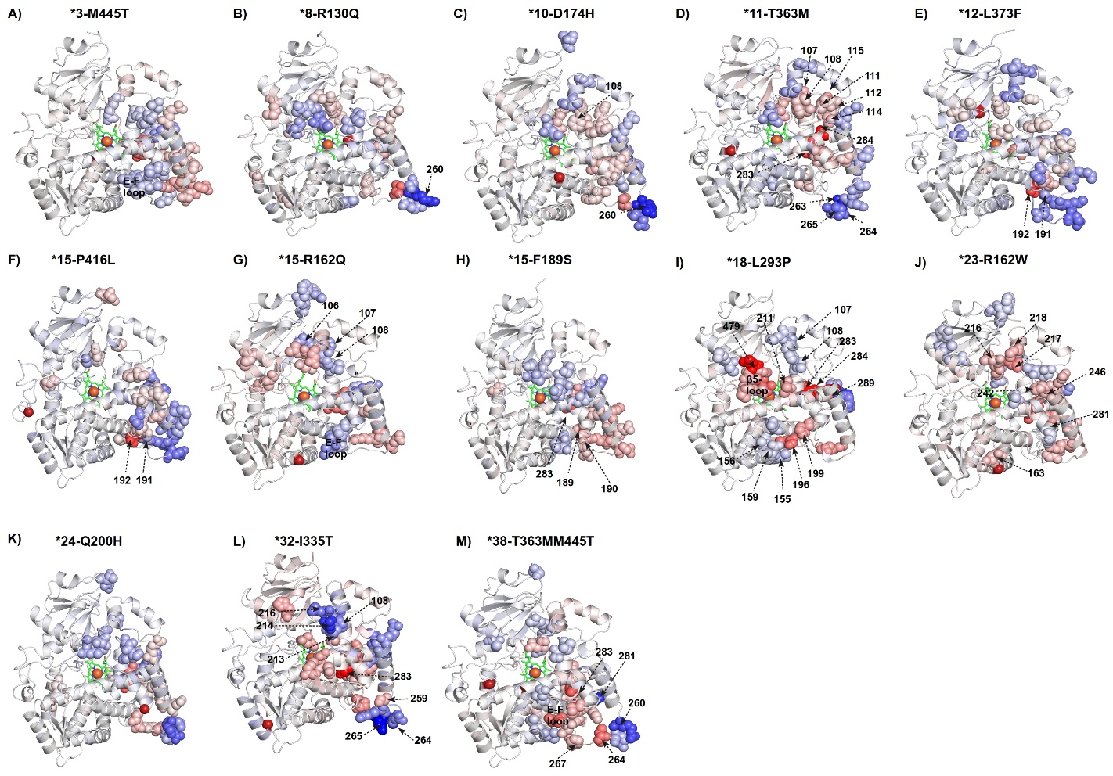
Figure S6: Structural mapping of the heatmap values of ΔCC analysis coloured under the same spectrum and represented as it is in ΔBC.

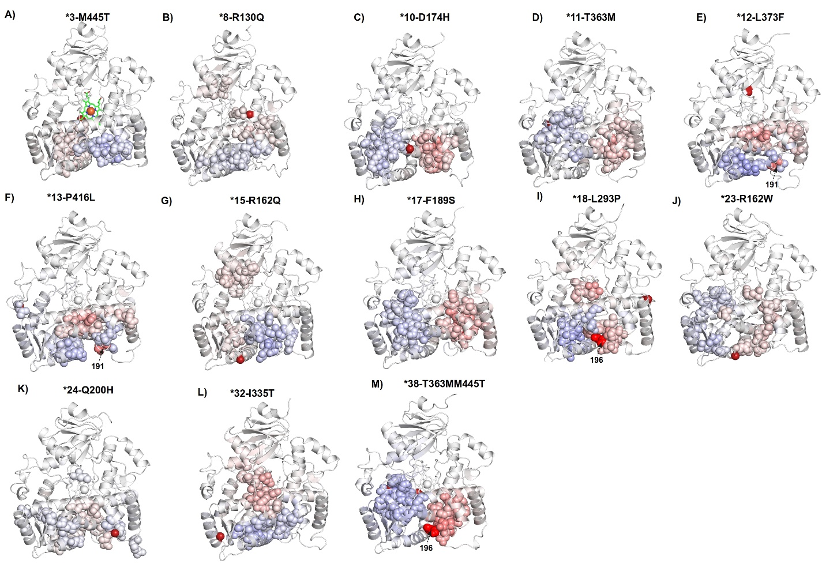
Figure S7: Structural mapping of the heatmap values from ΔEC coloured under the same spectrum and represented as it is in ΔBC.

