SSII 2019 MATH 2060 NAME:
Quiz 10

1. Using the General Form of Green's Theorem, calculate 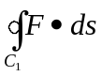, where 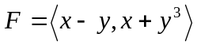 and C₁
is the outer boundary curve of D oriented counterclockwise. The domain D in Figure has area 8.
y

C₁
D
C₂
x
1

2. Evaluate the surface integral 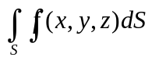:
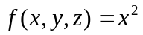 over the cone  