SSII 2019 MATH 2060 Name:
Quiz 1

1. Write inequalities to describe the solid rectangular box in the first octant bounded by the planes 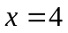, 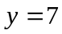, and 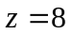

2. Find an equation of the sphere with center (8,-4,8) that touches the xy-plane

3. Calculate the given quantity if: 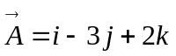; 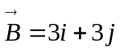; 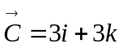
a) 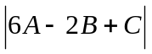

b) Determine a unit vector perpendicular to the plane that contains 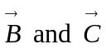 vectors

c) Find the volume of the solid whose edges are 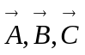

d) Find the angle between 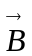 and 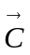

e) Determine the vector projection of onto

4. a) Find a vector perpendicular to the plane through the points
P(0,0,2), Q(2,0,0), R(0,2,0)

b) Find the area of triangle PQR

