SSII 2019 MATH 2060 NAME:
Quiz 2

1. Show that the lines L₁: 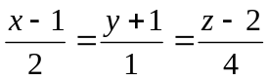 and L₂: 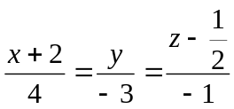
intersect and find the point of intersection

2. Find an equation for the plane that passes through the origin and whose normal vector is parallel to the line of intersection of the planes 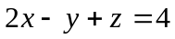 and 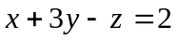

3. Find the distance from the point (-1,2,1) to the plane through the point (-3,5,1) with normal vector 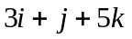

4. Classify and sketch the graph of the surface 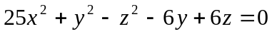 (show the vertex).

