SSII 2019 MATH 2060 NAME
Quiz 3

1. Find a tangent vector and the equation of the tangent line at the point P₀ where t = 0.2 on the graph of the vector function 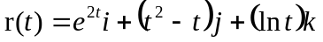

2. Find the curvature of the parabola given by 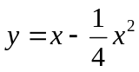 at x = 2. Sketch the circle of curvature at (2,1), and find its center and radius

3. An object starts from rest at the point P(1,2,0) and moves with an acceleration of 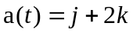. Find the location of the object after t = 2 seconds

