SSII 2019 MATH 2060 NAME
Quiz 4
SHOW ALL WORK
1. Describe and sketch the domain of the function 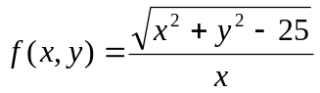

2. Describe the domain and range of the function 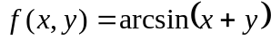

3. Show that the following limit does not exist 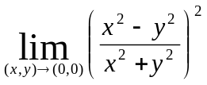

4. a) Discuss the continuity of the function 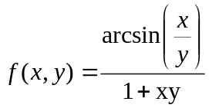

b) Find the limit of the function 