SSII 2019 MATH 2060 NAME:
Quiz 5

1. Find 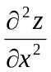 for 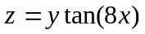

2. Find an equation of the tangent plane and find symmetric equations of the normal line to the surface at the indicated point
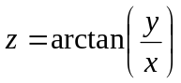, 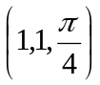

3. Use the linear approximation of 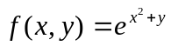 at (0,0) to estimate f(0.01,-0.02)

4. The volume V of a cylinder is computed using the values 3.5 m for diameter and 6.2 m for height. Use differentials to estimate the maximum percentage error in V if each of these values has a possible error of at most 5%.

