SSII 2019 MATH 2060 NAME:
Quiz 6

1. Find the critical point(s), and classify each point as a local maximum, a local minimum, or a saddle point(s)

2. Find the absolute extrema of f on the closed, bounded set S in the plane
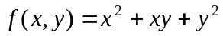, S is the disk 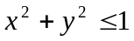

3. Use Lagrange multipliers to find the point on the intersection of the plane 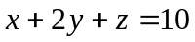 and the paraboloid 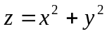, that is closest to the origin

