SSII 2019 MATH 2060 NAME:
Quiz 7

1. Sketch the region of integration and then compute the integral with the order of integration reversed
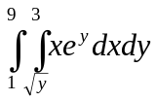

2. Find the volume of the solid bounded above by the plane 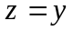 and below in the xy-plane by the part of the disk 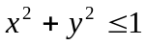 in the first quadrant

3. Evaluate 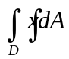, where D is the region bounded above by the line 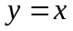 and below by the circle 