SSII 2019 MATH 2060 NAME:
Quiz 8

1. Find the mass of the lamina corresponding to the parabolic region 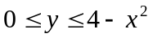, where the density at the point (x,y) is proportional to the distance between the point (x,y) and the x-axis (use double integral)

2. Use a triple integral to find the volume of the solid bounded by the graphs of the equations 

